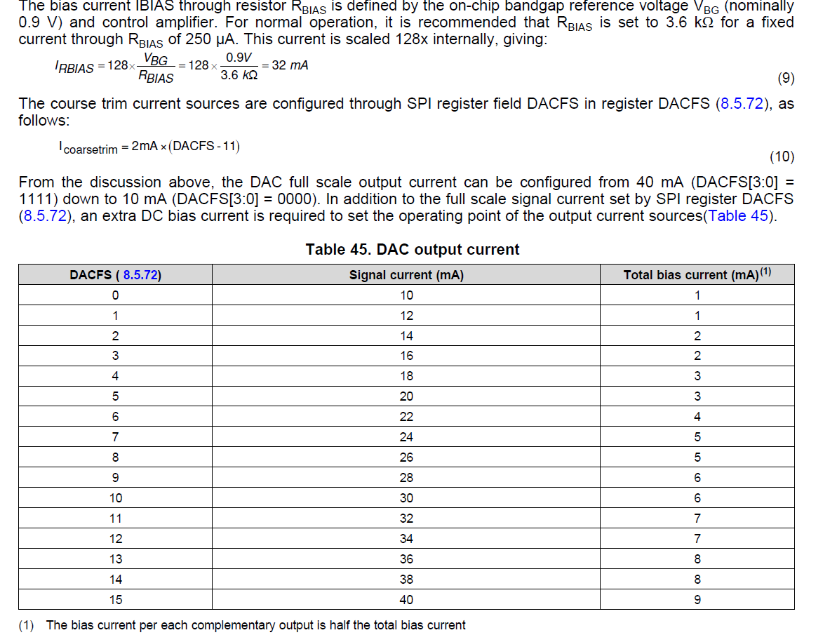

DAC Coarse Gain Options

IOUTP = IOUTFS × CODE / 65536
IOUTN = IOUTFS × (65535 – CODE) / 65536
where CODE is the 16-bit decimal representation of the DAC data input word, which ranges from 0 to
65535. For the case where IOUTP and IOUTN drive resistor loads RLOAD directly, this translates into single
ended voltages at IOUTP and IOUTN:

VOUTP = IOUTP × RLOAD
VOUTN = IOUTN × RLOAD

Assuming that the data is full scale (65535 in offset binary notation) and the RLOAD is 25 Ω, the differential
voltage between pins IOUTP and IOUTN is expressed as:

VOUTP = 40 mA × 25 Ω = 1 V
VOUTN = 0 mA × 25 Ω = 0 V
VDIFF = VOUTP – VOUTN = 1V

