Response Texas Instruments
Analog or Digital
1. I want to verify that the issue is indeed an analog issue and not a digital capture issue:
1.1. Try another test pattern like toggle mode to verify that all bits are working as expected.
1.2. Vary the gain and capture data to see if the oscillation is amplified.
1.3. Is it possible to remove or power down in the ADC input clock and not power down the ADC?
Answers:
1.1 Tried Ramp / all zeros / all ones -> ok
1.2 Increasing the gain in LNA 18dB to 24 dB adds more external noise to the signal (modulates it) / digital gain from 1 to 6dB increases signal / changing VCA attenuator does not change amplitude
1.3 Yes it is possible: shutting down the clock removes the 50 MHz completely
To us it seems like the problems are between the LNA and the PGA ….

2. Layout Concerns
2.1. Are the analog and digital grounds combined or separate?
2.2. Do you see the same oscillations on the analog power supplies going into the device pins, AVDD_5V, AVDD_3V.
2.3. You mention that you are probing at the ADC input. Do you mean the AFE input? Which pins, INP, INM or ACT?
2.4. What are the bypass capacitors on the power supply pins and how many? Are the caps close to the pins.
2.5. For the INP and INM pins, are there any vias going through a ground plane or near a PS plane?
2.6. Is there sufficient isolation of power planes (clearance)?
2.7. How are the power supplies isolated from each other.
My suspicion is that the second harmonic is generated in the ADC and feeding into the AFE inputs through a GND, Power or close proximity plane.
Answers:
2.1 There is no ground on the top layer (except for power supplies), second layer is divided in analog and digital ground, separation is underneath the AFE’s. Unfortunately another ground layer is present which is on the full size of the PCB, and grounds on both sides are connected intensely with huge amount of via’s present. // I cross checked with an older PCB where the analog and digital grounds are truly separated without the extra via’s towards a hidden ground plane and the results were identical.
2.2
2.3 Yes the inputs are connected directly to the AFE’s (4 x 8 inputs), all inputs are identical. A single connector is used to connect to a pre-amp PCB which was not connected during the measurements.
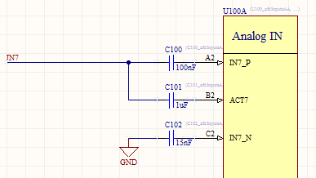

2.4 There are 4 AFE’s they all have bypass capacitors according to underlying schematic
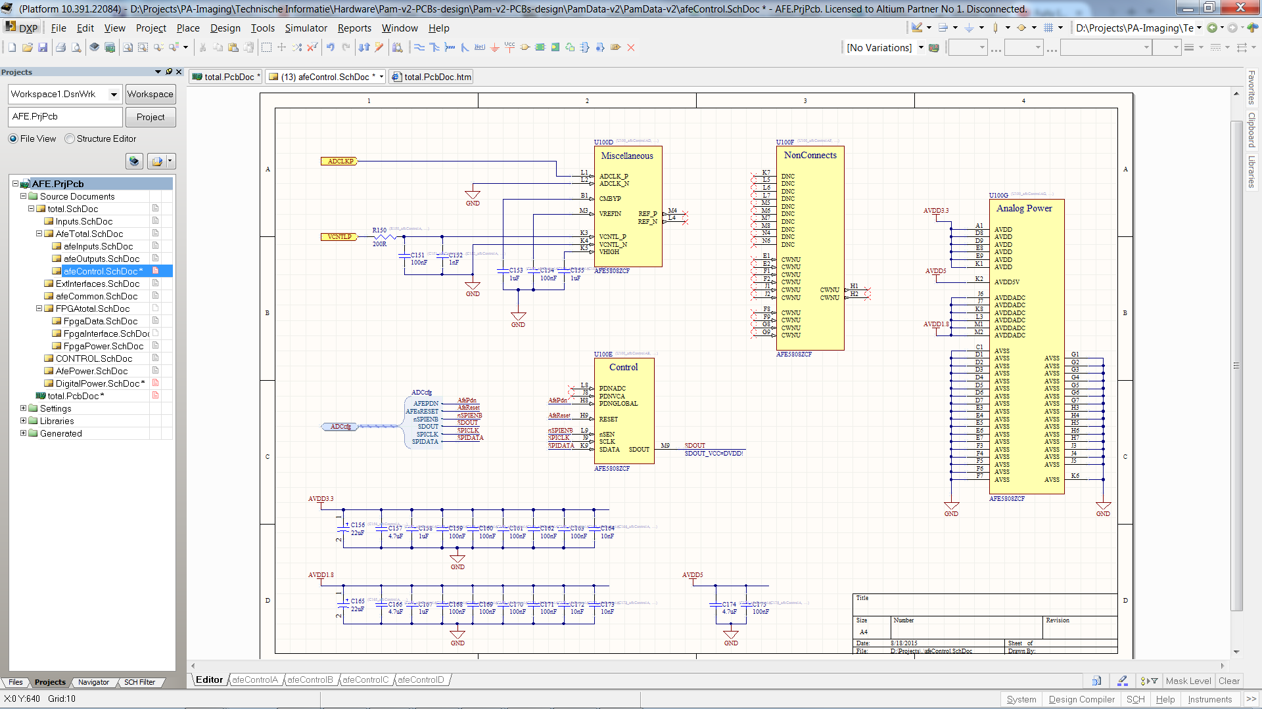
2.5 The input signals go to a layer below the Gnd layer using via’s, then the signals are surrounded by via’s connected to the Gnd layer on both sides
2.6 It looks ok to me
2.7 Each analog and digital power supply has its own in and output filter (L and C), digital and analog supplies are physically separated on the board with their own ground layer on the top side.

