SPI Debugging: Test 1: Read Register 0x00

void spi_setup(void)
{
SPI_InitTypeDef spi;

/* SPI configuration */
RCC_APB2PeriphClockCmd(RCC_APB2Periph_SPI1, ENABLE); /* SPI Clock */
SPI_I2S_DeInit(SPI1);
SPI_StructInit(&spi);

/**
* WARNING! ADS124S08 Datasheet states:
* Only SPI mode 1 (CPOL = 0, CPHA = 1) is supported.
*/
spi.SPI_Mode = SPI_Mode_Master; /* Master */
spi.SPI_Direction = SPI_Direction_2Lines_FullDuplex;
spi.SPI_CPOL = SPI_CPOL_Low; /* CLK Low */
spi.SPI_CPHA = SPI_CPHA_2Edge; /* 2nd edge */
spi.SPI_NSS = SPI_NSS_Soft;
spi.SPI_BaudRatePrescaler = SPI_BaudRatePrescaler_256;
spi.SPI_FirstBit = SPI_FirstBit_MSB; /* MSB first */
SPI_DataSizeConfig(SPI1, SPI_DataSize_8b); /* 8bit MODE */
SPI_Init(SPI1, &spi);
SPI_Cmd(SPI1, ENABLE); /* ENABLE */
}

void ads124xxx_spi_test(SPI_TypeDef *SPIx)
{
uint32_t tmp;

__SPI_ENA();
if (!SPI_ENABLED(SPIx))
return;

while (SPI_BUSY(SPI1));
SPI1->DR = 0x00 | 0x20; /* Reg Addr + OPCODE */
while (SPI_BUSY(SPI1));
tmp = SPI1->DR;
printf("* %s: WR=0x20,RD=%04x\r", __func__, tmp);

while(SPI_BUSY(SPI1));
SPI1->DR = 0x00; /* Read 1 register */
while (SPI_BUSY(SPI1));
tmp = SPI1->DR;
printf("* %s: WR=0x00,RD=%04x\r", __func__, tmp);
__SPI_DIS(); /* CS disable */
}

int main (void)
{
SysTick_Config(SystemCoreClock / 1000); /* SysTick @1ms */
gpio_setup();
USART1_Init(); /* IO redirection */
spi_setup();

printf("\r -----------------\r");
printf( " ADS124xxx Test\r");
printf( " -----------------\r");

ads124xxx_reset(); /* RESET ADC */
ads124xxx_spi_test(SPI1);
while (1) {
GPIOB->ODR ^= GPIO_Pin_6; /* Toggle LED */
delay(500);
}
}
Console Output:

-----------------
ADS124xxx Test
-----------------
* ads124xxx_reset: ADC Reset
* ads124xxx_spi_test: WR=0x20,RD=0000
* ads124xxx_spi_test: WR=0x00,RD=0008

SPI bus waveform:

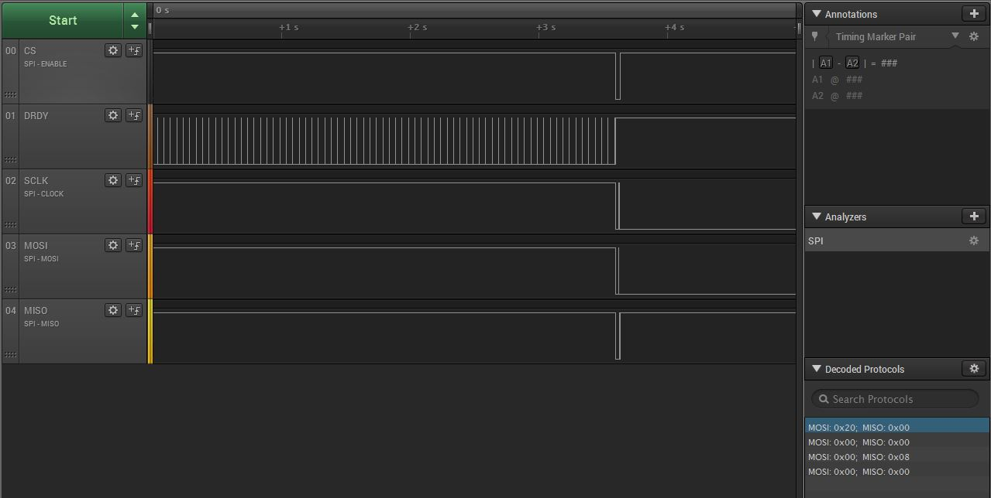

Zoomed in:

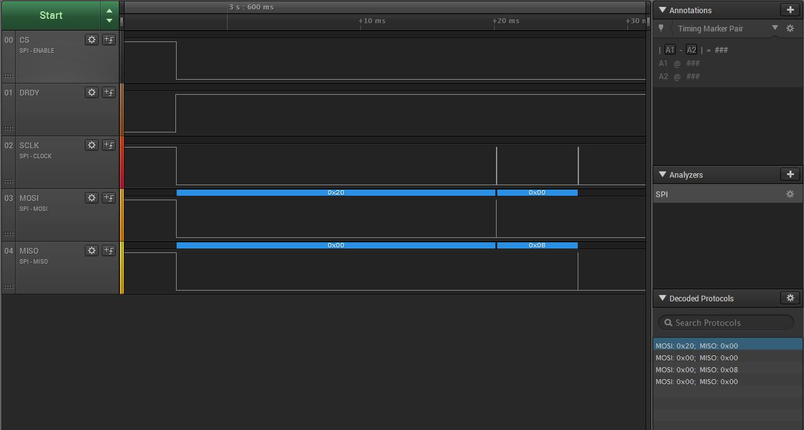

Zoomed in, first write 0x20:

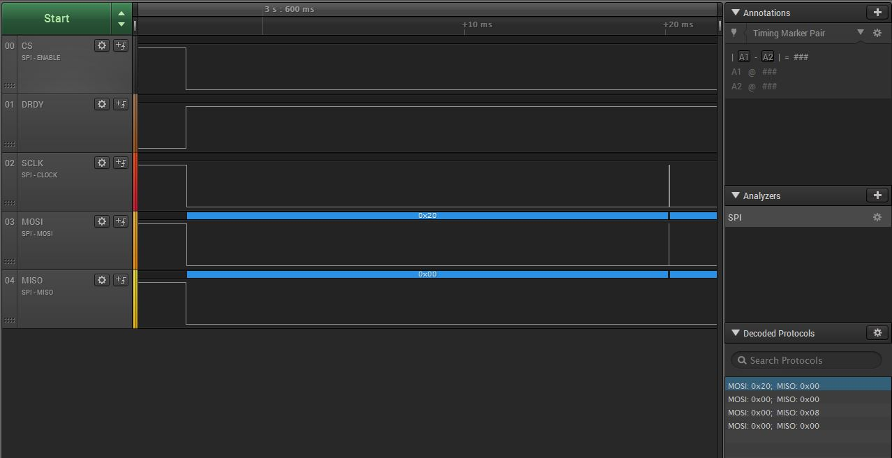

Read back value, 0x00

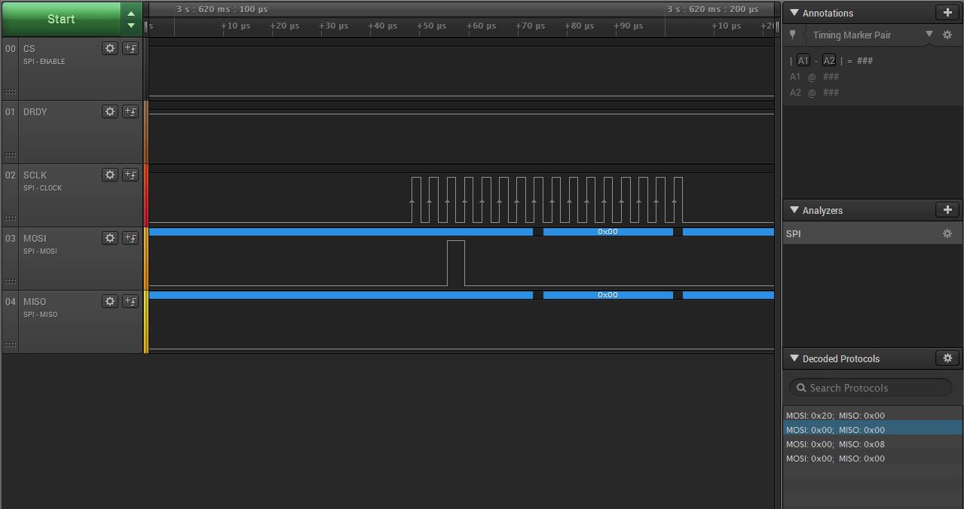

Zoomed in, Read value:

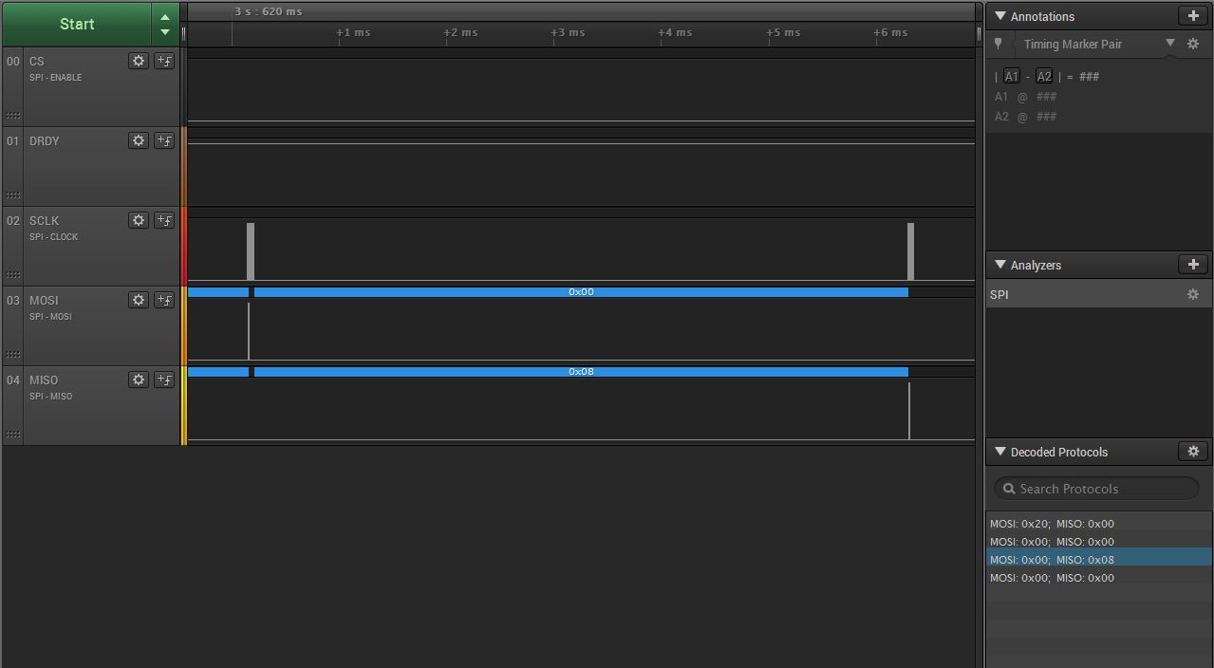

Zoomed in, next transfer:

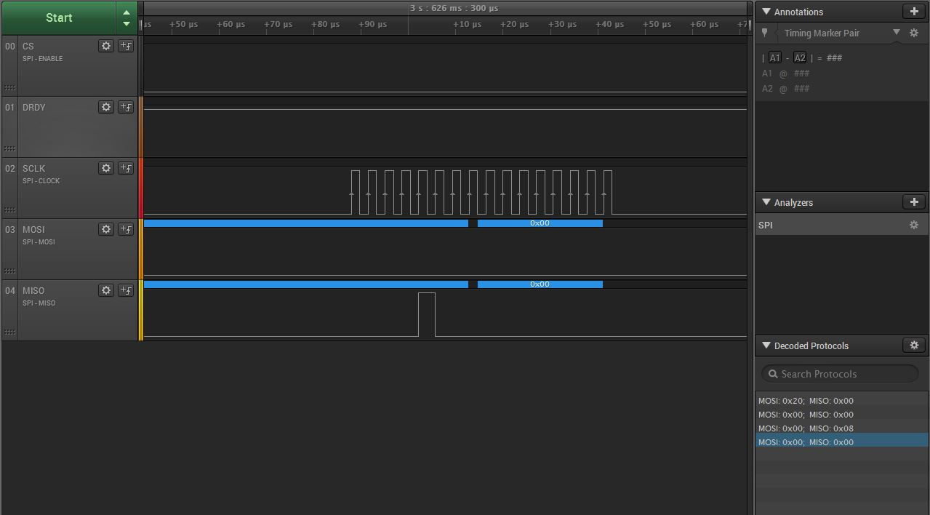

SPI Debugging: Test 2: Dump Registers

uint8_t ads124xxx_spi_regrd(SPI_TypeDef *SPIx, uint8_t reg)
{
uint16_t tmp;

__SPI_ENA(); /* CS enable */
if (!SPI_ENABLED(SPIx))
return 0;
while (SPI_BUSY(SPI1));
SPI1->DR = reg | REGRD_OPCODE_MASK; /* Reg Addr + OPCODE */
while (SPI_BUSY(SPI1));
tmp = SPI1->DR;

while(SPI_BUSY(SPI1));
SPI1->DR = 0x00; /* Read 1 register */
while (SPI_BUSY(SPI1));
tmp = SPI1->DR;
__SPI_DIS(); /* CS disable */

return tmp;
}

void ads124xxx_dump_regs(SPI_TypeDef *SPIx)
{
uint16_t i, dat;

printf(" ----------------- \r");
printf(" Register Map\r");
printf(" ----------------- \r");
for (i = 0; i < 0x12; i++) {
dat = ads124xxx_spi_regrd(SPI1, i); /* Read register */
printf(" Reg %02xh: %02xh\r", i, dat);
}
printf(" ----------------- \r");
}

int main (void)
{
SysTick_Config(SystemCoreClock / 1000); /* SysTick @1ms */
gpio_setup();
USART1_Init(); /* IO redirection */
spi_setup();

printf("\r -----------------\r");
printf( " ADS124xxx Test\r");
printf( " -----------------\r");

ads124xxx_reset(); /* RESET ADC */
ads124xxx_dump_regs(SPI1);

while (1) {
GPIOB->ODR ^= GPIO_Pin_6; /* Toggle LED */
delay(500);
}
}

Console Output:

-----------------
ADS124xxx Test
-----------------
* ads124xxx_reset: ADC Reset
-----------------
Register Map
-----------------
Reg 00h: 08h
Reg 01h: 80h
Reg 02h: 01h
Reg 03h: 00h
Reg 04h: 14h
Reg 05h: 10h
Reg 06h: 00h
Reg 07h: ffh
Reg 08h: 00h
Reg 09h: 10h
Reg 0ah: 00h
Reg 0bh: 00h
Reg 0ch: 00h
Reg 0dh: 00h
Reg 0eh: 00h
Reg 0fh: 40h
Reg 10h: 00h
Reg 11h: 00h
-----------------

SPI bus waveform:

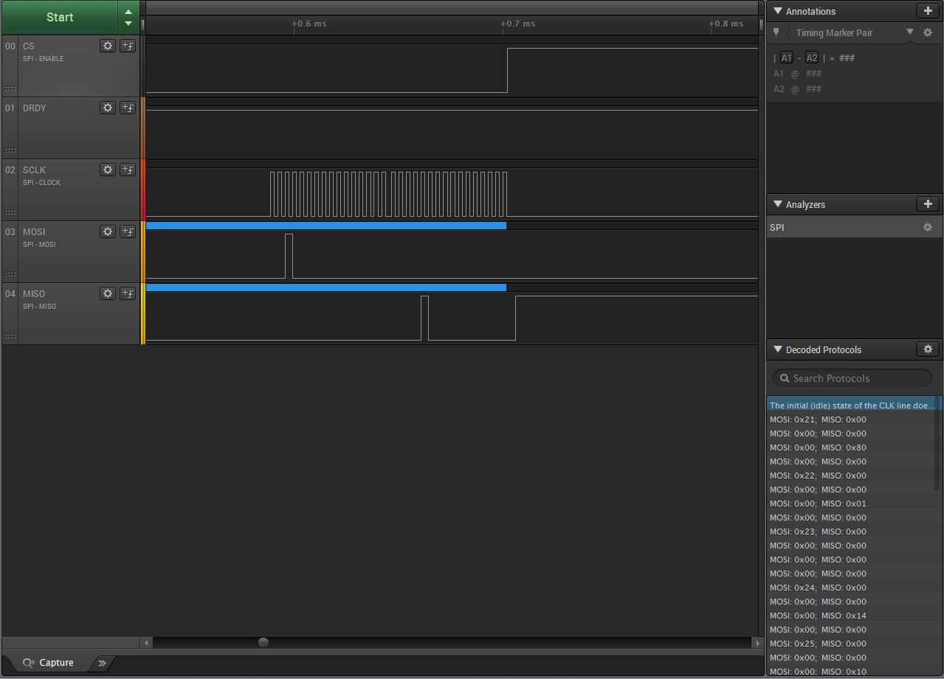

NOTE! Strange that the decoder is unable to recognize the first transfer on the SPI bus!
The logic analyzer settings appears to match the settings with the SPI master.

