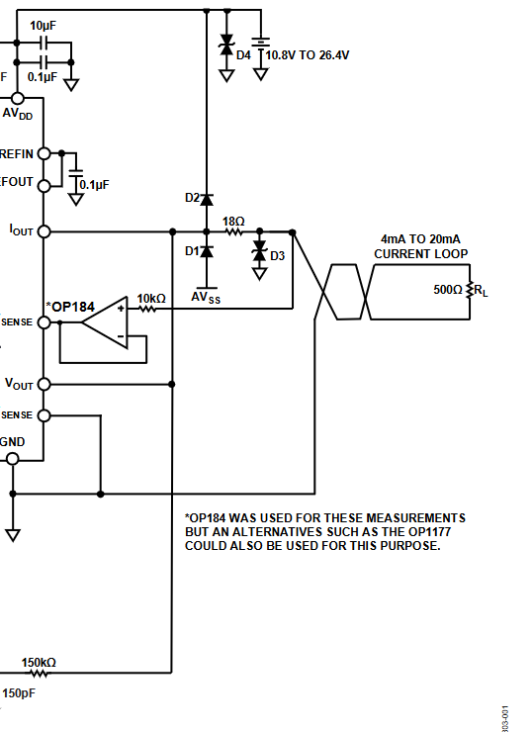

DAC8771

to Hart Out
DAC8742

Or use OPA188

To Hart in
DAC8742

Combined volt and mA output with Hart and FF/PA injection
Actually, idea from Analog Devices (CN-0278)
Would this work with the combination DAC8771 & DAC8742?
Obviously, the voltage output is not used in the loop but saves a jackplug if you need voltage output.
The whole thing should be isolated.

