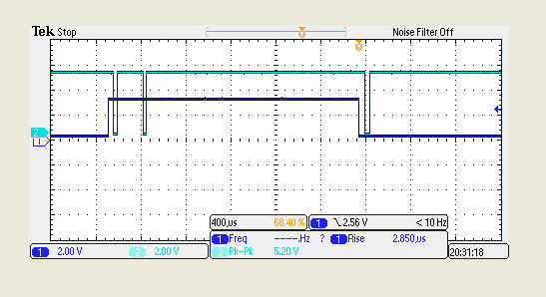

3.3 V

360 mV

**A**

ADC /CS

Input to ADC

**Figure 1.0** Problem is data acquisition at point A is 30+ counts more than expected. That is every time an ADC input goes from 3.3 V to 360 mV, first read of 360 mV is 30+ counts more and the 6reading after the first reading are consistent and correct.

ADC read value: 48570, 48550, **5324**, 5288, 5289, 5288, 5288, 5288, 48561, 48537, **5325**, 5288, 5289, 5288, 5288, 5288.....

ADC DOUT

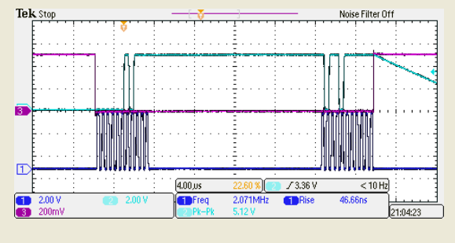

ADC CLOCK

ADC /CS

**Figure 1.1**