TSW14J10EVM
http://www.ti.com/tool/TSW14J10EVM?keyMatch=tsw14J10evm&tisearch=Search-EN-Everything
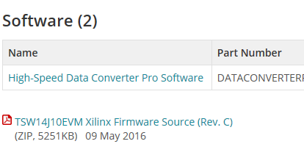

The firmware developed to be used with the TSW14J10EVM and Xilinx Development Platforms uses a separate clock input for REFCLK and Core clock to give maximum flexibility and support all line rates and subclasses with a single programmable design. The Xilinx IP used in the firmware can be driven by a single clock in many circumstances (see the clocking section of the Xilinx IP product guide for more details).

REFCLK is used by the transceivers only and for this design it will be linerate/10 or linerate/20 depending on which linerate band is used.

CORE clock supplied to the IP is always linerate/40. The TI EVM will supply either linerate/40 or linerate/10 depending on which linerate band is used. When supplying linerate/10, the Xilinx firmware will divide this by 4 using an MMCM to create a coreclk with linerate/40. This is only required at low line rates because the LMK04828 on the TI EVM’s cannot divide the clock enough to give the frequency required by the firmware.

Xilinx Info
As for the JESD204 IP example design.
1) Open Vivado and create a project.
2) Configure and add a JESD204 IP (I created my_jesd204_tx).
3) Right click on the IP under “Design Sources” and select “Open IP Example Design”

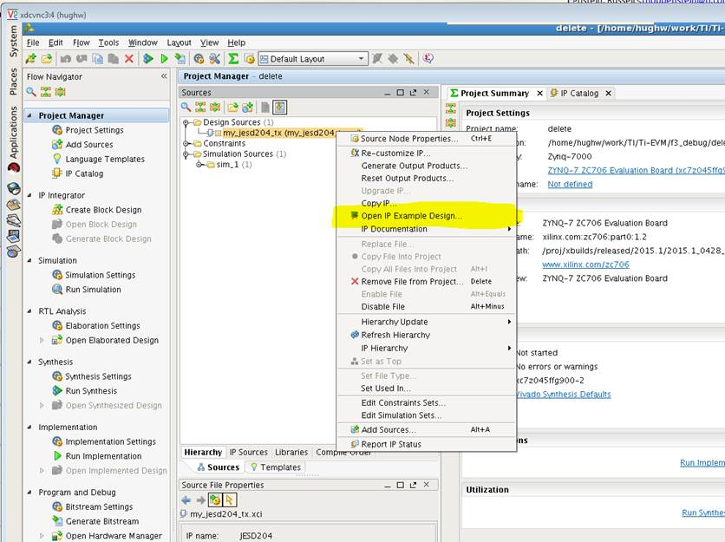

This will create an example design and demo testbench that shows the IP running with the configuration you have generated.
Please see Chapters 5 and 6 in
http://www.xilinx.com/support/documentation/ip_documentation/jesd204/v6_2/pg066-jesd204.pdf
For much more detail.

