# **Software Flow**

Following are the major HSDC DLL functions involved in Capture sequence. Please note that the J50 firmware doesn’t support TX operation, but there might be re-usable functions in DLL layer for configuring TX IPs. **It is simply retained from base code but TX path is non-functional**

FW uses SPI interface for both register R/W and also data transfer from DDR3 external memory.The firmware has two SPI slaves. One SPI slave is dedicated to DDR3.The two SPI slaves share common clock, miso and mosi signals. They have separate enable signals. To access the DDR3 SPI slave, disable the SPI slave for register access by de-asserting its enable pin (FTDI PIN D3) and asserting enable pin for DDR3 SPI (FTDI PIN D4)

## ADC Related

### Initialize_ADC_Session

This function extracts the ADC INI parameter values and assigns it to DLL flags and global variables.

### Configure_PLL

This function takes in PLL_Type (TXPMA/RXPMA/CMUPLL), MIF Command Array, MIF Command Length, fabric PLL (fPLL value) value as arguments, these values gets passed from LabVIEW layer. MIF command array holds the MIF values parsed by the LabVIEW layer from MIF files available in the

\*\Texas Instruments\High Speed Data Converter Pro\14J50 Details\MIF Files folder of HSDC Pro.

They are used to reconfigure JESD TX & RX PHY IP & the transmitter PLL (CMU PLL) parameters.

In case of J50, we will be using only the RXPMA as PLL Type. TXPMA and CMUPLL are related to TX operation and is not supported in J50 FW

Following are the sequence of operations called by this function

1. Write the fPLL value passed from LabVIEW to the fPLL counters. fPLL is used to generate the parallel clocks named as ‘link clock’ (lanerate/40) in FW used for both TX and RX operation
2. Write 1 to address 0x 801000 + 0x00 to set the fPLL reconfig controller in polling mode. Setting it in polling mode makes the controller use Status register to indicate its busy (reads 0 when busy). If it is in wait request mode, controller will use wait request signal to indicate its busy
3. Write the fPLL value passed from LabVIEW layer to Address 0x14 (0x 801000 + 0x14), to configure C counter settings. There are two counters used, C1 for TX and C2 for RX. fPLL value extracted from the INI file looks like 0x081010 and is passed by the LabVIEW layer.

**INI File: Fabric PLL Counter = 0.611G to 0.7G: 0x081010, 0.7G to 2.4G: 0x080808, 2.4G to 8G:0x080202**

0x**08**_xx_xx- indicates the address for C2 counter, and it is 0x04_xx_xx for C1 counter

0x08**1010**- indicates the value to be written for C counter. Value is split by half and is written to HIGH Count and LOW Count registers. Sum of both HIGH and LOW counts give the actual C counter setting, in this case of 1010 actual C counter value is 20. Refer the Implementing Fractional PLL Reconfiguration with Altera PLL and Altera PLL Reconfig Megafunctions for more details

Above INI parameter indicates that fPLL counter needs to be configured with different settings for 3 different lane rate ranges.

0x081010- Configure C2 with value of 20 and this is only for lane rates between 0.611G to 0.7G.

0x080808- Configure C2 with value of 16 and this is only for lane rates between 0.7G to 2.4G

0x080202- Configure C2 with value of 4 and this is only for lane rates between 2.4G to 8G

1. Write 1 to Start Address 8 (0x 801000 + 0x8) to start the reconfiguration process
2. Keep polling the status register4 (0x 801000 + 0x04) to check if the reconfig controller is busy or finished executing the instruction successfully (reads 1)
3. MIF file content parsed by LabVIEW layer are stored as 32bit words in a buffer and is written to on-chip MIF BRAM in firmware
4. Based on the PLL Type parameter, either TX PMA, RX PMA or CMU PLL the MIF file streaming commands are sent to the transceiver reconfig controller Base address = 0x800400

MIF related register R/Ws happen in Altera_Streamer_Based_Config function as per the Transceiver Reconfig controller registers, please refer "Transceiver Reconfiguratio Controller for Dynamic reconfiguration in Arria V and Cyclone V devices"

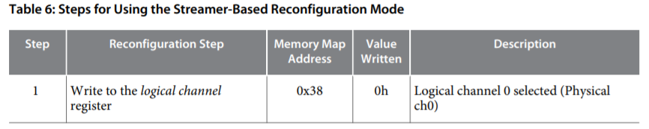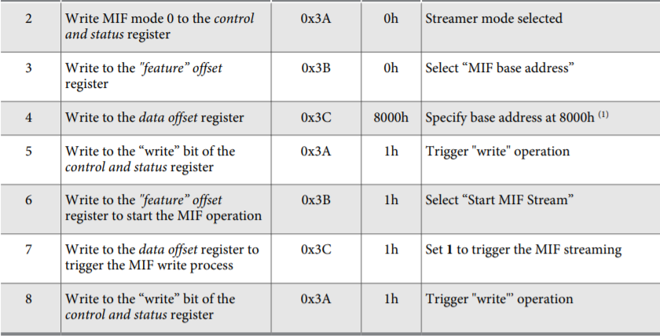

Note that QSYS Interconnect used in FW is of byte addressing scheme. So the register addresses from DLL are of byte-addressing and needs to be divided by 4 to indicate word addressing. Online documents from Intel might use word addressing scheme

When configuring RX PMA, repeat these steps 8 times with a different logical channel number each time. Similarly TXPMA and CMUPLL gets configured if they are available in FW. Logical Channel Numbers are mentioned below

|  |  |  |
| --- | --- | --- |
| TX | RX | CMUPLL |
| 8 | 0 | 12 |
| 9 | 1 | 13 |
| 10 | 2 | 14 |
| 11 | 3 | 15 |
| 16 | 4 | 20 |
| 17 | 5 | 21 |
| 18 | 6 | 22 |
| 19 | 7 | 23 |

### Configure_TSW14J50_ADC_Session

This function takes care of configuring RX JESD Base IP related parameters and few other SERDES related parameters: SERDES Polarity Inversion, SYNC Polarity Inversion and Lane Mapping configuration. Following is the sequence of operations involved

1. In this function SERDES options: SERDES & SYNC Polarity and Lane Mapping are configured for the targeted mode based on INI parameters
2. Following it, function Configure_RX_JESD_Megacore_IP gets called, it takes care of configuring JESD Base IP related parameters: LMFSK, Scrambling and Lane Power down settings. Base IP link layer is put in reset at the start by issuing Frame soft reset (write 1 to 0x440000+0x2c000) and is de-asserted at the end after configuring IP parameters

### Start_ADC_to_DDR

This function initiates capture process, following is the sequence of operations involved

1. Calculate the samples to be captured in terms of 256 bit words from the samples/channel value entered by user in HSDC Pro. DLL takes into account the bit packing pattern or channel pattern mentioned and calculates the required number of samples
2. If trigger mode enabled, set the trigger settings to RX_TRIGGER_REGISTER (0x400000 + 0x20004). DLL sets bit3 of the trigger register and keeps polling it. FW clears this bit once a trigger is received
3. If it is normal capture, set the capture start bit (Bit0 of the capture register) with required number of samples to RX_CAPTURE_REG (0x400000 + 0x20000). Number of samples is written to bits [31:4] of RX_CAPTURE_REG. If it is triggered capture, write only the samples to be captured as the capture start bit will be set by FW Logic whenever trigger is received
4. With capture start bit set, FW starts capturing the ADC data on JESD link to memory and HSDC DLL keeps polling for the capture done bit (Bit1 of the capture register) which is set by FW once the required number of samples are captured from JESD link

### Read_DDR_to_File

1. In this function, if it is normal capture DLL keeps polling for the DONE bit, bit1 of the RX_CAPTURE_REG (0x400000 + 0x20000) until it is set by firmware
2. If it is triggered capture, LabVIEW layer keeps polling for bit3 of the RX_TRIGGER_REGISTER to be cleared by firmware, once cleared and capture DONE bit is set by FW, DLL proceeds to read the captured data
3. Enables the SPI slave for DDR3 memory and starts reading from base address 0x0