TSW14J56revD EVM Firmware
FPGA Design Document



1. Overview 4
2. Quartus Tool Version: 5
3. Architecture: 7
3.1 ArriaV GZ Native PHY transceiver IP TX/RX 7
3.2 Transceiver Reset Controller: 11
3.3 Transceiver Reconfiguration Controller: 11
3.4 JESD204B Base IP TX/RX 12
3.5 Assembler & Deassembler (Transport layer) 12
3.6 dec_data_capture module 13
3.7 Enc_data_gen module 16
3.7.1 BCM Feature: 20
3.8 DDR3 memory controller IP 20
3.9 BRAM Memory 22
3.10 FX3 Interface (CYUSB301X) 23
3.10.1 FX3 Main Module 23
3.10.2 FX3 Register Control 24
3.11 Trigger module 24
3.12 framesoftrst 27
3.13 Eye Scan Modules 27
3.14 Clocking architecture 31
3.14.1 fPLL 33
3.14.2 CMU PLL 34
4. Different Firmware Builds 35
4.1 LED Status: 35
4.2 TSW14J56REVD_FIRMWARE 36
4.2.1 Auto Duplicate First Channel Data: 36
4.3 TSW14J56REVD_AEQ_FIRMWARE 36
4.4 TSW14J56REVD_FIRMWARE_SYSREF_TO_SMA 37
4.5 TSW14J56REVD_RX_ALT_SYNC_LVDS_FIRMWARE 37
4.6 TSW14J56REVD_LMK_SYSREF_TRIGGER 37
4.7 TSW14J56REVD_ADC_DDR_DAC_BRAM_256KB_XCVR_FIRMWARE 37
4.8 TSW14J56REVD_BRAM_ADC_DAC_DDR_128K_XCVR_FIRMWARE 38
4.9 TSW14J56REVD_SERDES_TEST_FIRMWARE 38
4.10 TSW14J56REVD_841_CER & TSW14J56REVD_FIRMWARE_CER 38
5. References 38

Overview
TSW14J56 is a hardware platform that can be used to evaluate the performance of TI’s JESD204B data converters. Examples of devices that can be used with TSW14J56 are ADS42JBx9 family, ADC12J4000, ADC12DJxx00 and DAC3xJ8x family. The devices are evaluated by connecting their EVMs as daughter cards to the FMC port on TSW14J56 and using the HSDCPRO software to send or capture data. To enable TSW14J56 to work, the board includes a FX3 USB3.0 controller, DDR3 memory and an ArriaV GZ FPGA. Inside the FPGA, there are interface controllers for connecting the FPGA to DDR3 memory and other external peripherals. Also present are SERDES transceivers for interfacing to the data converter under evaluation, JESD204B IP, Reconfiguration controllers to dynamically switch between supported modes and PLL’s for internal clock management.
This document gives a detailed description of the FW modules and also lists the FW builds maintained with HSDC Pro

Figure1: Major FW Blocks
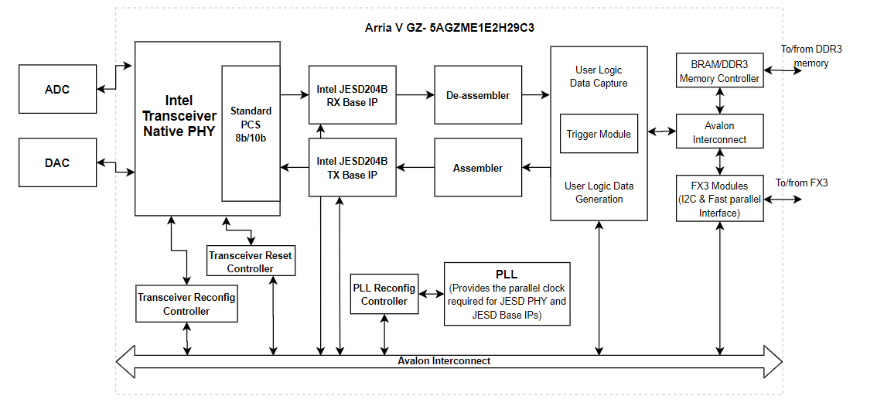

Quartus Tool Version:
The firmware is developed with Quartus II 14.0 Subscription version software and needs Intel JESD204B license for compilation

Figure 2: Functional Block Diagram
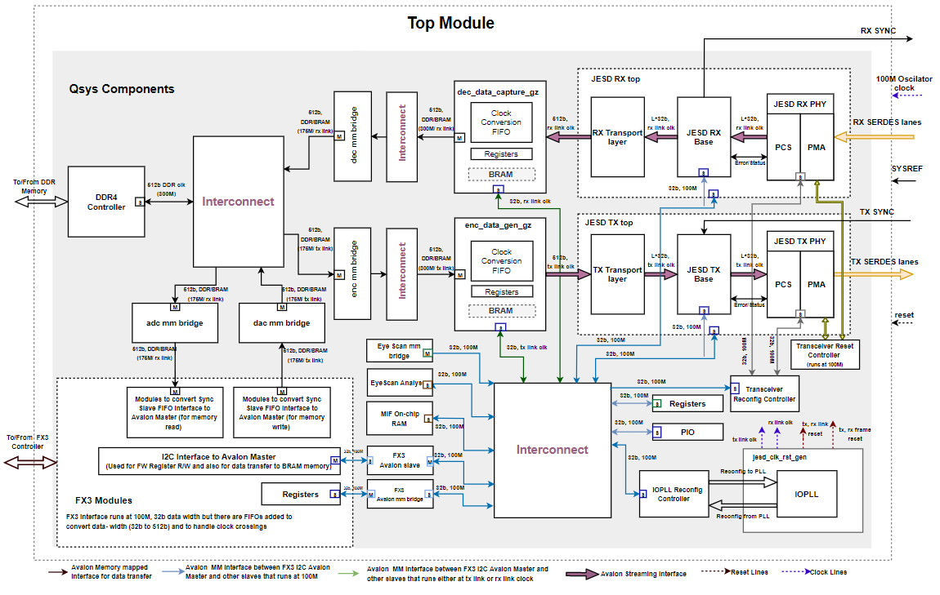

Architecture:

The FPGA architecture is divided in to modules as shown below.
- ArriaV GZ Native PHY transceiver IP TX/RX
- JESD204B Megacore IP TX/RX
- Assembler & Deassembler (Transport layer)
- enc_data_gen module
- dec_data_capture module
- DDR3 memory controller IP
- Fx3 modules
- trigger module
- framesoftrst
- EyeScan Modules

ArriaV GZ Native PHY transceiver IP TX/RX
The transceivers of ArriaV are categorized in banks of six channels each. The ArriaV GZ FPGA part 5AGZME1 contains up to 12 high speed transceivers, supporting 12.5Gbps and their arrangement is as highlighted below on GXB_L0 and GXB_L1. We are using the CMU PLL (clock multiplier Units) either channel1 or channel4 as the clocking source to generate high speed serial clock for transmitters to other transceiver channels through x1 clock network (within transceivers of a single bank) and xN clock network (for transceivers of different banks). Note that the CMU Units of channel1 or channel4 can’t be used for clock data recovery if used as clock multiplier units. Hence, a maximum of 10 transceivers can be run simultaneously because the transceiver in either channel 1 or 4 used as the clocking source.

Please refer the Chapter 2 ‘Transceiver Clocking in ArriaV devices’ of ArriaV Device Handbook on transceivers for more details on transceiver clocking, sections x1 Clock Line Architecture, x6 and xN Clock Line Architecture
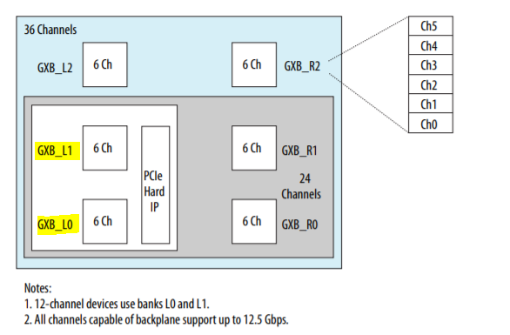
Figure 3: Transceiver Arrangement

The user interface (UI) for the RX Native PHY IP, which is ‘xcvr_native_rx’ in the firmware design is shown in figure3 below. PMA output is set to 40 bit/lane which would be connected to PCS. PCS does 8B/10B decoding and 32bit/lane would be given out after word alignment. The design has single Native PHY IP instance supporting 8 RX lanes. The 256 bit parallel output data of 8 lanes is connected to the JESD Megacore module (JESD Base IP). Native PHY IP was used as the JESD PHY was not available during this FW development

The user interface (UI) for the TX Native PHY IP, which is ‘xvr_native’ in the firmware design is shown in figure4 & figure5 below. There are 2 instances of PHY IP each handling 4 TX lanes. IP uses CMU PLL for generating the serial clock for transmitters and is sourced to other channels of same bank through x1 clock network. Since there are 2 transceiver banks each with 6 channels and uses x1 clock network (which can distribute within same bank and not across banks), 2 IP instances are used. PHY IP uses Standard PCS with interface data width set to 32 and PMA interface data width is set to 20. PCS layer receives 32bit/lane from the JESD Base IP and does 8B/10B encoding and feeds the same to PMA layer

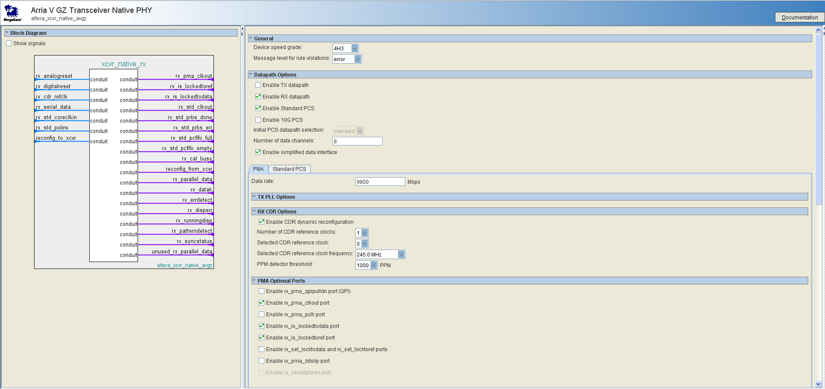
Figure4: RX Native PHY IP

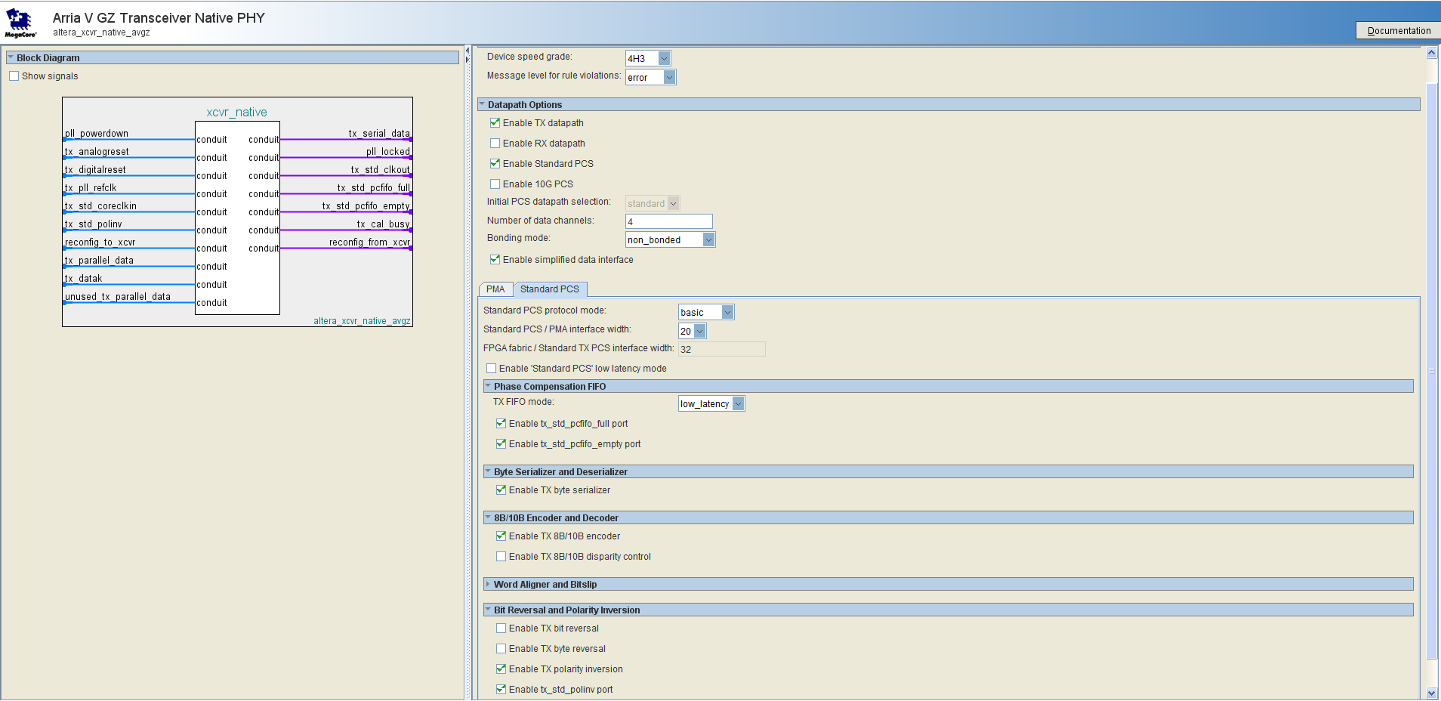
Figure5: TX Native PHY IP (PCS)
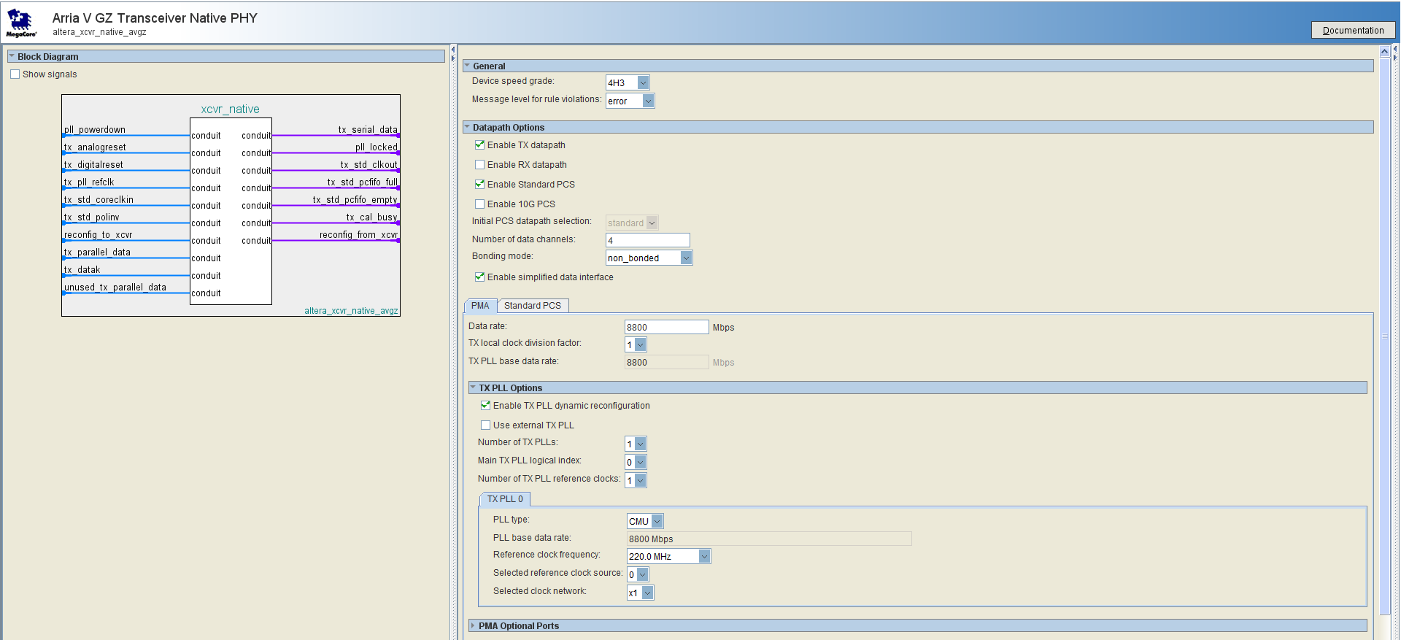
Figure6: TX Native PHY IP (PMA)

Transceiver Reset Controller:
The design uses Alter/Intel’s Transceiver Reset Controller IP to reset the transceiver channels of JESD PHY IP both TX and RX. It controls both analog and digital resets and resets all 8 transceiver channels together not individually.

Transceiver Reconfiguration Controller:
Design uses transceiver reconfiguration controller for configuring the transceivers (TX PMA, RX PMA & CMU PLL) dynamically by streaming MIF files. MIF files for different data rates are generated and stored in HSDC Pro in below location (C:\Program Files (x86)\Texas Instruments is the default HSDC Installed path)
C:\Program Files (x86)\Texas Instruments\High Speed Data Converter Pro\14J56revD Details\MIF Files

To start reconfiguration, HSDC SW writes the contents of the MIF file are to on-chip RAM and then sends commands to the transceiver reconfiguration controller. Please refer "Transceiver Reconfiguration Controller for Dynamic reconfiguration in ArriaV and Cyclone V devices

JESD204B Base IP TX/RX
This IP implements the JESD204B link layer with the BASE alone enabled. The IP core has a number of internal registers that must be configured correctly to enable it to work. In TSW14J56, these internal registers are programmed through the FX3-> I2C interface from a PC running the HSDCPRO software. The software reads the required configuration values from the device initialization (INI) file and writes them to their respective register address. It also reconfigures JESD configuration values (LMFSK) run-time to support different JMODEs. HSDC software reads the required config values from device initialization (INI) file and writes them to the registers.
The main purpose of this IP is to implement the JESD CGS and ILAS sequence with the Deserialized data from the Transceiver IP. Input/output of the JESD Base IP is of 32bit data width per lane and operates at data rate/40 clock (known as link clock) and uses Avalon Streaming Interface. The link clock is sourced by a fabric PLL in design which is reconfigured run-time such that it is always data rate/40 irrespective of the reference clock input. The data coming out of the RX JESD IP is formatted in Transport layer and is then stored in either DDR or BRAM memory. Similarly data read from either DDR or BRAM memory is formatted in Transport layer before sent to TX JESD IP. By default, single IP instance supports maximum of 8 lanes

Assembler & Deassembler (Transport layer)
Rx transport layer (altera_jesd204_deassembler) receives 32bit data per lane from the JESD Base IP for every link clock, buffers the same to form 256bit data aligned with Start of multi-frame (SOMF) and sends the same to capture module ‘dec_data_capture_gz’ through Avalon Streaming Interface. JESD IP can operate with any number of active lanes (from 1-8) depending on the JMODE, but the transport layer always sends 256 bit data out of it. This is implemented using shift registers and counters the threshold of which is based on ‘L’. For example if the active lanes L=4, for every link clock (lane rate/40 clock), transport layer receives 32bits per lane, so 128bit every clock. This gets buffered and in 2 clocks, we have 256bit data which can be shared to data capture module. The Valid signal of Avalon Streaming interface is asserted once in every 2 clocks so the capture module receives valid 256bits and operates with it.

TX transport layer (altera_jesd204_assembler) receives 256b data from data generation module ‘enc_data_gen’ through Avalon Streaming Interface, sends out 32bit data per lane aligned with SOMF to the JESD Base IP on all active lanes. This is implemented using shift registers and counters the threshold of which is based on ‘L’. Considering L=4 case, out of the 256bits received from data generation module, 128bits are sent to JESD base per clock and transport layer asserts ready signal in Streaming interface only once in every 2 link clocks.

Below figure shows how RX transport layer ‘deassembler’ & TX transport layer ‘assembler’ works for LMF 442 case. Data format of JESD Base & the data packing in transport layers are shown
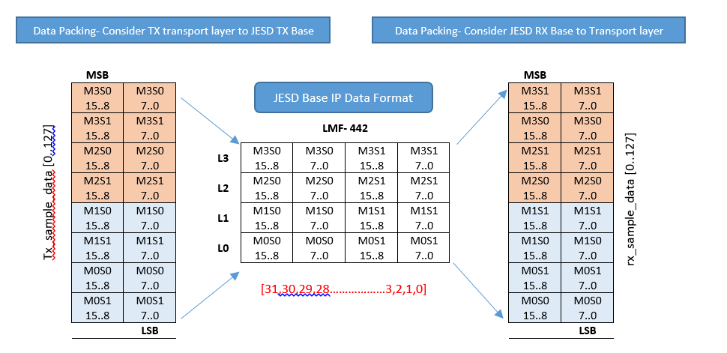
Please note that the first octet sent/received in JESD Base IP is MSB bits [31:24] and first bit sent/received in the IP is MSB bit [31]

dec_data_capture module
This module receives 256b data from the RX transport layer at RX link clock and writes the same to DDR3 memory at DDR clock (175M) or link clock if BRAM is used. It has a state machine to sequence capture operation and registers controlled by HSDC software. Data write happens only when ‘capture’ bit is set by the HSDC software for the user specified samples and once the ‘done’ bit is set in firmware, data write stops and the software starts to read captured samples. There is a FIFO to handle clock crossing between link clock and DDR clock. The interface is as shown above and the important signals are given in below table

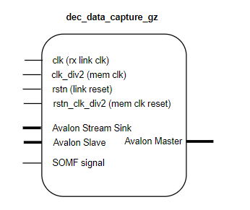
Table1: Signals for controlling the behavior of the receive firmware
*Offset Address | Size | Description
0x20000 | 32 | [0]- capture start  [1]- capture done  [3]- xcvr mode  [31:4] data length
*register address = offset address + base address, base address= 0x400000
Capture start: when set high indicates start of data capture from JESD204B Base IP into the memory.
Capture done: This bit is set high when the length of data written to memory equals the user specified samples (value in the data length register). It indicates the end of data capture.
Xcvr mode: This bit puts the module in transceiver mode when set high. This is applicable only for DDR memory in which case memory usage is split between data capture and generation modules. Only half the memory is used for data capture and remaining half is used for data generation, so base address for data capture starts at 0 and base address for data generation starts at 0x1000000 (1GB)
Data length: sets the length of data to capture from the JESD204B IP and store in memory. The value of the data length register is written by HSDC SW in terms of 256b words and is right shifted & used as 512b words to keep track of the words written to DDR memory. Following is the capture state machine implemented in dec data capture module. Below flow is for simple capture without trigger. For trigger, there will slight changes where capture start bit would be set by firmware once the trigger pulse is received and then SM moves from AVST IDLE to SOMF WAIT
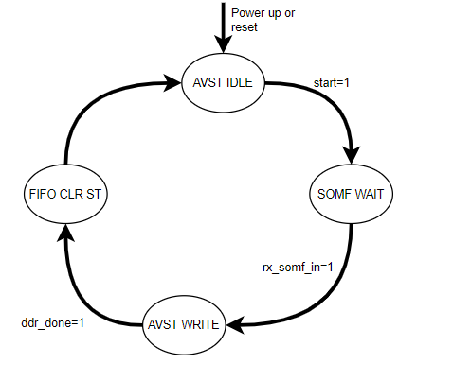
Figure7: Data Capture FSM
IDLE:
- Write enable signal to the FIFO and write enable to memory is held LOW
- Memory address counter is forced to zero
When the capture start bit is set to high, the state will transition from IDLE to SOMF WAIT.
SOMF WAIT:
- State machine waits for the SOMF pulse from JESD204B RX Base IP. It is used to align the start of data capture to the local multi frame counter that runs inside Base IP(LMFC)
- With SOMF being HIGH, if valid from the transport layer goes HIGH, FIFO write enable goes HIGH & data gets written. If valid is LOW, FIFO write enable stays LOW and State moves to AVST WRITE
AVST WRITE:
- As long as valid from transport layer is HIGH, this state keeps writing data to FIFO.
- Once FIFO word of 256b and is not empty, memory write request is issued and the memory address counter starts incrementing.
- Memory address counter is incremented in steps of the write burst size 8
- When the address counter reaches the value set in data length register, the capture done bit is set high to indicate the end of data capture and the state transitions to FIFO CLR WAIT
FIFO CLR WAIT:
- Reset to the intermediate FIFO is asserted and held HIGH and state machine moves to IDLE

Enc_data_gen module
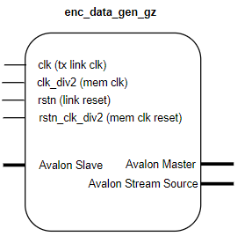
Figure8: Interface to enc_data_gen module
This module reads 512b data from the DDR memory at DDR clock (175M) or from BRAM at TX link clock, sends the same to TX transport layer at link clock. There is FIFO to handle clock crossing between DDR clock and link clock. It has a state machine to sequence Send process and registers controlled by HSDC software. Data gets played continuously on the TX SERDES lanes when ‘Send’ & ‘Loop’ bits are set HIGH by the HSDC software and it can be stopped with ‘Stop’ bit. The ‘Loop’ bit is set by default so data gets played continuously, to have a single shot (play only once) this bit can be set LOW. Important register signals are listed below

Table2: Signals for controlling the behavior of the transmit firmware
*Offset Address | Size | Description
0x20000 | 32 | [0]- read start  [1]- read loop  [2]- read stop  [3]- xcvr mode  [31:4] data length
*register address = offset address + base address, base address= 0x0
Read start: This bit is set to HIGH to trigger reading data from memory
read loop: When set to HIGH forces the memory address counter to wrap around to zero for every iteration of sending data. This puts the memory read operation in an infinite loop to ensure data is played continuously. To have a single shot (play only once) this bit can be set LOW
read stop: When set forces the enc_data_gen module into IDLE state. In IDLE state, the address counter is reset to zero, read enable signals are de-activated and the data interface to the JESD204B IP holds the last data read from memory.
Xcvr mode: This bit puts the module in transceiver mode when set high. This is applicable only for DDR memory in which case memory usage is split between data capture and generation modules. Only half the memory is used for data capture and remaining half is used for data generation, so the base address for data capture starts at 0 and base address for data generation starts at 0x1000000 (1GB)
data length: sets the length of data to be read from memory that needs to be sent to JESD Base IP. The value of the data length register is given in terms of 512b words. Following is the Send state machine (SM) implemented in enc data gen module. State machine moves to next state only when the conditions are met else stays in the same state
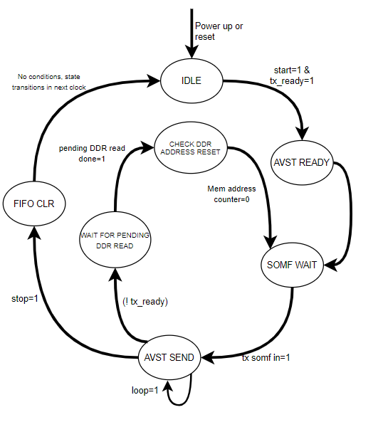
Figure9: Data Generation FSM
IDLE:
- FIFO is held in reset and Avalon data and valid of the Base IP streaming interface are held LOW
- Memory address counter is forced to reset
- When the ready signal from Base IP goes HIGH and read start bit is set by software, state moves to AVST_READY and FIFO is out of reset.
AVST_READY:
- In this state, read request to the memory is issued and FIFO starts getting filled. Memory address counter starts incrementing. It is incremented in steps of the read burst size 8
- State moves to SOMF WAIT in the next clock if in normal Send mode. In case of trigger mode, waits for external trigger to be received before moving to next state
SOMF_WAIT:
- State machine waits for TX SOMF signal and FIFO is filled with 64 words each of 512b
AVST_SEND_DATA:
- If the link ready signal from the Base IP is HIGH, read request is issued to FIFO and a counter keeps track of the read requests (FIFO reads counter). FIFO read back data and valid signal are assigned to the Avalon streaming interface of Base IP.
- Once the FIFO reads counter reaches value set in data length register, it is forced to 0 and the data gets played from the start again
- If the stop bit is set by software, FIFO reads counter is forced to 0, valid to Base IP is held LOW and state moves to FIFO CLR and the control register ‘0x20000’ is cleared
- Or if the link ready status is lost, state moves to WAIT_FOR_PENDING_DDR_READ
FIFO_CLR:
- FIFO is held in reset and state moves to IDLE.
- Valid and data of the streaming interface retains the same value
WAIT_FOR_PENDING_DDR_READ:
- State machine moves into this state whenever the TX link is lost. In this state, memory address counter holds its previous value and a pending read requests counter updates as and when data is received from memory and no new requests are made.
- Until the pending requests are addressed, FIFO read requests are issued
- Once the pending counter turns zero, state moves to CHECK_DDR_ADDRESS_RESET
CHECK_DDR_ADDRESS_RESET:
In this state, memory address counter is forced to 0 and state moves to DDR_READY

BCM Feature:

Requirement was to send a pattern on one of the SMA pins aligned with TX SERDES lanes. The pattern is added as another column in DAC tone csv file that gets loaded in HSDC Pro and it needs to be sent on SMA TRIG OUTC whenever Send button is clicked in HSDC GUI. Please refer to Section VII in HSDC Pro FAQ & Troubleshooting Guide.docx, linked in references to understand the steps required for BCM testing.

Currently, HSDC SW and firmware architecture is such that user can either generate the DAC tone in HSDC GUI or load a csv file which has the DAC data. Once ‘Send’ button is clicked, SW sends the DAC samples to firmware through FX3 controller Synchronous Slave FIFO interface and it gets stored in either BRAM or DDR4 memory. Once the samples get written and if the JESD TX link is up, the stored samples gets sent on TX SERDES lanes and is played in a continuous loop until it is stopped from HSDC Pro (in next Send) or the TX link is lost. User needs to add BCM pattern in the same csv file which has the DAC data. HSDC SW considers BCM as part of the DAC data (with some changes in DAC INI) and writes it to the FW memory, this way there is only minimal changes required in the Send Process and re-uses the existing architecture to get BCM working. But in this approach, resolution of BCM data observed in the SMA pin is one out of n samples in a 512b word, since this resolution is sufficient for the current support activity, we went ahead and implemented

To support BCM Feature, added a FIFO enc_fifo_BinChinst 512x512 which gets filled by the Avalon master of DDR memory. Out of the 512b read from the FIFO, 256b is sent to TX transport layer through Avalon Streaming Interface where it is buffered and sent to JESD base IP. And the rest 256b is BCM data, out of which MSB bit[255] is sent out on the SMA pin SYNCC

DDR3 memory controller IP
The firmware contains an instance of the DDR3 memory controller. The controller interfaces to 8Gb of external memory and is used to read and write data into the memory. The interface is quarter rate with an output width of 512bits. It can support clock speeds up to 800MHz. A 100MHz external reference clock is provided via differential pair pins [G20 G21] to the PLL inside the controllers. Three output pins are used to indicate the state of the memory controller: local_cal_fail, local_init_done, local_cal_success
Local_cal_fail: when high, indicates that the memory calibration failed. This signal is connected to LED D8 on TSW14J56. D8 should be turned on during normal operation.
Local_cal_success: when HIGH, indicates that memory calibration was successful. This pin is connected to LED D7 on TSW14J56. D7 should be turned off during normal operation.
Local_init_done: when HIGH indicates that the memory startup sequences all checked out successfully. This pin is connected to LED D6 on TSW14J56. D6 should be turned off during normal operation

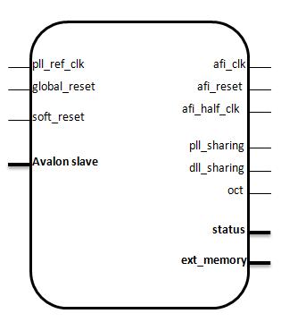
Figure10: DDR3 memory controller interface
To setup the memory controller:
- Open the user interface (UI) for the DDR3 memory controller (shown in figure 3) from QSYS or Megawizard
- Apply the default settings for MICRON MT41J128M16HA-15E from the preset window on the left of the UI.
- Set the desired memory clock frequency and the reference input clock frequency on the PHY settings tab of the UI. A memory interface clock frequency of 700MHz generated from a 100MHz external reference clock is shown in figure below.
- On the Memory interface tab set the following parameters:
  - Total Interface width = 64, DQ/DQS group size = 8, Row address width = 15, Column address width = 10, Bank address width = 3
- On the controller settings tab set the burst size to 8. For this design, data is written to and read from the memory in bursts to maximize the read and write efficiency.

The interface between the DDR3 memory and the JESD204B IP is shown in figure. The 256bits wide data interface of the JESD204B IP is converted to 512b data width with FIFO (in the data capture module) and written to DDR memory through the Avalon Memory mapped interface. Similarly there is a FIFO to convert 512b data read from DDR to 256b in the data generation module before sending it to JESD Base IP
In case of transceiver mode, if the DDR memory is used, it is shared by both data capture and generation modules in which case only half of the memory is available for each. Also the throughput is reduced due to parallel read and write transactions. Whereas in non- transceiver mode, entire DDR memory 1GB size is available for either capture or generation storage

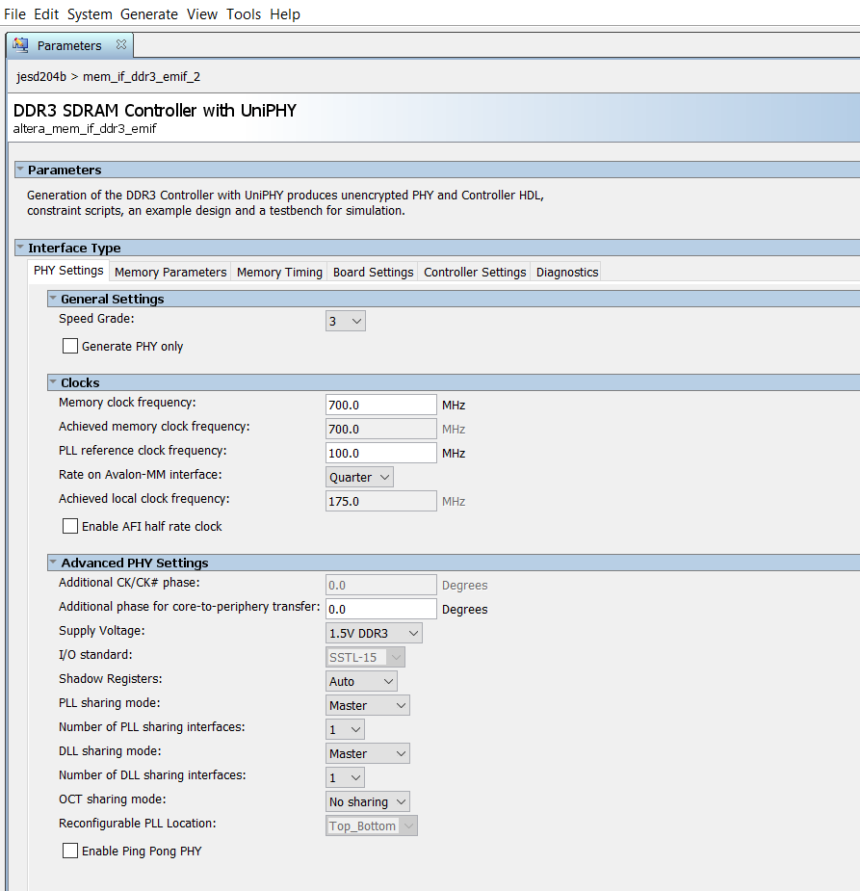
Figure11: User interface to configure external DDR3 memory

BRAM Memory
BRAM memory is supported only in two FW builds mentioned below, maximum BRAM size possible with other FW modules included was 256KB. Note that BRAM data read and write happens through FX3 I2C interface and not the 32b fast parallel interface (Synchronous slave FIFO interface). Only DDR memory is read or written using the FX3 fast parallel interface. Since HSDC Pro SW does read or write to BRAM using FX3->I2C->Avalon Memory mapped interface, capture or generation would be slower with BRAM FW builds
- TSW14J56REVD_BRAM_ADC_DAC_DDR_128K_XCVR_FIRMWARE
- TSW14J56REVD_ADC_DDR_DAC_BRAM_256KB_XCVR_FIRMWARE

FX3 Interface (CYUSB301X)

FX3 Main Module
FX3 Main has the fx3interface, fx3toddr, ddrtofx3 and fx3_i2c_main as sub-modules as shown below. It has three Avalon Memory Mapped masters two for memory read and write and one for register control. It also has fx3 interface signals both I2C signals and Synchrous slave interface signals (fast parallel 32b interface) from the FX3 controller chip connected to it. This module generates and sends the fx3 pclk to FX3 chip.
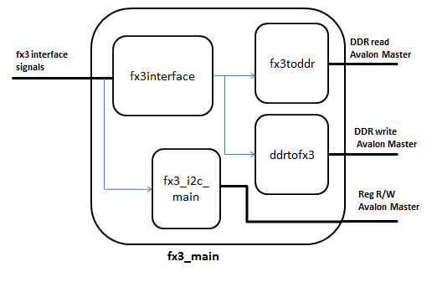
Figure12: Block diagram of fX3 Main Module

The fx3 interface module has two state machines, one for stream data in from fx3 and another for stream data out to fx3 to handle the Synchronous Slave FIFO Interface. Refer the FX3 application note “Designing with the EZ-USB FX3 Slave FIFO Interface” AN65974” for the implementation details, also linked in the references section below. This module gets the ADC and DAC start pulses from the fx3ctrl module which acts as a register file for fx3. It also sends control lines and 32bit data signals to fx3toddr and ddrtofx3 module.

The fx3toddr module has a state machine to write data to memory through Avalon Master Interface. It has a FIFO to store and convert 32b data input from the fx3interface to 512bit with FIFO depth of 256 words.

The ddrtofx3 module has a state machine to read data from memory through Avalon Master Interface. It has a FIFO which stores the 512b data from the memory and outputs 32bit to the fx3interface module with FIFO depth of 256 words.

The fx3_i2c_main module is connected to the fx3 i2c signals. It has Avalon Master to write and read from registers based on the i2c command given. The i2cslave module will convert the i2c signals to appropriate control signals and issues it to write_master module. This write_master module is connected to Avalon bus and it will write or read to FX3 register control module and other Avalon slaves inside Qsys

Please refer the I2C packet Structure Excel sheet placed parallel to this document for more details on I2C interface

FX3 Register Control
This module has an Avalon slave interface connected to the Avalon bus and holds the FX3 registers. ADC start pulse to initiate memory to FX3 transfers and DAC start pulse to initiate FX3 to memory transfers are generated in this module. It also holds a register for the data length, number of 32b words to be written or read back from memory

Trigger module
The trigger mode in TSW14J56 has two options namely:
- Normal Trigger mode
- SYSREF based trigger mode

Please refer the ‘TSW14J56 RevD Trigger Modes.doc’, path linked in references for detailed information on the Trigger Modes

Normal Trigger mode
In this mode there when capture or gen module is in IDLE state waiting for an external trigger to be received. After the external trigger rising edge is detected the capture or generation immediately starts. In the capture module it enters SOMF WAIT state and starts the capture after RX SOMF pulse. The external trigger is sampled with respect to the frame clock.

SYSREF based trigger mode
In the SYSREF based trigger mode there are two sub modes (i) Master triggering mode (ii) Slave triggering mode.
In general this mode is used to synchronize two ADC or DAC setups based on a common continuous SYSREF signal in both the setups.
The trigger generating setup is called master setup and trigger receiving setup is called slave setup
Below the two of the sub modes are explained in detail (common for both TX and RX)
(i)Master triggering mode
In master mode the trigger pin is configured as an output. The trigger generation is by toggling a bit in the dedicated trigger register. This toggling is done by the HSDC software through the FX3 I2C interface. The rising edge of the toggled signal is sent to the trigger module. The output from this trigger module for slave triggering starts at the first rising edge of the SYSREF signal. The output signal from the trigger module for initiating capture or generation, starts at the second rising edge of the SYSREF signal.

External Trigger

SYSREF

Trigger o/p for slaves

Trigger o/p for cap/gen

(ii)Slave triggering mode
In Slave mode the trigger pin is configured as input. Module waits for the external trigger and generates the trigger aligned to the first encountered SYSREF rising edge. The rising edge of this SYSREF aligned trigger starts the capture or generation.

External trigger

SYSREF

The signals that control the triggering in capture module (dec_data_capture) are listed in table 4 below
*Offset Address | Size | Description
0x20004 | 32 | [0]- X  [1]- X  [2]- X  [3]-trigger status  [6:4]- Delay clk  [7]- ext trig mode en  [8]-Trig sel  [9]- master / slave  [10]- soft trig tog bit  [11]- sysref rise/fall  [12]- out trigger pol  [13]- SYSREF trig en  [16:14]- sysref cnt  [31:17]-XX
Table 4: Signals for controlling the triggering in dec_data_capture
*register address = offset address + base address, base address= 0x400000
The signals that control the triggering in generation module (enc_data_gen) are listed in table 5 below
*Offset Address | Size | Description
0x20004 | 32 | [0]- X  [1]- X  [2]- X  [3]-trigger status  [6:4]- Delay clk  [7]- ext trig mode en  [8]-SYSREF trig en  [11:9]- sysref cnt  [12]- sysref rise/fall  [13]- out trigger pol  [14]- master/slave  [15]- soft trig tog bit  [31:16]-XX
*register address = offset address + base address, base address= 0x000000
In the current firmware most of the parameters out trigger pol, sysref cnt, sysref rise/fall are hardcoded.

framesoftrst
This module is confined to the JESD RX side. The JESD RX Megacore module during reconfiguration is set in reset state. The reset state is controlled by software through the FX3 I2C interface. The deassertion of this reconfig reset was random. This module was included in order to make sure the deassertion occurs only at the rising edge of SYSREF rising edge. This mechanism helped in achieving consistent SOMF clock generation from the JESD RX Megacore.
Soft reset

SYSREF

Soft reset aligned to SYSREF

Eye Scan Modules
EyeQ scan is a technique used to evaluate the performance of high speed SERDES lanes. TSW14J56revD uses transceiver native PHY to implement the physical layer eye scan logic in firmware. The EyeQ Scan is performed using on-chip signal quality monitoring circuitry, developed by Intel. EyeQ uses a phase interpolator and sampler to estimate the vertical and horizontal eye opening using the specified horizontal phase and vertical height values. The firmware logic will go over the horizontal phase from ‘0 to 31’ for each vertical height from ‘0 to 63’ and for both the top and bottom polarities of vertical height. The received ‘bit counter’ and ‘error counter’ values from transceiver, for each horizontal phase and vertical height will be stored in block RAM inside FPGA and in turn will be read by HSDC Pro and displayed in the intensity graph.
The user is requested to refer ‘Intel Transceiver PHY IP Core User’ document for detailed information on the EyeQ Scan operation. To perform Eye scan with HSDC Pro, please refer the TSW14J56revD SERDES Test Options.docx for the steps required

Firmware blocks Involved:
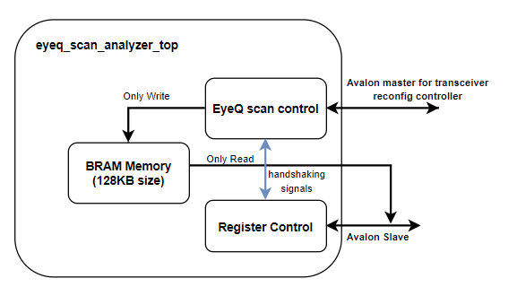
Figure13: Block diagram of Eye Scan Module
To perform Eyescan, user has to enable the ‘Enable EyeQ block’ and ‘Enable Bit Error Rate Block’ in the Transceiver Reonfiguration Controller Intel IP. Eyeq scan analyzer handles the register controls necessary for performing eye scan. Eye scan start and stop and the sequence of register read writes to PHY transceiver reconfig controller are controlled by EyeQ scan control module and the eye scan error counts are written to BRAM. Once done, HSDC SW reads the error counts from BRAM through the same Fx3-> I2C-> Avalon slave interface used for register read write operations.
EyeQ scan control module performs eye scan with the following two state machines (SM)- SM1 controls the EyeQ process and SM2 handles the register R/W to transceiver reconfig controller. SM1 moves out of IDLE state once the eye scan start bit is set by HSDC SW
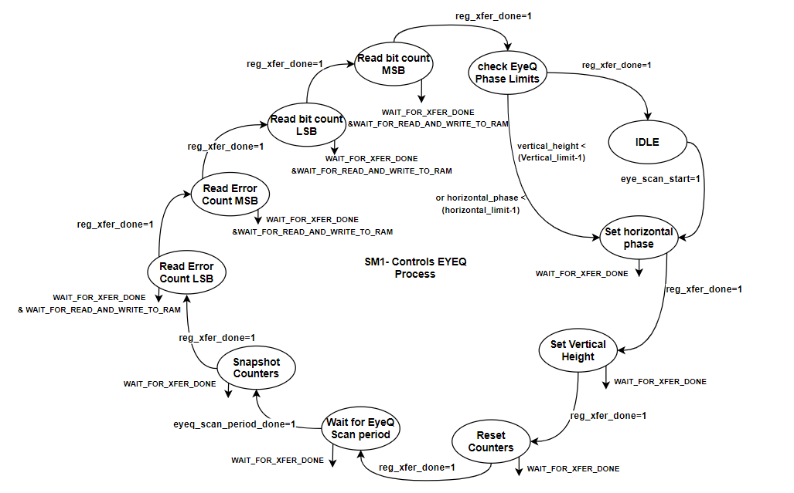
Figure14: Eye Scan FSM1
State machine moves through the states to set Horizontal clock phase, Vertical height, reset bit error rate counters and waits for the EyeQ scan period set by HSDC SW to be completed. In each of this state, SM waits for the register read write transfer to be complete in WAIT_FOR_XFER_DONE before moving on. Once the ‘waits for the EyeQ scan period’ is over, state machine moves to next states which reads error counts and the total bits received from transceiver reconfiguration controller. Register read write operations are handled in another state machine (SM2) which runs parallel to this machine and reg_xfer_done is the hand shaking signal between the two. WAIT_FOR_XFER_DONE checks for reg_xfer_done to be HIGH, also checks if the controller is busy and has a logic for timeout and error handling cases.
As the error and bit counts are read, they are written to BRAM in WAIT_FOR_READ_AND_WRITE_TO_RAM state. Once done, the state machine moves to CHECK_EYEQ_PHASE_LIMTS in which the current horizontal phase and vertical height is compared with the limits set by HSDC SW. If the entire horizontal and vertical ranges are covered state machine moves to IDLE, if not it moves to ‘Set Horizontal Phase’ and iterates again
State machine to handle transceiver register read write is as shown below. There are two parallel state machine flows- one for register read and other for register write. Within read and write also, if it is EyeQ offset register, the flow is different than a reconfig register. Please refer ArriaV transceiver PHY IP core user guide, Section “Transceiver Reconfiguration Controller EyeQ Registers” for more details
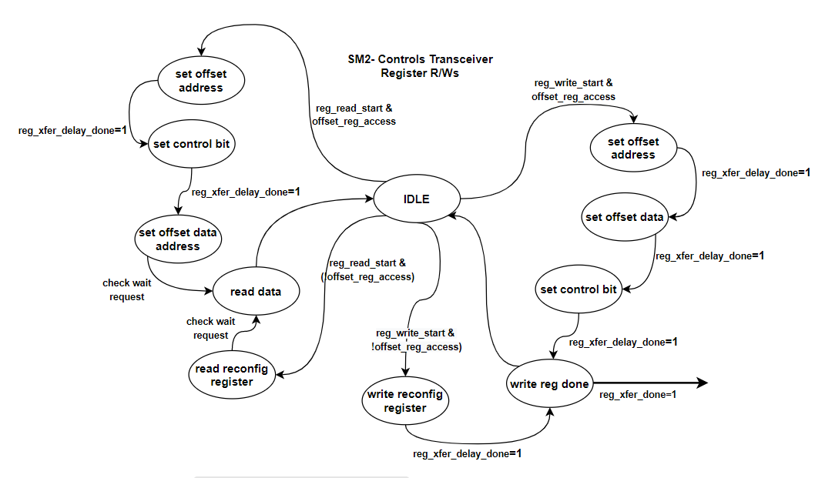
Figure15: Eye Scan FSM2

Clocking architecture
The core of the FPGA can be divided broadly into 2 regions: the fabric, and the transceivers. Each region contains a PLL that is used to generate clocks needed in that region. The PLL for the FPGA fabric is commonly referred to as the fPLL. Likewise, the PLL used to generate the high speed clock for the transceivers is known as the CMU PLL.
In TSW14J56, both the fPLL and the CMU PLL share a common reference clock as shown in figure. This common reference clock can be provided through the FMC port to differential pair pins [R22,R23] on the FPGA or can also be provided through differential pair pins [N23,N24] on the FPGA via an SMA connector. There are 3 clock domains present in the firmware and these are illustrated in figure 12.
- All configuration interfaces are clocked at 100MHz. This includes the JESD204B IP core, the PLL reconfiguration controller and the transceiver reconfiguration controller
- The JESD204B IP is clocked at link clock lane rate/40 where lane rate is the SERDES data rate. Link clock is generated using fPLL, fabric PLL. Link clock is also provided as the parallel clock for PHY IP transceivers.
High speed clock for the receivers is recovered from data using Clock Data Recovery (CDR) unit and the high speed clock for transmitters are generated using CMU PLL (Clock multiplier Units). Note that CMU can either function as high speed clock generator or as clock data recovery unit and not as both.
- The data interface to the memory interface is clocked at a fixed 175MHz. Since the controller is quarter rate, the external memory runs at 4x175= 700M

The transceivers are grouped into banks of six channels each and ArriaVGZ FPGA part 5AGZME1 contains up to 12 high speed transceivers, supporting 12.5Gbps. We are using the CMU PLL (clock multiplier Units) either channel1 or channel4 as the clocking source to generate high speed serial clock for transmitters, hence those 2 CMUs can’t be used as CDRs
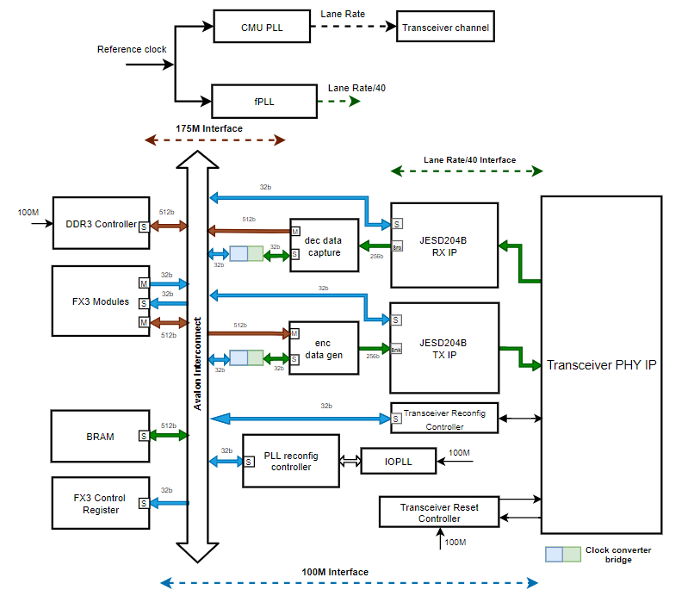
Figure16: Clocking Structure

fPLL
As mentioned earlier, the fPLL generates the clock required for the FPGA fabric. This clock is used mainly as the device clock to the JESD204B IP. Figure 13 shows how the fPLL generates the device clock from the reference clock provided at pins [R22, R23]. The reference clock is multiplied by 4 and then divided down with the C-counter. The value of the C-counter is programmable and can be dynamically re-configured to support different device clock frequencies and it is possible through PLL reconfiguration controller. HSDC Pro SW connects to the PLL reconfig controller through FX3->I2C->Avalon Memory mapped Interface and configures the counter settings
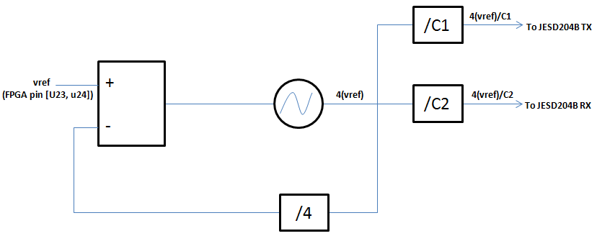
Figure 1: JESD204B device clock generation by fPLL
Understanding C-counter re-configuration
The value used to configure the C-counter consists of three bytes: an address byte, a high count byte and a low count byte. The outputs of the C1 and C2 counters are used as the device clocks to the JESD204B transmitter and JESD204B receiver blocks respectively. The C counter reconfiguration value is illustrated below for C1 (transmit) and C2 (receive):

For transmit (C1):
04 | HIGH COUNT | LOW COUNT

For receive (C2):
08 | HIGH COUNT | LOW COUNT

In both transmit and receive, the sum of HIGH COUNT and LOW COUNT gives the actual C counter value.
For example, to configure the C counter to decimal 20 (0x14) in the receiver firmware, the hex value 0x 080A0A or 0x08080C etc may be used. Likewise, to configure the C counter in the transmit firmware to 20, either 0x040A0A or 0x04080C etc can be used as well. HIGH COUNT and LOW COUNT cannot be zero. The Avalon read and write commands that are used to achieve fPLL reconfiguration can be found in the Appendix. Details of the C-counter reconfiguration can be found in “Implementing Fractional PLL Reconfiguration with Altera PLL and Altera PLL Reconfig Megafunctions”

CMU PLL
This PLL generates the high speed SERDES clock required by the transmitters.
By default, the CMU PLL is set to multiply the reference clock provided at pins [R22, R23] by 40. This default multiplier can be dynamically changed by streaming a MIF file. The HSDCPRO software can be used to stream the MIF file to change the CMU PLL settings. MIF files for CMU PLL re-configuration are automatically generated after generating the IP in Quartus software. To start reconfiguration, the contents of the MIF file are first written to on-chip RAM. In TSW14J56, this RAM is dual port with dimensions of 16×128 and base address of 0x801100. After writing the MIF file to RAM, the transceiver reconfiguration controller is then triggered with a series of Avalon write commands to begin the reconfiguration process. Details of how to stream a MIF file to change the default settings of the CMU PLL can be found in Using the Transceiver Reconfiguration Controller for Dyanmic Reconfiguration in Arria V and Cyclone V Devices
The CMU PLL can span the frequency range from 0.611GHz to 10.3125GHz (lower speed grade device: 5AGZME1E3H29C4) or 0.611GHz to 12.5GHz (higher speed grade device: 5AGZME1E2H29C3).

Different Firmware Builds
Following firmware files are maintained for TSW14J56revD platform in HSDC Pro. All of the FWs use the same firmware architecture as explained in this document except for some minor changes. Please refer below for more details. Please note timing is not closed in any of the J56 FW builds mentioned below and yet to be fixed
- TSW14J56REVD_FIRMWARE
- TSW14J56REVD_AEQ_FIRMWARE
- TSW14J56REVD_FIRMWARE_SYSREF_TO_SMA
- TSW14J56REVD_RX_ALT_SYNC_LVDS_FIRMWARE
- TSW14J56REVD_LMK_SYSREF_TRIGGER
- TSW14J56REVD_ADC_DDR_DAC_BRAM_256KB_XCVR_FIRMWARE
- TSW14J56REVD_BRAM_ADC_DAC_DDR_128K_XCVR_FIRMWARE
- TSW14J56REVD_SERDES_TEST_FIRMWARE
- TSW14J56REVD_841_CER
- TSW14J56REVD_FIRMWARE_CER

A common LED Status is maintained for all FW builds except for the SERDES_TEST_FIRMWARE (it doesn’t support capture or generation)

LED Status:
Please see below description of the on-board user LED signals for this FW build. Please note J56 platform User LEDs are active LOW
User LEDs | Functionality
D1 | Indicates TX SYNC is established when OFF
D2 | Indicates presence of TX link clock and JESD link is established when blinking
D3 | Indicates RX SYNC is established when OFF  (and the reverse if incase RX SYNC pin P/N is swapped in device)
D4 | Indicates presence of RX link clock and JESD link is established when blinking
D5 | Indicates trigger input signal, if LED debug INI parameter is 1 else unused
D6 | DDR4 initialization done when off  (if LED debug INI parameter is 1, indicates RX link is established when OFF  Else stays OFF when data capture to memory is in progress)
D7 | DDR4 calibration successful and completed when off  (if Binary Channel Mode is enabled, indicates BCM data)
D8 | DDR4 calibration failed when off  (if LED debug INI parameter is 1, indicates presence of SYSREF when blinking)

TSW14J56REVD_FIRMWARE
Firmware supports both capture and generation with DDR3 memory of 1GB size. Since DDR memory is split and used by both TX and RX, throughput available is reduced to half of maximum available, due to which FW can’t be used for higher lane rates in transceiver mode
TSW14J56 (with ArriaV GZ Speed grade3 FPGA) transceivers supports a maximum of 12.5Gbps SERDES Data rate. DDR3 on-board memory theoretical throughput is 89.6Gbps (175M * 512b). Assuming 70% efficiency of DDR, practical throughput possible is 62.72Gbps (theoretical * 0.7). With this throughput, for 8L modes max lane rate achievable is 9.8G and in transceiver mode lane rate possible is 4.9G only. Using DAC with BCM¹ feature and 8L JMODE further reduces the max lane rate by half to 4.9G.

Auto Duplicate First Channel Data:
To support higher lane rates and enhance the DDR throughput for TX path, ‘Auto Duplicate First Channel data’ feature is added in this Firmware. This feature duplicates one channel data (the first channel) to all channels in firmware before sending them to JESD Base IP which in turn sends on the TX SERDES lanes. With this feature, HSDC Pro SW needs to write only the first channel data to DDR memory and is duplicated for other channels by firmware. This greatly reduces the amount of DAC data stored in memory and also reduces the memory read and write transactions which in turn enhances the throughput. Please refer the ‘TX Auto Duplicate first channel data.docx’, linked in references section for more details.
Also FW supports Eye scan feature to understand RX SERDES performance and trigger modes HW, SW and SYSREF based for both ADC capture and DAC generation are supported. Please refer the ‘TSW14J56 RevD Trigger Modes’ for more details on HSDC Pro trigger modes
Note¹: Current Architecture for BCM feature is such that BCM pattern gets written along with DAC data to the same DDR memory but is read back and sent on SMA pin instead of JESD link. BCM pattern occupies the same size as DAC data, so the memory available for valid DAC data is reduced by half and the throughput also reduced by half as the DAC data gets read back along with valid BCM data for every read transaction. Refer the ‘BCM Feature’ section under Enc_data_gen module for more details

TSW14J56REVD_AEQ_FIRMWARE
Recompiled TSW14J56REVD_FIRMWARE with Adaptive Equalization (AEQ) option enabled which improves the RX SERDES performance at higher lane rates and helps with signal integrity. FW supports all features of REVD FW: Eye scan feature to understand RX SERDES performance and trigger modes HW, SW and SYSREF based for both ADC capture and DAC generation are supported but doesn’t support ‘Auto Duplicate First Channel’ feature mentioned above.

TSW14J56REVD_FIRMWARE_SYSREF_TO_SMA
Recompiled TSW14J56REVD_FIRMWARE to send SYSREF out on SMA pin TRIG OUTB which is one of the trigger output signals in other FW builds FW supports all features of REVD FW: Eye scan feature to understand RX SERDES performance and trigger modes HW, SW and SYSREF based for both ADC capture and DAC generation are supported but doesn’t support ‘Auto Duplicate First Channel’ feature mentioned above.

TSW14J56REVD_RX_ALT_SYNC_LVDS_FIRMWARE
This firmware build was developed back in 2015 and it was never updated, the source files are lost. In an attempt to generate the design, we tried recompiling the TSW14J56REVD_FIRMWARE with the only change being ALT SYNC signal sent in LVDS standard instead of 2.5V CMOS signal (which is the case in all other FW builds). But there were issues with this FW build and needs further debug, capture timed out when testing with ADS54J66 device and we reverted back to the rbf file released in 2015 with older HSDC Pro versions. So, there is no design file available for this FW build currently and we are not sure of the features supported
Currently this FW is used for testing ADS54J54, ADS54J64, ADS58J64 and ADS54J66 devices

TSW14J56REVD_LMK_SYSREF_TRIGGER
This firmware was done as part of a support request for TI India Medical team using the TSW14J56REVD_FIRMWARE as base design. FW supports all features of the base FW: Eye scan feature to understand RX SERDES performance and trigger modes HW, SW and SYSREF based for both ADC capture and DAC generation are supported except for ‘Auto Duplicate First Channel’ feature
Deterministic Latency was not achieved with ADS52J65 device, time between SYSREF pulse detection to SYNC signal de-assertion from JESD204B IP is not consistent across multiple captures and they preferred to have SYSREF in Pulsed Mode, not as continuous signal. We had to set ‘SYSREF Single Detection’ bit in register 0x54 in JESD204B IP in the HSDC SW board DLL every time capture is pressed as it is auto-clear bit, so IP samples SYSREF pulses for every capture click. This way we could achieve deterministic latency. But if the link fails because of bad data or clock it can result in non-deterministic latency, as the SYSREF single detect bit will not be set then (Since we set that in board DLL only on capture). Instead of the DLL change, FW design changes were made to achieve deterministic latency. Whenever SYNC goes LOW a logic is added in firmware to set the ‘sysref single detect’ bit in JESD IP, assert reset to JESD Base IP and send a pulse signal out on FMC K22 to the LMK in ADS52J65 EVM to trigger SYSREF pulses and establish the link again. SYSREF pulses to Base are gated once link is established and SYNC signal is HIGH. With these FW changes, able to achieve deterministic latency with ADS52J65 device

TSW14J56REVD_ADC_DDR_DAC_BRAM_256KB_XCVR_FIRMWARE
Firmware supports ADC capture with DDR memory of 1GB size and supports DAC data generation with BRAM memory of 256KB size. This FW build was part of the feature addition “Trigger Auto-rearm with delay”. In other FW builds, trigger feature gets disabled once trigger is armed and a single trig pulse is received. To do another triggered capture or generation, user has to re-enable trigger feature in HSDC Pro. Trigger logic is modified in this FW build to automatically re-arm trigger settings (both TX and RX) and wait for next trig pulse after the first one is received. Also added support in HSDC Pro for delaying the trigger pulse received in firmware, user can delay trigger in terms of link clocks
FW was tested with AFE77xx EVM with the modes RX- 2x2RX_24410 at 245.76M and TX - 2x2TX_44210 at 491.52M, lane rate is 10Gbps in loopback mode. AFE77xx DAC Channels looped back as ADC Input, the data generated out to DAC is captured and verified in HSDC Capture window. Since the data sent out and received back are both SOMF signal aligned, sample index of the first valid tone data received in HSDC should be consistent, but we observed that there is +/- one sample index mismatch in ADC capture window. We believe it is due to NCO’s enabled in the device and mentioned as known issue in HSDC release notes. Please note FW is not tested extensively with any other device.
FW also supports ‘Single shot generation’ DAC data gets played only once and not in continuous loop, when the INI parameter ‘single generation = 1’ is set in the DAC INI file

TSW14J56REVD_BRAM_ADC_DAC_DDR_128K_XCVR_FIRMWARE
Firmware supports ADC capture with BRAM memory of 256KB size and supports DAC data generation with DDR memory of 1GB size. FW uses I2C interface for reading data captured in BRAM memory, capture in HSDC Pro might be slower. Transceiver RX blocks has adaptive equalization (AEQ) option enabled and also FW supports eye scan feature. Also FW supports HW, SW and SYSREF based trigger modes for both ADC capture and DAC generation. Please refer the ‘TSW14J56 RevD Trigger Modes’ for more details on HSDC Pro trigger modes

TSW14J56REVD_SERDES_TEST_FIRMWARE
This firmware has a different architecture, please refer the ‘TSW14J56revD SERDES FW Architecture’ design document for more details

TSW14J56REVD_841_CER & TSW14J56REVD_FIRMWARE_CER
CER FW builds support normal HSDC Pro Capture and generation though it is not tested extensively, in addition they also support CER testing. Please refer the ‘User Manual J56 CER testing with HSDC Pro’ and ‘TSW14J56 CER Firmware’ document for more details

References
Please refer Intel documents for the following if the online search with ‘Altera’ doesn’t result in relevant documents

- “Embedded Peripherals IP User Guide”, Altera Corporation, ch. 18, pg. 18-1, June 2011.
- Chapter 2 ‘Transceiver Clocking in ArriaV devices’ of ArriaV Device Handbook on transceivers
- “Avalon Interface Specifications”, Altera Corporation, May 2013.
- “Functional Description-UniPHY”, Altera Corporation, December 2013.
- “JESD IP Core User Guide”, Altera Corporation, June 2014.
- “Altera Transceiver PHY IP Core User Guide”, Altera Corporation, ch. 14, pg 14-1, December 2013.
- “Implementing Fractional PLL Reconfiguration with Altera PLL and Altera PLL Reconfig Megafunctions”, Altera Corporation, AN-661, November 2013.
- “Using the Transceiver Reconfiguration Controller for Dyanmic Reconfiguration in Arria V and Cyclone V Devices”, Altera Corporation, AN-676, December 2013.
- “Designing with the EZ-USB FX3 Slave FIFO Interface” AN65974- Application note from Cypress FX3
- \*\ TSW14J56\Reference Documents\Other Documents\I2C packet Structure.xlsx
- \*\ \TSW14J56\Reference Documents\Other Documents\TSW14J56 RevD Trigger Modes.doc
- ArriaV transceiver PHY IP core user guide, Section “Transceiver Reconfiguration Controller EyeQ Registers”
- Section VII in \* \TSW14J56\Reference Documents\User Manual\HSDC Pro FAQ & Troubleshooting Guide.docx
- Transceiver Reconfiguration Controller for Dynamic reconfiguration in ArriaV and Cyclone V devices

