TSW14J56revD SERDES Test Options – User Guide

Contents
Document Revision History 2
Introduction 3
Transmitter: Pattern Generator 3
Overview 3
Steps to generate SERDES Test Pattern 3
Transmitter: GUI Controls 4
Analog Controls 5
Test Patterns 5
Receiver: EyeQ Scan 6
Overview 6
Steps to perform EyeQ Scan 6
Receiver: EyeQ Scan GUI Controls 7
Receiver: Pattern Verifier 8
Overview 8
Steps to verify SERDES Test Pattern 8
Receiver: Pattern verifier GUI Controls 9

Document Revision History
The following ‘Table 1 - Document Revision History’ lists the revision history for this user guide.

Table 1 - Document Revision History
Date | Version | Revision Details | Author
18th May 2016 | 1.0 | Initial Release | Gokul Prasath N

Introduction

This user guide describes on how to use the ‘SERDES test options’ with TSW14J56revD, using High Speed Data Converter Pro software. The ‘SERDES test options’ has the following test functions that can be used to verify the SERDES data,
- Transmitter: Pattern Generator – SERDES test patterns like PRBS patterns can be generated from J56 and verified using DAC EVM, for testing the SERDES physical lane connection.
- Receiver: Altera developed EyeQ scan feature – using on-chip signal quality monitoring circuit, to estimate the actual eye opening at the receiver for individual SERDES lanes.
- Receiver: Pattern Verifier – Used to verify the SERDES test patterns generated by ADC EVM like PRBS test pattern, to verify the SERDES physical lane connection.

Transmitter: Pattern Generator

Overview
The ‘Pattern Generator’ feature in TSW14J56revD can be used to generate SERDES test patterns, which in turn can be verified using DAC EVM. The FPGA firmware uses Altera’s Data pattern generator soft IP core to generate 40bit test patterns to the transceiver’s data input, which is serialized and transmitted through SERDES lanes. This feature supports the following test patterns.
- PRBS-7
- PRBS-15
- PRBS-23
- PRBS-31
- High Frequency (10101010 x 5)
- Low Frequency (11110000 x 5)

Steps to generate SERDES Test Pattern
The ‘Pattern Generator’ feature is only available in special firmware and not with the default firmware. This is due to the transceiver architecture that is being used with the default firmware. Hence, to support this feature the transceiver architecture has been changed in the special firmware to get 40bit input data from pattern generator instead of 32bit input data from JESD IP in the default firmware.

Please note that, this special firmware does not have JESD interface related logics implemented and hence the JESD related operations like synchronization process will not be valid. Also note that, the LED status are not valid with this build, as the JESD logic is not integrated.

Kindly, follow the below provided steps to create the ‘SERDES Test’ INI, for generating the ‘SERDES Test Pattern’ from J56revD, for that particular DAC INI mode configuration.

- Please perform the following DAC INI File Changes
  - Update the Interface name parameter as below.
Interface name="TSW14J56REVD_SERDES_TEST_FIRMWARE"
  - In the “MIF Config” parameter, replace the “TX_PMA_x” and “TX_PLL_x” with “TX_PMA_SERDES_TEST_x” and “TX_PLL_SERDES_TEST_x” respectively. For example,
Before changing:
MIF Config= 0.611G to 3.90625G:TX:TX_PMA_x10, 0.611G to 3.90625G: :CMU:TX_PLL_x10, 3.90625G to 10G:TX:TX_PMA_x40,3.90625G to 10G:CMU:TX_PLL_x40
After changing:
MIF Config= 0.611G to 3.90625G:TX:TX_PMA_SERDES_TEST_x10, 0.611G to 3.90625G: :CMU:TX_PLL_SERDES_TEST_x10, 3.90625G to 10G:TX:TX_PMA_SERDES_TEST _x40,3.90625G to 10G:CMU:TX_PLL_SERDES_TEST _x40
- Please remove the ‘SerDesTest Options’ under the ‘Menu Disable’ parameter under ‘DAC’ section in the ‘Device and File Info.ini’ file present in “14J56revD details” folder.
- Launch the HSDC Pro, Select the Modified DAC INI file and update the firmware.
- Configure the ‘Data Rate’ as set in DAC and generate any tone and click on send. Please note that, this step is needed to configure the PLL and transceiver for the configured rate. Also note that, this
- Click on “Instrument Options -> SERDES Test Options” and select ‘TSW14J56revD TRANSMITTER’ tab.
- After configuring the pattern to generate and click on ‘Apply’ to start generating the pattern. Please refer ‘Figure 1 - SERDES Test Options: Transmitter settings’ for the snapshot of the GUI.

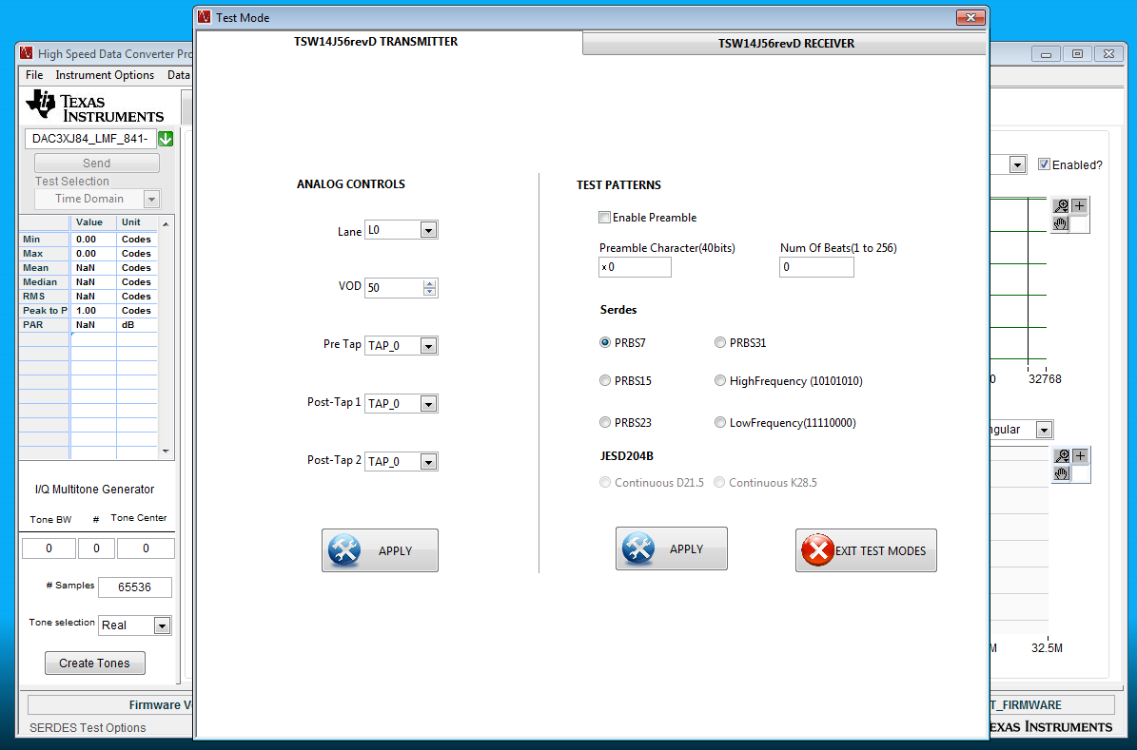
Figure 1 - SERDES Test Options: Transmitter settings

Transmitter: GUI Controls
The ‘SERDES Test Options’ window can be accessed using “Instrument Options -> SERDES Test Options” menu selection from HSDC Pro. Please note that, the ‘Transmitter’ tab will only enabled for the modified DAC INI file as mentioned in the previous section. The detailed explanation for the controls present under this tab, as shown in “Figure 1 - SERDES Test Options: Transmitter settings”, will be explained in the following.

Analog Controls
This section can be used to tweak / change the Analog settings of the Transceiver used in TSW14J56revD FPGA. Brief description about each controls will be listed in the following. The user is requested to refer ‘Altera Transceiver PHY IP Core User’ document for detailed information on each Analog parameters.

- Lane: Used to select the “Physical Lane” of the SERDES, to which the Analog settings has to be applied. For example, if “L0” is selected from the list, Analog settings will be applied to the ‘physical lane 0 (TX0)’, when the user clicks on “Apply” button under ‘Analog Controls’ section.
* Kindly, note that the configured ‘Test Pattern’ will be sent on all the ‘8 physical lanes’ irrespective of the selected lane.
- VOD: Voltage On Differential output, which is used to control the transmitter differential output voltage value. The valid values are from 0 to 63.
- Pre Tap: Pre-emphasis pre-tap settings. The following encodings are defined.
  - 5’b00000 and 5’b10000 : 0
  - 5’b00001–5’b01111 : -15 to -1
  - 5’b10001–5b’11111 : 1 to 15
- Post-Tap 1: Pre-emphasis first post-tap settings. The following encodings are defined.
  - 5’b00000–5’b11111 : 0 – 31
- Post-Tap 2: Pre-emphasis second post-tap settings. The following encodings are defined.
  - 5’b00000 and 5’b10000 : 0
  - 5’b00001–5’b01111 : -15 to -1
  - 5’b10001–5b’11111 : 1 to 15
- Apply: Clicking on this button will update all the ‘Analog Controls’ displayed on the GUI to the selected ‘Lane’.

Test Patterns
This section is used to select the ‘SERDES Test Pattern’, which has to be transmitted on all the ‘8 physical lanes’. Brief description about each controls will be listed in the following. The user is requested to refer the section ‘Data Pattern Generator’ under the ‘Embedded Peripherals IP User Guide’ document for the detailed information on each parameters.

- Enable Preamble: If checked, enables the preamble mode. In this mode, the configured preamble character is sent for the specified number of times before the selected pattern is generated, so that the receiver can determine the word boundary in the bit stream.
- Preamble Character(40bits): The 40bit preamble character, that has to be repeated for the number of beats, before sending the actual pattern.
- Number of Beats(1 to 256): The number of beats to repeat the preamble character.
- Serdes: SERDES test pattern to send on serial lanes. The selected test pattern will be generated, when the user clicks on ‘Apply’ button.
- JESD204B: Currently, the JESD204B test pattern are not supported.
- Apply: Clicking on this button will configure the pattern generator with the specified parameters.
- Exit Test Mode: Clicking on this button, will exit all other test modes by generating the default 0x55 test pattern from the pattern generator.

Receiver: EyeQ Scan

Overview
TSW14J56revD uses transceiver native PHY to implement the physical layer logic in the firmware. The EyeQ Scan is performed using on-chip signal quality monitoring circuitry, developed by Altera.

EyeQ uses a phase interpolator and sampler to estimate the vertical and horizontal eye opening using the specified horizontal phase and vertical height values. The firmware logic will go over the horizontal phase from ‘0 to 31’ for each vertical height from ‘0 to 63’ and for both the top and bottom polarities of vertical height. The received ‘bit counter’ and ‘error counter’ values from transceiver, for each horizontal phase and vertical height will be stored in block RAM inside FPGA and in turn will be read by HSDC Pro and displayed in the intensity graph.

The user is requested to refer ‘Altera Transceiver PHY IP Core User’ document for detailed information on the EyeQ Scan operation.

Steps to perform EyeQ Scan
Please follow the following steps to perform EyeQ scan with HSDC Pro.
- Connect to the board and select the required ADC INI file in the HSDC Pro and update the firmware.
- Configure the ‘Data Rate’ as set in ADC and click on capture. Please note, this step is needed to configure the PLL and transceiver for the configured rate. It is not a problem, even though the capture is timed out, we still be able to see the respective Eye Diagram as it is not related to JESD SYNC or any other JESD related signals.
- Click on Instrument Options -> SERDES Test Options and select ‘TSW14J56revD RECEIVER’ tab and then ‘EyeQ Scan’ tab.
- Select the ‘Physical Lane’ for which EyeQ scan has to be performed in the ‘Lane’ control and configure the ‘Time per iteration’, which is the time period to scan for each horizontal phase and vertical height iteration.
- Click on the ‘Start’ button to start scan for the EyeQ. Once the ‘Test Time Progress’ is completed, as displayed in the progress bar, the corresponding Eye will be displayed in the intensity graph as shown in ‘Figure 2 - SERDES Test Options: Receiver - EyeQ’.
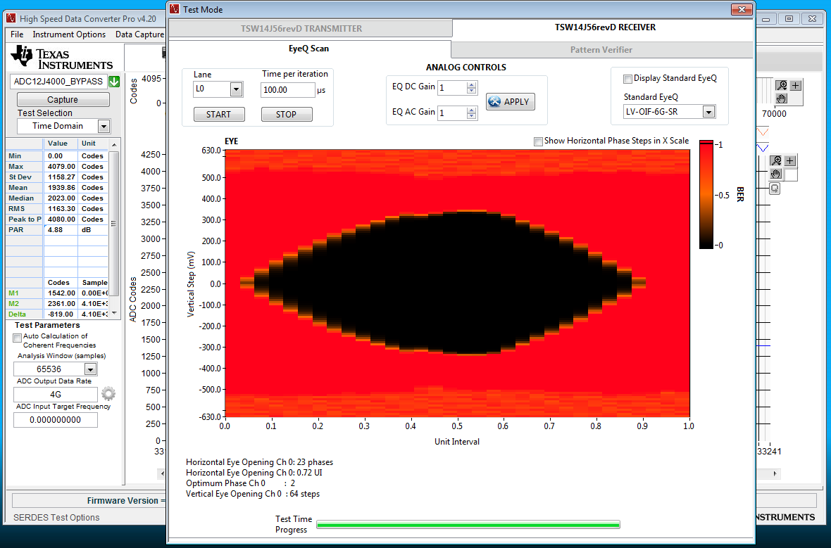
Figure 2 - SERDES Test Options: Receiver - EyeQ

Receiver: EyeQ Scan GUI Controls

The description for different controls in the ‘EyeQ Scan’ window snapshot as shown in ‘Figure 2 - SERDES Test Options: Receiver - EyeQ’ is listed below.

- Lane: Used to select the desired physical lane, for which the ‘EyeQ’ scan has to be performed.
- Time per iteration: The time period to scan for each horizontal phase and vertical height iteration.
- Start: To start scanning for the EyeQ.
- Stop: To stop scanning for the EyeQ.
- EQ DC Gain: Sets the gain for the Receiver Linear Equalization Control. The following encodings are defined:
  - 3’b000–3’b011:0–3
  - 3'b100-3'b110:4
  - 3'b111:Reserved
- EQ AC Gain: Sets the gain for the RX buffer. The following encodings are defined:
  - 4’b0000–4’b1111: 0–15
- Apply: To apply the EQ DC and AC gain to the transceiver.
- Eye Graph: The intensity graph, which displays the Eye diagram.

Receiver: Pattern Verifier

Overview
The ‘Pattern Verifier’ feature in TSW14J56revD can be used to verify the SERDES test patterns, which is generated by ADC EVM. The FPGA firmware uses Altera’s Data pattern Checker soft IP core to check the 40bit test patterns from the transceiver’s data output, which is de-serialized from the SERDES lanes. This feature supports to check the following test patterns.
- PRBS-7
- PRBS-15
- PRBS-23
- PRBS-31
- High Frequency (10101010 x 5)
- Low Frequency (11110000 x 5)

Steps to verify SERDES Test Pattern
The ‘PRBS Verifier’ feature is only available in special firmware and not with the default firmware. This firmware is same as that of one used to generate SERDES test pattern. Kindly, refer the ‘Steps to generate SERDES Test Pattern’ section for the firmware details and limitations.

Kindly, follow the below provided steps to create the ‘SERDES Test’ INI, for verifying the ‘SERDES Test Pattern’ from ADC EVM using the J56revD, for that particular ADC INI mode configuration.

- Please perform the following ADC INI File Changes
  - Update the Interface name parameter as below.
Interface name="TSW14J56REVD_SERDES_TEST_FIRMWARE"
  - Add the following INI parameter.
Enable Controls = "Pattern Verifier"
  - In the “MIF Config” parameter, replace the “RX_PMA_x” with “RX_PMA_SERDES_TEST_x”. For example,
Before changing:
MIF Config= 0.611G to 3.90625G:RX:RX_PMA_x10,3.90625G to 10G:RX:RX_PMA_x40
After changing:
MIF Config= 0.611G to 3.90625G:RX:RX_PMA_SERDES_TEST_x10,3.90625G to 10G:RX:RX_PMA_SERDES_TEST_x40
  - A sample ADC INI file named “ADC12J4000_BYPASS_SERDES.ini” is also included with HSDC Pro, with the above modifications, for reference. This can be accessed at “<HSDC Pro Installation Directory>\14J56revD Details\ADC files”
- Select the Modified ADC INI file in the HSDC Pro and update the firmware.
- Configure the ‘Data Rate’ as set in ADC and click on capture. Please note, this capture will timeout as the JESD module was disconnected in the firmware for PRBS pattern generation/verification logic addition. This step is needed to configure the PLL and transceiver for the configured rate.
- Click on Instrument Options -> SERDES Test Options and select ‘TSW14J56revD RECEIVER’ tab and then ‘Pattern Verifier’ tab.
- After configuring the pattern to verify and click on ‘Start Checker’ to validate the pattern. The number of bits and errors and pattern valid status will be displayed in the respective indicators as shown in ‘Figure 3 - SERDES Test Options: Receiver - Pattern Verifier’

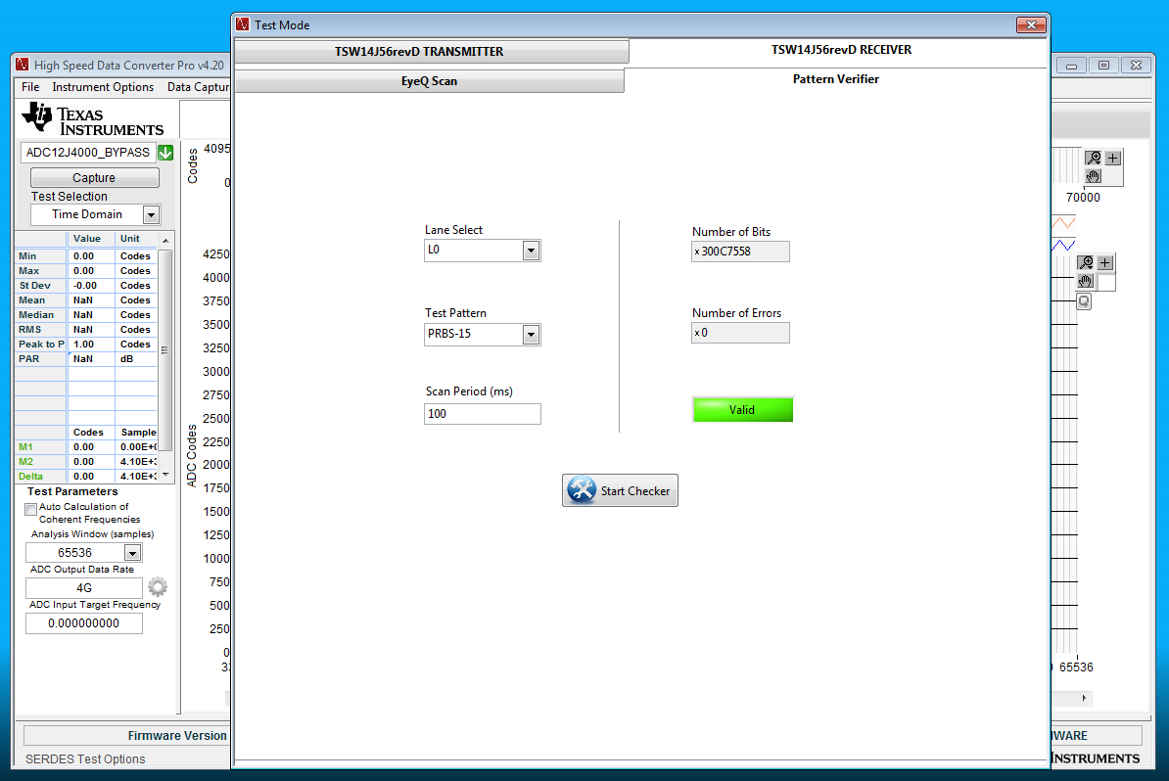
Figure 3 - SERDES Test Options: Receiver - Pattern Verifier

Receiver: Pattern verifier GUI Controls
The ‘SERDES Test Options’ window can be accessed using “Instrument Options -> SERDES Test Options” menu selection from HSDC Pro. Please note that, the ‘Pattern Verifier’ tab under the ‘Receiver’ tab will only enabled for the modified ADC INI file as mentioned in the previous section. The detailed explanation for the controls present under this tab, as shown in ‘Figure 3 - SERDES Test Options: Receiver - Pattern Verifier’, will be explained in the following.

- Lane Select: Used to select the desired physical lane, where ‘Test Pattern’ has to be verified. For example, if ‘L0’ is selected, then the data from physical lane 0 (RX0) will be sent to the data pattern checker to check for the valid pattern.
- Test Pattern: Used to select the test pattern to check.
- Scan Period (ms): Time duration in millisecond, to scan the pattern data and to check pattern. Only after the scan period is completed after clicking on ‘Start Checker’ button, the pattern results will be updated to ‘Number of bits’, ‘Number of Errors’ and valid indicator.
- Number of Bits: Number of bits checked for the pattern, during the scan period. This register’s size is 64bits.
- Number of Errors: Number of error bits received while checking for the pattern, during the scan period. This register’s size is also 64bits.
- Start Checker: Clicking on this button, will start checking for the pattern until the scan period is completed and will populate the result in the respective indicators.

