

TSW14J57 ADC INI File Guide

Rev | Date | Revision Details | Author
1.0 | 21th April 2017 | Initial Submission | Mohamed Abrar Sait

Table of Contents

TSW14J57 ADC INI File for v1.0 DLL 1
Sample INI File of v1.0 DLL 2
Parameters used by v1.0 DLL 2
[ADC] 2
[Version 1.0] 3

Channel Pattern Creation: 5
Example: 6

Bit Packing Channel Pattern Creation: 7

TSW14J57 ADC INI File for v1.0 DLL

Sample INI File of v1.0 DLL

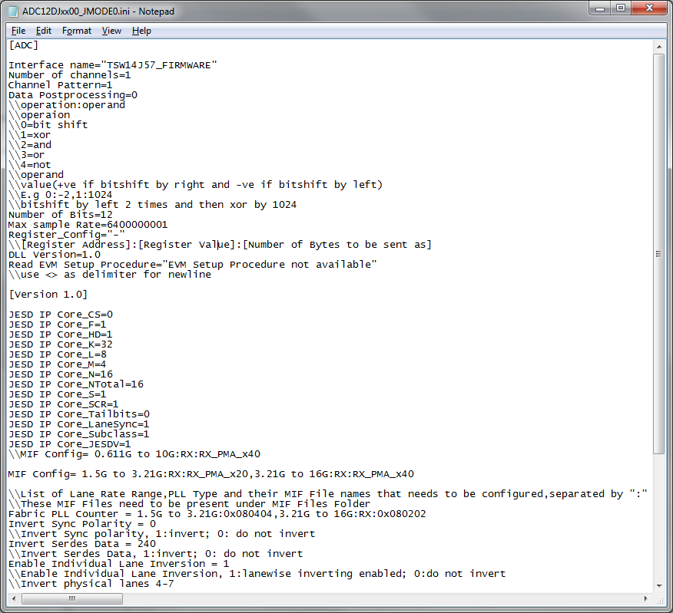

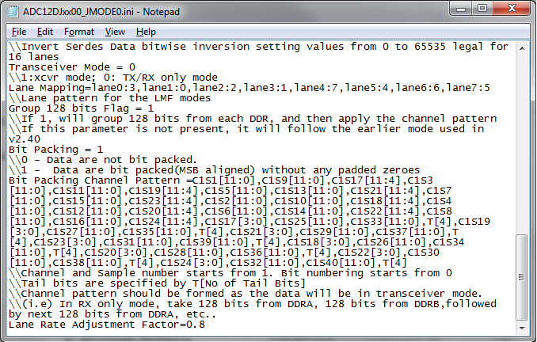

Parameters used by v1.0 DLL
ADC INI File for v1.0 contains two sections in the ini file : “[ADC]” and “[Version 1.0]”. Parameters in [ADC] section and all the parameters in [Version 1.0] section are used by the v1.0 DLL.

[ADC]
S/N | Parameter | Description
1 | Interface name="TSW14J57_FIRMWARE" | Firmware to be used for this device.
2 | Number of channels=1 | Number of ADC analog input channels.
3 | Channel Pattern=1 | Represents the channel pattern for decoding the data when the data is not bit packed(If data is bit packed, then “Bit Packing Channel Pattern” under “Version 1.0” section will be used). TSW14J57 Channel Pattern also supports sample reordering within a channel. Format is [Channel Number]-[Sample Number of Channel]  Eg: 1-2,2-2,1-1,2-1 when pattern is CH1 Sample2,CH2 Sample2, CH1 Sample1, CH2 Sample1. Sample reordered channel pattern(1-1,2-1,..) is optional, and only channel pattern(1,2,..) is required.
4 | Data Postprocessing=0 | For performing logical operations like 2’s complement etc.  operation:operand  \\operaion  \\0=bit shift  \\1=xor  \\2=and  \\3=or  \\4=not  \\operand  \\value(+ve if bitshift by right and -ve if bitshift by left)  \\Example 0:-2,1:1024  \\bitshift by left 2 times and then xor by 1024  \\ not function is applied to the entire data. The operand value is not used.
5 | Number of Bits=12 | ADC resolution (12bit,14bit, 16bit etc)
6 | Max sample Rate=740000000 | Maximum ADC sampling frequency. If exceeds, warns the user, but allows him to continue capture after confirmation.
7 | Min sample Rate=10000000 | Minimum ADC sampling frequency. If goes below the minimum sampling frequency, warns the user, but allows him to continue capture after confirmation.
8 | Register_Config="-" | Parameter to write to custom registers of TSW14J57.  Eg: Register_Config="0x400D0:0x04:4,0x400F0:0:4"  Format = [Register Address]:[Register Value]:[Number of Bytes to be sent as, which is the register size in bytes]  All the 3 values in the above format supports entries in both decimal(just the number) and hexadecimal(prefixed with 0x).  Multiple registers can be specified separated by comma.
9 | DLL Version=1.0 | (Required)Needs to be specified as 1.0
10 | Menu Enable="Trigger Option" | (Optional) This parameter is used to over-ride the menu disable settings of the board, for the current device. The menu names specified here will be enabled for the current device.
11 | Menu Disable="Number of Channels" | (Optional) This parameter is used to over-ride the menu enable settings of the board, for the current device. The menu names specified here will be disabled for the current device.
12 | Read EVM Setup Procedure = "EVM Setup Procedure not available" | Any specific procedure that needs to be followed for setting up the EVM
13 | Channel Display Names = Channel 1,Channel 2 | (Optional) Specify the Custom Channel names here. If this parameter is not present, then it uses the default Channel names
14 | GUI Channels to Disable = 1,3,5 | (Optional) Specify the Channel numbers which are to be disabled when the device is selected
15 | Y Scale Voltage Range=-2V to 2V | (Optional) Specify the Voltage range for the Time domain graph Y axis here. The Y axis can be displayed in Voltage by enabling the menu ‘Y Scale in Voltage’  By default, the range will be from -2V to 2V
16 | Max FFT Analysis Window Size = 1048576 | (Optional) Sets the Maximum FFT Analysis Window Size. By default it is 524288
17 | Mixer Type =0 | (Optional)This parameter takes  0-> Straight Mixer - Default - (Fout=Fin+NCO)  1-> Down Mixer (Fout=Fin-NCO)  This parameter will come into effect when Additional device parameters section is enabled. Based on this parameter value, the NCO will be added or subtracted from Fin to get Fout. The Fout will be used as the Input Target frequency in all the calculations.  Based on the parameter value, the formula to find Fout will be displayed near to NCO control in Additional Device Parameters popup.
18 | Transport Layer Ratio=0.5 | (Optional) This is a multiplication factor used in Lane rate calculation to make adjustments to the lane rate. This parameter will override the “Lane Rate Adjustment Factor” parameter.  This is applicable for all device INIs.  With this parameter, the Lane rate equation will become,  Lane Rate = N'(Fs)(10)(No Of Channels)( Transport Layer Ratio)/(L*8)  This parameter can take floating point numbers like 0.2, 0.73, 1.2..etc. This value gets multiplied to the lane rate and gives the effective Lane Rate for HSDC Pro to use.  By default, Transport Layer Ratio factor value is 1. This is Device ini driven.
19 | Skip Reconfig=1 | When this parameter is set to 1 in the ini file, it skips the reconfiguration. Please note that at least one ADC capture must be done using the similar INI file with this parameter not added or set to zero. This is to configure the FPGA once with the selected ADC INI file.
20 | Enable Individual Lane Inversion = 1 | If this parameter is set to 1 then the value of 'Invert Serdes Data' ini parameter will behave as numeric value with each bit corresponding to each physical lane inversion and the maximum allowed value is 65535. If this parameter is not present or set to zero then value of 'Invert Serdes Data' is used as binary value to enable/disable inversion for all lanes.
21 | Skip Pll Reconfig = 1 | Skips the reconfiguration of the IOPLL that produces Lane rate/40 clock.
22 | Skip Phy Reconfig = 1 | Skips the reconfiguration of the PHY module
23 | Number of Thresholds for CER = 10 | This parameter enables the mentioned number of thresholds. In the mentioned example, 10 thresholds will be enabled in the CER Testing popup. Default value : 5. This is supported only in TSW14J57revD currently.
24 | Read Sync Details = TRUE | This parameter when set to True in the ini, reads the Sync Details in CER Testing when the test is running. Default Value: False. This is supported only in TSW14J57revD currently.
25 | CER Autolog= True | Enables the CER auto logging feature. The log file will be generated in the board details folder with the name, 'CER_Log_%TimeStamp%'. A new file is created everytime 'Start test' is pressed. If "CER Log Interval(minutes)" parameter is not present or is set to -1 in the ini file, the CER and Sync data is logged only when 'Stop Test' is pressed. Default Value: False
26 | CER Log Interval(minutes)= 60 | This parameter indicates the time interval(in minutes) for which the logging should be performed. The parameter, "CER Log Interval(minutes)" also supports fractional values. Eg: To set the logging interval to 6 seconds, "CER Log Interval(minutes)" should be set to 0.1 in the device ini file. If this parameter is set to -1 the CER and Sync data is logged only when 'Stop Test' is pressed. This parameter has no effect if "CER Autolog" is set to False. Default Value: -1
27 | CER ADC Mode = 1 | This value is written to the 0x8001C register before writing the ‘No. of Samples per cycle’ to the firmware
28 | CER Samples Per Clock Divider = 40 | ‘No. of Samples per cycle’ control in the CER popup can be only a multiple of this parameter. If a non multiple of this parameter is entered in the ‘No. of Samples per cycle’ then HSDC Pro coerces the value of the ‘No. of Samples per cycle’ to the next higher multiple
29 | CER Debug Capture = True | Enables the option in CER Popup to perform Debug Capture
30 | JESD PHY IP FIFO1 Bit Packing Pattern = C1S1[15:0],C1S2[15:0],C2S1[15:0],C2S2[15:0],C3S1[15:0],C3S2[15:0],C4S1[15:0],C4S2[15:0],C5S1[15:0],C5S2[15:0],C6S1[15:0],C6S2[15:0],C7S1[15:0],C7S2[15:0],C8S1[15:0],C8S2[15:0],C9S1[15:0],C9S2[15:0],C10S1[15:0],C10S2[15:0],C11S1[15:0],C11S2[15:0],C12S1[15:0],C12S2[15:0],C13S1[15:0],C13S2[15:0],C14S1[15:0],C14S2[15:0],C15S1[15:0],C15S2[15:0],C16S1[15:0],C16S2[15:0] | Bit packing pattern for the FIFO1 data captured in PHY IP mode using CER Debug Capture option. Every sample is written as U16. (Since it is written as U16, bitpacking pattern cannot have a sample like C1S1[16:0] or C1S1[31:0]. If a sample is given as C1S1[11:0] and no other occurrence of C1S1 in bit packing pattern, 4 additional zeros will be appended to this 12 bit sample and it will be written as U16 to the bin file)
31 | JESD PHY IP FIFO2 Bit Packing Pattern = C8S1[3:0],C7S1[3:0],C6S1[3:0],C5S1[3:0],C4S1[3:0],C3S1[3:0],C2S1[3:0],C1S1[3:0],C16S1[3:0],C15S1[3:0],C14S1[3:0],C13S1[3:0],C12S1[3:0],C11S1[3:0],C10S1[3:0],C9S1[3:0] | Channel pattern for the FIFO2 data captured in PHY IP mode using CER Debug Capture option. Every sample is written as U32. (Since it is written as U32, bitpacking pattern cannot have a sample like C1S1[32:0] or C1S1[63:0]. If a sample is given as C1S1[27:0] and no other occurrence of C1S1 in bit packing pattern, 4 additional zeros will be appended to this 28 bit sample and it will be written as U32 to the bin file)
32 | JESD Base IP FIFO1 Bit Packing Pattern = C1S1[15:0],C1S2[15:0],C2S1[15:0],C2S2[15:0],C3S1[15:0],C3S2[15:0],C4S1[15:0],C4S2[15:0],C5S1[15:0],C5S2[15:0],C6S1[15:0],C6S2[15:0],C7S1[15:0],C7S2[15:0],C8S1[15:0],C8S2[15:0],C9S1[15:0],C9S2[15:0],C10S1[15:0],C10S2[15:0],C11S1[15:0],C11S2[15:0],C12S1[15:0],C12S2[15:0],C13S1[15:0],C13S2[15:0],C14S1[15:0],C14S2[15:0],C15S1[15:0],C15S2[15:0],C16S1[15:0],C16S2[15:0] | Channel pattern for the FIFO1 data captured in Base IP mode using CER Debug Capture option. Every sample is written as U16. (Since it is written as U16, bitpacking pattern cannot have a sample like C1S1[16:0] or C1S1[31:0]. If a sample is given as C1S1[11:0] and no other occurrence of C1S1 in bit packing pattern, 4 additional zeros will be appended to this 12 bit sample and it will be written as U16 to the bin file)
33 | JESD Base IP FIFO2 Bit Packing Pattern = C1S1[31:0],T[32] | Channel pattern for the FIFO2 data captured in Base IP mode using CER Debug Capture option. Every sample is written as U32. (Since it is written as U32, bitpacking pattern cannot have a sample like C1S1[32:0] or C1S1[63:0]. If a sample is given as C1S1[27:0] and no other occurrence of C1S1 in bit packing pattern, 4 additional zeros will be appended to this 28 bit sample and it will be written as U32 to the bin file)
34 | FTLO FIFO1 Bit Packing Pattern = C1S5[7:0],C1S3[11:0],C1S1[11:0],C1S11[3:0],C1S9[11:0],C1S7[11:0],C1S5[11:8],C1S15[11:0],C1S13[11:0],C1S11[11:4],C1S21[7:0],C1S19[11:0],C1S17[11:0],C1S27[3:0],C1S25[11:0],C1S23[11:0],C1S21[11:8],C1S31[11:0],C1S29[11:0],C1S27[11:4],C1S37[7:0],C1S35[11:0],C1S33[11:0],C1S4[3:0],C1S2[11:0],C1S39[11:0],C1S37[11:8],C1S8[11:0],C1S6[11:0],C1S4[11:4],C1S14[7:0],C1S12[11:0],C1S10[11:0],C1S20[3:0],C1S18[11:0],C1S16[11:0],C1S14[11:8],C1S24[11:0],C1S22[11:0],C1S20[11:4],C1S30[7:0],C1S28[11:0],C1S26[11:0],C1S36[3:0],C1S34[11:0],C1S32[11:0],C1S30[11:8],C1S40[11:0],C1S38[11:0],C1S36[11:4],T[32] | Channel pattern for the FIFO1 data captured in Formatted Transport Layer Output mode using CER Debug Capture option. Every sample is written as U16. (Since it is written as U16, bitpacking pattern cannot have a sample like C1S1[16:0] or C1S1[31:0]. If a sample is given as C1S1[11:0] and no other occurrence of C1S1 in bit packing pattern, 4 additional zeros will be appended to this 12 bit sample and it will be written as U16 to the bin file)

[Version 1.0]

S/N | Parameter | Description
1 | JESD IP Core_CS=1 | Number of extra bits padded in a sample to make it 16 bits. CS = NTotal – Number Of Bits. NTotal is 16.
2 | JESD IP Core_F=1 | Number of octets(bytes) Per Frame. Value should be less than or equal to 8.
3 | JESD IP Core_HD=1 | High Density format (0 or 1)
4 | JESD IP Core_K=32 | Number of frames per multiframe. (F * K) value should be multiple of 4, and <= 32. (F * K) value should also match with the (F’ * K’), where F’ and K’ are the corresponding values configured in the ADC device.
5 | JESD IP Core_L=8 | No. of lanes per converter device (link). Maximum is 8.
6 | JESD IP Core_M=4 | No. of converters per device.
7 | JESD IP Core_N=16 | Converter resolution i.e. Number of bits in sample.
8 | JESD IP Core_NTotal=16 | Total no. of bits per sample. NTotal should be 16. NTotal = N + CS
9 | JESD IP Core_S=1 | Number of Samples per Channel per Frame.
10 | JESD IP Core_SCR=1 | Scrambler enable(1) or disable(0). This setting should be same as the configuration in the device GUI.
11 | JESD IP Core_Tailbits=0 | Number of Tail bits present in the device.
12 | JESD IP Core_LaneSync=1 | Initial Lane Alignment Enable(1) or Disable(0). If enabled, TSW14J57 firmware will validate the ILA sequence after initial sync occurs. If ILA sequence is not validated, sync will not be set.
13 | JESD IP Core_Subclass=1 | Device Subclass Version. Use Value 1(Subclass 1).
14 | JESD IP Core_JESDV=1 | JESD204 Version. 0 – JESD204A, 1 – JESD204B. Use Value 1(JESD204B).
14 | MIF Config= 0.611G to 1.5G:RX:RX_PMA_x5,1.5G to 3.125G:RX:RX_PMA_x10,3.125G to 8G:RX:RX_PMA_x40 | The MIF file that needs to be streamed based on the lane rate calculated from ADC Output Data Rate.  Format :  [Lower Range] to [Higher Range]:RX:[MIF File Name]
15 | Fabric PLL Counter = 0.611G to 1.5G:0x080404,1.5G to 3.125G:0x080808,3.125G to 8G:0x080202 | Fabric PLL Register Value that needs to be written based on the lane rate calculated from ADC Output Data Rate.  Format :  [Lower Range] to [Higher Range]:[Fabric PLL Register Value]
16 | Invert Sync Polarity = 0 | JESD Configuration Register Values.
17 | Invert Serdes Data = 1 | JESD Configuration Register Values.
18 | Transceiver Mode = 0 | 0 – TX/RX Only Mode. 1 – Transceiver Mode
19 | Lane Mapping = lane0:0,lane1:1,lane2:2,lane3:3,lane4:4,lane5:5,lane6:6,lane7:7 | Physical SerDes lanes to Logical SerDes Lanes mapping for arranging the actual lane (physical) 0 to L-1 data from ADC to the FPGA’s lane (logical) 0 to L-1 data.  Eg: ‘Rx lane 0’ of ADC’s FMC conn is connected to ‘Rx lane 3’ of FPGA’s FMC conn then  “Lane Mapping=lane0:3”  Where,  ‘Lane0’ –logical lane 0 data input to FPGA’s JESD RX IP.  ‘:3’ –physical lane 3, which corresponds to the “RX3” on the FMC conn.
20 | Bit Packing = 1 | (Optional) Flag which specifies whether the data are bit packed(1) without any padded zeroes, or not(0). If data are bit packed, the channel pattern needs to be specified using “Bit Packing Channel Pattern” parameter.
21 | Bit Packing Channel Pattern = C1S1[11:0],C1S9[11:0],C1S17[11:4],C1S2[11:0],C1S10[11:0],C1S18[11:4],C1S3[11:0],C1S11[11:0],C1S19[11:4],C1S4[11:0],C1S12[11:0],C1S20[11:4],C1S5[11:0],C1S13[11:0],C1S21[11:4],C1S6[11:0],C1S14[11:0],C1S22[11:4],C1S7[11:0],C1S15[11:0],C1S23[11:4],C1S8[11:0],C1S16[11:0],C1S24[11:4],C1S17[3:0],C1S25[11:0],C1S33[11:0],T[4],C1S18[3:0],C1S26[11:0],C1S34[11:0],T[4],C1S19[3:0],C1S27[11:0],C1S35[11:0],T[4],C1S20[3:0],C1S28[11:0],C1S36[11:0],T[4],C1S21[3:0],C1S29[11:0],C1S37[11:0],T[4],C1S22[3:0],C1S30[11:0],C1S38[11:0],T[4],C1S23[3:0],C1S31[11:0],C1S39[11:0],T[4],C1S24[3:0],C1S32[11:0],C1S40[11:0],T[4] | (Optional) Channel Pattern when the data is bit packed. This parameter is not needed when the data is not bit packed. Example, C1S1[11:4],C1S2[11:4] specifies that in the 1st 16bit data read from DDR, the first 8 bits from MSB end, are from D11 to D4 bits of Channel 1, Sample 1, which is followed by D11 to D4 bits of Channel 1, Sample 2.
22 | Number of Channels for Lane Rate = 4 | (Optional)If this parmeter is present in ini file, DLL uses this parameter for lane rate calculation
23 | Is Capture Trigger SMA | (Optional) 0 - BUSY_Z (G16 on FMC) is Capture Trigger  1- SMA J3 is Capture Trigger
24 | Sysref Based Master Slave Trigger = 1 | (Optional) Master/Slave triggering with respect to SYSREF rising edge. In master mode (Software trigger in HSDC Pro behaves as Master Mode) the output trigger is generated at first rising edge of SYSREF and capture will automatically started at second rising edge. In case of slave triggering mode (Hardware trigger in HSDC Pro behaves as Slave Mode) the capture happens at the first SYSREF rising edge after the input trigger rising edge.  0- Disabled(Default – Normal Trigger Mode) 1-Enabled (Sysref Trigger Mode)
25 | LED Debug = 1 | (Optional) Provided for probing the following signals to the corresponding LEDs on board  D8-SYSREF  D7- Binary Channel Data (Data to FMC GPIO)  D6-FIFO write  D5- Trigger In  . 0- Disabled(Default) 1-Enabled  Note: User has to select the INI which has this parameter set and has to perform ‘Instrument Options -> Reset Board’, to make the D5-8 LEDs show the status of above signal, for every FPGA firmware download.
26 | Lane Rate Adjustment Factor=0.5 | This is a multiplication factor used in Lane rate calculation to make adjustments to the lane rate – used to account for any variations in lane rate. This is applicable for 14J57 RevB device INIs.  With this parameter, the Lane rate equation will become,  Lane Rate = N'(Fs)(10)(No Of Channels)(Lane Rate Adjustment Factor)/(L*8)  This parameter can take floating point numbers like 0.2, 0.73, 1.2..etc. This value gets multiplied to the lane rate and gives the effective Lane Rate for HSDC Pro to use.  By default, lane rate adjustment factor value is 1. This is Device ini driven.
27 | VOD Value =1 | (Optional)Sets the VOD Value. Will be set to Tx SerDes lanes only, for Rx it will not take any effect.
28 | Trigger Input Polarity Selection = 1 | (Optional) Sets the Trigger input polarity (trigger edge) that has to be taken as trigger edge.  1 – Rising Edge  0 – Falling Edge //0 - default
29 | Trigger Output Default State = 1 | (Optional) This is used to set default state of the Trigger output from the TRIG OUT SMAs (applicable for Software Trigger and SYSREF Based Master Trigger)  0 - active high 1-active low //1 - default
30 | Trigger Output Pulse Width = 40 | (Optional) Sets the ‘Software Trigger’ output pulse width, the number of frame clock cycles to assert the trigger before bringing the trigger back to the default state. Maximum possible pulse width is 256 frame clocks, since it is 8 bit field.

Channel Pattern Creation:

Channel Pattern
Lane0
Lane1
Lane2
Lane3
.
.
.
.
Lane n
FIFO
DDR
SPI / FX3 GPIF
DLL
Standard Byte Stream
[L0: '4' bytes ] [L1: '4' bytes ]
[L2: '4' bytes ]…[L ‘n’: '4' bytes ] [L0: '4' bytes ] [L1: '4' bytes ]
[L2: '4' bytes ]…[L ‘n’: '4' bytes ]
JESD/LVDS
Protocol & Transport layer

‘n’ – number of Lanes (in JESD)/wires (in LVDS)

The data that are read by TSW14J57 DLL from the DDR will be like 4 bytes from Lane 0, 4 bytes from Lane 1, 4 bytes from Lane 2,….,4 bytes from Lane n. Irrespective of number of bits in a sample, it will read 4 bytes(32 bits) from each lane as shown in the below table,

Lane 0 | A0 | A1 ① | A2 | A3 ⑤
Lane 1 | B0 | B1 ② | B2 | B3 ⑥
Lane 2 | C0 | C1 ③ | C2 | C3 ⑦
Lane 3 | D0 | D1 ④ | D2 | D3 ⑧

The Channel pattern for the above case (where each sample is 16 bit) would be like

- [4 bytes from Lane 0], [4 bytes from Lane 1], [4 bytes from Lane 2], [4 bytes from Lane 3], [4 bytes from Lane 0], [4 bytes from Lane 1], [4 bytes from Lane 2], [4 bytes from Lane 3],… repeats

- A0,A1,B0,B1,C0,C1,D0,D1,A2,A3,B2,B3,C2,C3,D2,D3

Channel pattern in the INI can be represented in any of the following forms,
- Channel numbers E.g.: 1,2,1,2 where pattern is CH1 Sample1, CH2 Sample1, CH1 Sample2, CH2 Sample2
- Channel and Sample numbers (i.e. [Channel number] – [Sample number of Channel]) Eg: 1-2,2-2,1-1,2-1 when pattern is CH1 Sample2,CH2 Sample2, CH1 Sample1, CH2 Sample1.

Note: Channel and Sample numbers will be used if the Samples read are not in an order for each Channel.

Channel Pattern for the above diagram with only Channel numbers,

- 1,1,2,2,3,3,4,4,1,1,2,2,3,3,4,4 or 1,1,2,2,3,3,4,4 (since the same pattern is repeated)

Channel Pattern for the above diagram with Channel and Sample numbers, (useful when samples are swapped in order)

- 1-1,1-2,2-1,2-2,3-1,3-2,4-1,4-2,1-3,1-4,2-3,2-4,3-3,3-4,4-3,4-4 or 1-1,1-2,2-1,2-2,3-1,3-2,4-1,4-2

Example:

ADC12J4000_D10_SDR:

Lane Mapping Diagram:
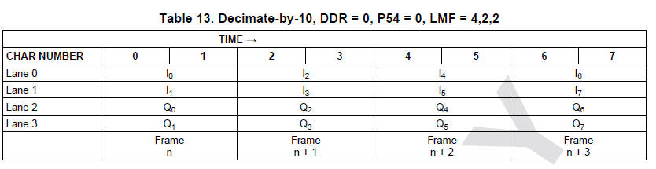

Representing the above Lane Mapping diagram in Channel & Sample numbers,

Lane0 | 1-1 | 1-3 ① | 1-5 | 1-7 ⑤
Lane1 | 1-2 | 1-4 ② | 1-6 | 1-8 ⑥
Lane2 | 2-1 | 2-3 ③ | 2-5 | 2-7 ⑦
Lane3 | 2-2 | 2-4 ④ | 2-6 | 2-8 ⑧

The final Channel Pattern would be 1-1,1-3,1-2,1-4,2-1,2-3,2-2,2-4,1-5,1-7,1-6,1-8,2-5,2-7,2-6,2-8

Bit Packing Channel Pattern Creation:

Bit Packing Channel Pattern will be used when the data is bit packed. For Example, C1S1[11:4],C1S2[11:4] specifies that in the 1st 16bit data read from DDR, the first 8 bits from MSB end, are from D11 to D4 bits of Channel 1, Sample 1, which is followed by D11 to D4 bits of Channel 1, Sample 2.

Example:

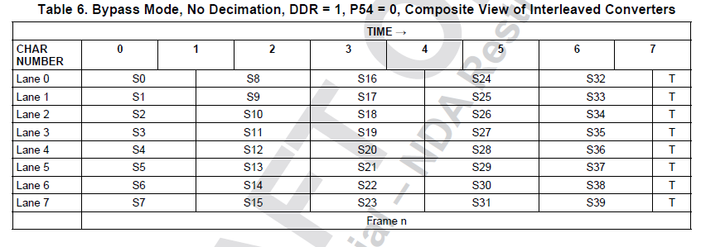

Bit Packing Channel Pattern = [4 bytes from Lane 0], [4 bytes from Lane 1], [4 bytes from Lane 2], [4 bytes from Lane 3], [4 bytes from Lane 4], [4 bytes from Lane 5], [4 bytes from Lane 6], [4 bytes from Lane 7], [4 bytes from Lane 8]

4 bytes in each lane are combined in the below table for the above Lane Mapping diagram,

 | 0,1,2,3 | 4,5,6,7
Lane 0 | C1S1[11:0],C1S9[11:0],C1S17[11:4] | C1S17[3:0],C1S25[11:0],C1S33[11:0],T[4]
Lane 1 | C1S2[11:0],C1S10[11:0],C1S18[11:4] | C1S18[3:0],C1S26[11:0],C1S34[11:0],T[4]
Lane 2 | C1S3[11:0],C1S11[11:0],C1S19[11:4] | C1S19[3:0],C1S27[11:0],C1S35[11:0],T[4]
Lane 3 | C1S4[11:0],C1S12[11:0],C1S20[11:4] | C1S20[3:0],C1S28[11:0],C1S36[11:0],T[4]
Lane 4 | C1S5[11:0],C1S13[11:0],C1S21[11:4] | C1S21[3:0],C1S29[11:0],C1S37[11:0],T[4]
Lane 5 | C1S6[11:0],C1S14[11:0],C1S22[11:4] | C1S22[3:0],C1S30[11:0],C1S38[11:0],T[4]
Lane 6 | C1S7[11:0],C1S15[11:0],C1S23[11:4] | C1S23[3:0],C1S31[11:0],C1S39[11:0],T[4]
Lane 7 | C1S8[11:0],C1S16[11:0],C1S24[11:4] | C1S24[3:0],C1S32[11:0],C1S40[11:0],T[4]

Final Bit Packing Channel Pattern would be,

C1S1[11:0],C1S9[11:0],C1S17[11:4],C1S2[11:0],C1S10[11:0],C1S18[11:4],C1S3[11:0],C1S11[11:0],C1S19[11:4],C1S4[11:0],C1S12[11:0],C1S20[11:4],C1S5[11:0],C1S13[11:0],C1S21[11:4],C1S6[11:0],C1S14[11:0],C1S22[11:4],C1S7[11:0],C1S15[11:0],C1S23[11:4],C1S8[11:0],C1S16[11:0],C1S24[11:4],C1S17[3:0],C1S25[11:0],C1S33[11:0],T[4],C1S18[3:0],C1S26[11:0],C1S34[11:0],T[4],C1S19[3:0],C1S27[11:0],C1S35[11:0],T[4],C1S20[3:0],C1S28[11:0],C1S36[11:0],T[4],C1S21[3:0],C1S29[11:0],C1S37[11:0],T[4],C1S22[3:0],C1S30[11:0],C1S38[11:0],T[4],C1S23[3:0],C1S31[11:0],C1S39[11:0],T[4],C1S24[3:0],C1S32[11:0],C1S40[11:0],T[4]

