- Remove R575 and R576 that are on the bottom of the board.

- Install 10 Ohm resistors for R577 and R578, part number ERJ-2RKF10R0X from Panasonic. These are near U16 on the top side.

- Replace R482 with a 16.2K resistor, part number ERJ-2RKF1622X from Panasonic. This is near U16 on the top side.

- L11 modification
Some boards may not have the change that was required to be made for L11. This is the old part and should be replaced. This part is located on the top side of the board.

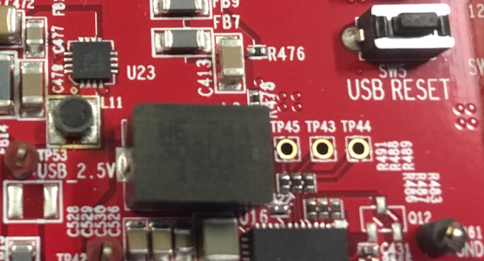

Below is the correct part. This is a XFL4020-222ME_2.2uH inductor from Coilcraft.

