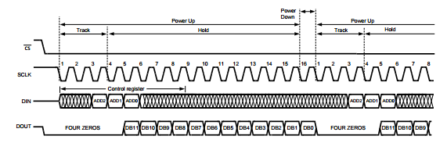

Is this DOUT for address “000”?

ADD2,ADD1,ADD0 = 000

ffjjjj