- To use the trigger on TSW14J56 RevB board we need to do couple of modification on the board as listed below,
  - Remove R241
  - Remove R242
  - Replace C61 with ‘0’ ohm resistor
- ‘REF_OSC_IN’ is the SMA connector to be used to provide the Trigger input/output.
- Add the following Parameter to the INI in section called [ADC] in case of ADC device or [DAC] in case of DAC device,
Menu Enable = “Trigger Option”
- Now open HSDC Pro and connect to the J56 board and select the device.
- In HSDC Pro, enable the Trigger Mode from the menu option (Data Capture Options -> Trigger Option). This will configure the current TSW14J56 as a slave.
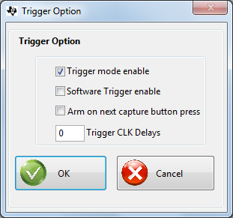
6) The Firmware will be armed and waiting for trigger

