In TSW14J56revD, the trigger edge for data capture is falling edge by default. But it can be configured to either rising or falling edge by adding an INI parameter

Process to add INI parameter:

1. ADC INI file will be available in the following path-
[HSDC Pro Installed path]\High Speed Data Converter Pro\14J56revD Details\ADC files
Default path: C:\Program Files (x86)\Texas Instruments\High Speed Data Converter Pro\14J56revD Details\ADC files

2. Add the ini parameter "Trigger Input Polarity Selection" below the JESD IP Core parameters in ini file (a sample screen shot shown below).
Trigger edge can be configured to rising edge by setting value ‘1’ to the parameter.

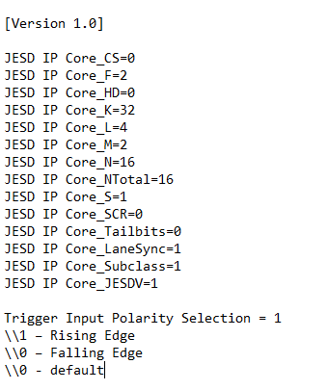

The delay between trigger edge sampling and start of data capture is also configurable in HSDC Pro GUI.
In the “Trigger Options” Menu we can set the “Trigger CLK Delays” as required

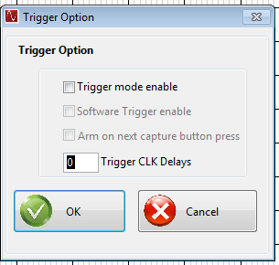

Total delay between trigger edge and data capture= Trigger CLK Delays + Waiting time for the first SOMF (start of multi-frame) in firmware

Trigger CLK Delays are in-terms of JESD link clocks that can be delayed whose frequency is (Lane Rate)/40

