Test condition: Power on when we not touch the screen, IC work normal
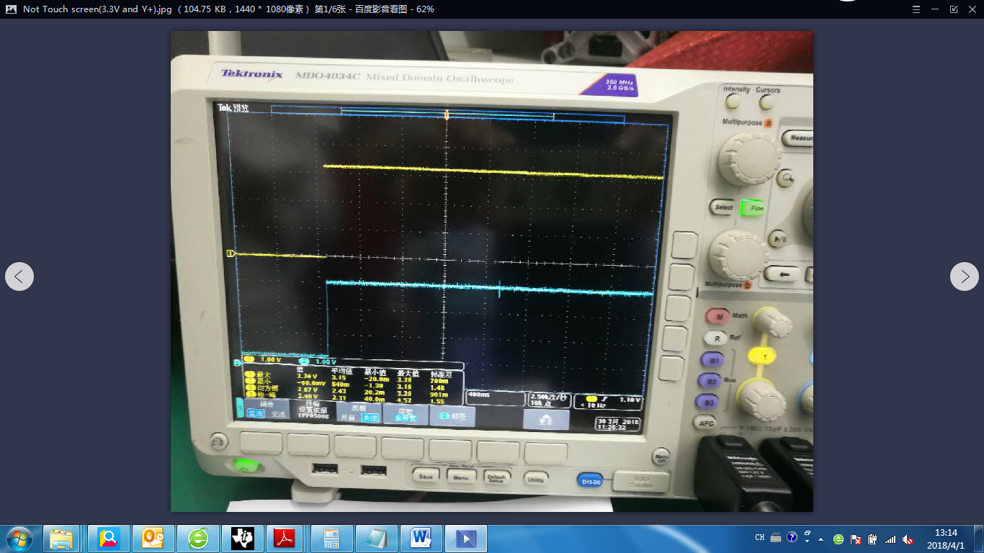
CH1: 3.3V power. CH2: Y+ input

Test condition: Power on when we touch the screen, IC does not work
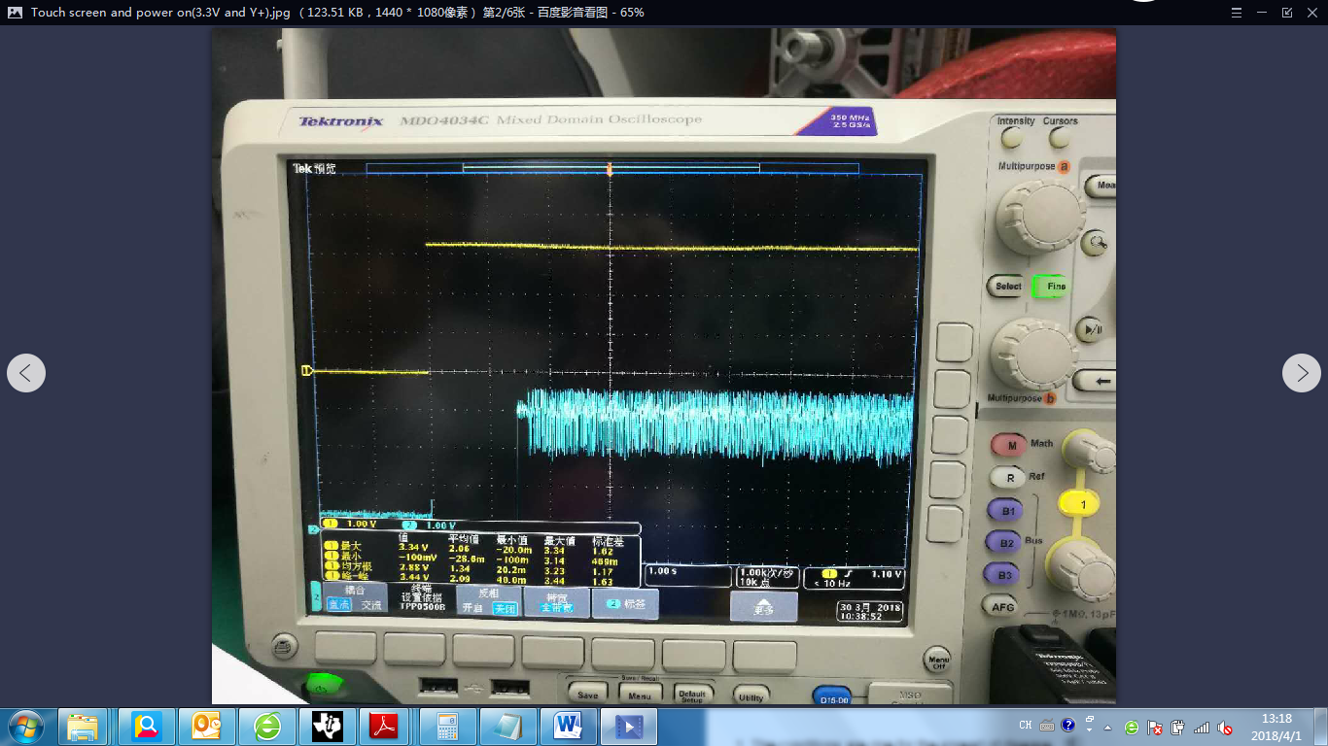
CH1: 3.3V power. CH2: Y+ input

