After afe4404evm upgrade firmware from 1.3 to 1.5, GUI shows unable to connect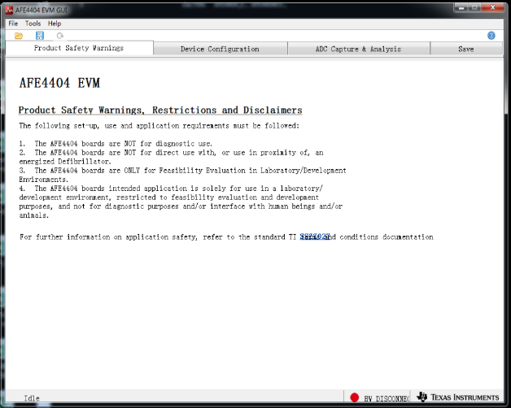

After the firmware upgrade, the display is as follows:
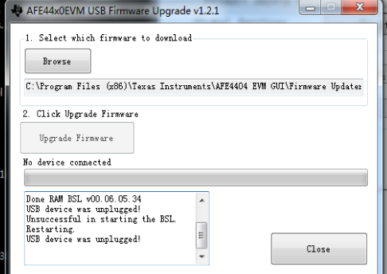

Then it fails to connect, the AFE44xx EVM (COM3) is no longer shown in the device manager, but HID-compliant device and USB input device
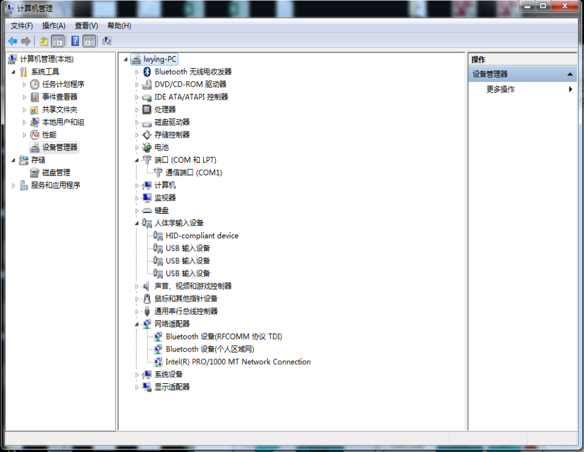

Pressing SW2 doesn't work, doesn't fix the problem

When it can be connected normally, after the 4404 is connected to the computer, the sensor’s LEDs flash, the LED1 on the 4404 development board is always on, and the LED2 and LED3 can be seen flashing when connected.
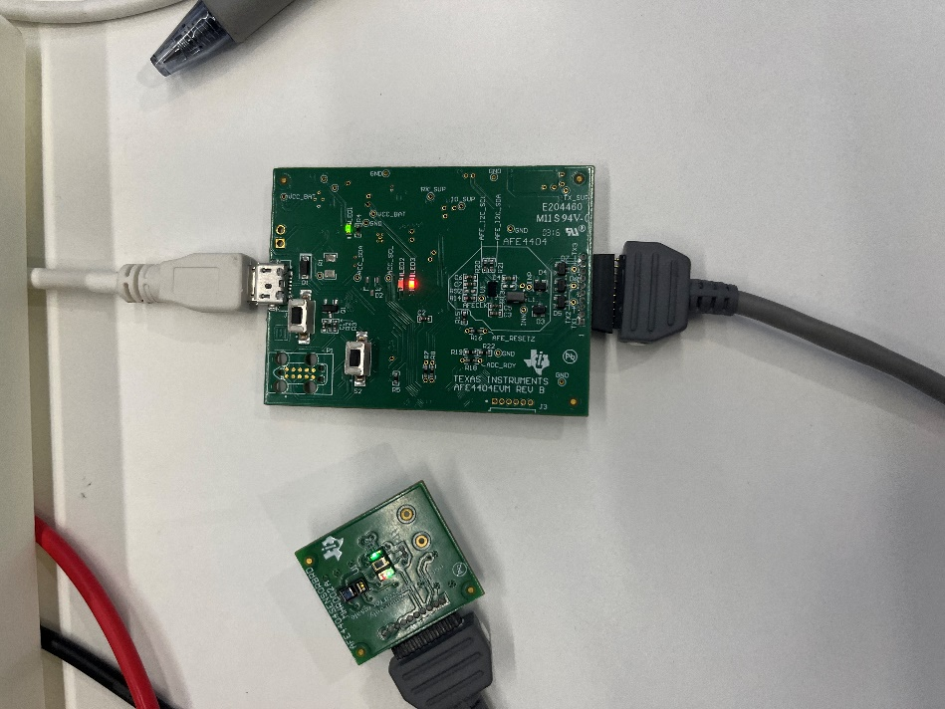

However, after the firmware upgrade, the sensor’s LEDs don’t flash, the LED1 on the 4404 development board is always on, and the LED2 and LED3 do not flash when connected.
