We can encrypt the source code (.m files) into p-code (.p files).

The p-code files run exactly in same fashion as source code.

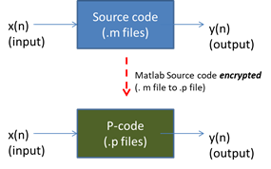

Like for .m file, the .p files also need Matlab to run.

We can provide .p file to customer