Green trace: PMT output with a bit less gain to see both signal and EMI from trigger cable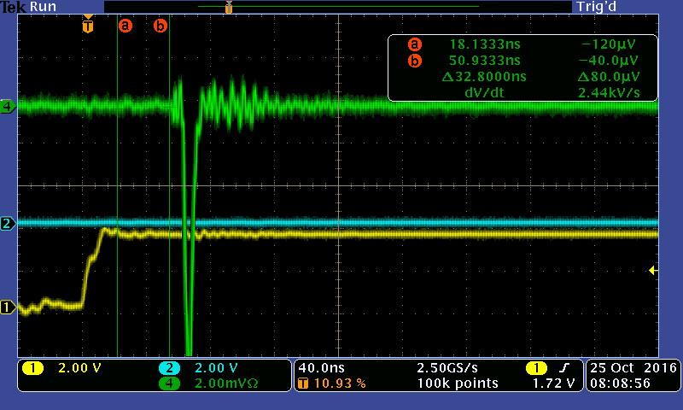

Larger signal from PMT plus coupled noise

