Device: DAC8580IPW ---Texas Instruments Digital to Analog Converters – DAC

Power Sequence:

SDIN(pin9)vs3.3V



From: **TI E2E support forums - Automated email** <[noreply@mail.e2e.ti.com](mailto:noreply@mail.e2e.ti.com)>  
Date: 2019年11月19日(火) 15:38  
Subject: DAC8580: Question about DAC8580 Data-Sheet  
To: user6188735 <[nishitani@ndr.co.jp](mailto:nishitani@ndr.co.jp)>

**A Message from the TI E2E™ support forums**

[user6188735](http://e2e.ti.com/members/6188735)

**Part Number:** DAC8580

1.

By DAC8580　Data-Sheet

P13, [During power up, all digital inputs and the reference input should be kept at zero volts. 　　If any pin is brought high before the power supplies, overvoltage protection circuitry turns on.]  
  
About item mentioned above, Which is target of power-pin?

DVvdd (+3.3V)　AVdd (+5V)　AVss (-5V)　all?  
DVdd (+3.3V) only?  
  
2.

In the case of our products (Industrial control-board)

1st step:   DVdd (+3.3V)  go from 0V to +3.3V

2nd step:  At nearly same-time of 1st step, Digital input (SDIN SDCLK OSR1 OSR2　・・・)   go to +3.3V, by 25kohm pull-up.

3rd step:  After 50msec delay, AVdd (+5V)　AVss (-5V)  go to +5V, -5V.

Is there something wrong?

Overvoltage protection circuit turn-on?

SDIN(pin9)vs+5V_A



SDIN(pin9)vs-5V_A



Schematic:

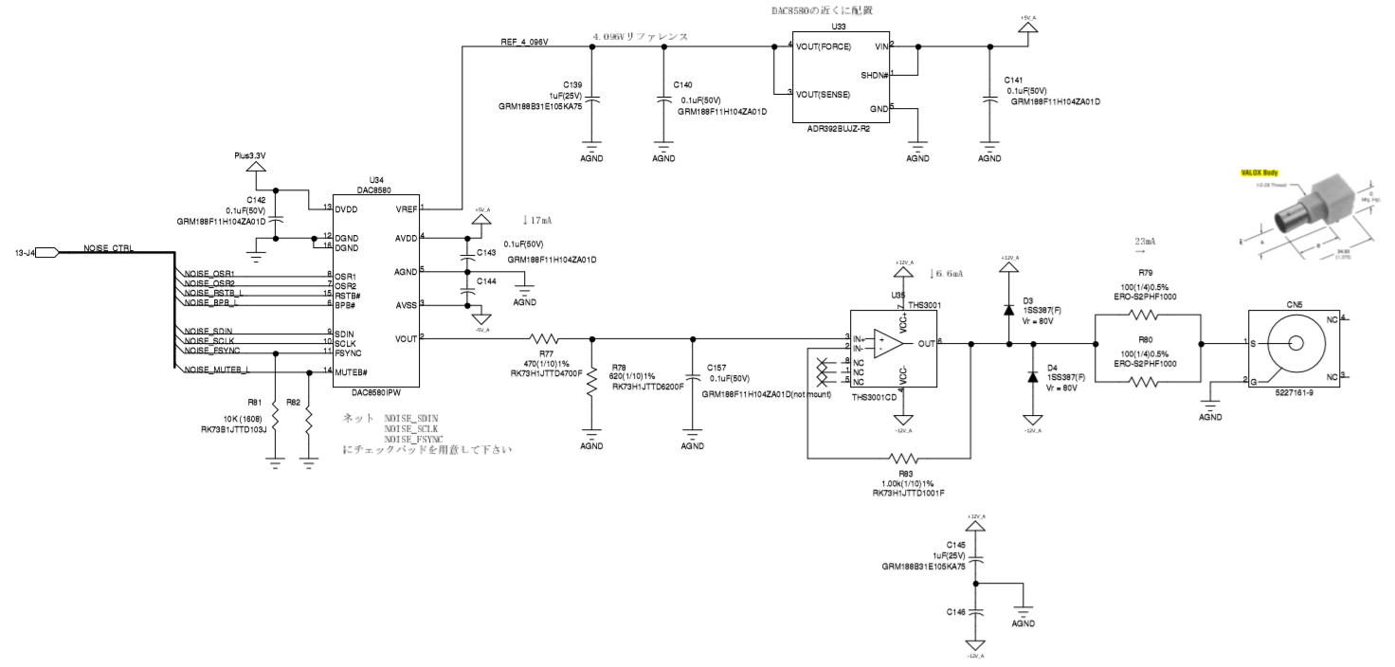

Note Digital control from FPGA ep2c15af484c8

END