1, power on the DAC38RF82EVM
2, start the EVM GUI
3, reset DAC
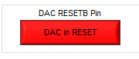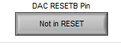
4, load Local.6144MSPS_4x_LMF_821.cfg
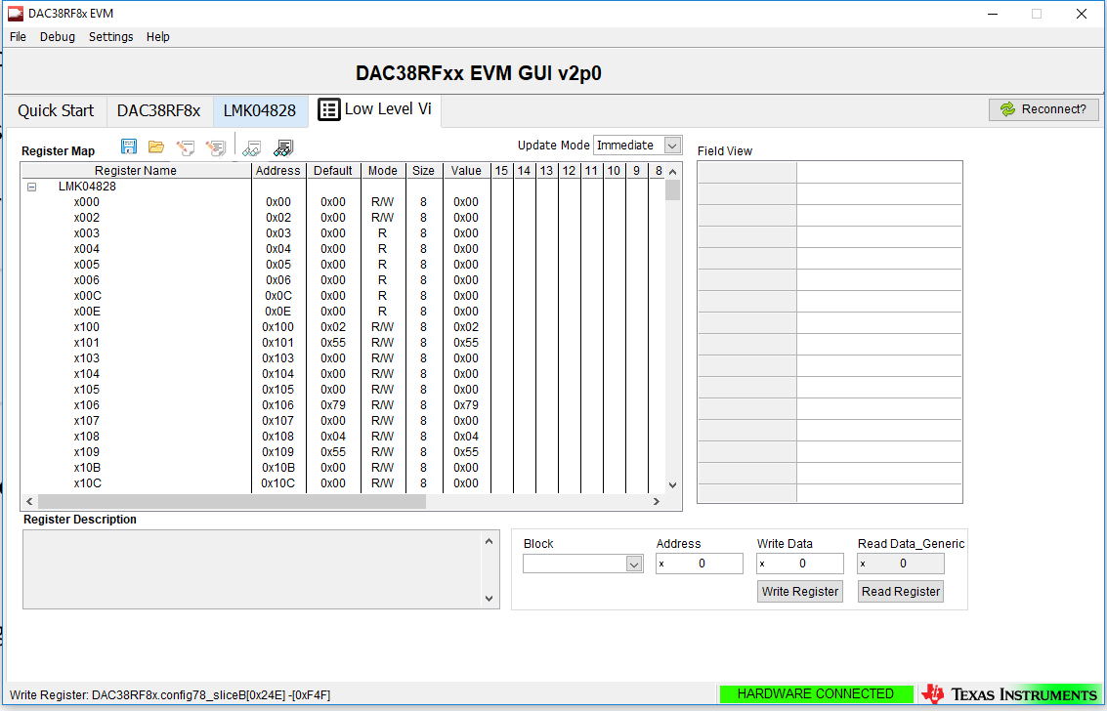
5, go through the settings
5.1 in quick start, setup PLL and DAC mode and click 
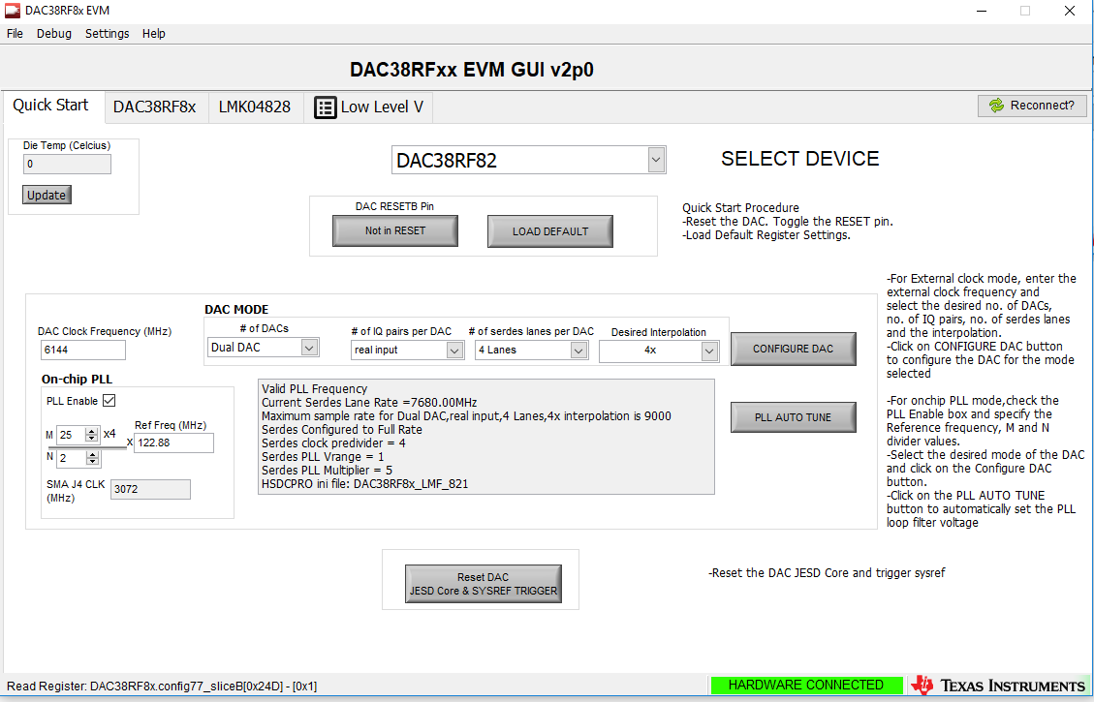
5.2 click 
5.3 check DAC PLL
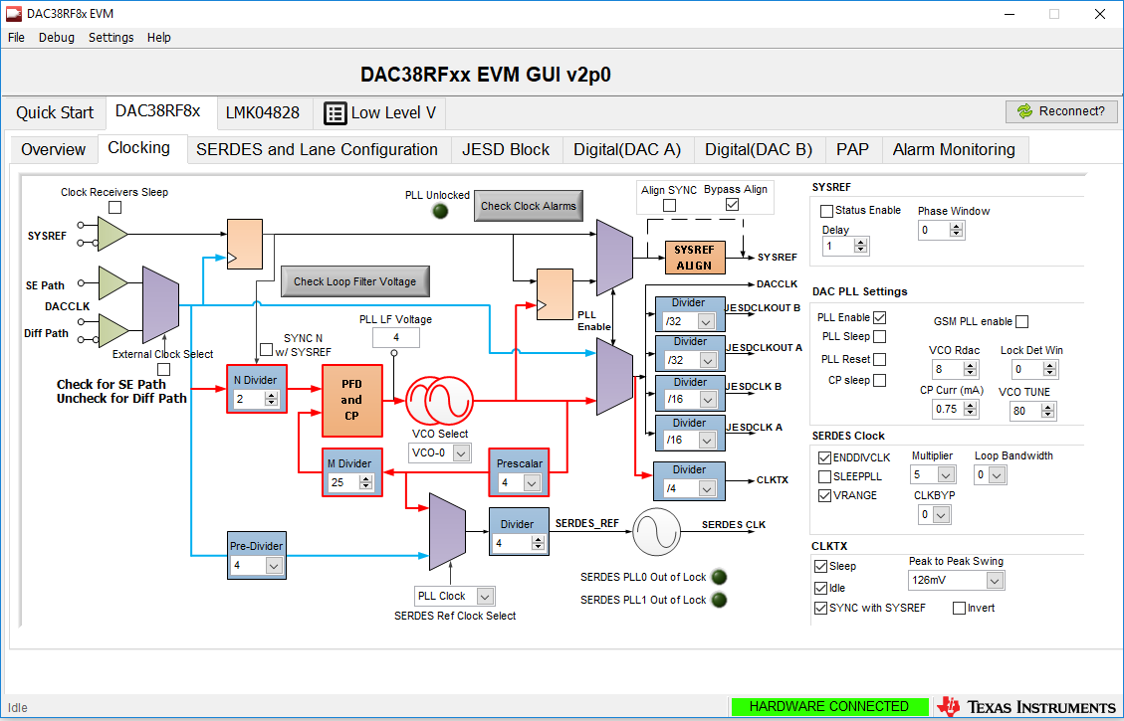
5.4 go through settings
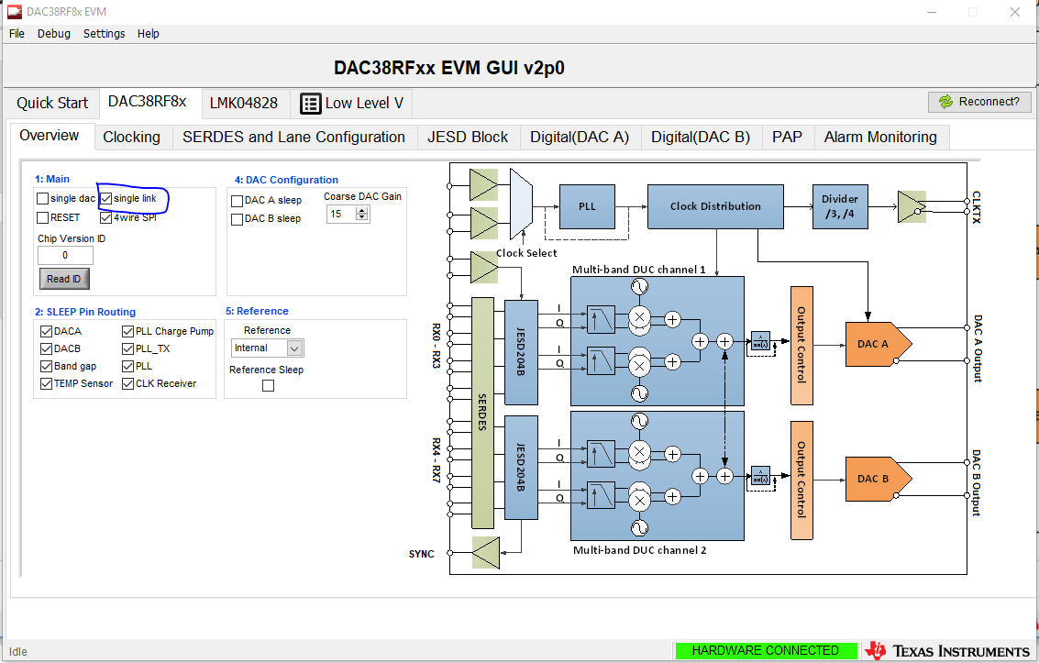
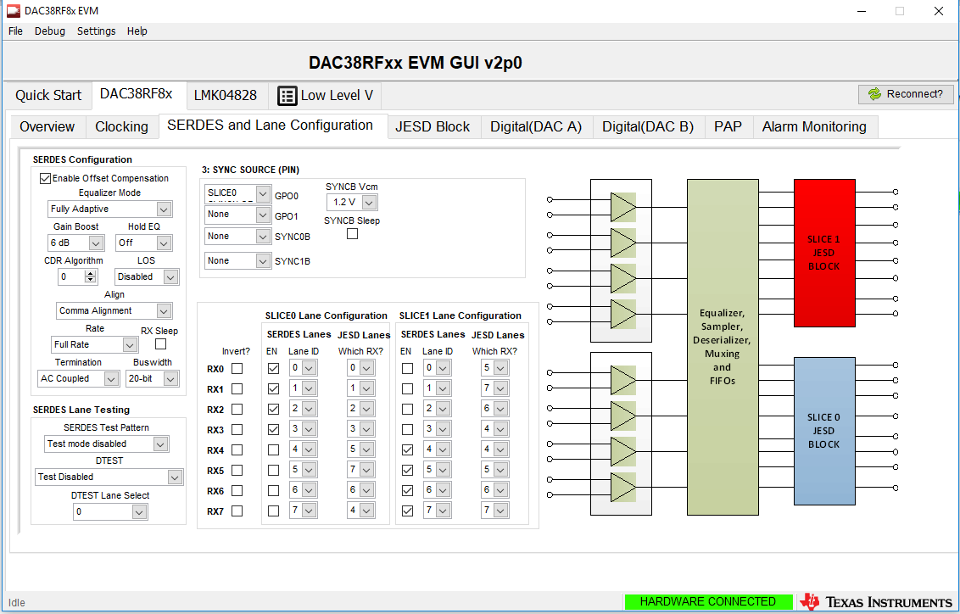
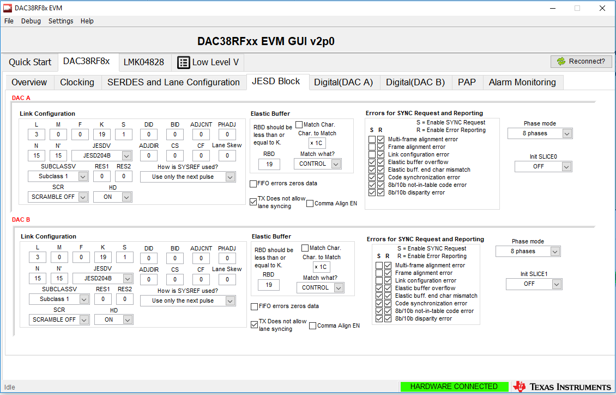
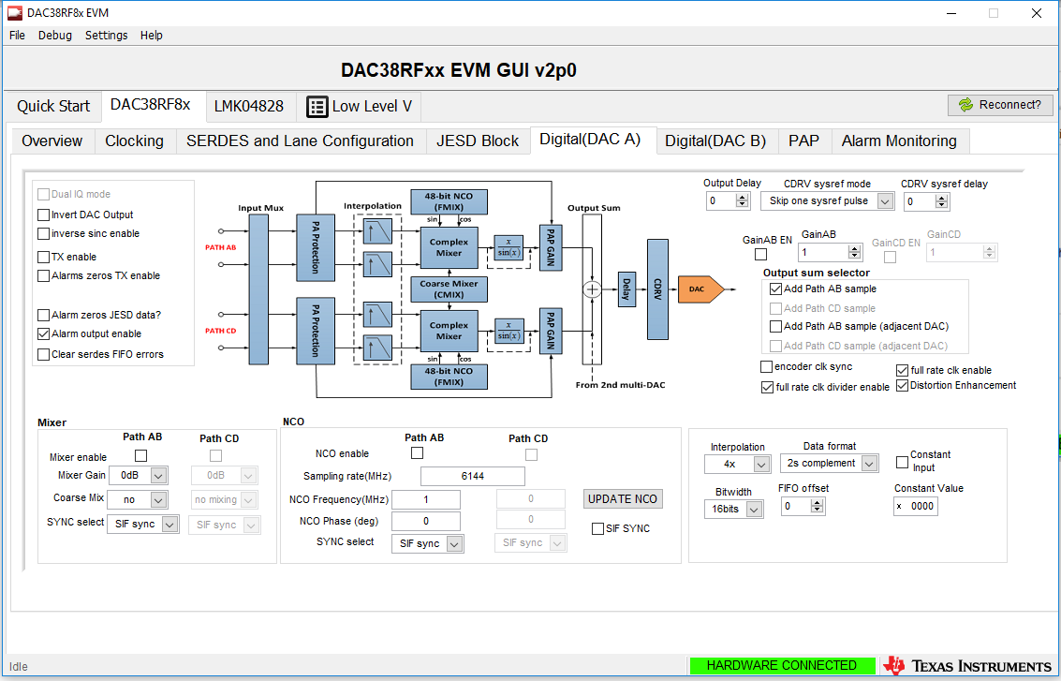
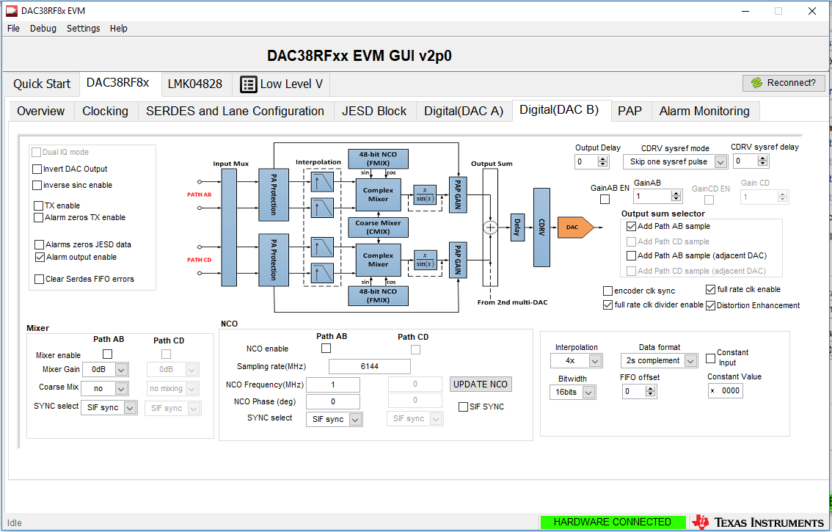
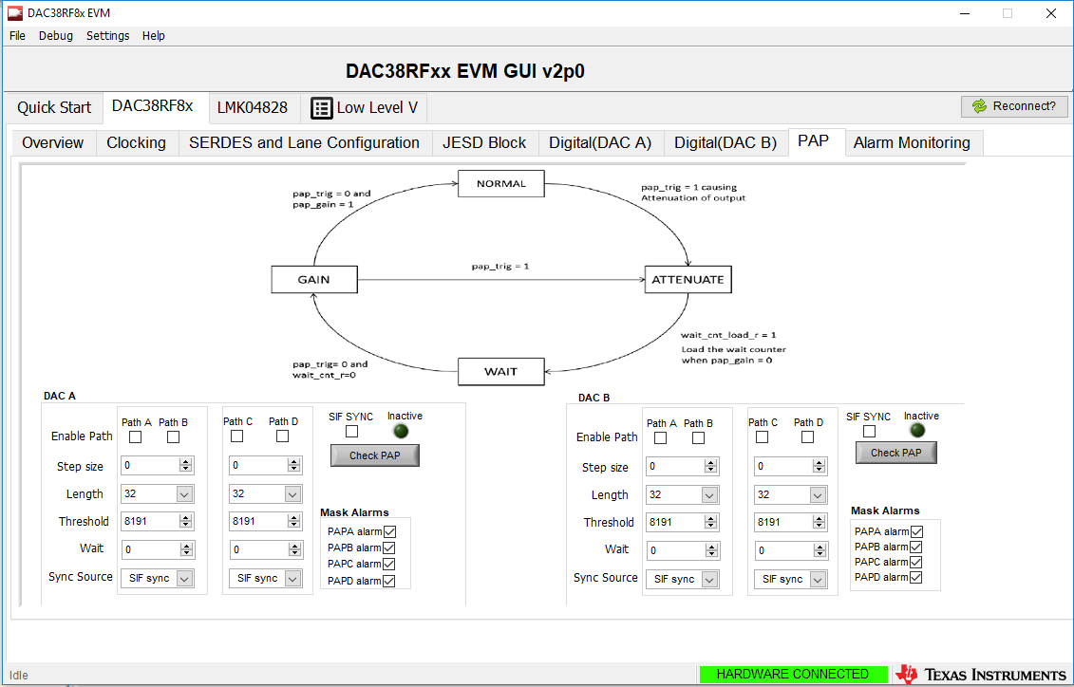
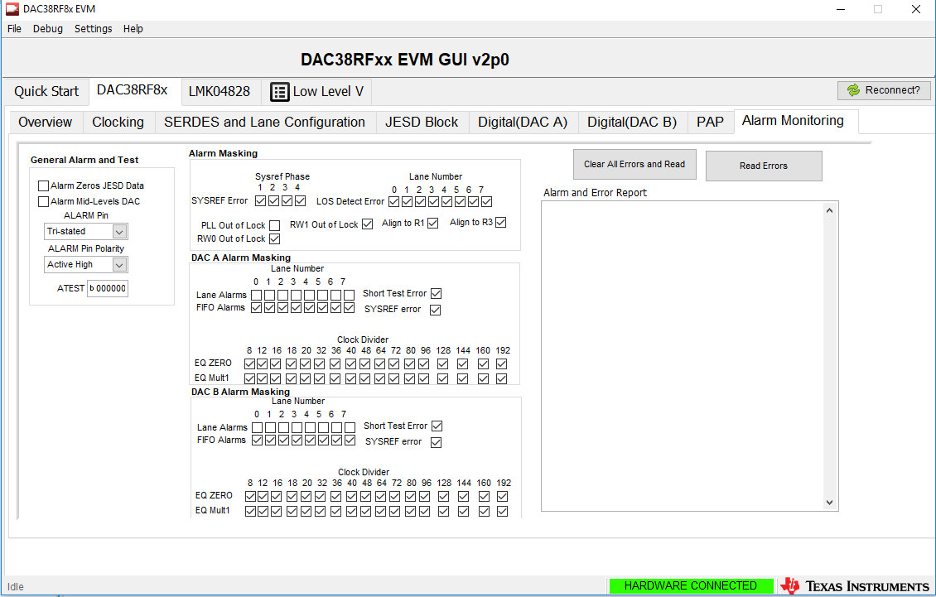
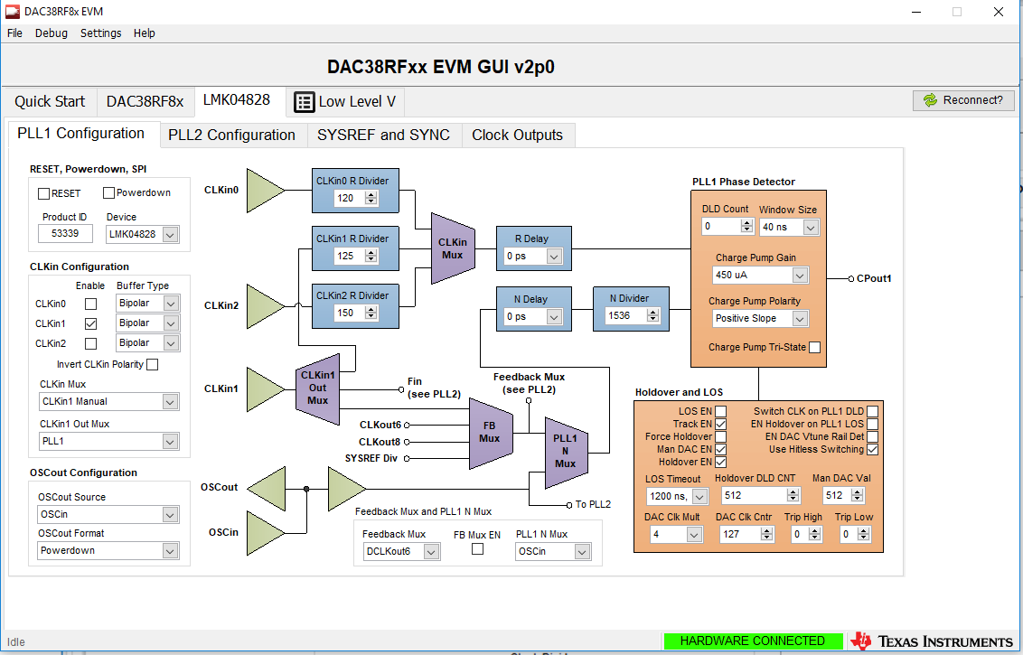
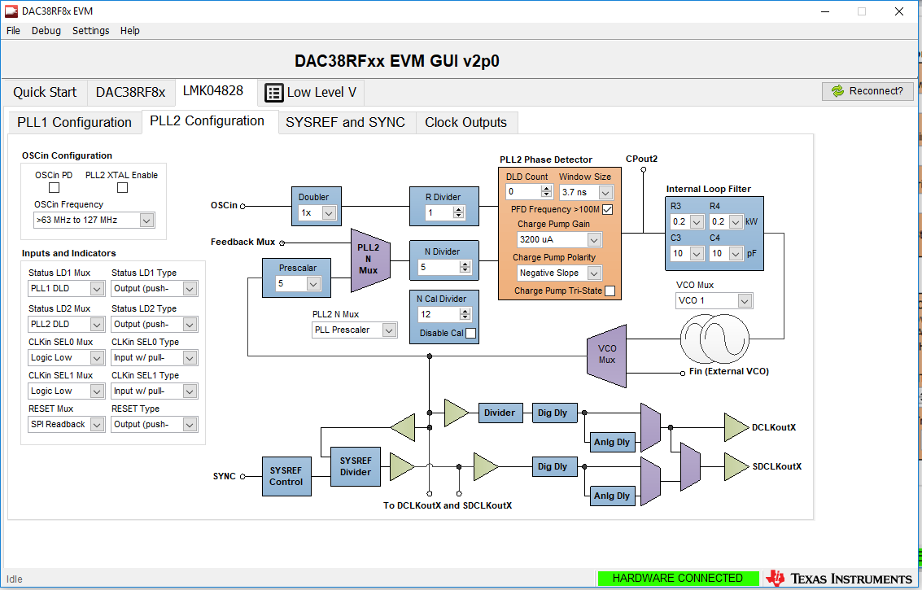
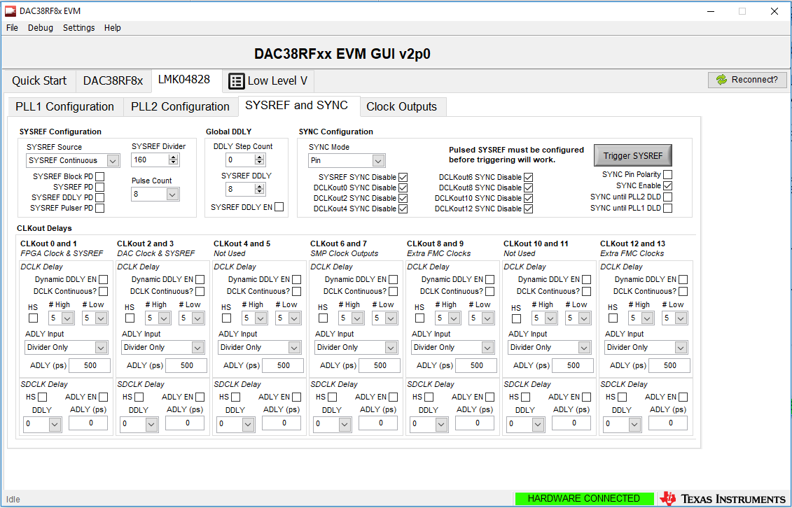
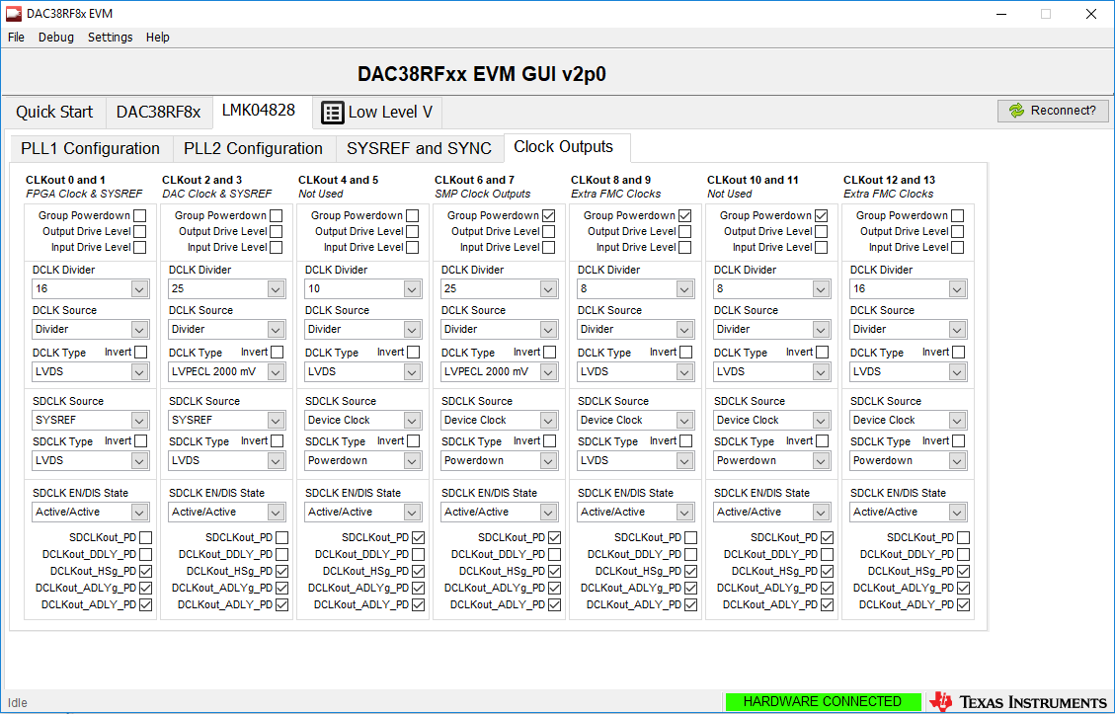
6, power on ZCU102
7, configure FPGA
8, reset FPGA logic
9, we got:
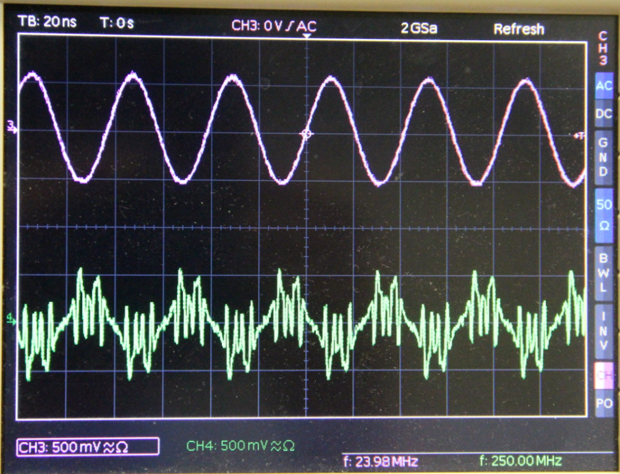
10, read DAC alarms
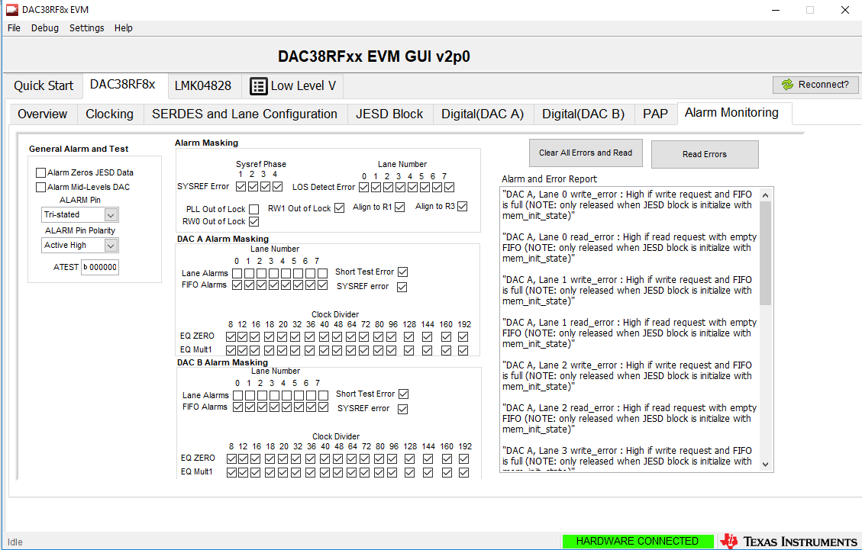
"DAC A, Lane 0 write_error : High if write request and FIFO is full (NOTE: only released when JESD block is initialize with mem_init_state)"
"DAC A, Lane 0 read_error : High if read request with empty FIFO (NOTE: only released when JESD block is initialize with mem_init_state)"
"DAC A, Lane 1 write_error : High if write request and FIFO is full (NOTE: only released when JESD block is initialize with mem_init_state)"
"DAC A, Lane 1 read_error : High if read request with empty FIFO (NOTE: only released when JESD block is initialize with mem_init_state)"
"DAC A, Lane 2 write_error : High if write request and FIFO is full (NOTE: only released when JESD block is initialize with mem_init_state)"
"DAC A, Line 2 read_error : High if read request with empty FIFO (NOTE: only released when JESD block is initialize with mem_init_state)"
"DAC A, Lane 3 write_error : High if write request and FIFO is full (NOTE: only released when JESD block is initialize with mem_init_state)"
"DAC A, Lane 3 read_error : High if read request with empty FIFO (NOTE: only released when JESD block is initialize with mem_init_state)"
"DAC B, Lane 4 write_error : High if write request and FIFO is full (NOTE: only released when JESD block is initialize with mem_init_state)"
"DAC B, Lane 4 read_error : High if read request with empty FIFO (NOTE: only released when JESD block is initialize with mem_init_state)"
"DAC B, Lane 5 write_error : High if write request and FIFO is full (NOTE: only released when JESD block is initialize with mem_init_state)"
"DAC B, Lane 5 read_error : High if read request with empty FIFO (NOTE: only released when JESD block is initialize with mem_init_state)"
"DAC B, Lane 6 write_error : High if write request and FIFO is full (NOTE: only released when JESD block is initialize with mem_init_state)"
"DAC B, Lane 6 read_error : High if read request with empty FIFO (NOTE: only released when JESD block is initialize with mem_init_state)"
"DAC B, Lane 7 write_error : High if write request and FIFO is full (NOTE: only released when JESD block is initialize with mem_init_state)"
"DAC B, Lane 7 read_error : High if read request with empty FIFO (NOTE: only released when JESD block is initialize with mem_init_state)"

11 We tried the NCO and constant input:
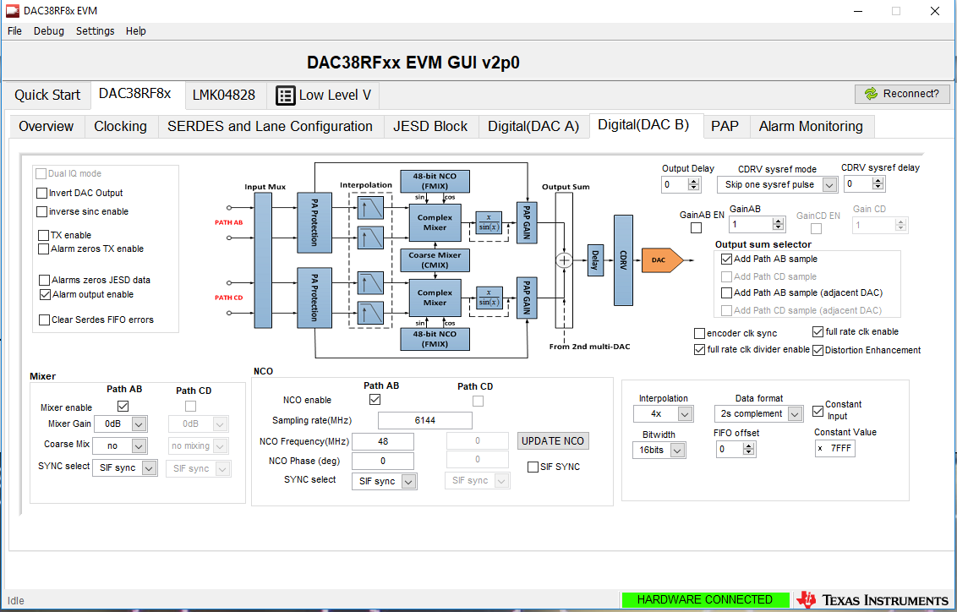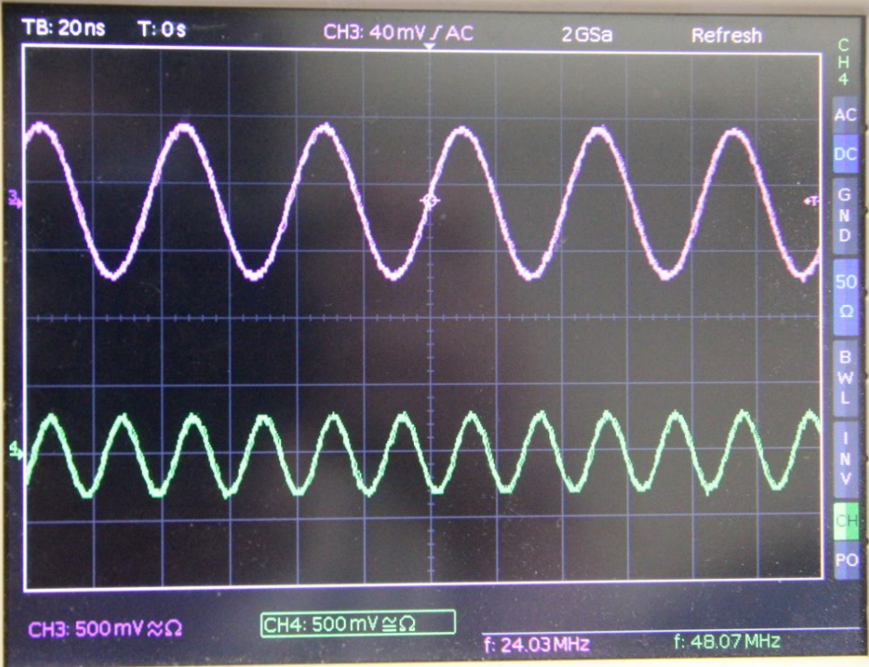
We tried different NCO frequencies and the constant values. The DAC B can output the correct frequency, but I think the amplitude is a bit low.
12, we tried to swap DAC A , B lanes
