Configuration
- I have installed 1GHz VCXO for U6. Therefore DAC5682ZEVM is working in internal PLL mode.
- I configured DAC5682ZEVM control as following;

- DAC mode: single
- Format: offset binary

- I configured HSDCProEVM control as following;

- Select DAC: DAC5681Z
- DATA Rate(SPS): 1G
- DATA Option: offset binary
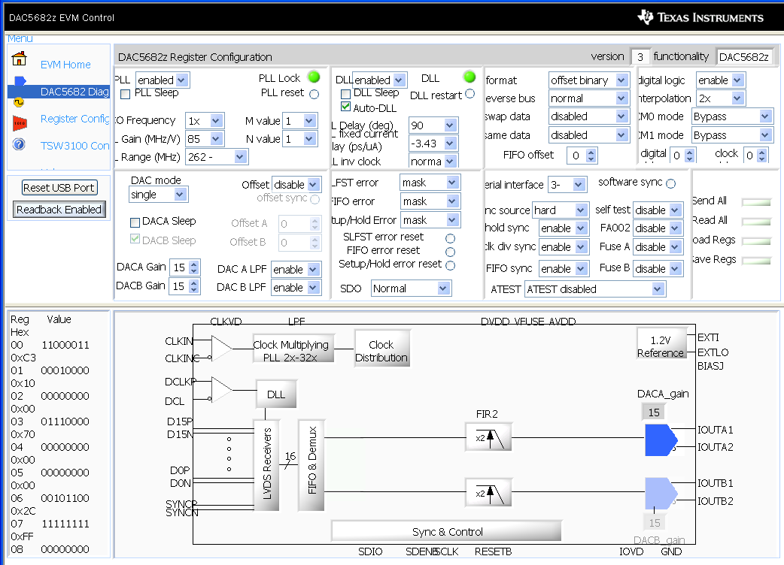
Fig. 1

Test and measurements: I generated 3 different pattern files from Excel.
- Test 1: 100ns wide pulse
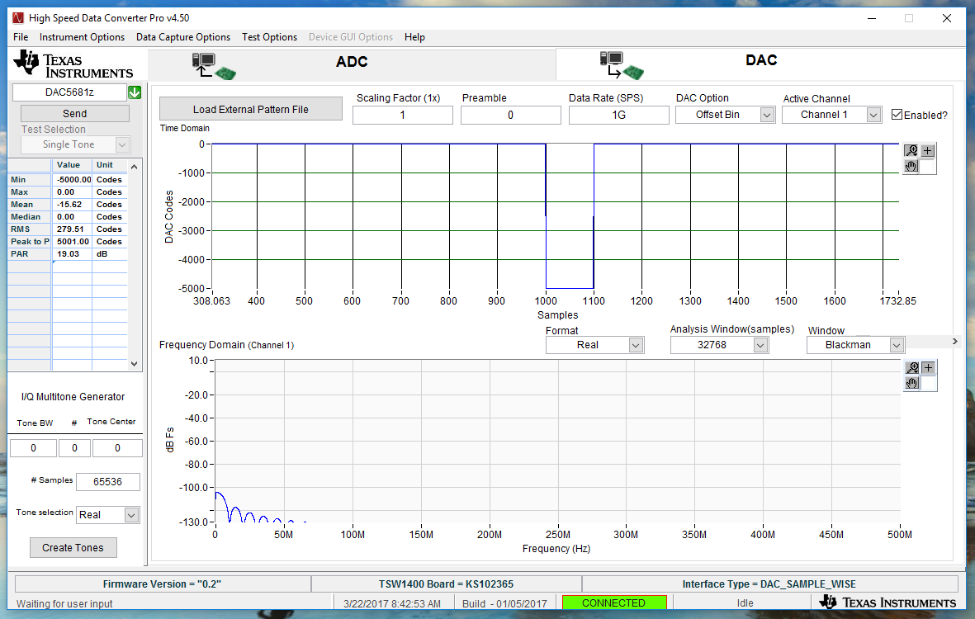
Fig.2: 100ns wide pattern waveform

Corresponding analog waveform is shown in Fig.3. Waveform was taken from J3 (IOUTA2).
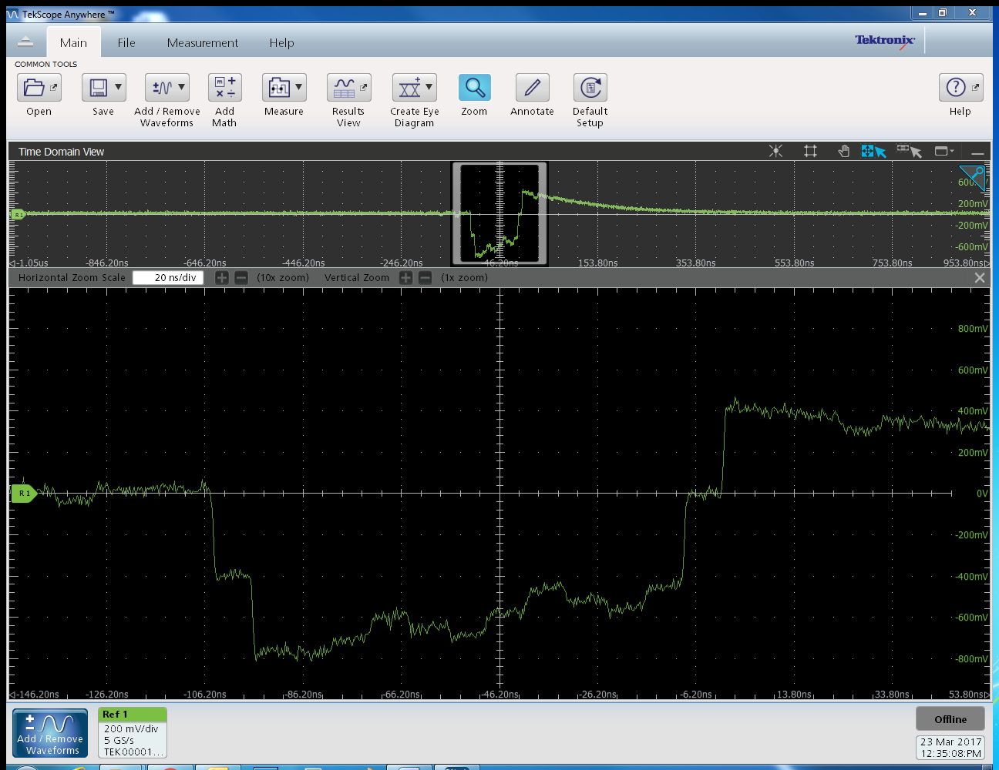
Fig.3

- Test 2: 5MHz sine wave

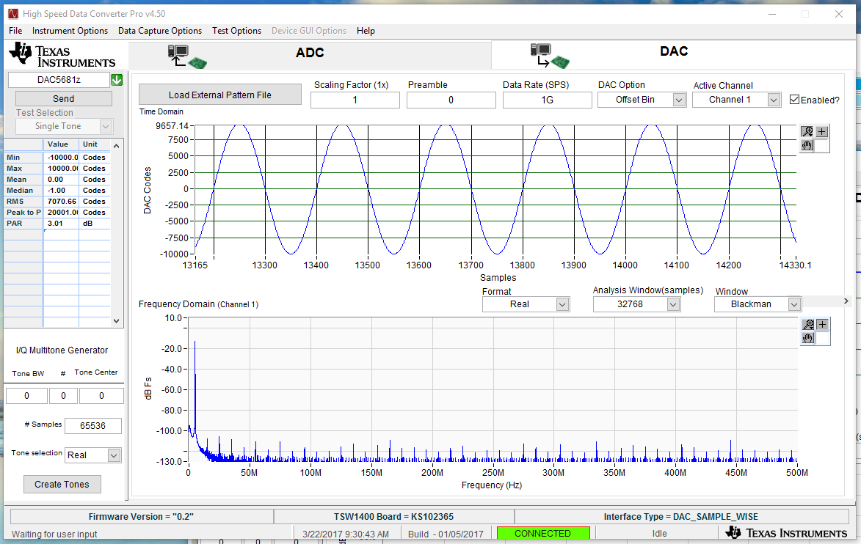
Fig.4: 5MHz pattern waveform
Corresponding analog waveform is shown in Fig.5.
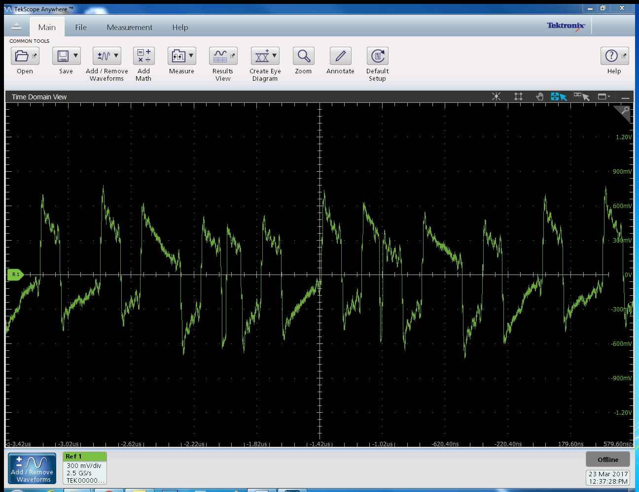
Fig.5

- Test 3: 32us long Ramp signal
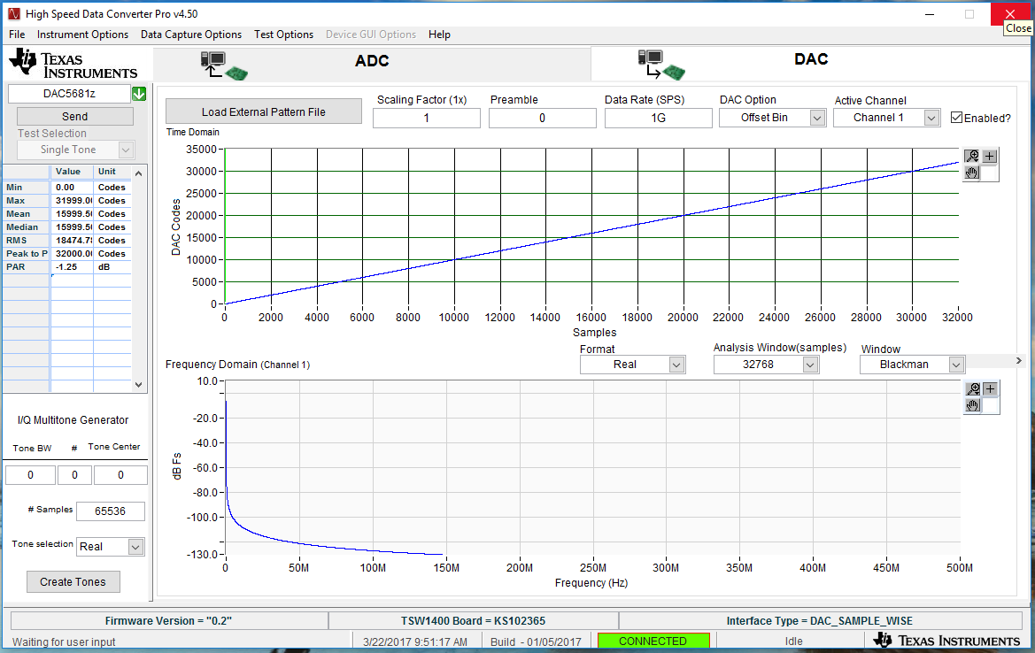
Fig.6: 32us Ramp pattern waveform
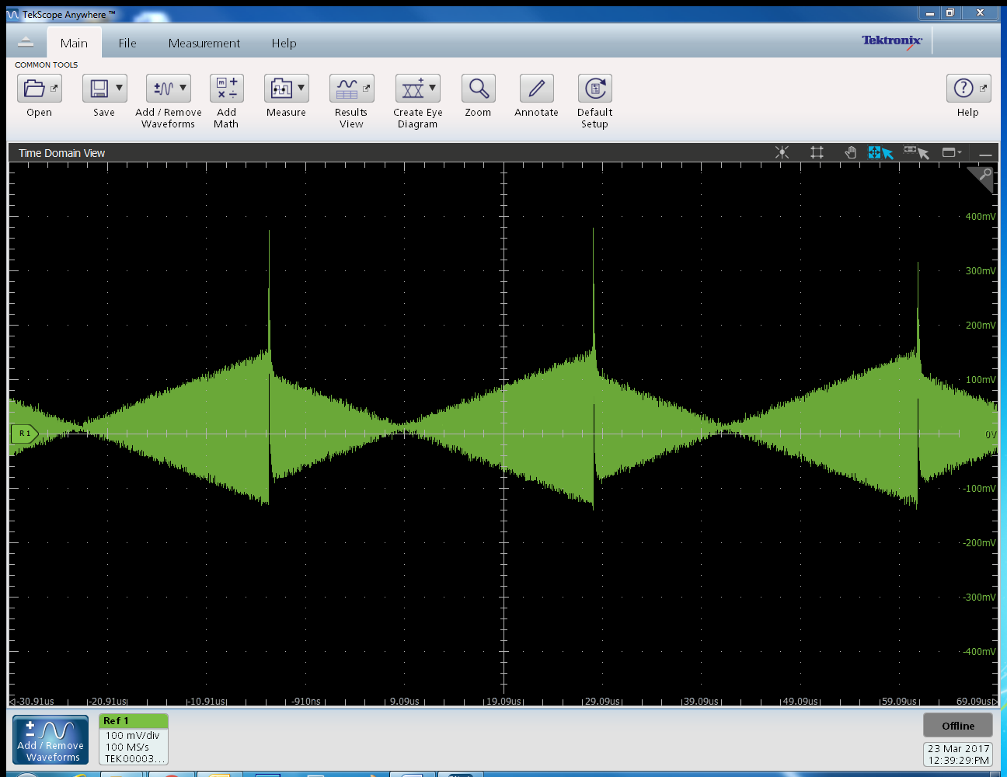
Fig.7
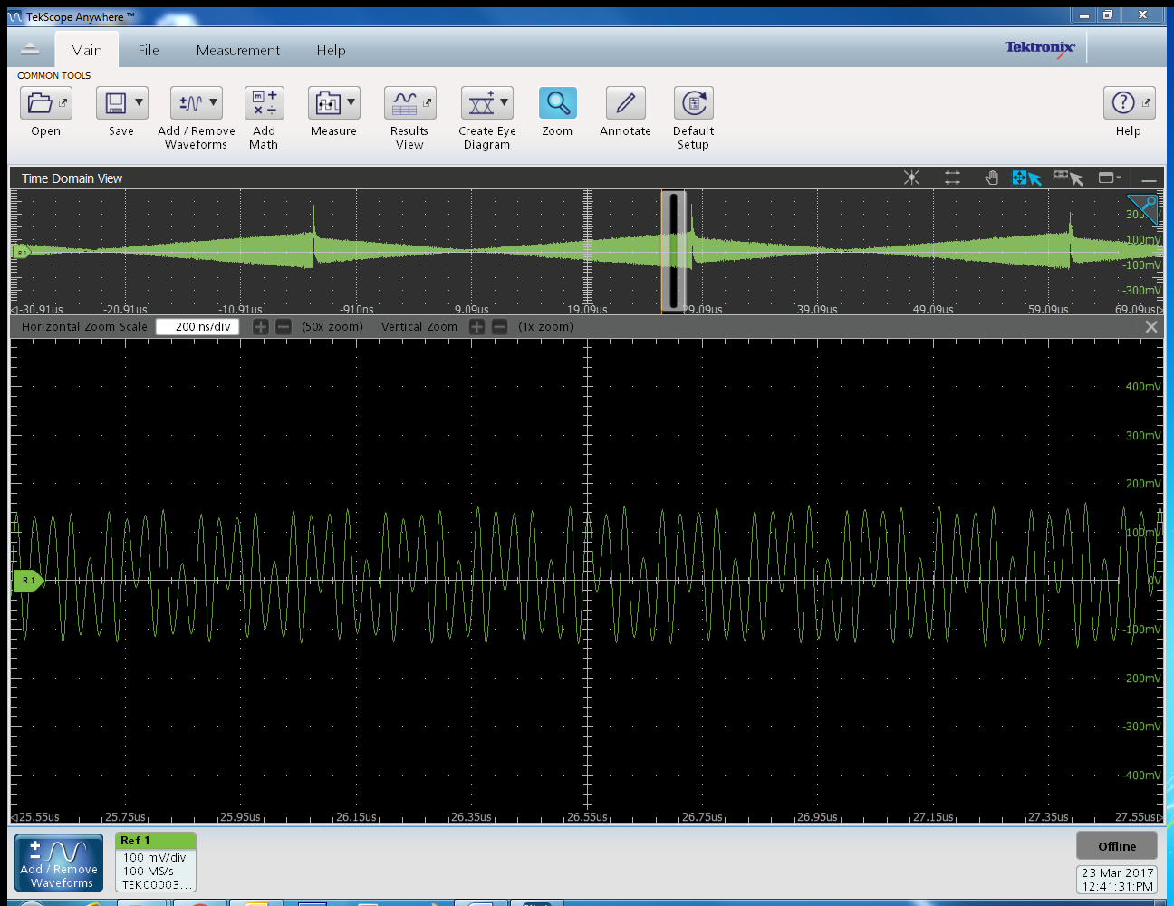
Fig.8. zoomed ramp signal waveform

