Here is the wave image:

Yellow line: MISO

Red line: clock

Blue line: MOSI

Green line: Busy

When we sent cmd 0x93, the SPI wave is:

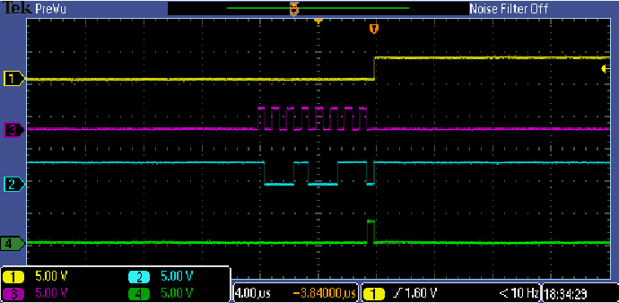

And then we will get the coordinate value, the SPI wave is :

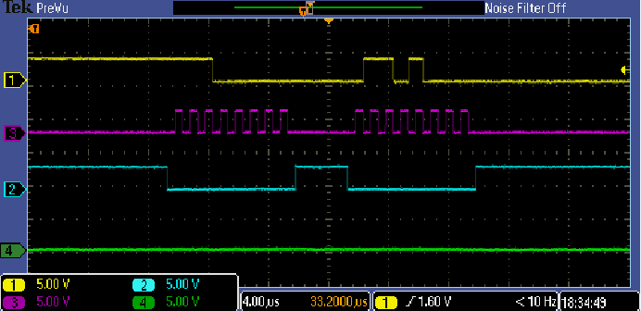

The follow picture is the complete picture of the upper two waves:

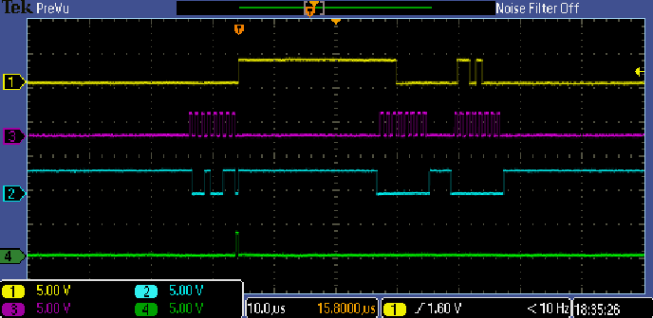

So our SPI wave looks different as the tsc2046 SPEC shows.

There are two 8bit data on the MISO, total 16 bit, our dirver ignore 3 LSB.

But the spec show as bellow:

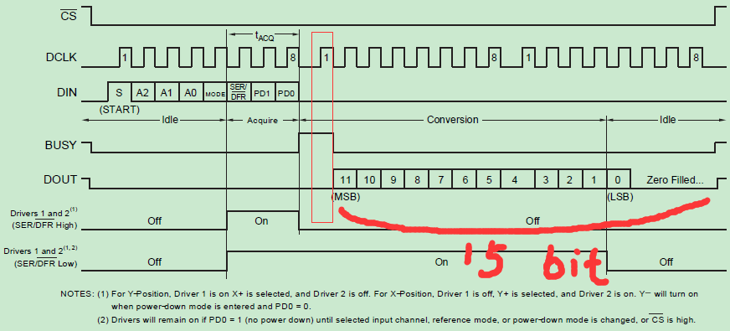

Seem spec show only 15bit data, the last three bit is zero filed.

But our SPI get 16bit data, the last three bit is ignore by our driver. This seems because the Busy

line change to low so quickly?

And I see the command on MOSI line has 9 bit , and the last bit is always 0, does this impact the busy line?