Where is the reason code:

In __mpu_init function:
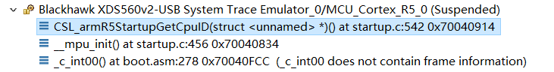
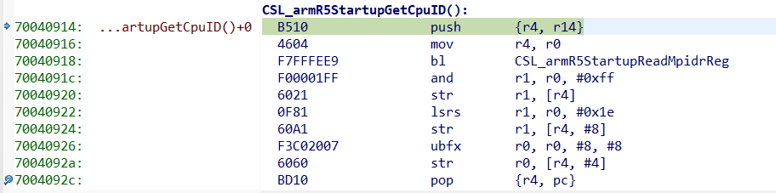

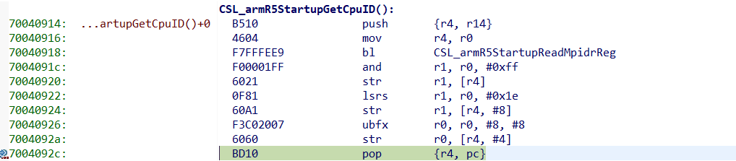
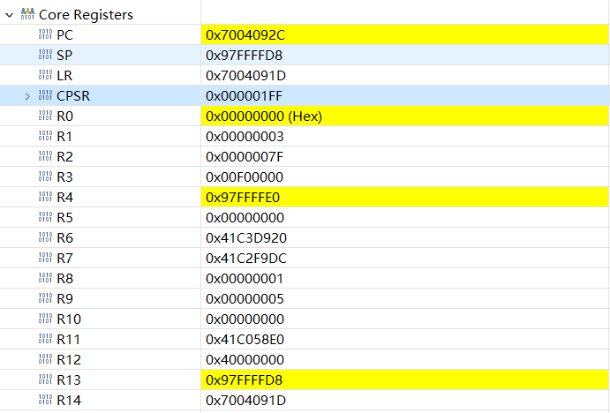
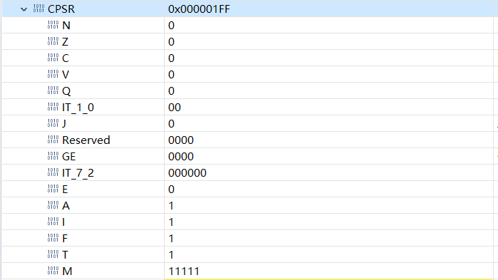

When run “pop {r4, pc} ” pc will go to 0x70040034, above is the register status at this instrction(pop {r4, pc}).

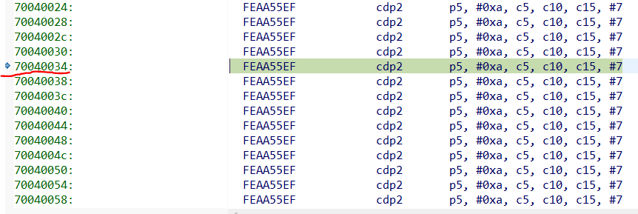

Because at thumb mode, so after cdp2 instruction, this will runto an un exception below.

