PRU Getting Started Labs
Draft 1, Updated May 19 2021
The first iteration of this document is focused on AM65x. It will be generalized in later drafts
In Microsoft Word you can navigate the document by going to the search field (Ctrl-F) and going to Headings

Introduction
--------------

The PRU Getting Started Labs apply to the PRU on AM335x, AM437x, AM57xx, and
AM65xx.

The Getting Started Labs demonstrate how to compile PRU firmware that is written
in C, assembly, or mixed C and assembly. Steps are provided for compiling the
firmware from Linux, or from Code Composer Studio (CCS).

The Getting Started Labs also demonstrate how to initialize the PRU from CCS,
another processor core running Linux, another processor core running RTOS, or
another processor core that runs bare metal code (no OS).

**NOTE:** In this guide commands to be executed for each step will be
marked in **BOLD**.

Lab Configuration

The following is the software configuration for this lab. The steps in this lab
are written against this configuration. The concepts of the lab will apply to
other configurations but will need to be adapted accordingly.

Hardware

- Any TI EVM board or BeagleBone Black (AM335x, AM437x, AM57xx, AM65xx)
- Power supply for the board
- Debug connection (JTAG emulator, FTDI cable, USB to UART cable, etc)

Software

- `Processor SDK <http://www.ti.com/processors/sitara-arm/design-development.html>`__
installed. Install Linux or RTOS Processor SDK as per your use case. This lab
assumes the latest Processor SDK is installed in /home/sitara. If you use a different location please
modify the below steps accordingly.
- The PRU Software Support Package is included in the
'example-applications/pru-icss-x.y.z/' folder of the Linux Processor SDK. If
you are using RTOS or running Windows on your development machine, you can
download the support package from the git repository
`here <https://git.ti.com/cgit/pru-software-support-package/pru-software-support-package>`__.
This lab assumes that the software package is installed in
/home/sitara/<ti-sdk...>/example-applications/pru-icss-x.y.z.
However, the notation ***<PRU\_SW\_PATH>*** will be used throughout
the labs to reference this assumed installation location. If you use
a different location please modify the steps below.
- `Code Composer Studio (CCS) <http://www.ti.com/tool/CCSTUDIO>`__
- `PRU Code Generation
Tools <http://software-dl.ti.com/codegen/non-esd/downloads/download.htm#PRU>`__
(also available through the CCS App Center)

Supported Platforms

AM335x, AM437x, AM57xx, AM65xx

Step 1: Creating a PRU Project
---------------------------------

Creating a CCS PRU Project

1. Launch CCSv10 and select the default Workspace.
2. Create a new PRU project.

a. Select **File->New->CCS Project**.
b. In the upper left dropdown, select the target processor family. In the
upper right dropdown, select the desired board. For example,
- BeagleBone Black: select **AM33x - Cortex A8** in the first dropdown,
and **BeagleBone_Black** in the second dropdown.
- AM65x Silicon Rev 1.0 IDK board: select “AM65x – Cortex A53** in the first dropdown, and **IDK_AM65x_SiRevA** in the second dropdown.
If your board is not defined,
just select the processor you are using in the second dropdown.
c. Select the **PRU tab**, specify a **Project Name (such as "pru_add")**,
and verify that Compiler version is **TI v2.1.0** or higher. Ensure that "Empty
Project (with main.c)" is selected.
Select **Finish**.

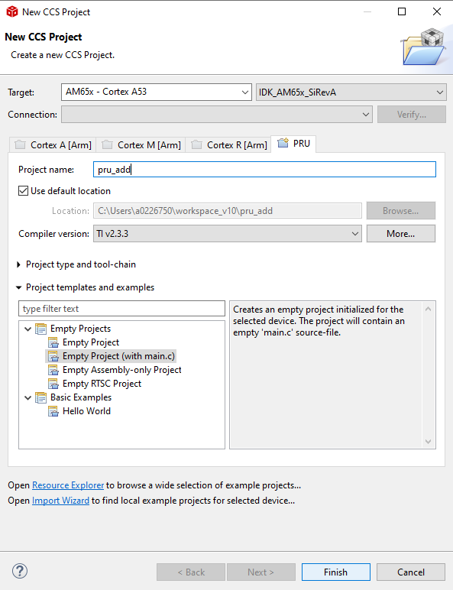
Screenshot of CCS New PRU Project Menu

**NOTE**

If the PRU compiler is not currently installed, select the **Cancel** button. Go
to **View->CCS App Center** and install the PRU Compiler. You can then redo step
2.

3. Main.c should open automatically. Let's start creating our example
code!

Creating a Linux PRU Project
use projects in PSSP/examples/am65x as a starting point

Step 2: Writing PRU Firmware
--------------------------------

Writing PRU Firmware with C/C++ Code
--------------------------------

This guide will explain how to create a simple PRU Firmware program using
C-Language. The firmware code will continuously add two numbers and save the
result. This code will also be used as a base for the Mixed C/Assembly Firmware
section found later.

The TI PRU C/C++ Compiler and Assembly Language Tools will take our C-code
Firmware program and create machine code that the PRU HW can execute.

.. seealso:: More information about the TI PRU Code Generation Tools (including
the TI PRU C/C++ Compiler and Assembly Language Tool) can be found at:

`TI PRU Code Generation Tools <http://www.ti.com/tool/PRU-CGT/>`_

- Create main.c file in CCS project.
  - If main.c was not already created:
    - Open CCS Project in Resource Explorer
    - Right click project name → Add File
  - Replace the text in your main.c file with the text in file <PRU\_SW\_PATH>/labs/Getting_Started_Labs/c_code/main.c

2) Add the include path for the PRU header files so that the compiler can
find them.
a. Select **Project->Properties**.
b. Select **Build->PRU Compiler->Include Options**.
c. In the box marked *"Add dir to #include search path"* **click the file icon with a green +**.
d. Specify the **directory to the include file**. For example, the AM65x
header files are at *<PRU\_SW\_PATH>/include/am65x*

**NOTE**

The header files simplify development by providing easy names for registers and
register bits. The headers are not actually used in the Getting Started Labs.
However, the Hands-On Labs show examples of using header files.

**NOTE**

If there is already a *${CCS\BASE\_ROOT}/pru/include* directory,
**delete it** by selecting it, and then clicking the file icon with a red X\ **.**

- Resource table: The Linux RemoteProc driver needs a resource table in order to load the PRU firmware
  - If not loading the firmware from a Linux core, comment out line “#include "resource_table_empty.h"”
  - If loading the firmware from a Linux core, add the resource table file:
    - Select Project->Add Files...
    - Navigate to the <PRU_SW_PATH>/labs/Getting_Started_Labs/c_code folder and select the resource_table_empty.h file.
    - The resource table includes rsc_types.h. Add the appropriate include path:
      - Select **Project->Properties**.
      - Select **Build->PRU Compiler->Include Options**.
      - In the box marked *"Add dir to #include search path"* **click the file icon with a green +**.
      - Specify the directory **<PRU\_SW\_PATH>/include**.

4) Add the linker command file.
a. If a linker command file was added to the project folder automatically,
delete it. For example, if you are using AM335x, look for AM335x_PRU.cmd
#. Select **Project->Add Files...**
#. Navigate to the *<PRU_SW_PATH>/Getting_Started_Labs/linker_cmd* folder
and select the linker command file that matches the PRU core you are using.

**NOTE**

For AM335x, AM57x, and K2G, the same linker command file can be used for all PRU
cores. For AM437x, AM437x_PRU_SS0.cmd should be used for PRU cores in PRU-ICSS0
and AM437x_PRU_SS1.cmd should be used for PRU cores in PRU-ICSS1. For AM65x,
AM65x_PRU0.cmd should be used for PRU0 in any PRU_ICSSG. AM65x_PRU1.cmd should
be used for PRU1 in any PRU_ICSSG. Similarly, RTU0.cmd for any RTU0, RTU1.cmd for any RTU1, TX_PRU0.cmd for any TX_PRU0, and TX_PRU1.cmd for any TX_PRU1.

- Look for the TODO comments in your main.c code for guidance on completing the example code.

The complete solution for the main.c code can be found in
<PRU\_SW\_PATH>/labs/Getting_Started_Labs/c_code/solution

Writing Assembly Code
Docs TODO. Code is already available in the Getting Started Labs folder.

Writing Mixed C and Assembly Code
Docs TODO. Code is already available in the Getting Started Labs folder.

Step 3: Compiling PRU Firmware
----------------------------------

PRU firmware needs to get compiled differently depending on what is loading the
PRU firmware into the PRU. If a Linux core is loading the PRU firmware, then the
PRU firmware must be compiled into an ELF file. If an RTOS core is loading the
PRU firmware, then the PRU firmware should be compiled into a hex array. If generating a hex array, please be sure to use PRU Compiler 2.3.1 or later.

Note that if you need to use assembly code, the C compiler can be used to generate a starting point for assembly development: just use C code compile option --keep_asm to see the ASM generated from your C code. See screenshot below for how to set this compiler option.
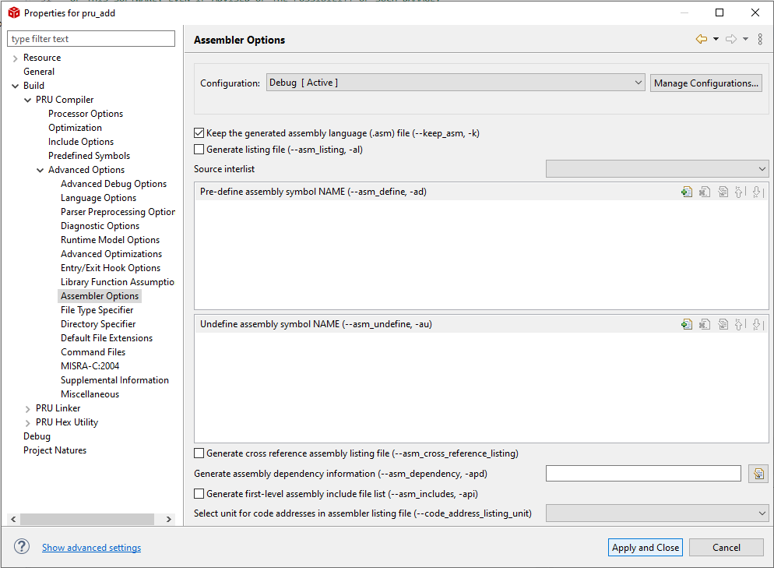

Compiling From CCS

Compiling to a .out file
- Select Project->Build All.
- This should now compile successfully! If not, correct any errors until build completes.

Compiling to a hex array file
Docs TODO. This would be needed if you were loading PRU from RTOS cores.

Compiling From Linux
Use Makefiles in examples/am65x as a template.

- Note that some of the include paths in the Makefile may need to be adjusted depending on where your code is.
- Run “make” from the terminal. If you have not set the PRU_CGT environment variable, you will get an error.
- Note that the PRU code generation tools (PRU_CGT) can be downloaded from https://www.ti.com/tool/PRU-CGT
  - TODO: SDK 6.3 and earlier PRU_CGT was packaged in Linux SDKs at sdk/linux-devkit/sysroots/x86_64-arago-linux/usr/share/ti/cgt-pru . This doesn’t apply to SDKs 7.x, what is plan for SDK 8.0?
- The generated project files will be available in a folder named **gen** in your project directory
- You can clean previously generated files with “make clean”
- Let us know if additional details are needed in the short term.

Step 4: Initializing the PRU
--------------------------------

Initializing the PRU from CCS
1) Select View->Target Configurations to see a list of available configurations. Note that this list may be empty.
a. To create a new Target Configuration right click in the white space in the Target Configurations window and select New Target Configuration.
Specify a filename (such as AM65x_IDK_SiRevA.ccxml if using a AM65x SR1 IDK EVM) and select Finish.
Select Connection as Texas Instruments XDS110 USB Debug Probe, if you are using on board debugger (AM64x, AM65x)

Select the Board (e.g., AM65x_IDK_SiRevA) and save the Target Configuration.

AM64x/AM65x requires you to set an initialization script for the DMSC_Cortex_M3_0 core.
Reference for AM65x: 6. CCS Setup for AM65XX — Processor SDK RTOS AM65XX (ti.com)
If you want to run a GEL script that sets pinmuxing, you could add that script to the initialization script.

Test the Target configuration. Power the board, make sure that an operating system is not getting loaded (e.g., boot switches set to SD card and then remove the SD card from the board), plug in your debug connection to the board, and click button “test Connection”. For AM65x EVM, plug USB cable to port labeled XDS110_USB.

Let’s launch the debugger and load the code!
- a. In the "Target Configurations" view, right click the Target Configuration file we just created and select Launch Selected Configuration. Note that Launch Selected Configuration might not appear if you right click the file in a view other than "Target Configurations".
- After it loads right click on the DMSC core and select Connect Target.
- The initialization script should run automatically. Among other things, it sets clocking so you can connect to the PRU cores.
- d. After the script runs, right click on the DMSC core and select Disconnect Target.
- e. Right click on the PRU_0 core and select Connect Target.
- f. Load the example you just build by selecting Run->Load->Load Program.
- g. Select “Browse Project”, navigate to the project you created, and select the .out file from the Debug folder.
- The PRU firmware has now been loaded into the PRU!

Initializing the PRU from Linux Core

Configure the Kernel
- The remoteproc and rpmsg modules are enabled by default and included out of the box in the Linux Processor SDK
- Documentation for manually configuring the Linux kernel will be provided later

Modify Device Tree Files to account for Pinmuxing
- See https://git.ti.com/cgit/apps/tida01555/tree/dts/am335x-boneblack-pruadc.dts for an example of adding PRU pinmux settings to the Linux devicetree
- General documentation for compiling a device tree binary is in the kernel user’s guide: http://software-dl.ti.com/processor-sdk-linux/esd/docs/latest/linux/Foundational_Components_Kernel_Users_Guide.html . In the TIDA01555 example, the user would build am335x-boneblack-pruadc.dts

Copy files to the target filesystem
* We need to get the new device tree and PRU firmware running on the Beaglebone Black. The easiest way to do this is with an SD card. There are lots of other alternatives (boot from TFTP with an initramfs, boot from TFTP and mount the FS over NFS, copy everything to the Beaglebone Black's eMMC, etc.).
Feel free to adapt these instructions to your desired setup.

* Use the script in sdk/bin to create a bootable SD card. You can find instructions on this process in the Linux SD Card Creation Guide: https://software-dl.ti.com/processor-sdk-linux/esd/docs/latest/linux/Overview/Processor_SDK_Linux_create_SD_card_script.html .

* Once the card is created, mount it on your Linux host to copy the files to it.

* The rootfs partition on the SD card contains the target filesystem. Copy the files from your development host to the SD card:

* Copy the PRU firmware binaries xxx.out to the /lib/firmware/pru directory of the rootfs partition.

* Copy the xxx.dtb file to the boot directory of the rootfs partition of the SD card. Note that it will probably be easier to keep everything straight if this dtb file has a unique name.

- Change the "EVM.dtb" symlink in the rootfs/boot directory to point to your new dtb file instead of the default.
  - sudo ln -f -s am335x-boneblack-prucape.dtb am335x-boneblack.dtb

- Use the sync command to make sure all of your changes have been committed to the SD card.

Boot the new device tree and FS on the Target

Now we're ready to try everything out.

* Move the SD card from the host PC to the target board.

- Make sure that your BOOTMODE switches are set for SD card boot. Reference the EVM User Guide for more information
- Boot the board
- Wait for the kernel to boot. At the prompt, login with "root" and no password.
- Use the remoteproc sysfs interface to specify which firmwares you want the remoteproc driver to load
  - Check which remoteproc node is associated with which core with this command: grep -Isr pru /sys/kernel/debug/remoteproc/
“pru” can be replaced with “rtu” to find RTU cores on ICSSG devices
TODO: TX_PRU search string?
  - Let’s say the PRU you want to load firmware into is at remoteproc1. Then you would type this into the AM65x command line:
  - echo 'pru/firmwareName.out' > /sys/class/remoteproc/remoteproc1/firmware
- Use the remoteproc sysfs interface to load and then run the PRU cores
  - echo 'start' > /sys/class/remoteproc/remoteproc1/state
- Once 'start' has been echoed into the 'state' attribute the remoteproc firmware will load the PRU cores and then run them
- If you would like to unload and then reload the PRU cores, use the commands below:
  - echo 'stop' > /sys/class/remoteproc/remoteproc1/state
  - echo 'start' > /sys/class/remoteproc/remoteproc1/state

Initializing the PRU from RTOS Core
Docs TODO.

Initializing the PRU from non-OS Core
Docs TODO.

Step 5: Testing the PRU Firmware
--------------------------------

Testing PRU Firmware in CCS

This section is going to demonstrate how to use different features in CCS to test the PRU Firmware.

We will assume you completed the c_code example, built it, initialized the PRU, and loaded that firmware into the PRU. You can run the code by clicking the green arrow at the top of the screen. However, don’t run the code just yet.

6. Set up your debugging environment

a. In CCS select **Window** -> **Show View** -> **Registers**
b. Then select **Window** -> **Show View** -> **Memory Browser**
c. Next select **Window** -> **Show View** -> **Disassembly**
d. Finally select **Window** -> **Show View** -> **Variables**
d. Take note of where the windows have appeared. Two may share the same window,
and you may need to switch between two tabs.

7. Step through the PRU function until you reach the while loop. You can use the “Step Over” or “Step Into” buttons, which are two of the yellow arrow buttons to the right of the green “Resume” button

8. Navigate to the **Memory Brower** window.

9. Under “Data_Memory”, you can type a specific memory address. Type in
0x100. You should see the value of 1 stored in 0x100, this is the variable "a".
The value of 2 should be stored in 0x104, this is "b". 0 will be stored in 0x108, this is "c".

10. Step through the loop once. The value at 0x108 should now be 3. This variable won't change
unless we manually change the variables that are summed to create that variable.

11. Double click the block of memory at 0x100 in the memory browser. Change the value to 7.

12. Step through the loop again. The value at 0x108 should now be 9.

Now open the **Variables** window. Note that you can adjust variable values here as well by clicking on a value and typing a new one in.

13. Now open the **Registers** window.

14. Expand the **core registers** dropdown. You will see these registers changing as well as you change variables and step through your code. In assembly code you would specify which core register is doing what, but if you program in C code the compiler handles this task.

16. Navigate to the **Disassembly** window. You can use this window to see what assembly code was generated from the C code that you wrote. Note that the Disassembly window has its own green arrows to step through the assembly instructions.

Testing PRU Firmware in Linux
CCS can take advantage of many debug tools that Linux does not have (pausing code, stepping through instructions, viewing internal registers, etc). However, there are some basic tools that can be used to test firmware from Linux:

- Save key variables to known locations in PRU DRAM / SRAM, and use devmem2 to view and modify those values.
  - For example, if you store variables in DRAM at 0x100, 0x104, and 0x108:
    - Use the Technical Reference Manual chapters “Memory Map” and PRU > section “Memory Maps” to determine the address for SRAM
    - Read variables with devmem2 0xADDRESS
      - AM335x example with DRAM at 0x100: devmem2 0x4a30100
    - Write variables with devmem2 0xADDRESS w 0xVALUE
      - AM335x example with DRAM at 0x100: devmem2 0x4a30100 w 0x5

Additional debug from Linux hints in a later document.

