AM62x RT Linux task interrupt issue

Background
- CPU：AM6234
- SDK：11.00.09.04, also test on SDK9.2, same result
- filesystem：tisdk-base-image
- Kernel：
Linux version 6.12.17-g685e771524+ (veichi@veichi-virtual-machine) (aarch64-oe-linux-gcc (GCC) 13.3.0, GNU ld (GNU Binutils) 2.42.0.20240723) #1 SMP PREEMPT_RT Tue Jul 8 09:59:11 CST 2025
- Core isolation：isolcpus=1-3
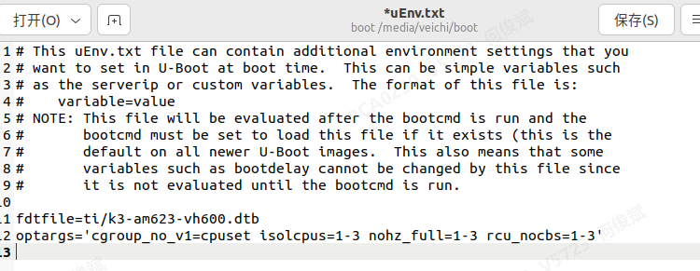
- Unload and closed irrelevant service and application.

Problem discription
Run CODESYS runtime，create user application EtherCAT_Task，task period set to 1ms，
Just an empty task without any calculation, task priority=1(FIFO priority=55), assign to core 3.
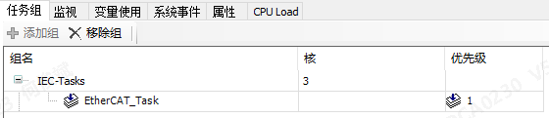
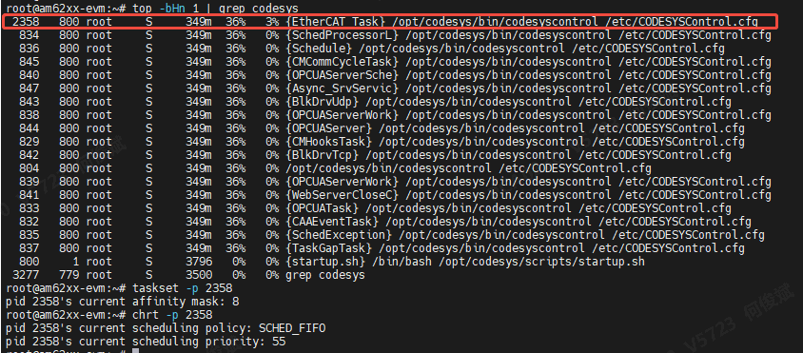

Monitor task, reset loop time after bus initialization each time, monitor again.
Average loop time is 126us, largest loop time is 474us which is 3 times of average loop time.

Increase EtherCAT slave node which increase EtherCAT_Task loop time also.
When average loop time is 334us, largest loop time is 909us which is >2 times of average loop time.

The ideal result should be no matter how much the average loop time, the largest loop time -average loop time should be <200us. (other vendor can achieve it with Codesys)

Support needs: how to achieve it on AM62x.

Test and analysis

Core 3 EtherCAT_Task impacted by Core0 thread
Run script on Core 0: loop_cat_hardirqs.sh，endless loop read interrupt count
#!/bin/bash
while true; do
cat /proc/interrupts >/dev/null 2>&1
done

The script thread priority=0, schedule method: SCHED_OTHER, assign to Core 0, Core 0 loading 100%
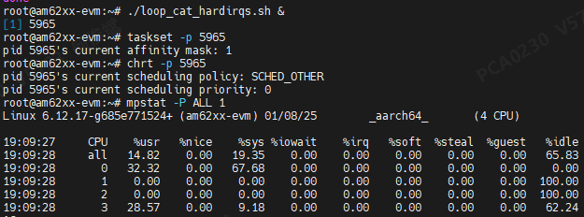

Monitor Core 3 EtherCAT task before and after running script on Core 0.
Before running script on Core 0
during running script on Core 0: loop_cat_hardirqs.sh
The average loop time increased ~150us, it proved Core 3 task was interrupted by Core 0.

Core 3 EtherCAT_Task impacted by Core 2 thread
Same test of section 3.1 on Core 2
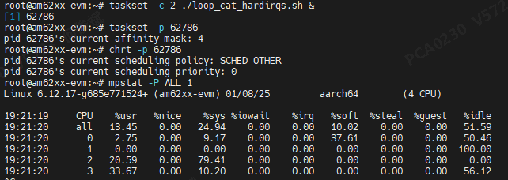
Monitor Core 3 EtherCAT task loop time.
Before running loop_cat_hardirqs.sh
During running loop_cat_hardirqs.sh on Core 2
EtherCAT task average loop time increased ~250us, it should be interrupted by core 2 task.

Core 3 priority 99 thread also impacted by Core 2 thread
Write another script to run on Core 3 instead of EtherCAT task:
loop_cat_hardirqs_50times.sh，loop 50 times to read interrupt count
#!/bin/bash
for ((i=1; i<=50; i++))
do
cat /proc/interrupts >/dev/null 2>&1
done

Run script on core 2: loop_cat_hardirqs.sh, same schedule method and priority as before
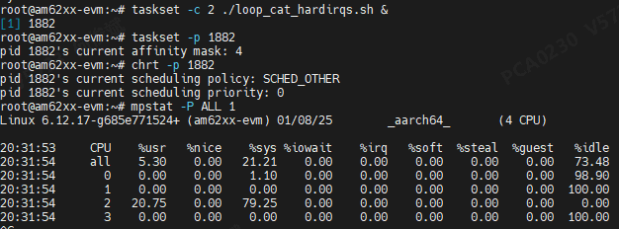

Run loop_cat_hardirqs_50times.sh 5 times on Core 3 in highest priority 99:

Before running loop_cat_hardirqs.sh on Core 2, Core 3 script execution time as below:
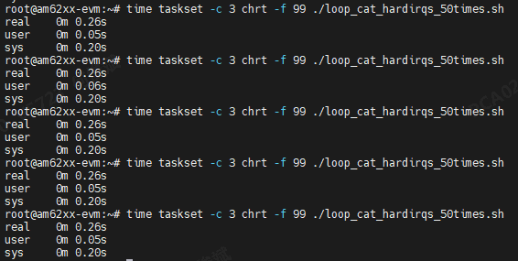
running loop_cat_hardirqs.sh on Core 2, Core 3 script execution time as below：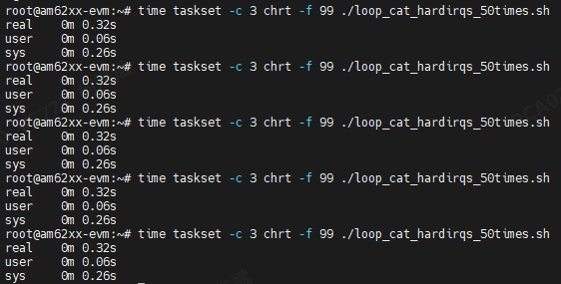
Core 3 script execution time increased from 0.26s to 0.32s. it is impacted by Core 2 script running.

summary
High priority task on isolated core, still impacted/interrupted by other core, lower priority task.

