1) G7 and G8 pins belong to CVDD power supply pins. The voltage amplitude of the failed chip CVDD is normal, which conforms to the standard of C67x DSP Datasheet Section 5.3 Recommended Operating Conditions.

----The chip CVDD supply voltage is normal. Measured voltage: 1.321V

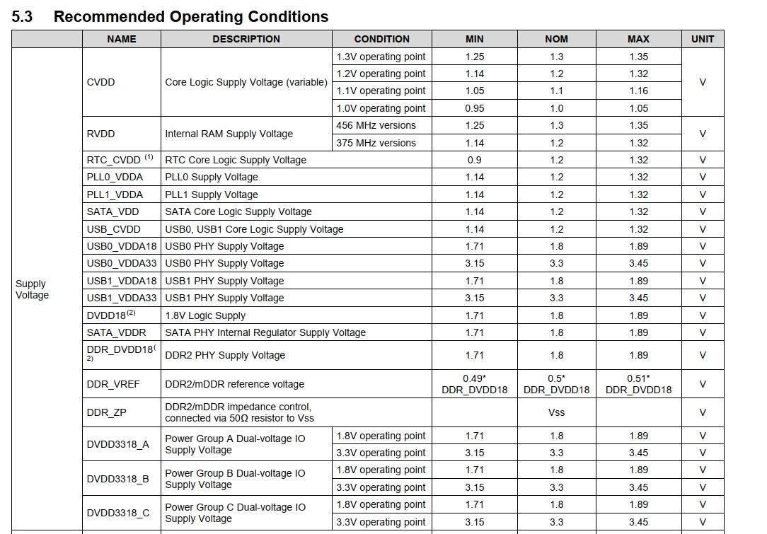

2) Main power rail RTC_CVDD, CVDD, All Static 1.8V IO supplies and LVCMOS IO supply groups used at 3.3V Nominal, is the voltage amplitude normal? For details, see Section 6.3.1.

Measured voltage: 1.835V 3.386V 1.225V

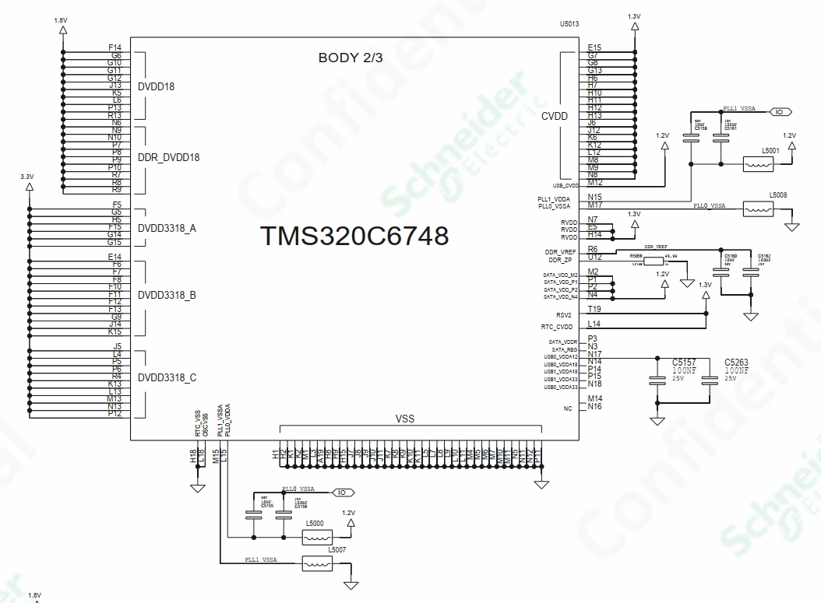

3) Please refer to the Power On Sequence of C67x DSP Datasheet 6.3 for the power-on Sequence of the faulty chip and board

POWER ON: 1.2V 1.3V -- >1.8V -- >3.3V

4) Whether the chip is bulging or not ？

---There is no