**SK-AM64B MMC1 Rework**

* Install 10K resistor on R70, R85, R84, R69, R68

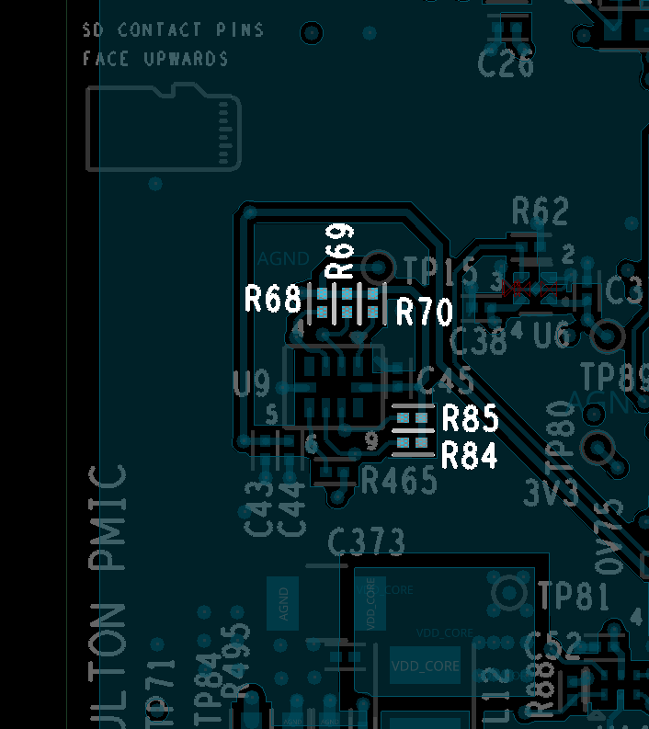

Top Side

* Install 49.9K resistor on R466

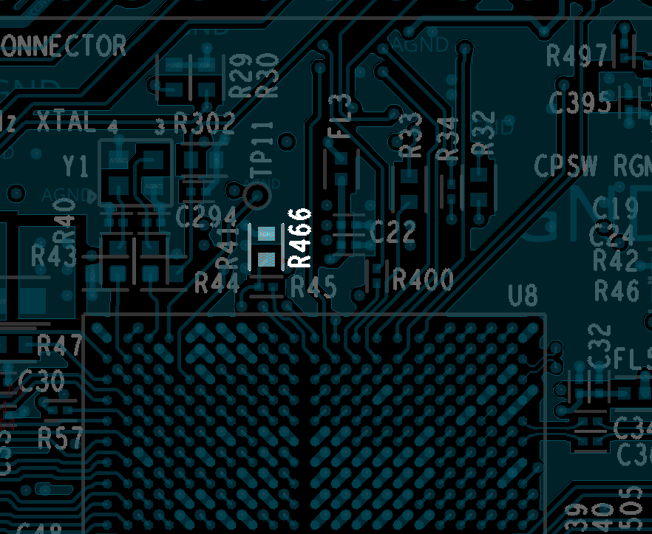

Top Side