Code Changes to NIMU and Explanation
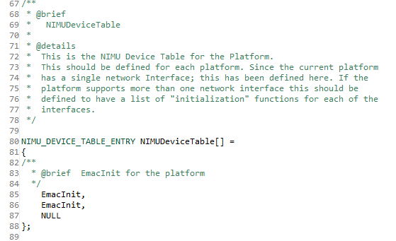
- Updated NIMUDeviceTable to include an initialization function for a second interface

- EMACInit_Core:
  - Create static global variable called PhysIdx which is used to set SGMII physical index. Also used to gate which interface is initialized
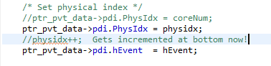
  - MAC address needs to be unique for separate interface to prevent packet misdirection. LSB of the MAC is incremented to make it unique
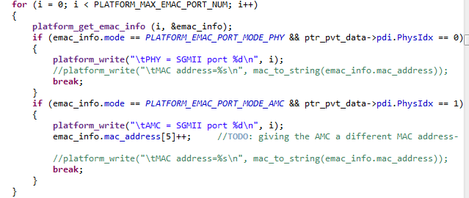
  - When setting driver interface functions, pointed the second interface to a different send function.
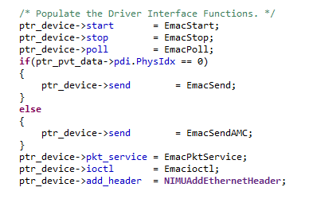
  - PA should only have to be initialized once
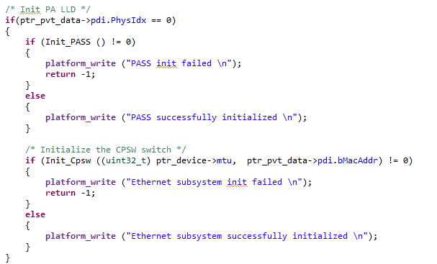
- Setup_Rx
  - Each interface needed its own receive queue, so gRxQHnd was made into an array, using PhysIdx as the index
  - Changed accumulator channel number so each interface has a separate one. The +8 comes from usable accumulator channels on each core
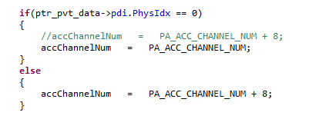
  - Registered a new interrupt/event for the second interface
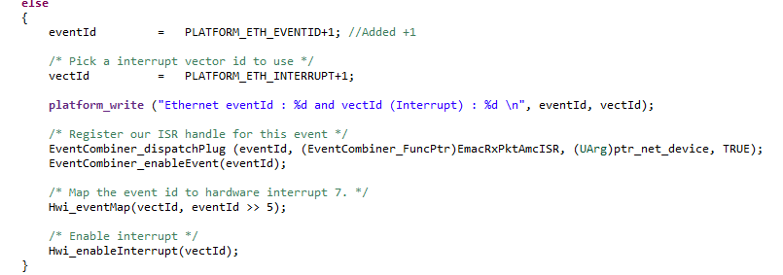

- EmacSendAMC
  - Needed to change physical index that send is using (in regular EmacSend, this PhysIdx is set to 0)
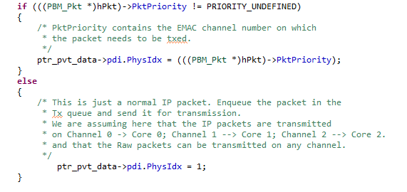
- EmacRxPktAmcISR
  - Same as ISR that is used for first port except event and accumulator numbers are changed to match those that the second interface uses.
- Qmss_QueueHnd gPaTxQHnd [NUM_PA_TX_QUEUES], gTxReturnQHnd[2], gTxFreeQHnd[2], gRxFreeQHnd[2], gRxQHnd[2], gTxCmdReturnQHnd[2], gTxCmdFreeQHnd[2];
  - The above variables were changed into arrays with two entries (one for each interface). This requires several other parts in the code to change as well
  - Setup_Rx
    - When these queues are used in Setup_Rx, they are indexed by [ptr_pvt_data->pdi.PhysIdx] which indicates the interface
  - Setup_Tx
    - Loop over the number of interfaces, indexing queues such as gTxFreeQHnd[index], thus setting up the queues for each interface
  - EMACSend/EMACSendAMC
    - Since each one of these is exclusive to an interface, the number used to index these queues is simply the one I know it is supposed to be (0 or 1)
  - EmacRxPktISR/EmacRxPktAMCISR
    - Once again index by [ptr_pvt_data->pdi.PhysIdx]
  - Add_MACAddress
    - Queues are indexed by [ethInfo->inport] which describes the appropriate interface
  - EmacStop
    - Queues are indexed by [ptr_pvt_data->pdi.PhysIdx] since each interface will call EmacStop

