AM57X testing of OpenCV

OpenCV (open source computer vision) is an open source collection of C++ (with some C) functions and utilities for image processing.
A good tutorial for OpenCV can be found at http://docs.opencv.org/2.4/doc/tutorials/tutorials.html
To meet the requirements of real-time processing of images and video OpenCV functions were optimized. TI’s hybrid ARM-DSP solutions provides very efficient implementation of OpenCV function where signal-processing-rich algorithms are processed by DSP while the ARM processes all other algorithms, controls and manages the DSP.
TI implementation of OpenCV contains implementation of OpenCV functions as well as a set of unit tests to verify the performances and the accuracy of the implementation. The following instructions show how to load and run unit tests of TI’s OpenCV implementation on AM57X device.

Pre-requisites
- X15 – AM572 EVM (or other AM57X based system) with connection to the network. See http://www.ti.com/tool/TMDXEVM5728 for information on X15 EVM
- Board runs AM57x LINUX operating system version PROCESSOR-SDK-LINUX-AM57X 02_00_02_XX or newer. Note – I do not know what will be the release version, it should replace 02_00_02_XX
- File system either on a SD card or mount to external server. If the file system resides on SD card, the card size should be at least 32GB.
Note – The following screen shots were taken from Tera Term terminal that is connected to the mother board of X15 EVM

Loading standard test data
It is recommended to build the OpenCV test in a separate directory. After login as a root the user can make a new directory.
The standard test code can be downloaded from https://github.com/Itseez/opencv_extra/archive/master.zip
There are multiple ways to download the data into the EVM
- If the EVM has display and keyboard the user can downloaded the data compressed file directly to the EVM and then unzip it
- Download the data compressed file to a PC on the network and use SCP or tftp or USB memory stick to move the data compressed file into the EVM. Then unzip it

The following screen shot shows how to download the standard data compressed file into the EVM and unzip it. It assumes that there is a TFTP master server for example Solarwinds or similar, and that the file opencv_extra-master.zip was downloaded from https://github.com/Itseez/opencv_extra/archive/master.zip and resides in the root directory of the TFTP server.
From the EVM terminal do the following
mkdir OpenCV create an new directory
cd OpenCV Move to the directory
tftp -l master.zip -r opencv_extra-master.zip -g 158.21r.zip -g xxx.xxx.xxx.xxx tftp and get the file opencv_extra-master.zip from remote terminal at IP address xxx.xxx.xxx.xxx and give it local name master.zip. Note in the screen shots here the server IP address is 158.218.109.189. The process takes few minutes because the file is very large. (More than 600MB)

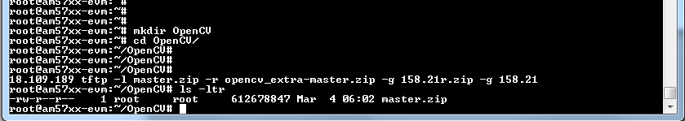
Next unzip the master.zip file unzip master.zip . After the unzip process ends, delete the master.zip file.

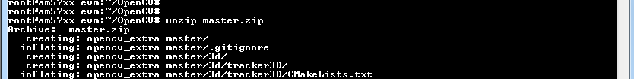
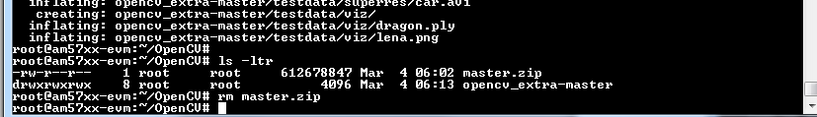
The directory opencv_extra-master contains the standard data for testing the OpenCV functions.

Notes:
An alternative way to TFTP is using SCP to push the compressed data file. The following screen shot shows how to push the compressed data file using SCP from an Ubuntu machine. The address 158.218.109.244 is the IP address of the EVM

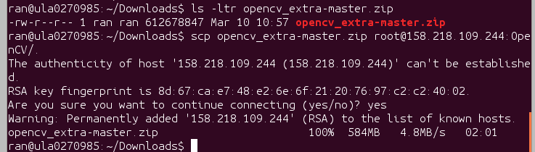

Loading TI Test Code
TI test code needs to be loaded from a git server. In the OpenCV directory of the EVM clone the tiopencv directory. git clone git://gitorious.design.ti.com/opencv/tiopencv.git (see note 1 below)

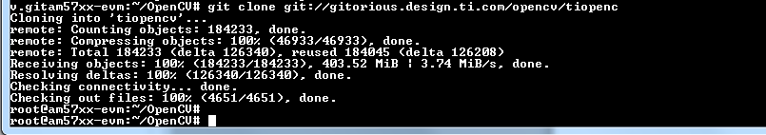

Next update the version that is used for testing, change directory to the new clone directory tiopencv cd tiopencv and do git checkout tiopencvdev (see note 2 below)

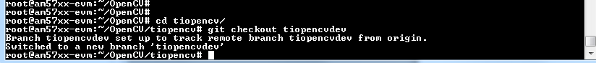

Note 1 – This document was written before the public release. The git location of the tiopencv directory may move to another location and the document should be updated
Note 2 – This document was written before the public release. The git branch that is checkout will be included in the main branch and the git checkout tiopencvdev may not be necessary.
Note 3 – The directory tiopencv has the following elements
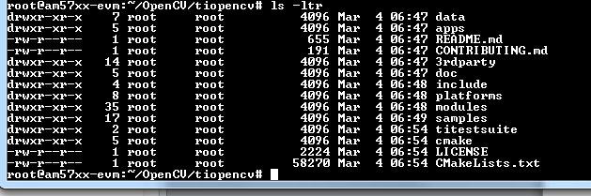

Setup Environment Variables and Run the Test Script
Three environment variables are needed. OPENCV_BUILDDIR specifies where the executable bin files are located. In TI file system export OPENCV_BUILDDIR=/usr/share/OpenCV/samples
The OPENCV_TEST_DATA_PATH specifies where the test data files are located. Following the instructions from above export OPENCV_TEST_DATA_PATH=~ /OpenCV/tiopencv
The OPENCV_OPENCL_DEVICE specifies what architecture is used for OpenCL. TI’s implementation of OpenCV uses OpenCL to distribute execution between ARM processor and one or more DSP cores. Thus OPENCV_OPENCL_DEVICE tells the system what processors are available. For AM57
Export OPENCV_OPENCL_DEVICE = ‘TI AM57:ACCELERATOR:TI Multicore C66 DSP’
For K2H export OPENCV_OPENCL_DEVICE = ‘TI KEYSTONE II:ACCELERATOR:TI Multicore C66 DSP’

In the following screen shot a source file environment.sh was built with the variables for AM57 and was execute
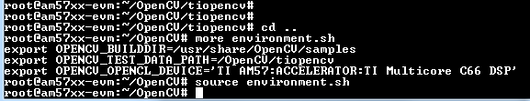

The runtests script runs all the OpenCV tests. It is located in directory titestsuite that is subdirectory of tiopencv. The following screen shot show how to start the runtests script

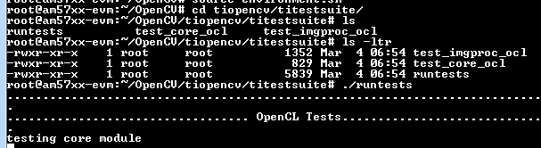

The script runs for a long time. The results are built in the file opencv_test_log.out during the execution of the script. Here is a screen shot from the start of the run:

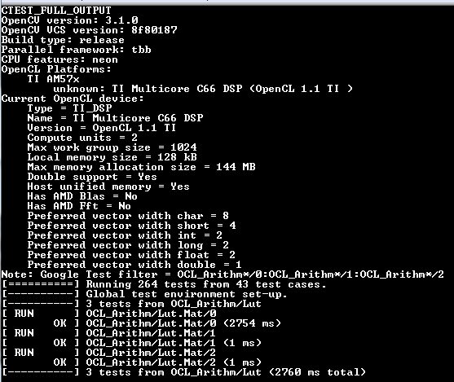

Problem and Issues (BusyBox v1.23.1 (2016-03-02 23:57:12 EST) , tiopencv and test data were loaded on 3/11/16)
- Photo module OpenCL tests are stuck, had to do control C to continue, The error message in the log file was

