Hi,
I am using TMS320C5515 EVM with ADS1298R. On my laptop I have WIN7 OS. I connect two USB cables to the EVM: one for JTAG and the second for communicating the USB port. After connecting the EVM, I saw that a new device appeared in the device manager, named: "Spectrum Digital TMS320C5510 DSK"
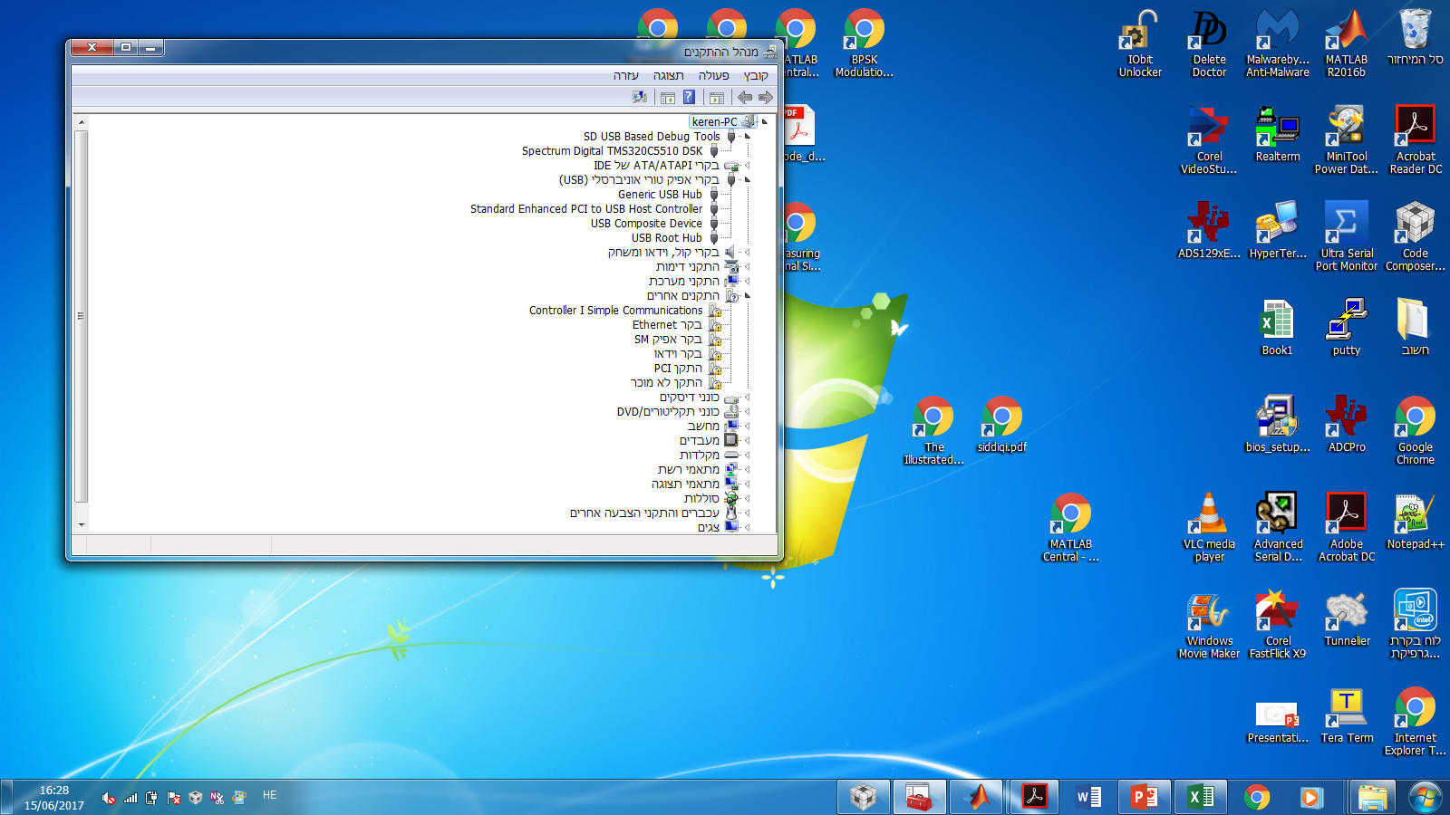
The USB connection of C5515 didn't appear, although it was physically connected. I downloaded the CSL program as it's in your site (taken from: http://www.ti.com/tool/SPRC133). I ran the CSL_USB_CDCExample_Out program successfully on CCS V6. After launching the code, the device "C5515 (COM2)" appeared in the device manager as below:
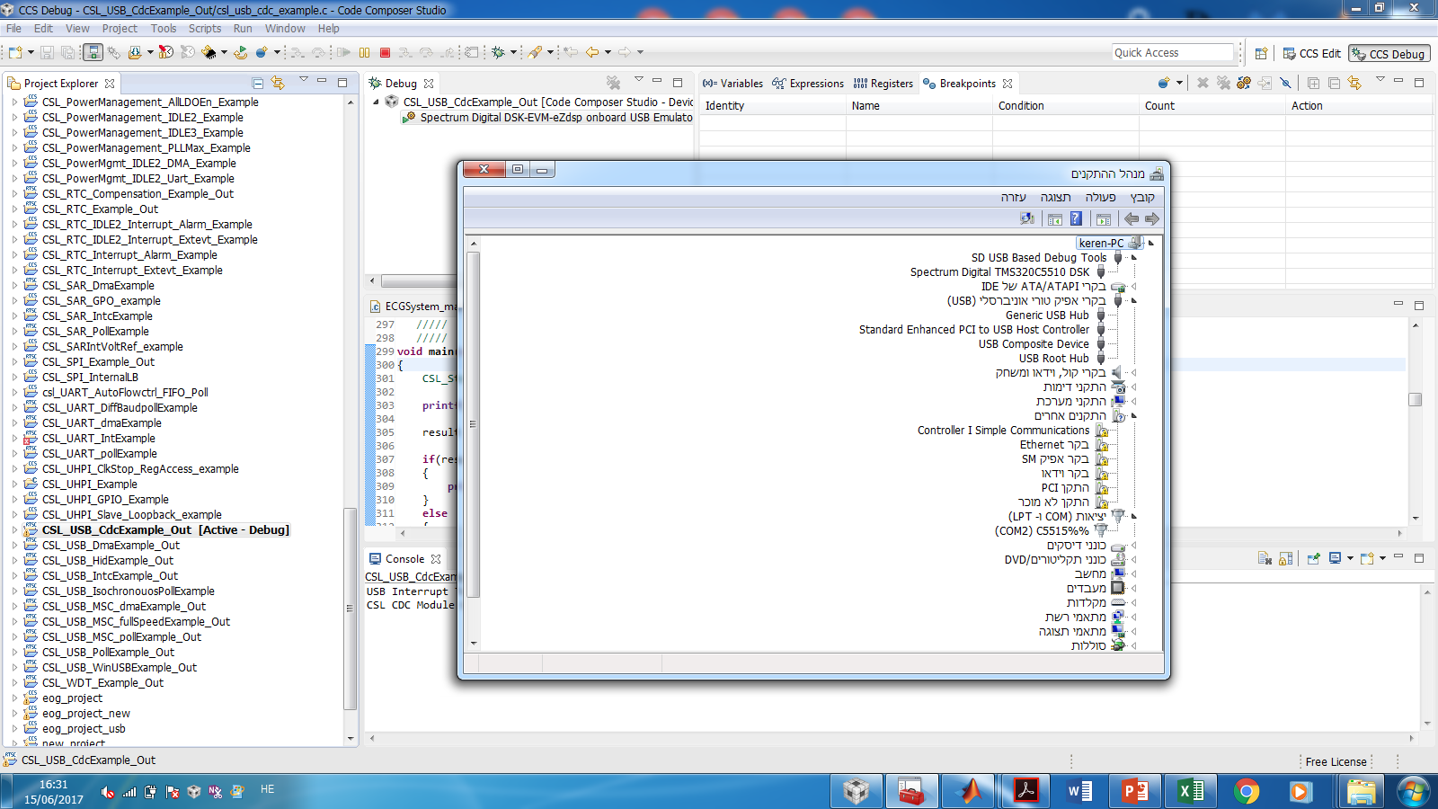
I got the messages: "CSL CDC Module Open Successful" and "USB SUSPEND Callback" at the console of CCS.
The COM port properties were the same as those of the CSL code:
Baud rate: 9600
Data bits: 8
Parity: none
Stop bits: 1
Flow control: none
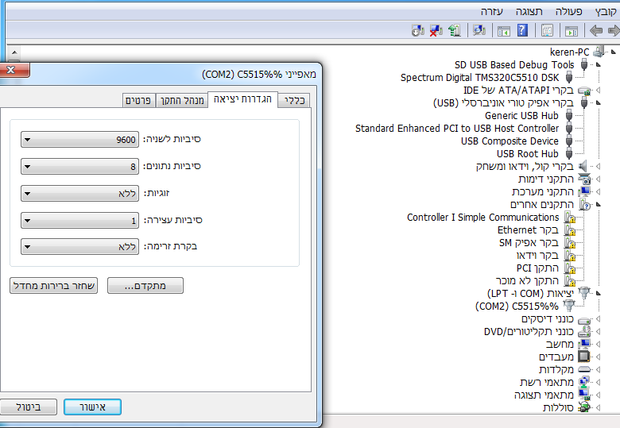
Then I opened PUTTY, filled in the parameters as below:
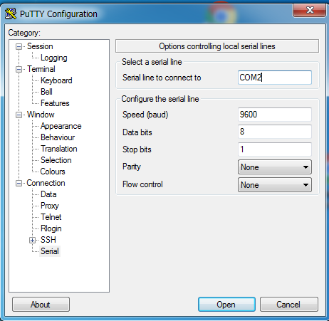
but PUTTY failed to open the COM port. I got this error: " Unable to open connection to COM2 Unable to configure serial port":
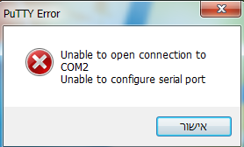
Moreover, I tried interfacing serial port with MATLAB but it failed to open serial port. I got error message. Here is the code with the error:
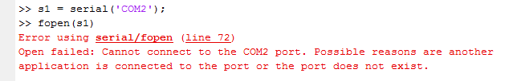
Could you explain those results?
Can you please explain us how to transfer data via USB COM port using TMS320C5515 EVM?
P.S. In the MMB0 the communication via USB port work properly for the ADS1298R (after downloading the appropriate drivers: NI-VISA and USBStyx drivers, as documented in http://www.ti.com/lit/ug/slau372a/slau372a.pdf ).
I would appreciate any help. Thanks in advance!!
Keren

