CPSW9G Port4 === 》PC

* Take CPSW9G-port4 as an example, and connect to PC, The default test is as follows. (the code is not modified)
* :Test1：TDA4: Create a vlan id13

**Result:**  Packet cannot be sent from CPSW9G (filtered by CPSW9G)

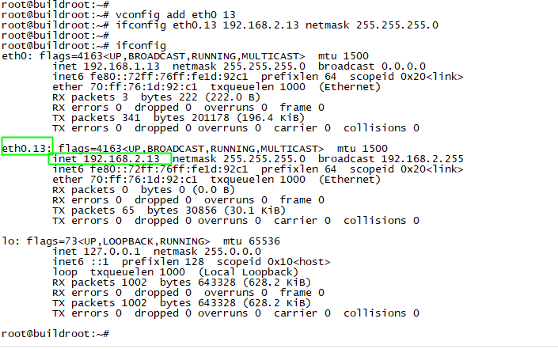

* Test2：Create a vlan id 300，and Vlan id 400 to 407

（By looking at the source code， ID300 belongs to the host port，Vlan id 400 to 407 belongs to other ports）

**Result:**  Packets can be sent from CPSW9G to PC, but Vlan ID is removed. Unable to ping

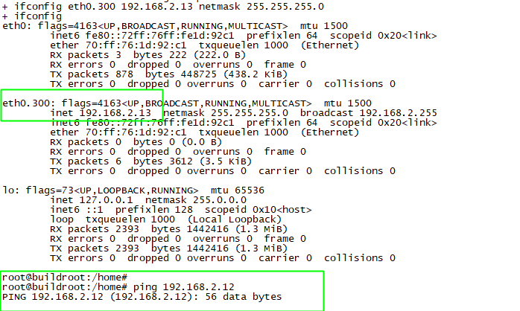

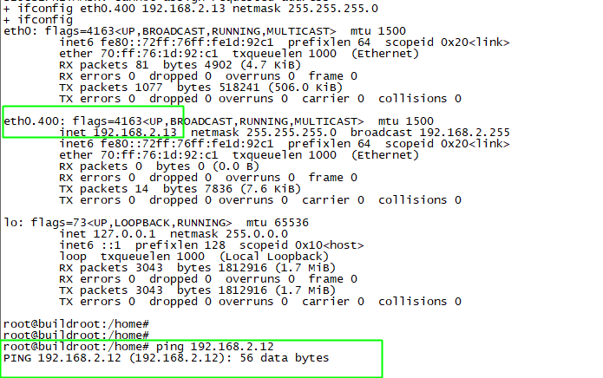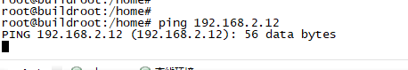

* The packet grabbed by the PC side can be seen without VlanID

(See the attachment for the original packets that grab vlanid300 and 400)

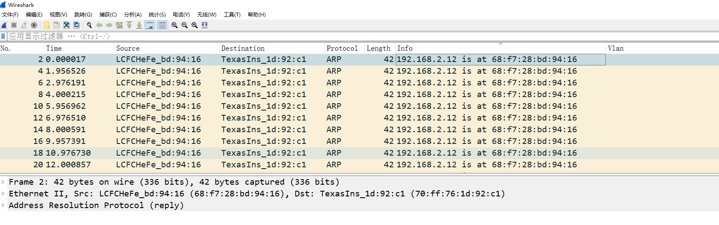

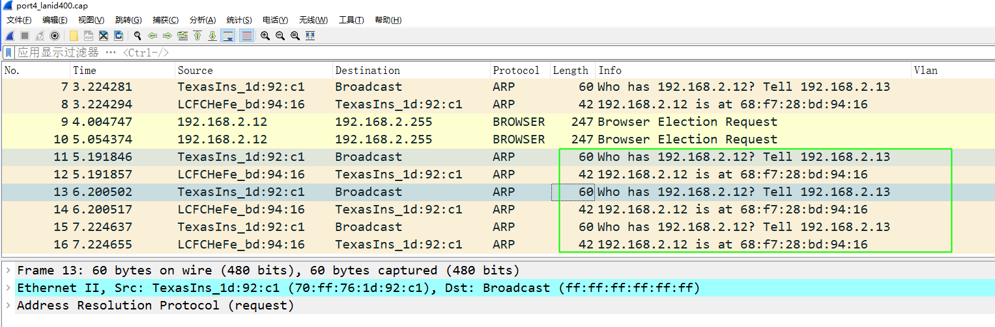

* Requirement:

**When sending packets trunck to port5, the VLAN ID(2/4/13) is retained  without any processing, and the corresponding VLANID packets can also be received normally.**