Here are the steps required to change the board id in Uboot:
- Type “i2c dev 0”
- Then, type “i2c probe” and following prompt will be displayed:
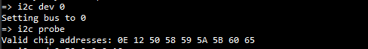
- To read the board id, type “i2c md 0x50 0.2 0x10” and following prompt will be displayed:
- To change the board id, type “i2c mw 0x50 8.2 0x34” and if you read it the board id should have changed.