One customer schematic referred a old board schematic, which did not connect VSS_OSC to GND directly.

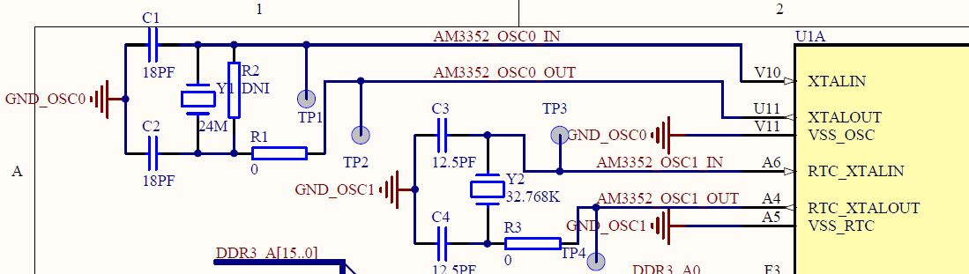

There are 3 boards, two boards can't boot, figured out the root cause is OSC0_OUT clock.

With the 18pf load capacitor, there is not clock generated, then change the capacitor to 10pf, 8pf, 6pf, OSC0_OUT can output clock, but the delay is larger and after POR as below, add a 1Mohm resistor on R2, also did not see improvement.

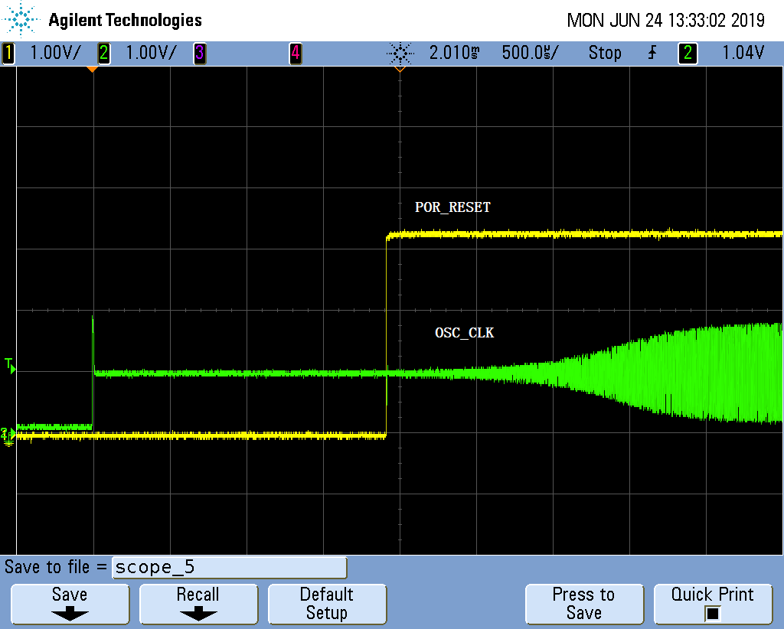

The working board, OSC_CLK output ahead of POR RESET as expected.

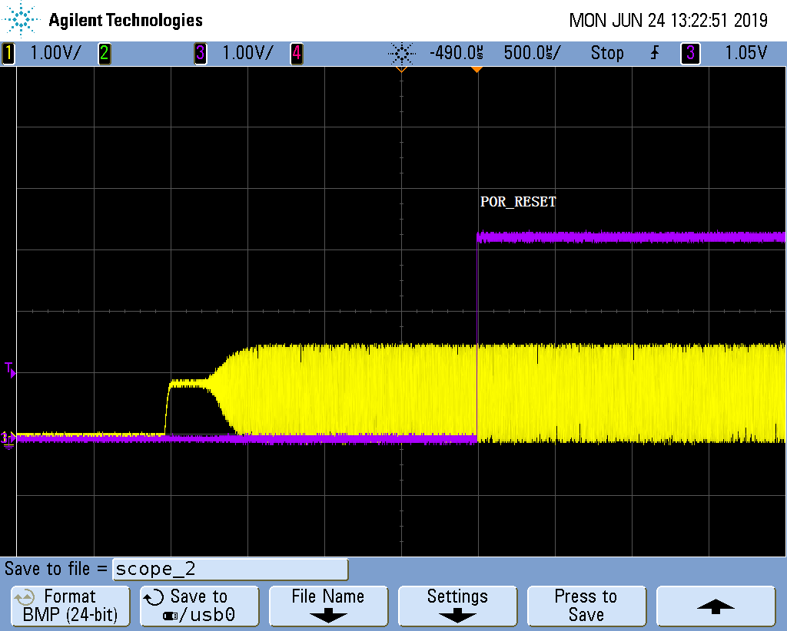

On the fail board, after power up, manually reset POR again, the board can boot up.

Another phenomenon, on the fail board, put normal oscilloscope probe on OSC_IN, the crystal stop working, AM3352 stop output CCCC from UART. it is very sensitive to loading capacitor. if use active oscilloscope probe, crystal can remain output clock.

the crystal clock layout as below:

