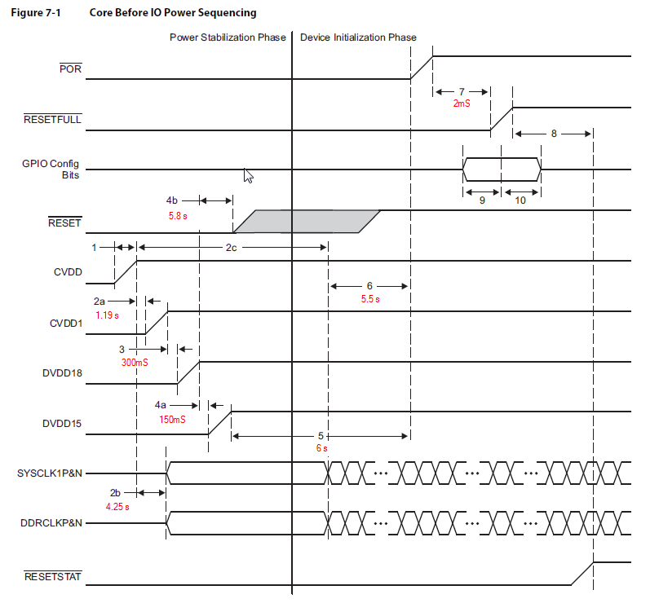

Figure 0‑3 DSP Power up/down sequence w/ measured values