Step 1: Follow the http://processors.wiki.ti.com/index.php/AM572x_GP_EVM_Hardware_Setup to setup the AM572x GP EVM.
Step 2: Connect CortexA15_0, below should be seen for the SOC initialization by GEL file from CCS console:
IcePick_D: GEL Output: Ipu RTOS is released from Wait-In-Reset.
IcePick_D: GEL Output: Ipu SIMCOP is released from Wait-In-Reset.
IcePick_D: GEL Output: IVAHD C66 is released from Wait-In-Reset.
IcePick_D: GEL Output: IVAHD ICONT1 is released from Wait-In-Reset.
IcePick_D: GEL Output: IVAHD ICONT2 is released from Wait-In-Reset.
CS_DAP_DebugSS: GEL Output: --->>> CONFIGURE DEBUG DPLL settings to 1.9 GHZs <<<---
CS_DAP_DebugSS: GEL Output: > Setup DebugSS 1.9GHz in progress...
CS_DAP_DebugSS: GEL Output: < Done with Setup DebugSS Trace export clock (TPIU) to 97MHz
CS_DAP_DebugSS: GEL Output: < Done with Setup DebugSS PLL Clocking 1.9GHz
CS_DAP_DebugSS: GEL Output: < Done with Setup DebugSS ATB Clocking 380MHz
CS_DAP_DebugSS: GEL Output: < Done with Setup DebugSS Trace export clock (TPIU) to 97MHz
CS_DAP_DebugSS: GEL Output: --->>> TURNING ON L3_INSTR and L3_3 clocks required for debug instrumention <<<<<<----
CS_DAP_DebugSS: GEL Output: ---<<< L3 instrumentation clocks are enabled >>>> ---
CS_DAP_DebugSS: GEL Output: --->>> Mapping TIMER supsend sources to default cores <<<<<<----
CS_DAP_PC: GEL Output: Cortex-A15 1 is not in WIR mode so nothing to do.
CortexA15_0: GEL Output: --->>> AM572x GP EVM <<<---
CortexA15_0: GEL Output: --->>> AM572x Target Connect Sequence Begins ... <<<---
CortexA15_0: GEL Output: --->>> I2C Init <<<---
CortexA15_0: GEL Output: --->>> AM572x Begin MMC2 Pad Configuration <<<---
CortexA15_0: GEL Output: --->>> AM572x End MMC2 Pad Configuration <<<---
CortexA15_0: GEL Output: --->>> AM572x PG2.0 GP device <<<---
CortexA15_0: GEL Output: --->>> PRCM Clock Configuration for OPPNOM in progress... <<<---
CortexA15_0: GEL Output: Cortex A15 DPLL OPP 0 clock config is in progress...
CortexA15_0: GEL Output: Cortex A15 DPLL is already locked, now unlocking...
CortexA15_0: GEL Output: Cortex A15 DPLL OPP 0 is DONE!
CortexA15_0: GEL Output: IVA DPLL OPP 0 clock config is in progress...
CortexA15_0: GEL Output: IVA DPLL OPP 0 is DONE!
CortexA15_0: GEL Output: PER DPLL OPP 0 clock config in progress...
CortexA15_0: GEL Output: PER DPLL already locked, now unlocking
CortexA15_0: GEL Output: PER DPLL OPP 0 is DONE!
CortexA15_0: GEL Output: CORE DPLL OPP 0 clock config is in progress...
CortexA15_0: GEL Output: CORE DPLL OPP already locked, now unlocking....
CortexA15_0: GEL Output: CORE DPLL OPP 0 is DONE!
CortexA15_0: GEL Output: ABE DPLL OPP 0 clock config in progress...
CortexA15_0: GEL Output: ABE DPLL OPP 0 is DONE!
CortexA15_0: GEL Output: GMAC DPLL OPP 0 clock config is in progress...
CortexA15_0: GEL Output: GMAC DPLL OPP 0 is DONE!
CortexA15_0: GEL Output: GPU DPLL OPP 0 clock config is in progress...
CortexA15_0: GEL Output: GPU DPLL OPP 0 is DONE!
CortexA15_0: GEL Output: DSP DPLL OPP 0 clock config is in progress...
CortexA15_0: GEL Output: DSP DPLL OPP 0 is DONE!
CortexA15_0: GEL Output: PCIE_REF DPLL OPP 0 clock config is in progress...
CortexA15_0: GEL Output: PCIE_REF DPLL OPP 0 is DONE!
CortexA15_0: GEL Output: --->>> PRCM Clock Configuration for OPP 0 is DONE! <<<---
CortexA15_0: GEL Output: --->>> PRCM Configuration for all modules in progress... <<<---
CortexA15_0: GEL Output: --->>> PRCM Configuration for all modules is DONE! <<<---
CortexA15_0: GEL Output: --->>> DDR3 Initialization is in progress ... <<<---
CortexA15_0: GEL Output: DDR DPLL clock config for 532MHz is in progress...
CortexA15_0: GEL Output: DDR DPLL clock config for 532MHz is in DONE!
CortexA15_0: GEL Output: Launch full leveling
CortexA15_0: GEL Output: Updating slave ratios in PHY_STATUSx registers
CortexA15_0: GEL Output: as per HW leveling output
CortexA15_0: GEL Output: HW leveling is now disabled. Using slave ratios from
CortexA15_0: GEL Output: PHY_STATUSx registers
CortexA15_0: GEL Output: Launch full leveling
CortexA15_0: GEL Output: Updating slave ratios in PHY_STATUSx registers
CortexA15_0: GEL Output: as per HW leveling output
CortexA15_0: GEL Output: HW leveling is now disabled. Using slave ratios from
CortexA15_0: GEL Output: PHY_STATUSx registers
CortexA15_0: GEL Output: Two EMIFs in interleaved mode - (2GB total)
CortexA15_0: GEL Output: --->>> DDR3 Initialization is DONE! <<<---
CortexA15_0: GEL Output: --->>> Mapping TIMER suspend sources to default cores <<<<<<----
CortexA15_0: GEL Output: --->>> IPU1SS Initialization is in progress ... <<<---
CortexA15_0: GEL Output: --->>> IPU1SS Initialization is DONE! <<<---
CortexA15_0: GEL Output: --->>> IPU2SS Initialization is in progress ... <<<---
CortexA15_0: GEL Output: --->>> IPU2SS Initialization is DONE! <<<---
CortexA15_0: GEL Output: --->>> DSP1SS Initialization is in progress ... <<<---
CortexA15_0: GEL Output: DEBUG: Clock is active ...
CortexA15_0: GEL Output: DEBUG: Checking for data integrity in DSPSS L2RAM ...
CortexA15_0: GEL Output: DEBUG: Data integrity check in GEM L2RAM is sucessful!
CortexA15_0: GEL Output: --->>> DSP1SS Initialization is DONE! <<<---
CortexA15_0: GEL Output: --->>> DSP2SS Initialization is in progress ... <<<---
CortexA15_0: GEL Output: DEBUG: Clock is active ...
CortexA15_0: GEL Output: DEBUG: Checking for data integrity in DSPSS L2RAM ...
CortexA15_0: GEL Output: DEBUG: Data integrity check in GEM L2RAM is sucessful!
CortexA15_0: GEL Output: --->>> DSP2SS Initialization is DONE! <<<---
CortexA15_0: GEL Output: --->>> IVAHD Initialization is in progress ... <<<---
CortexA15_0: GEL Output: DEBUG: Clock is active ...
CortexA15_0: GEL Output: --->>> IVAHD Initialization is DONE! ... <<<---
CortexA15_0: GEL Output: --->>> PRUSS 1 and 2 Initialization is in progress ... <<<---
CortexA15_0: GEL Output: --->>> PRUSS 1 and 2 Initialization is in complete ... <<<---
CortexA15_0: GEL Output: --->>> AM572x Target Connect Sequence DONE !!!!! <<<---
CortexA15_0: GEL Output: --->>> Mapping TIMER suspend sources to default cores <<<<<<----
CortexA15_0: GEL Output: --->>> IPU1SS Initialization is in progress ... <<<---
CortexA15_0: GEL Output: --->>> IPU1SS Initialization is DONE! <<<---
CortexA15_0: GEL Output: --->>> IPU2SS Initialization is in progress ... <<<---
CortexA15_0: GEL Output: --->>> IPU2SS Initialization is DONE! <<<---
CortexA15_0: GEL Output: --->>> DSP1SS Initialization is in progress ... <<<---
CortexA15_0: GEL Output: DEBUG: Clock is active ...
CortexA15_0: GEL Output: DEBUG: Checking for data integrity in DSPSS L2RAM ...
CortexA15_0: GEL Output: DEBUG: Data integrity check in GEM L2RAM is sucessful!
CortexA15_0: GEL Output: --->>> DSP1SS Initialization is DONE! <<<---
CortexA15_0: GEL Output: --->>> DSP2SS Initialization is in progress ... <<<---
CortexA15_0: GEL Output: DEBUG: Clock is active ...
CortexA15_0: GEL Output: DEBUG: Checking for data integrity in DSPSS L2RAM ...
CortexA15_0: GEL Output: DEBUG: Data integrity check in GEM L2RAM is sucessful!
CortexA15_0: GEL Output: --->>> DSP2SS Initialization is DONE! <<<---
CortexA15_0: GEL Output: --->>> IVAHD Initialization is in progress ... <<<---
CortexA15_0: GEL Output: DEBUG: Clock is active ...
CortexA15_0: GEL Output: --->>> IVAHD Initialization is DONE! ... <<<---
CortexA15_0: GEL Output: --->>> PRUSS 1 and 2 Initialization is in progress ... <<<---
CortexA15_0: GEL Output: --->>> PRUSS 1 and 2 Initialization is in complete ... <<<---

Step 3: Load vps_examples_displayDss_a15_0_debug/release.xa15fg and run:
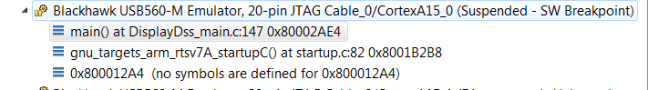
CCS console:
[CortexA15_0] DISP_DSS_APP: Sample Application - STARTS !!!
*** VPDMA Firmware Loading... ***
VPDMA Firmware Address = 0xa0011fc0
VPDMA Load Address = 0x4897d004
VPDMA Firmware Version = 0x4d0001b8
VPDMA List Busy Status = 0x00000000
*** VPDMA Firmware Load Success ***

*** VPDMA Firmware Loading... ***
VPDMA Firmware Address = 0xa0011fc0
VPDMA Load Address = 0x4899d004
VPDMA Firmware Version = 0x4d0001b8
VPDMA List Busy Status = 0x00000000
*** VPDMA Firmware Load Success ***

*** VPDMA Firmware Loading... ***
VPDMA Firmware Address = 0xa0011fc0
VPDMA Load Address = 0x489bd004
VPDMA Firmware Version = 0x4d0001b8
VPDMA List Busy Status = 0x00000000
*** VPDMA Firmware Load Success ***

*** VPDMA Firmware Loading... ***
VPDMA Firmware Address = 0xa0011fc0
VPDMA Load Address = 0x489dd004
VPDMA Firmware Version = 0x4d0001b8
VPDMA List Busy Status = 0x00000000
*** VPDMA Firmware Load Success ***

Build time : [17:02:58 May 25 2017]
FVID2 Version : [FVID_02_01_00_01]
BSP Version : [BSP_01_08_00_xx]
Platform : [EVM]
SOC : [AM572X]
SOC Revision : [ES2.0]
FT Revision : [3]
Package : [UNKNOWN]
Core : [A15]
Board Detected : [AM572X GP EVM]
EEPROM Base Board Name: [AM572PM_]
Base Board Revision : [REV A]
Daughter Card Revision: [REV A]

Load 4 YUV422I_YUYV video frames of size 1920x1080 to location: 0x0x81600000
Trying to Load buffer from SD card.
Couldnot Load buffer from SD card.
waiting for 1 min to load buffer from scripting consolePress any key (in UART console) after loading buffer
loadRaw(0x81600000, 0, "C:\\display_yuyv422_prog_packed_1920_1080.tigf", 32, false);

Similar printout from UART console:
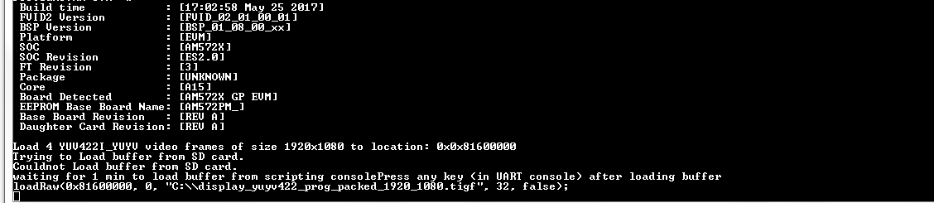
Step 4: Use View----- Scripting Console to open the console:
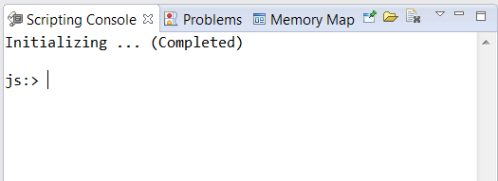
Step 5: Use Alt+F8 to halt A15_0 core, it can’t load during run
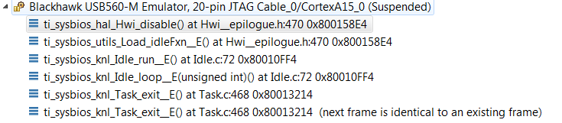
Step 6: Load the first video till finish:
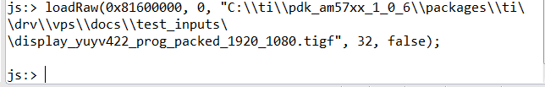
Step 7: Run A15_0 for UART to accept input
Step 8: Press “enter” in UART console, it asks you to enter the second video:
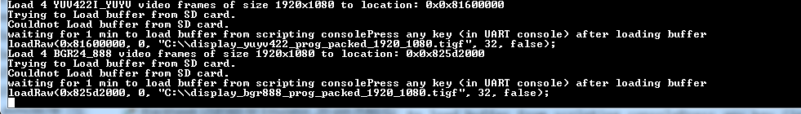
Step 9: Use Alt+F8 to halt A15_0 core again
Step 10: Load the second video till finish:

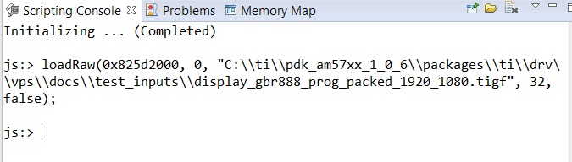
Step 11: Run A15_0 again for UART to accept input
Step 12: Press “enter” in UART console (same info printed in CCS console):
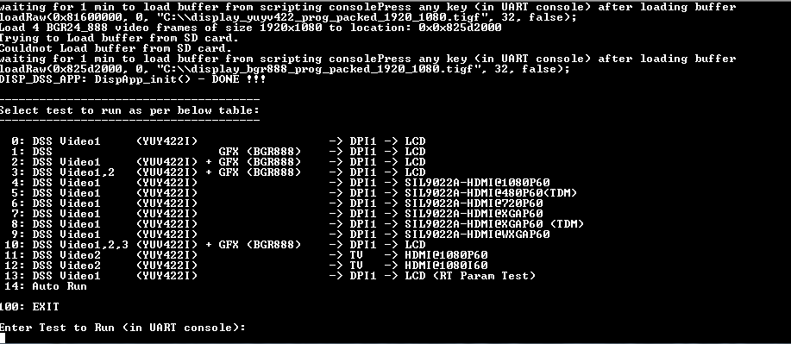
Step 13: select the test to run by enter the test number (E.g. 0) in UART:
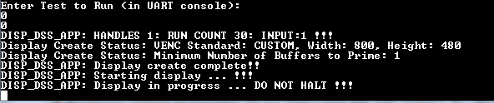
Video shall be displayed on LCD (due to AM572x GP EVM uses 800x480 pixel LCD, the display is partial)
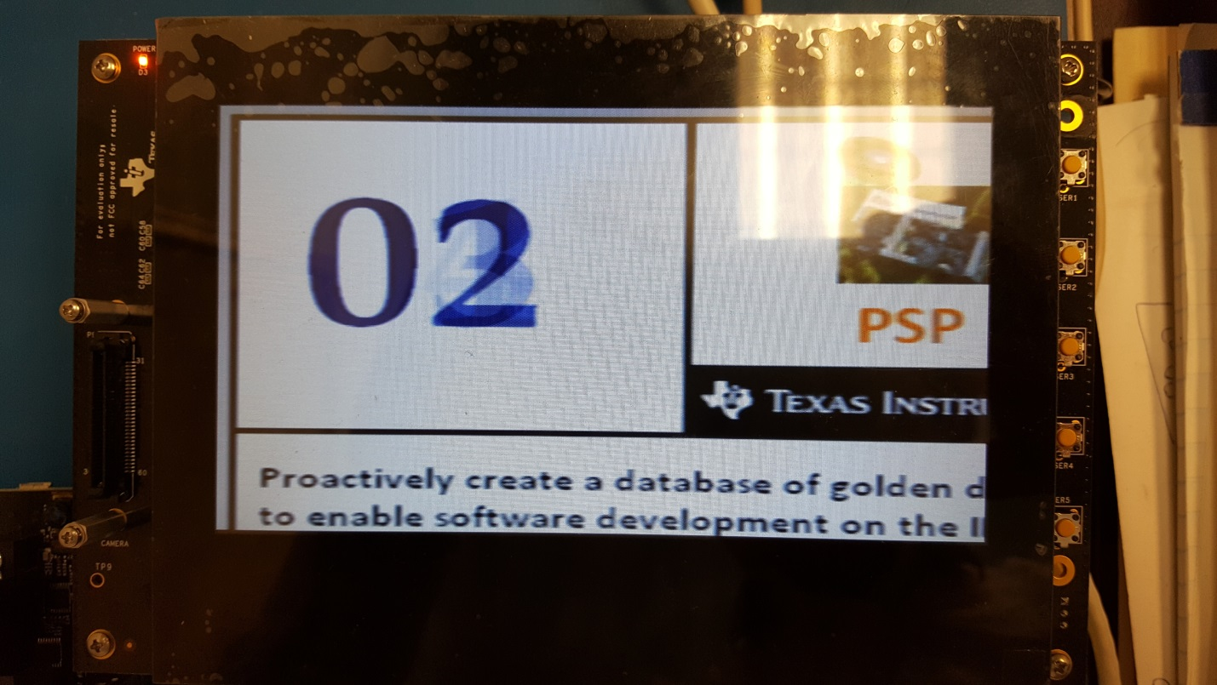
Step 14:
After the test done, statistics are printed and a new test can be selected:
