When I connect the DATA Concentrator EVM to the PC with 64 bit-Windows7 OS.
The following pops up:
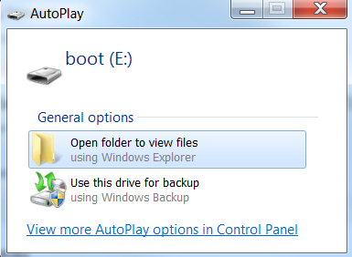
When I click open, I can see the following two files:

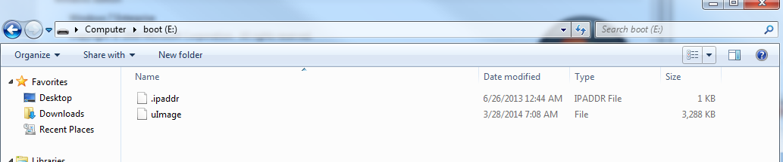
I have configured the COM ports as mentioned in the Quick start guide
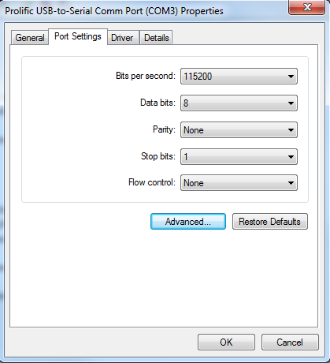
When I connect the DATA Concentrator EVM to the PC with Linux (Ubuntu).
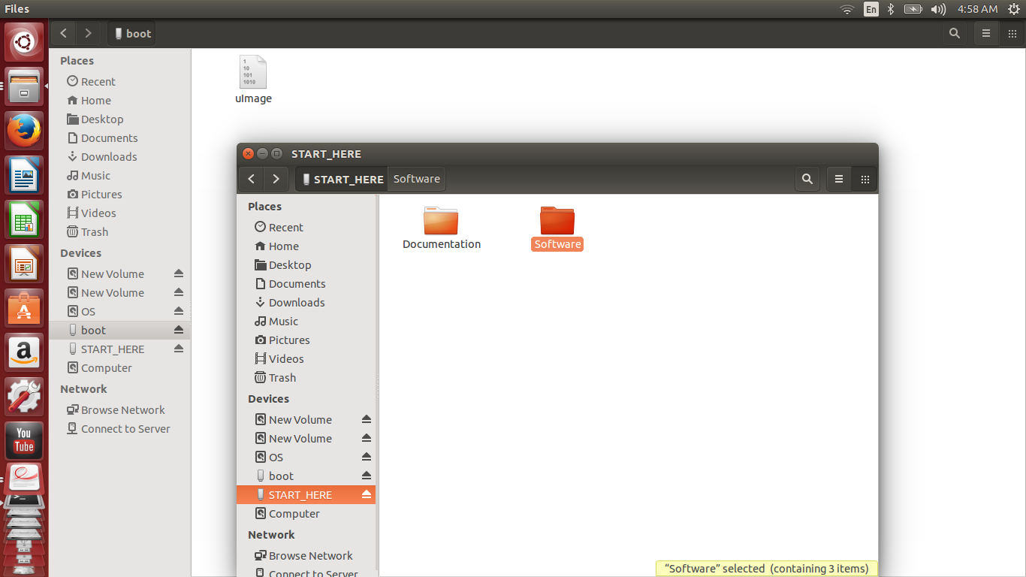

I got two folders Boot and Start here.

