EMIF Boot Mode Flash Interface Operation
Figure 1 below is a capture of the flash ouptuts and input during a normal DSP EMIF boot, where EMIF CE1 and the lower address and data line activity from the flash device are captured shortly after the flash reset is released. Here when CE1 is asserted low, the DSP starts to DMA 1KB data from flash to the DSP’s internal SRAM.
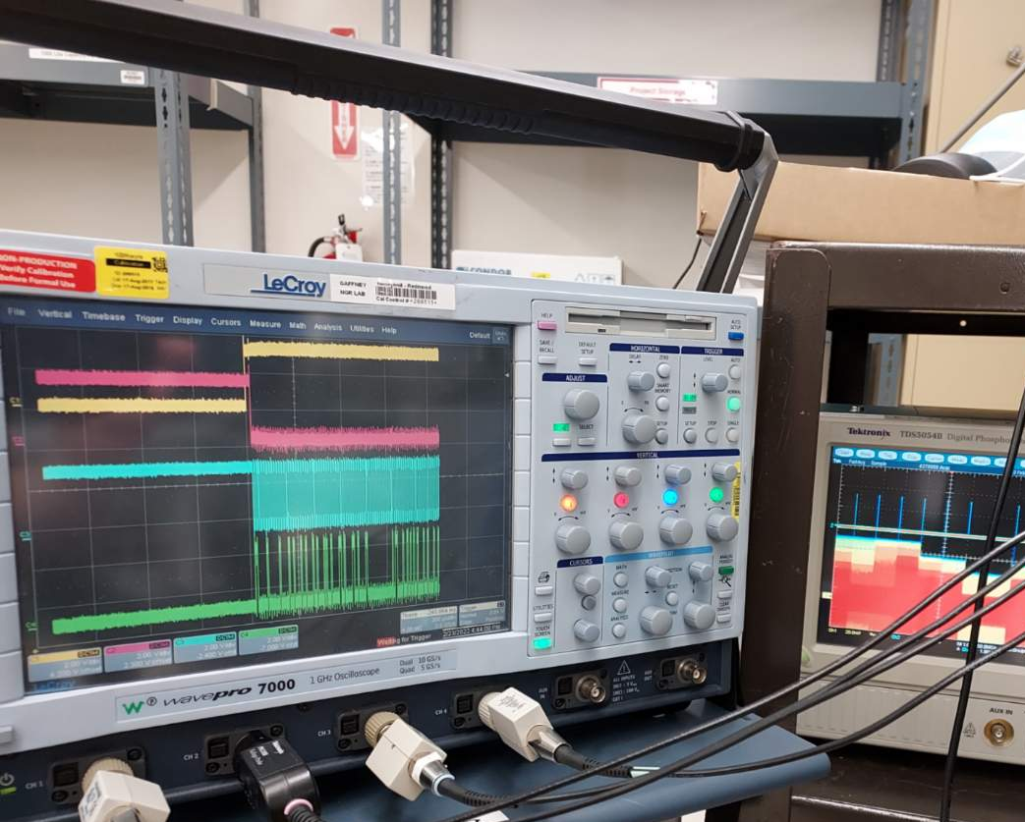
Figure 1 – Good boot of EMIF to flash (EMIF Boot mode).
Note: YELLOW flash reset is released high, then PINK/RED flash CE1 asserts low, BLUE flash lower address line and GREEN flash data line toggle during the DMA transfer.
During a failed boot state, the DSP EMIF CE1 is seen either not asserting, asserting late, or not holding up assertion during the entire 1K ROM transfer phase (as shown in Figure 2, below) from flash to the DSP internal SRAM. Thus, either no image or a corrupted image is present in SRAM which executes erratically by the DSP.
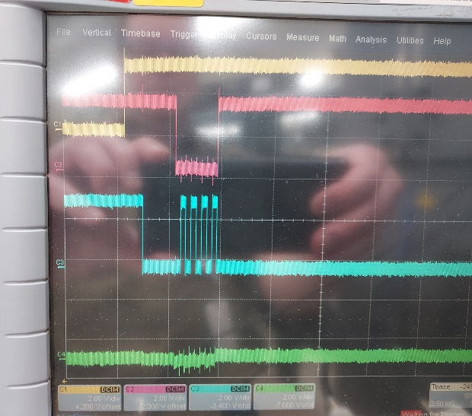
Figure 2 – Failed boot EMIF flash cold temperature -55C. Note late and imcomplete CE1 assertion relative to flash device release, but then CE1 is not held for the complete DMA of the 1K ROM image transfer to SRAM.
Further investigation showed that during a normal good boot event (Figure 3), CE1 asserts as expected while the other EMIF chip enable interfaces CE0 (FPGA base memory region) and CE2 (external SDRAM region) are held strongly unasserted during the EMIF Boot phase since those peripherals are not utilized during the EMIF boot time.
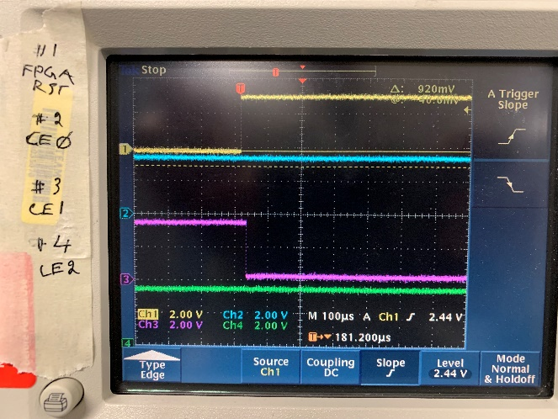
Figure 3 – CE0, CE1, & CE2 conditions during good boot. Note: YELLOW flash reset asserts high, PINK CE1 flashasserts low, stays low.
As can be seen in Figure 4 below during a failed boot event, CE1 is seen asserting late and then letting go, EMIFs CE0 and CE2 SDRAM are being asserted erratically during the EMIF Boot phase.
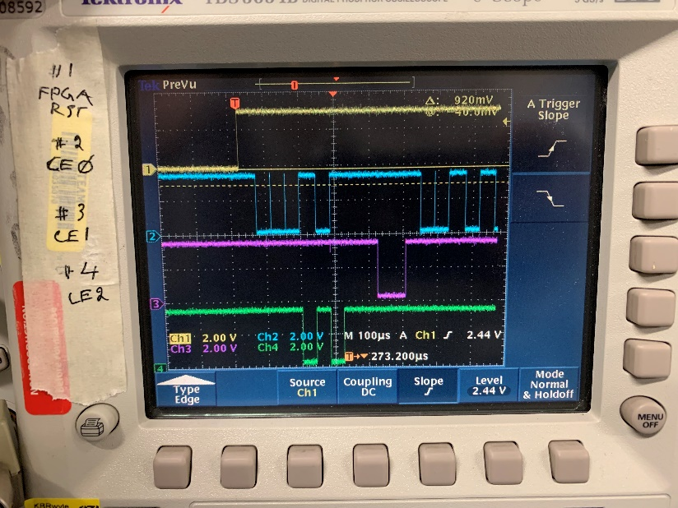
Figure 4 – YELLOW flash reset released at boot, CE0 BLUE(FPGA BMR), CE1 PINK (FLASH Access), & CE2 GREEN (SDRAM) states during a failed boot. Note that this particular failure event occurred between -15C and -18C immediately after power was applied.
Embedded here are more Scope shots depicting the three chip enables.

