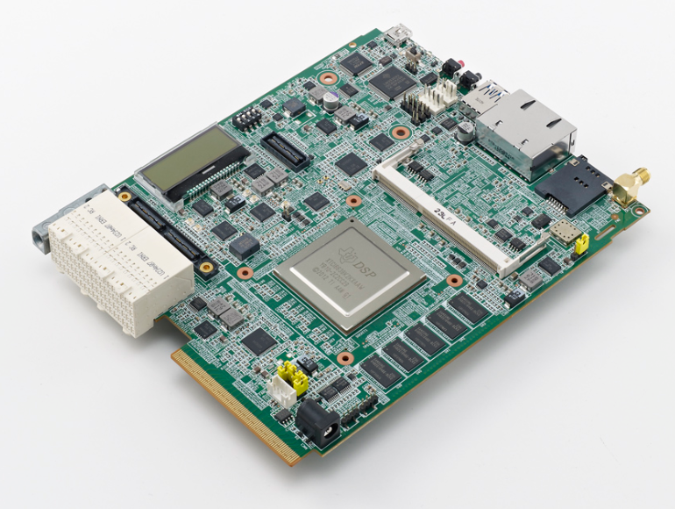
EVMK2H Evaluation Module
Quick Start Guide
Need updated graphic. For this build suggest we not use a graphic for the first page. Start with Photo of EVM.
EVMK2H Evaluation Module
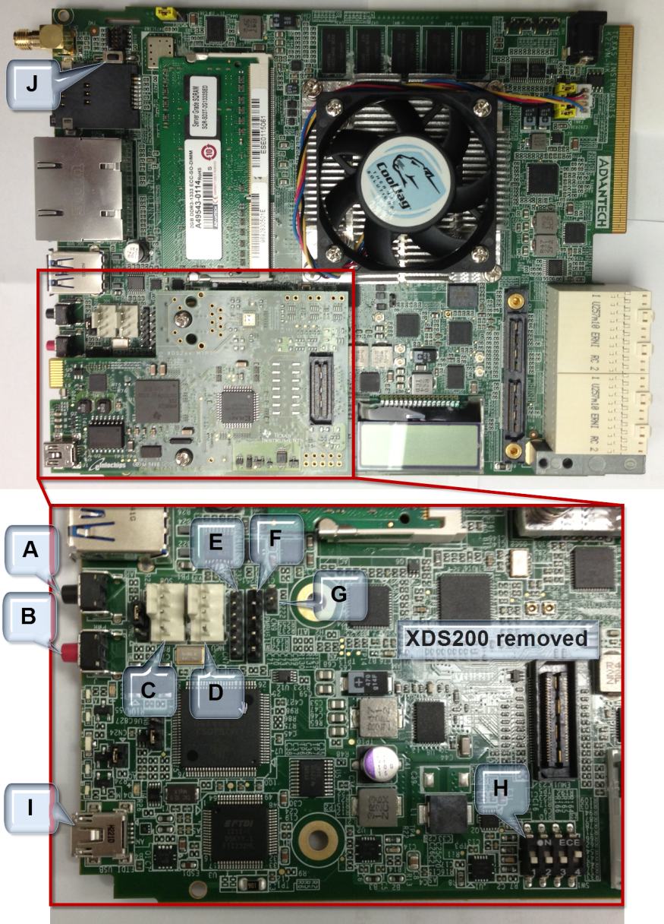
A | No Functionality | F | Reserve for factory programming
B | 1 press: safe shutdown of SOC;  2 presses within 0.5sec: warm reset;  3 presses with 0.5 sec: full reset;  4 presses with 0.5 sec: cancel reset | G | MCU Reset Jumper for BMC field update
C | COM2: SoC UART Console | H | Dip switch for boot configuration:  0001: No Boot/JTAG DSP Little Endian Boot mode  0010: NOR SPI Boot
D | COM1: MCU UART Console | I | Provide 2 console ports in USB interface ( same as “C” and “D”)
E | Reserve for factory programming | J | MCU Reset: Resets the microcontroller and will reset the entire board

Instructions to boot up out-of-box demonstration:
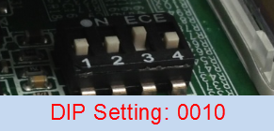 | 1  Ensure EVM configuration switch are set as shown for NOR SPI Boot.
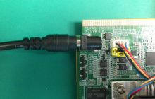  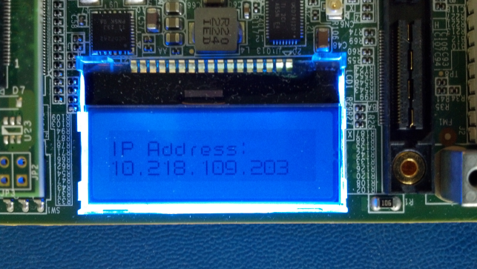  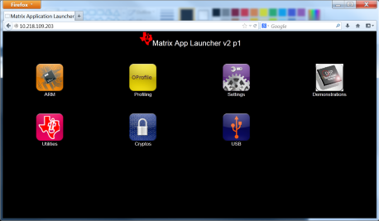 | 2  Connect Ethernet cable to ENET0. There should be a PC attached on the same network running DHCP server.  3  Insert DC-in cable to apply 12V power.  4  Note the IP address displayed on LCD screen. Enter this address into a web browser from PC that is on same network as EVM.  5  The browser will now connect to EVM and you can run out of box demonstration.

Getting Started:  Please see the ‘Getting Started’ chapter in the MCSDK User Guide for hardware and software setup: http://processors.wiki.ti.com/index.php/MCSDK_User_Guide_for_KeyStone_II.  Important Notes when handling the EVM:  - Plug in all the cables before powering ON the EVM to ensure proper grounding.  - Do not unnecessarily flex the boards, while inserting cables. Excessive flexing can break the PCB traces.  - Use proper ESD procedures when handling the EVM.  - Warning: Some components on the EVM may be too hot to touch with your bare hand when power is on.  Online Information  - TI device product page  http://www.ti.com/product/tci6634k2k  http://www.ti.com/product/tci6636k2h  http://www.ti.com/product/tci6638k2k  http://www.ti.com/product/66ak2h06  http://www.ti.com/product/66ak2h12  - Multicore SDK  http://www.ti.com/tool/bioslinuxmcsdk  http://processors.wiki.ti.com/index.php/MCSDK_User_Guide_for_KeyStone_II  - CCS v5 http://processors.wiki.ti.com/index.php/Category:Code_Composer _Studio_v5  - EVM  http://www.ti.com/tool/evmk2h  EVMK2H Information:  http://www.advantech.com/Support/TI-EVM/default.aspx  This link contains:  - Hardware & Software details  - User Guide  - Technical Reference Manual  EVMK2H EVM Support:  Please write to EVM667xsupport@advantech.com.tw for technical queries related to this EVM.  Advantech Address:  Advantech Co., Ltd.  No. 1, Alley 20, Lane 26, Rueiguang Rd., Neihu Dist., Taipei 114, Taiwan, R. O. C.  Toll Free: 0800-777-111  Phone:886-2-2792-7818  http://www.advantech.com/ | TI Worldwide Technical Support  Internet  TI Semiconductor Product Information Center Home Page  support.ti.com  TI Semiconductor KnowledgeBase Home page  support.ti.com/sc/knowledgebase  Product Information Centers  Americas  Phone +1(972) 644-5580 Fax +1(972)927-6377  Internet/Email support.ti.com/sc/pic/americas.htm  Europe, Middle East and Africa  Phone  European Free Call 00800-ASK-TEXAS  (00800 275 83927)  International +49 (0) 8161 80 2121  Russian Support +7 495 981 0701  Note: The European Free Call (Toll Free) number is not active in all countries. If you have technical difficulty calling the free call number, please use the international number above.  Fax +(49) (0) 8161 80 2045  Internet support.ti.com/sc/pic/euro.htm  Japan  Fax  International +81-3-3344-5317  Domestic 0120-81-0036  Internet/Email  International support.ti.com/sc/pic/japan.htm  Domestic www.tij.co.jp/pic  Asia  Phone  International +91-80-413816651-  Domestic Toll-Free-Number Toll-Free-Number  Australia 800-999-084 Malaysia 1-800-80-3973  China 800-820-8682 New Zealand 0800-446-934  Hong Kong 800-96-5941 Philippines 1-800-765-7404  India 1-800-425-7888 Singapore 800-886-1028  Indonesia 001-803-8861-1006 Taiwan 0800-006800  Korea 080-551-2804 Thailand 001-800-886-0010  Fax +886-2-2378-6808 Email tiasia@ti.com  ti-china@ti.com  Internet support.ti.com/sc/pic/asia.htm  Important Notice: The products and services of Texas  Instruments Incorporated and its subsidiaries described herein are sold subject to TI's standard terms and conditions of sale. Customers are advised to obtain the most current and complete information about TI products and services before placing orders. TI assumes no liability for applications assistance, customer's applications or product designs, software performance, or infringement of patents. The publication of information regarding any other company's products or services does not constitute TI's approval, warranty or endorsement thereof.  The floating bar is a trademark of Texas Instruments.  All other trademarks are the property of their respective owners

