The call stack shows that program is getting into exception when QSPIDisable() function is getting called from QSPI_open_v0().
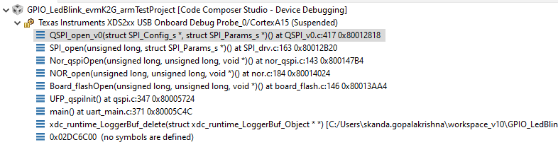
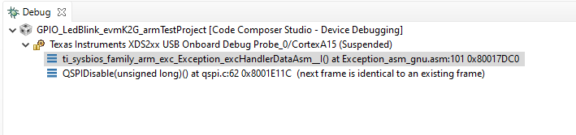
On Further analysis it is observed that the struction “hwAttrs” is not updating with the proper values from “spiInitCfg” leading to the exception.
