AIC3109EVM ADC to DAC Experiment
C5517 project
Modified from
C5505 project

C5517
(TARGET BOARD)
XDS100v2
(with Pin Convertor)

CCSv12 (PC)
JTAG

Fig.1 Structure of experiment

Picture.2 error window
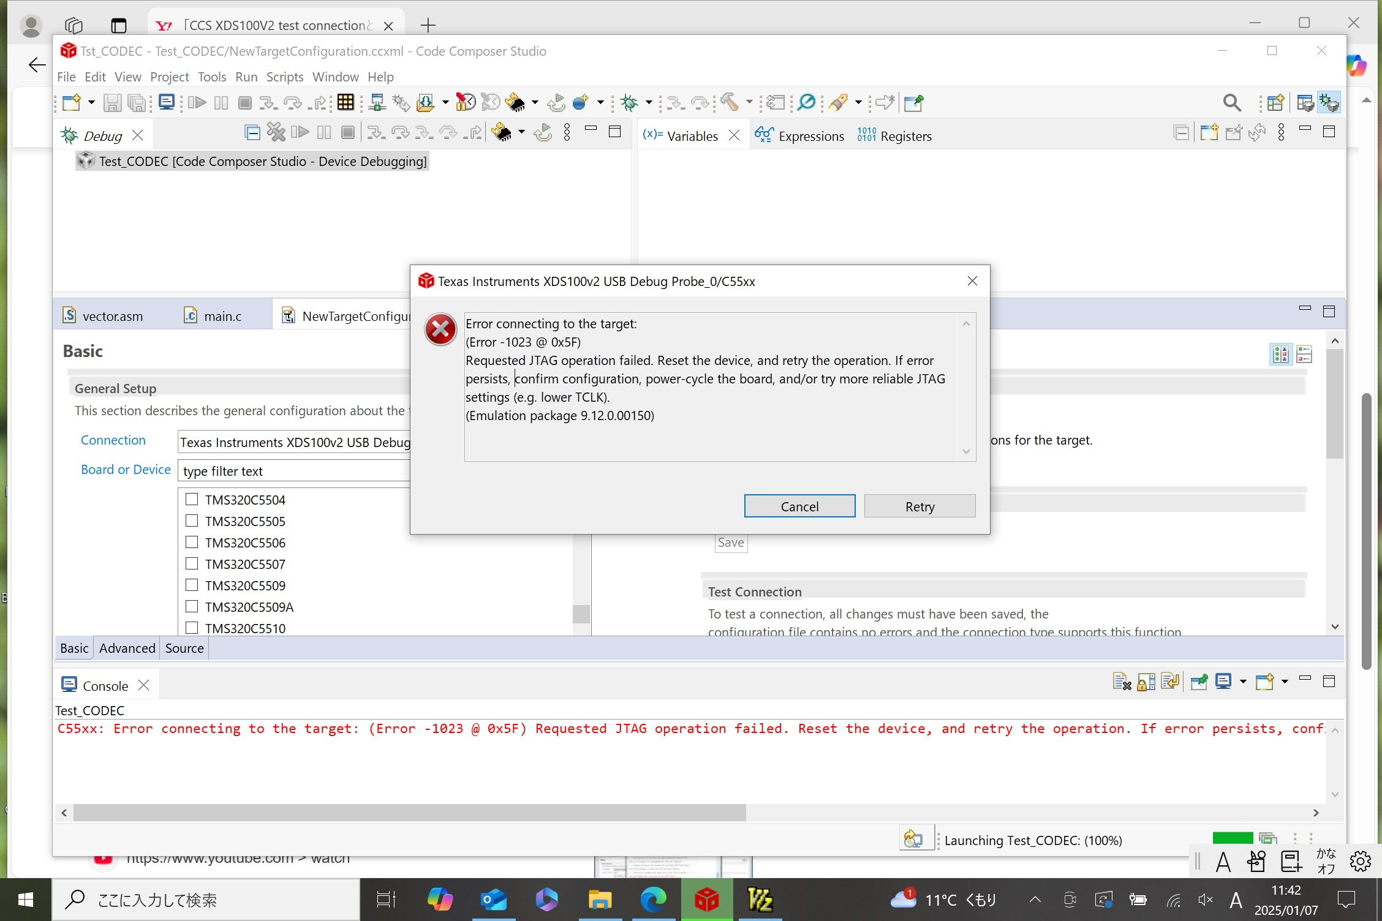
Pin Extender Board
JTAG

