1. **Generate -20dBV single tone at 5.5KHz and 13KHz. Both single tones have the same amplitude in spectrum.**

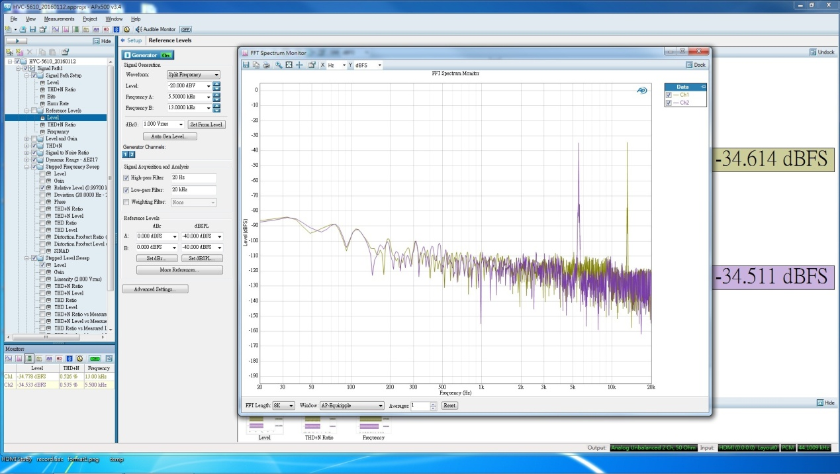

Figure 1. -20dB 5.5KHz and 13KHz single tone.

1. **Generate -40dBV single tone at 5.5KHz and 13KHz. Both single tones have the same amplitude in spectrum.**

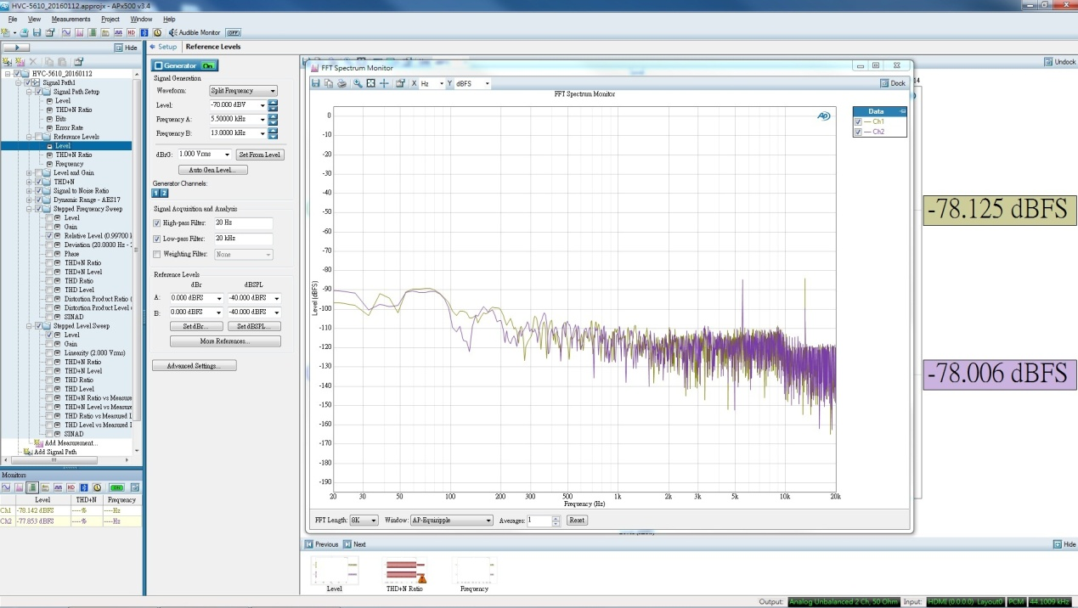

Figure 2. -40dB 5.5KHz and 13KHz single tone.

1. **Generate -75dBV single tone at 5.5KHz and 13KHz. The 13KHz disappear in spectrum.**

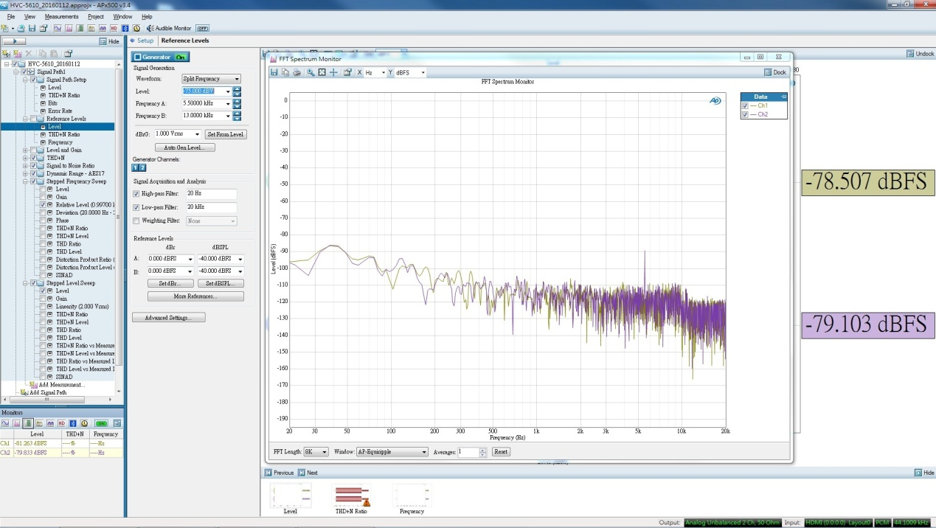

Figure 3. -75dB 5.5KHz and 13KHz single tone.

1. **Generate -80dBV single tone at 5.5KHz and 11KHz. Both single tones have the same amplitude in spectrum**

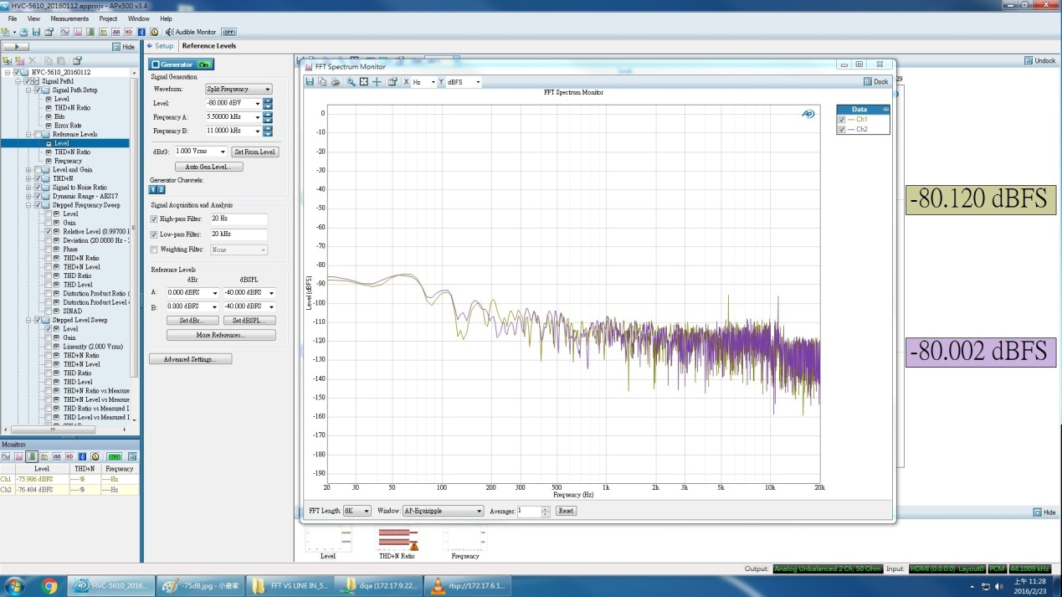

Figure 4. -80dB 5.5KHz and 11KHz single tone.

1. **Generate -90dBV single tone at 5.5KHz and 11KHz. Both single tones disappear in spectrum**

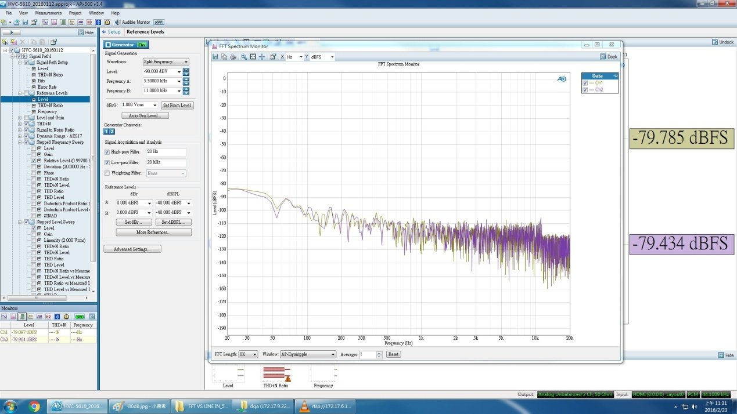

Figure 5. -90dB 5.5KHz and 11KHz single tone.