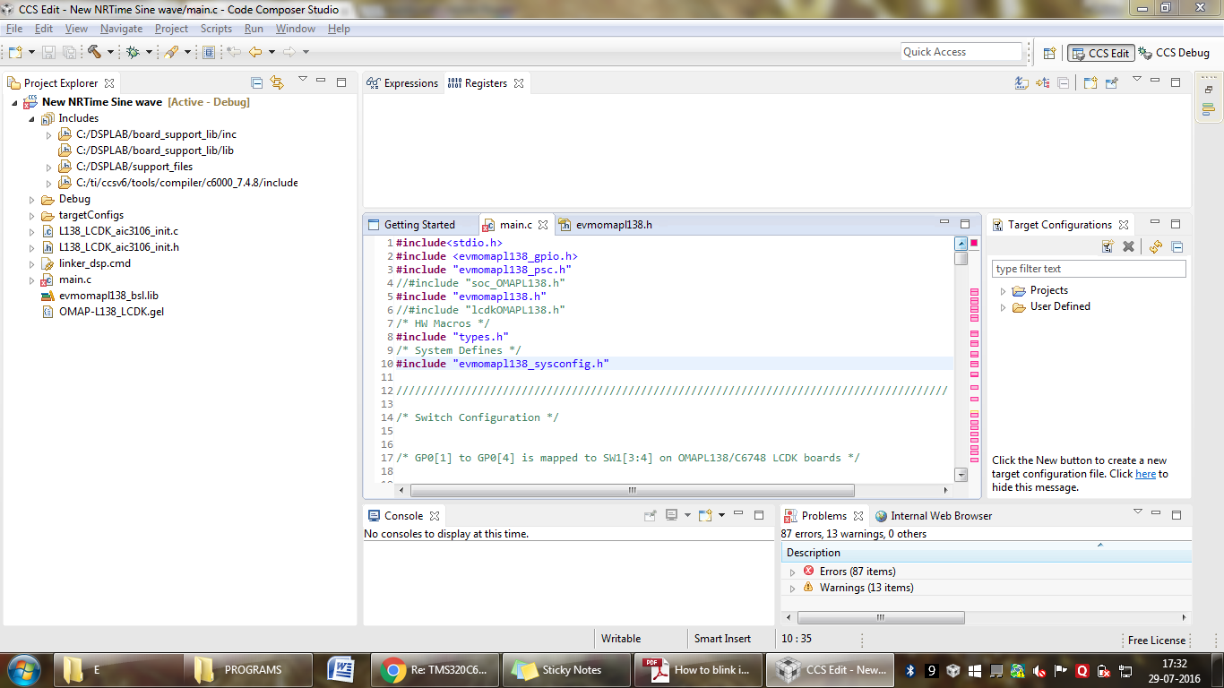**#include**<stdio.h>

**#include** <evmomapl138_gpio.h>

**#include** "evmomapl138_psc.h"

//#include "soc_OMAPL138.h"

**#include** "evmomapl138.h"

//#include "lcdkOMAPL138.h"

/* HW Macros */

**#include** "types.h"

/* System Defines */

**#include** "evmomapl138_sysconfig.h"

////////////////////////////////////////////////////////////////////////////////////////

/* Switch Configuration */

/* GP0[1] to GP0[4] is mapped to SW1[3:4] on OMAPL138/C6748 LCDK boards */

/* Pin Multiplexing bit mask to select GP0[1] to GP0[4] pin. */

**#define** PINMUX1_GPIO0_1_ENABLE (SYSCFG_PINMUX1_PINMUX1_27_24_GPIO0_1_SYSCFG_PINMUX1_PINMUX1_27_24_SHIFT)

**#define** PINMUX1_GPIO0_2_ENABLE (SYSCFG_PINMUX1_PINMUX1_23_20_GPIO0_2_SYSCFG_PINMUX1_PINMUX1_23_20_SHIFT)

**#define** PINMUX1_GPIO0_3_ENABLE (SYSCFG_PINMUX1_PINMUX1_19_16_GPIO0_3_SYSCFG_PINMUX1_PINMUX1_19_16_SHIFT)

**#define** PINMUX1_GPIO0_4_ENABLE (SYSCFG_PINMUX1_PINMUX1_15_12_GPIO0_4_SYSCFG_PINMUX1_PINMUX1_15_12_SHIFT)

/* LED Configuration */

/* GP6[12], GP6[13], GP2[12] and GP0[9] is mapped to D4, D5, D6, D7 LEDs on OMAPL138/C6748 LCDK boards */

/* Pin Multiplexing bit mask to select GP6[12] pin. */

**#define** PINMUX13_GPIO6_12_ENABLE (SYSCFG_PINMUX13_PINMUX13_15_12_GPIO6_12_SYSCFG_PINMUX13_PINMUX13_15_12_SHIFT)

/* Pin Multiplexing bit mask to select GP6[13] pin. */

**#define** PINMUX13_GPIO6_13_ENABLE (SYSCFG_PINMUX13_PINMUX13_11_8_GPIO6_13_SYSCFG_PINMUX13_PINMUX13_11_8_SHIFT)

/* Pin Multiplexing bit mask to select GP2[12] pin. */

**#define** PINMUX5_GPIO2_12_ENABLE (SYSCFG_PINMUX5_PINMUX5_15_12_GPIO2_12_SYSCFG_PINMUX5_PINMUX5_15_12_SHIFT)

/* Pin Multiplexing bit mask to select GP0[9] pin. */

**#define** PINMUX0_GPIO0_9_ENABLE (SYSCFG_PINMUX0_PINMUX0_27_24_GPIO0_9_SYSCFG_PINMUX0_PINMUX0_27_24_SHIFT)

**void** **PinMuxSetup_leds**(**void**)

{

**unsigned** **int** savePinmux = 0;

/*

** Clearing the bit in context and retaining the other bit values

** in PINMUX13 register.

*/

savePinmux = (HWREG(SOC_SYSCFG_0_REGS + SYSCFG0_PINMUX(13)) & ~(SYSCFG_PINMUX13_PINMUX13_15_12));

/* Setting the pins corresponding to GP6[12] in PINMUX13 register.*/

HWREG(SOC_SYSCFG_0_REGS + SYSCFG0_PINMUX(13)) =(PINMUX13_GPIO6_12_ENABLE | savePinmux);

/*

** Clearing the bit in context and retaining the other bit values

** in PINMUX13 register.

*/

savePinmux = (HWREG(SOC_SYSCFG_0_REGS + SYSCFG0_PINMUX(13)) & ~(SYSCFG_PINMUX13_PINMUX13_11_8));

/* Setting the pins corresponding to GP6[13] in PINMUX13 register.*/

HWREG(SOC_SYSCFG_0_REGS + SYSCFG0_PINMUX(13)) =(PINMUX13_GPIO6_13_ENABLE | savePinmux);

/*

** Clearing the bit in context and retaining the other bit values

** in PINMUX5 register.

*/

savePinmux = (HWREG(SOC_SYSCFG_0_REGS + SYSCFG0_PINMUX(5)) & ~(SYSCFG_PINMUX5_PINMUX5_15_12));

/* Setting the pins corresponding to GP2[12] in PINMUX5 register.*/

HWREG(SOC_SYSCFG_0_REGS + SYSCFG0_PINMUX(5)) =(PINMUX5_GPIO2_12_ENABLE | savePinmux);

/*

** Clearing the bit in context and retaining the other bit values

** in PINMUX0 register.

*/

savePinmux = (HWREG(SOC_SYSCFG_0_REGS + SYSCFG0_PINMUX(0)) &~(SYSCFG_PINMUX0_PINMUX0_27_24));

/* Setting the pins corresponding to GP0[9] in PINMUX0 register.*/

HWREG(SOC_SYSCFG_0_REGS + SYSCFG0_PINMUX(0)) =(PINMUX0_GPIO0_9_ENABLE | savePinmux);

}

**void** **PinMuxSetup_switches**(**void**)

{

**unsigned** **int** savePinmux = 0;

/* Setting the pins corresponding to GP0[1] in PINMUX1 register.*/

/*

** Clearing the bit in context and retaining the other bit values

** in PINMUX1 register.

*/

savePinmux = (HWREG(SOC_SYSCFG_0_REGS + SYSCFG0_PINMUX(1)) &~(SYSCFG_PINMUX1_PINMUX1_27_24));

HWREG(SOC_SYSCFG_0_REGS + SYSCFG0_PINMUX(1)) =(PINMUX1_GPIO0_1_ENABLE | savePinmux);

/* Setting the pins corresponding to GP0[2] in PINMUX1 register.*/

/*

** Clearing the bit in context and retaining the other bit values

** in PINMUX1 register.

*/

savePinmux = (HWREG(SOC_SYSCFG_0_REGS + SYSCFG0_PINMUX(1)) &~(SYSCFG_PINMUX1_PINMUX1_23_20));

HWREG(SOC_SYSCFG_0_REGS + SYSCFG0_PINMUX(1)) =(PINMUX1_GPIO0_2_ENABLE | savePinmux);

/* Setting the pins corresponding to GP0[3] in PINMUX1 register.*/

/*

** Clearing the bit in context and retaining the other bit values

** in PINMUX1 register.

*/

savePinmux = (HWREG(SOC_SYSCFG_0_REGS + SYSCFG0_PINMUX(1)) &~(SYSCFG_PINMUX1_PINMUX1_19_16));

HWREG(SOC_SYSCFG_0_REGS + SYSCFG0_PINMUX(1)) =(PINMUX1_GPIO0_3_ENABLE | savePinmux);

/* Setting the pins corresponding to GP0[4] in PINMUX1 register.*/

/*

** Clearing the bit in context and retaining the other bit values

** in PINMUX1 register.

*/

savePinmux = (HWREG(SOC_SYSCFG_0_REGS + SYSCFG0_PINMUX(1)) &~(SYSCFG_PINMUX1_PINMUX1_15_12));

HWREG(SOC_SYSCFG_0_REGS + SYSCFG0_PINMUX(1)) =(PINMUX1_GPIO0_4_ENABLE | savePinmux);

}

////////////////////////////////////////////////////////////////////////////////////////

//static void Delay(volatile unsigned int delay)

**int** **main**(**void**)

{

/* The Local PSC number for GPIO is 3. GPIO belongs to PSC1 module.*/

PSCModuleControl(SOC_PSC_1_REGS, HW_PSC_GPIO, PSC_POWERDOMAIN_ALWAYS_ON,

PSC_MDCTL_NEXT_ENABLE);

/* Pin Multiplexing of pins GP0[1] to GP0[4] of GPIO Bank 2 for DIP SWITCHEs in OMAPL138 LCDK board */

PinMuxSetup_switches();

/* Pin Multiplexing of pins GP6[12], GP6[13], GP2[12], GP0[9], for LEDs in OMAPL138 LCDK board */

PinMuxSetup_leds();

/* 2,3,4,5 is the GPIO no for GP0[1] to GP0[4]; Refer page no 901 in OMAPL138/C6748 TRM */

/* SWITCHEs SETUP */

/* Sets the pin 2 (GP0[1]) as input.*/

GPIODirModeSet(SOC_GPIO_0_REGS, 2, GPIO_DIR_INPUT);

/* Sets the pin 3 (GP0[2]) as input.*/

GPIODirModeSet(SOC_GPIO_0_REGS, 3, GPIO_DIR_INPUT);

/* Sets the pin 4 (GP0[3]) as input.*/

GPIODirModeSet(SOC_GPIO_0_REGS, 4, GPIO_DIR_INPUT);

/* Sets the pin 5 (GP0[4]) as input.*/

GPIODirModeSet(SOC_GPIO_0_REGS, 5, GPIO_DIR_INPUT);

/* LEDs SETUP */

/* Sets the pin 109 (GP6[12]) as output.*/

GPIODirModeSet(SOC_GPIO_0_REGS, 109, GPIO_DIR_OUTPUT);

/* Sets the pin 110 (GP6[13]) as output.*/

GPIODirModeSet(SOC_GPIO_0_REGS, 110, GPIO_DIR_OUTPUT);

/* Sets the pin 45 (GP2[12]) as output.*/

GPIODirModeSet(SOC_GPIO_0_REGS, 45, GPIO_DIR_OUTPUT);

/* Sets the pin 10 (GP0[9]) as output.*/

GPIODirModeSet(SOC_GPIO_0_REGS, 10, GPIO_DIR_OUTPUT);

**while**(1)

{

/* 2,3,4,5 is the GPIO no for GP0[1] to GP0[4]; Refer page no 901 in OMAPL138/C6748 TRM */

**if** (GPIOPinRead(SOC_GPIO_0_REGS, 2))

{

GPIOPinWrite(SOC_GPIO_0_REGS, 109, GPIO_PIN_LOW);

**printf**("S1 is not pressed\n");

}

**else**

{

**printf**("S1 is pressed\n");

GPIOPinWrite(SOC_GPIO_0_REGS, 109, GPIO_PIN_HIGH);

}

**if** (GPIOPinRead(SOC_GPIO_0_REGS, 3))

{

GPIOPinWrite(SOC_GPIO_0_REGS, 110, GPIO_PIN_LOW);

**printf**("S2 is not pressed\n");

}

**else**

{

**printf**("S2 is pressed\n");

GPIOPinWrite(SOC_GPIO_0_REGS, 110, GPIO_PIN_HIGH);

}

**if** (GPIOPinRead(SOC_GPIO_0_REGS, 4))

{

GPIOPinWrite(SOC_GPIO_0_REGS, 45, GPIO_PIN_LOW);

**printf**("S3 is not pressed\n");

}

**else**

{

**printf**("S3 is pressed\n");

GPIOPinWrite(SOC_GPIO_0_REGS, 45, GPIO_PIN_HIGH);

}

**if** (GPIOPinRead(SOC_GPIO_0_REGS, 5))

{

GPIOPinWrite(SOC_GPIO_0_REGS, 10, GPIO_PIN_LOW);

**printf**("S4 is not pressed\n");

}

**else**

{

**printf**("S4 is pressed\n");

GPIOPinWrite(SOC_GPIO_0_REGS, 10, GPIO_PIN_HIGH);

}

}

}

////////////// Errors ///////////////////////////////////////////////////////////////////////////

