How can i use uniflash to load the uboot with uart on board?

- Using UART to load the U-boot binaries
Preconditions: Irzsz packet is installed
- Using x & y modem protocols

Steps to be followed using UART x&y modem protocols:

$ sb --xmodem $OUT_R5/tiboot3.bin > $UART_BOOT_MCU_UART < $UART_BOOT_MCU_UART
$ sb --ymodem $SYSFW_ITB > $UART_BOOT_MCU_UART < $UART_BOOT_MCU_UART
$ sb --ymodem $OUT_AXX/tispl.bin > $UART_BOOT_MAIN_UART < $UART_BOOT_MAIN_UART
$ sb --xmodem $OUT_AXX/u-boot.img > $UART_BOOT_MAIN_UART < $UART_BOOT_MAIN_UART

The picture 1 shows using the UART using x & x modem protocol to load files to boot the board into U-Boot.
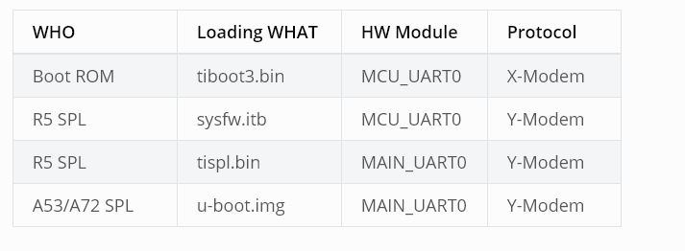
Picture1

- Using OSPI device
Below commands can be used to download tiboot3.bin, tispl.bin and u-boot.img over tftp and then flash it to OSPI at respective addresses.
Assumption – The u-boot files are loaded from SD Card.
=> sf probe
=> tftp ${loadaddr} tiboot3.bin
=> sf update $loadaddr 0x0 $filesize
=> tftp ${loadaddr} tispl.bin
=> sf update $loadaddr 0x80000 $filesize
=> tftp ${loadaddr} u-boot.img
=> sf update $loadaddr 0x280000 $filesize
=> tftp ${loadaddr} sysfw.itb
=> sf update $loadaddr 0x6C0000 $filesize

To boot kernel from OSPI, at the U-Boot prompt:
=> setenv boot ubi
=> boot

- Using QSPI

- When using QSPI_1 build with dra7xx_evm_config
U-Boot # mmc rescan
U-Boot # fatload mmc 0 ${loadaddr} MLO
U-Boot # sf probe 0
U-Boot # sf erase 0x00000 0x100000
U-Boot # sf write ${loadaddr} 0x00000 ${filesize}
U-Boot # fatload mmc 0 ${loadaddr} u-boot.img
U-Boot # sf write ${loadaddr} 0x40000 ${filesize}

change SW2[5:0] = 110110 for qspi boot.
- Booting from QSPI from u-boot

U-Boot # sf probe 0
U-Boot # sf read ${loadaddr} 0x1e0000 0x800000
U-Boot # sf read ${fdtaddr} 0x140000 0x80000
U-Boot # setenv bootargs console=${console} root=/dev/mtdblock19 rootfstype=jffs2
U-Boot # bootz ${loadaddr} - ${fdtaddr}

