Just to illustrate the steps that are needed, I did it on my environment:
Step 1: First I changed the setting of PDK_INSTALL_PATH and SDK_INSTALL_PATH in the file pdksetupenv.bat that is in my directory C:\ti\Releases\PROCESSOR_SDK_RTOS_AM57X_02_00_00_00\pdk_am57xx_1_0_0\packages to the values below. You may have a different location for pdk and different location for CCS, so change accordingly

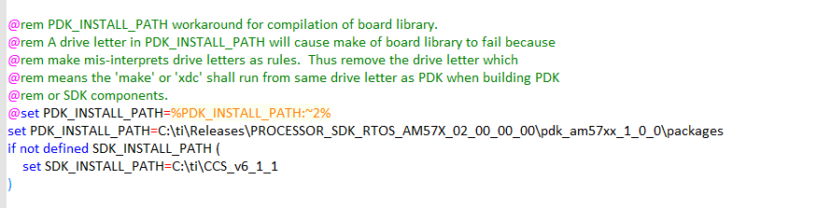
Step 2: Next I made sure that CCS detected ALL the component of the release if the release was not installed in the default location (c:\ti). In CCS (any prospective) I click on the window Tab and choose Preferences. A dialogue box is opened. Choose Code Composer Studio-> RTSC -> Products and add the location where the release is. In my case it is in C:\ti\Releases\PROCESSOR_SDK_RTOS_AM57X_02_00_00_00. See the screen shot below

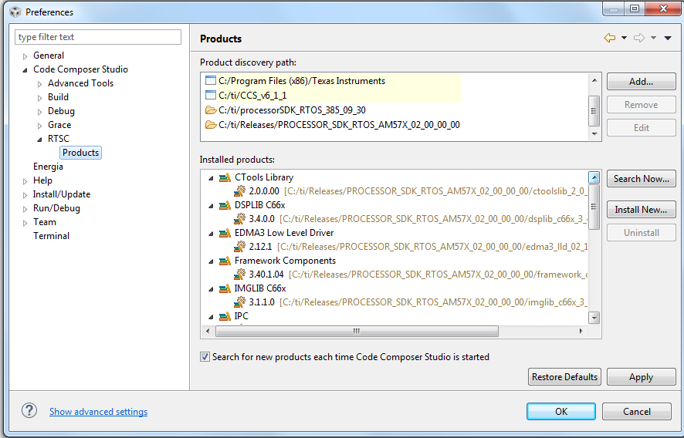
Click on Apply and OK. CCS will try to see if there are new modules to add. If there are, Select all and finish. Click OK on the security warning:
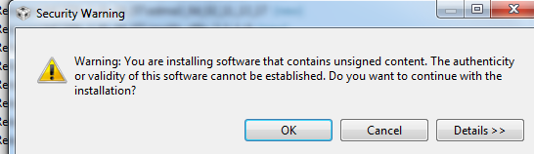
Click yes on the restart dialogue box:
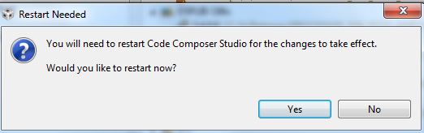

CCS will restart. After CCS restart, close CCS because the batch files that we use will not work with CCS in the background.
Step 3: Run the batch files
Open a CMD windows and cd it to the packages directory of pdk. In my setting it is C:\ti\Releases\PROCESSOR_SDK_RTOS_AM57X_02_00_00_00\pdk_am57xx_1_0_0\packages the default location is c:\ti\pdk_version\packages.
Run the first batch file pdksetupenv.bat, see the following screen shot:
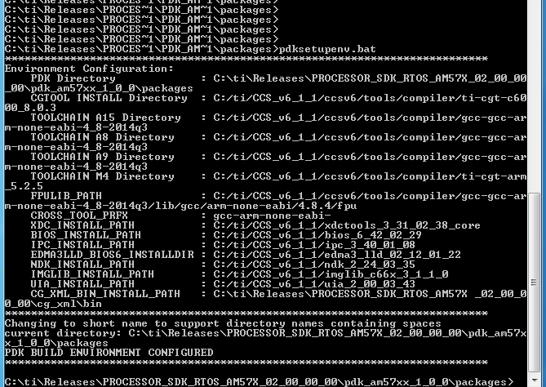
Finally following the instruction at the top of the pdkprojectCreate.bat I run the batch file twice, once for the ARM projects and once for the DSP projects. (I have not run the m4 projects)
The ARM projects create:

The DSP projects create:
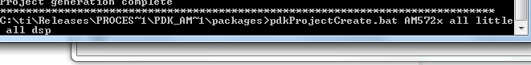

It takes a while to run the batch files. Check for error messages. If the batch files run correctly, DSP and ARM projects are created.

Step 4: Using CCS to build projects
Start CCS in the Edit prospective, from the Project tab select import project, browse to the packages location. The next screen shots show what projects are available. Choose the one that you want and continue
