KeyStone II SOC Memory Performance
Brighton Feng, Vincent Han

Abstract
KeyStone II SOC integrates up to eight 1.2GHz C66x DSP cores and four 1.4GHz ARM Cortex A15 cores. Each DSP core has up to 1MB Local memory; all DSP cores and ARM cores share up to 6MB internal shared memory; 64-bit 1600MTS DDR3 interface is provided to support up to 8GB external memory. All the memories can be accessed by DSP cores, ARM cores and multiple DMA masters through TeraNet switch fabric.
Memory access performance is very critical for software running on the KeyStone II SOC. This application report provides measured performance data including throughput and latency achieved under various operating conditions. Some factors affecting memory access performance are discussed, such as access stride, index and conflict, etc.
The application report should be helpful for analyzing following common questions:
- Should I use DSP core, ARM core or DMA for data copy?
- How should I partition data processing tasks between DSP cores and ARM cores?
- How many cycles will be consumed for my function with many memory accesses?
- How much degradation will be caused by multiple masters sharing memory?

Contents
Introduction 4
Comparison of DSP Core, ARM core and EDMA3/IDMA for memory copy 6
Latency of DSP core access memory 11
Latency of DSP core access LL2 11
Latency of DSP core access MSRAM 12
Latency of DSP core access external DDR memory 14
Latency of ARM core access memory 18
Latency of ARM core access MSRAM 18
Latency of ARM core access extern DDR memory 19
Performance of DMA access memory 22
DMA Transfer overhead 22
EDMA performance Difference between 14 transfer engines 23
EDMA Throughput vs Transfer Flexibility 24
First Dimension Size (ACNT) Considerations, Burst width 24
Two Dimension Considerations, Transfer Optimization 25
Index Consideration 25
Address Alignment 26
Performance of Multiple masters sharing memory 26
Performance of Multiple masters sharing MSMC RAM 30
Performance of Multiple DSP cores sharing MSMC RAM 30
Performance of Multiple EDMA sharing MSMC RAM 31
Performance of Multiple masters sharing DDR 34
Performance of Multiple DSP cores sharing DDR 35
Performance of Multiple EDMA sharing DDR 39
Performance of Multiple ARM cores sharing memory 42
References 43
Figures
Figure 1. KeyStone II SOC Memory System 4
Figure 2. DSP Core access LL2 12
Figure 3. DSP Core access MSRAM 13
Figure 4. Performance of DSP core access MSRAM vs LL2 14
Figure 5. DSP Core Load/Store on DDR3A 16
Figure 6. DSP Core Load/Store on DDR3B 17
Figure 7. ARM Core access MSRAM 19
Figure 8. ARM Core access DDR3A 20
Figure 9. ARM Core access DDR3B 21
Figure 10. effect of ACNT size on EDMA throughput 24
Figure 11. Linear 2D transfer 25
Figure 12. Index effect on EDMA throughput 26
Figure 13. Multiple DSP cores copy date to/from same shared memory 27
Figure 14. Multiple ARM cores copy date to/from same shared memory 27
Figure 15. Multiple EDMA TCs copy date to/from MSRAM 28
Figure 16. Multiple EDMA TCs copy date to/from DDR3A 29
Figure 17. Data organization on MSMC RAM banks 30
Figure 18. Data organization on DDR banks 34
Figure 19. Multiple master access different rows on same DDR bank 35
Figure 20. Multiple master access different rows on different DDR banks 35
Figure 21. Comparison of multiple DSP cores and multiple ARM cores sharing DDR 42
Tables
Table 1. KeyStone II Memory system comparison 5
Table 2. Theoretical bus bandwidth of CPU, and DMA on 1.2GHz KeyStone II 6
Table 3. Maximum Throughput of Different Memory Endpoints on 1.2GHz KeyStone II 7
Table 4. Transfer throughput comparison between DSP core, EDMA and IDMA 8
Table 5. EDMA CC0 and CC4 Transfer Overhead 22
Table 6. EDMA CC1, CC2 and EDMA CC3 Transfer Overhead 22
Table 7. Difference between TCs 23
Table 8. Throughput comparison between TCs on 1.2GHz KeyStone II 23
Table 9. Performance of Multiple DSP cores sharing MSMC RAM 30
Table 10. Performance of Multiple EDMA sharing MSMC RAM 32
Table 11. Performance of Multiple DSP cores sharing DDR 35
Table 12. Effect of DDR priority raise count 38
Table 13. Performance of Multiple EDMA sharing DDR 39
Table 14. Probability of multiple masters access same DDR bank in 8 banks 41
Table 15. Performance of Multiple ARM cores sharing memory 42

Introduction
Figure 1 shows the memory system of KeyStone II SOC. The number on the line is the bus width. Most modules run at DSP CoreClock/n; ARM core speed may be different from DSP core speed; the DDR typically runs at 1600MTS (Million Transfer per Second).
- KeyStone II SOC Memory System
For different devices in the KeyStone II family, the size of memory are different, the number of CPU core and the number of EDMA transfer controller are also different. Table 1 summarizes these differences of KeyStone II devices.
- KeyStone II Memory system comparison
 | K2H/K2K | K2L | K2E
L1D(KB/core) | 32 | 32 | 32
L1P/L1I(KB/core) | 32 | 32 | 32
Local L2 (KB/core) of DSP core | 1024 | 1024 | 512
Shared L2 cache (KB) of all ARM cores | 4096 | 1024 | 4096
Multicore Shared RAM (KB) | 6144 | 2048 | 2048
Number of DDR3 controller | 2 | 1 | 1
Maximum DDR3 memory space (GB) | 10 | 8 | 8
Number of DSP core | 8 | 4 | 1
Number of ARM core | 4 | 2 | 4
Number of EDMA transfer controller | 14 | 10 | 14
The KeyStone II devices has up to eight C66x DSP cores, each of them has:
- 32KB L1D (Level 1 Data) SRAM, which runs at the DSP Core speed, can be used as normal data memory or cache;
- 32KB L1P (Level 1 Program) SRAM, which runs at the DSP Core speed, can be used as normal program memory or cache;
- 512KB or 1MB LL2 (Local Level 2) SRAM, which runs at the DSP Core speed divided by two, can be used as normal RAM or cache for both data and program.
The KeyStone II devices has up to four Cortex A15 ARM cores, each of them has:
- 32KB L1D (Level 1 Data) cache;
- 32KB L1I (Level 1 Instruction) cache;
All Cortex A15 cores share 1MB to 4MB L2 cache, which is unified for data and program.
All DSP cores and ARM cores share 2MB to 6MB MSRAM (Multicore Shared RAM), which runs at the DSP Core speed divided by two, can be used as data or code memory.
64-bit 1600MTS DDR3 SDRAM interface is provided on the SOC to support up to 8GB external memory, which can be used as data or program memory. The interface can also be configured to only use 32 bits or 16 bits data bus.
Memory access performance is very critical for software running on the SOC. On KeyStone II SOC, all the memories can be accessed by DSP cores, ARM cores and multiple DMA masters.
Each C66x core has the capability of sustaining up to 128 bits of load/store operations per cycle to the level-one data memory (L1D), capable of handling up to 19.2GB/second at 1.2GHz DSP core speed. When accessing data in the level-two (L2) unified memory or external memory, the access rate will depend on the memory access pattern and cache.
There is an internal DMA (IDMA) engine that can move data at a rate of the DSP Core speed, capable of handling up to 9.6GB/second at a 1.2GHz core clock frequency. The IDMA can only transfer data between level-one (L1), local level-two (LL2) and peripheral configuration port, it can not access external memory.
The TeraNet switch fabric, which provides the interconnection between the C66x cores (and their local memories), ARM cores, external memory, the Enhanced DMA v3 (EDMA3) controllers, and on-chip peripherals. The TeraNet runs at DSP core frequency divided by three. There are two main TeraNet switch fabrics, one has 128 bit access bus to each end point, so, in theory, capable of sustaining up to 6.4GB/second at 1.2GHz core clock frequency; the other TeraNet switch fabric has 256 bit access bus to each end point, so, in theory, capable of sustaining up to 12.8GB/second at 1.2GHz core clock frequency.
There are ten or fourteen EDMA transfer controllers that can be programmed to move data, concurrently, in the background of CPUs activity, between the on-chip level-one (L1) of DSP cores, level-two (LL2) memory of DSP cores, MSRAM, external memory, and the peripherals on the device, two or four of them connect to the 256-bit TeraNet switch, the other eight or ten connect to the 128-bit TeraNet switch. The EDMA3 architecture has many features designed to facilitate simultaneous multiple high-speed data transfers. With a working knowledge of this architecture and the way in which data transfers interact and are performed, it is possible to create an efficient system and maximize the throughput utilization of the EDMA3.
This document gives designers a basis for estimating memory access performance, provides measured performance data achieved under various operating conditions. Most of the tests operate under best-case situations to estimate maximum throughput that can be obtained. Most of the performance data in this document is examined on the KeyStone II EVM (EValuation Module) with 64-bit 1600MTS DDR memory.
Comparison of DSP Core, ARM core and EDMA3/IDMA for memory copy
The throughput of memory copy is limited by the worst of following three factors:
- Bus bandwidth
- source throughput
- destination throughput
Following tables summarizes the theoretical bandwidth of the C66x core, ARM A15 core, IDMA and EDMA on KeyStone II.
- Theoretical bus bandwidth of CPU, and DMA on 1.2GHz KeyStone II
Master | Maximum bandwidth MB/s | Comments
C66x core  A15 core | 19,200 | (128 bits)/ (8 bit/byte)*1200M= 19200MB/s
IDMA | 9,600 | (64 bits)/ (8 bit/byte)*1200M = 8000MB/s
EDMA (256-bit width TC) | 12,800 | (256 bits)/(8 bit/byte)*(1200M/3)=12800MB/s
EDMA (128-bit width TC) | 6,400 | (128 bits)/(8 bit/byte)*(1200M/3)=6400MB/s
Table 3 summarizes the theoretical throughput of different memories on KeyStone II EVM with 64-bit 1600MTS DDR external memory.
- Maximum Throughput of Different Memory Endpoints on 1.2GHz KeyStone II
Memory | Maximum Bandwidth MB/s | Comments
LL2 | 16,000 | (256 bits)/ (8 bit/byte)*(1200M/2) = 16000MB/s
MSRAM | 153,600 | (8*256 bits)/ (8 bit/byte)*(1200M/2) = 307200MB/s
DDR3 | 12,800 | (64 bits)/(8 bit/byte)*(1600M)=12800MB/s
Following table shows the transfer throughput measured for large linear memory block copy with EDMA, IDMA and CPUs for different scenarios on 1.2GHz KeyStone II EVM with 64-bit 1600MTS DDR.
The C code for the memory copy test with CPU is as following:
//Copy multiple of 8 bytes data to show the max throughput of data transfer by CPU
void MemCopy8(unsigned long long * restrict dst, unsigned long long * restrict src, Uint32 uiCount)
{
int i;
for(i=0; i< uiCount/4; i++)
{
*dst++=*src++;
*dst++=*src++;
*dst++=*src++;
*dst++=*src++;
}
}
On DSP, the test result with this C code is reasonable; on ARM, we use gcc ARM compiler v4.7.3, the test result with this C code is not good because the compiler does not utilize advanced features of ARM core. To achieve better performance on ARM core, following hand-optimized assembly code is used.
AsmMemCopy:
PUSH {r4-r5}
Loop_start:
PLD [r1,#256]
SUBS r2,r2,#64
LDRD r4,r5,[r1,#0]
STRD r4,r5,[r0,#0]
LDRD r4,r5,[r1,#8]
STRD r4,r5,[r0,#8]
LDRD r4,r5,[r1,#16]
STRD r4,r5,[r0,#16]
LDRD r4,r5,[r1,#24]
STRD r4,r5,[r0,#24]
LDRD r4,r5,[r1,#32]
STRD r4,r5,[r0,#32]
LDRD r4,r5,[r1,#40]
STRD r4,r5,[r0,#40]
LDRD r4,r5,[r1,#48]
STRD r4,r5,[r0,#48]
LDRD r4,r5,[r1,#56]
STRD r4,r5,[r0,#56]
ADD r1,r1,#64
ADD r0,r0,#64
BGT Loop_start

POP {r4-r5}
BX lr
In these tests, the memory block size is 128KB, the memory block size for other EDMA copy is 128KB; IDMA LL2->LL2 block size is 32KB.
The throughput is measured by taking total bytes copied and dividing it by the time it used.
- Transfer throughput comparison between DSP core, EDMA and IDMA
Throughput(MB/s) for Src-> Dst | C66x  (C code) | A15 (Assembly code) | EDMA
LL2 -> LL2 (DSP L1 cache only) | 3833 |  | 6294
LL2-> MSRAM (DSP L1 cache only) | 4499 |  | 6307
MSRAM-> LL2 (DSP L1 cache only) | 4137 |  | 6307
MSRAM-> MSRAM (non-cacheable) | 518 | 147 | 11399
MSRAM-> MSRAM (DSP L1 cache only; ARM L1D and L2 cache) | 3916 | 4269 | 11399
LL2 -> DDR3A (DSP non-cacheable) | 1554 |  | 6294
LL2 -> DDR3A (DSP L1 cache only) | 3132 |  | 6294
LL2 -> DDR3A (DSP L1 and L2 cache) | 2231 |  | 6294
DDR3A -> LL2 (DSP non-cacheable) | 179 |  | 6080
DDR3A -> LL2 (DSP L1 cache only) | 1321 |  | 6080
DDR3A -> LL2 (DSP L1 and L2 cache) | 2192 |  | 6080
MSRAM -> DDR3A (non-cacheable) | 1543 | 147 | 11061
MSRAM -> DDR3A (DSP L1 cache only) | 3124 |  | 11061
MSRAM -> DDR3A (L1 and L2 cache) | 1081 | 4183 | 11061
DDR3A -> MSRAM (non-cacheable) | 170 | 65 | 7503
DDR3A -> MSRAM (DSP L1 cache only) | 1291 |  | 7503
DDR3A -> MSRAM (L1 and L2 cache) | 2145 | 3496 | 7503
DDR3A -> DDR3A (non-cacheable) | 154 | 65 | 3991
DDR3A -> DDR3A (DSP L1 cache only) | 831 |  | 3991
DDR3A -> DDR3A (L1 and L2 cache) | 1802 | 2763 | 3991
LL2 -> DDR3B (DSP non-cacheable) | 1516 |  | 6203
LL2 -> DDR3B (DSP L1 cache only) | 2995 |  | 6203
LL2 -> DDR3B (DSP L1 and L2 cache) | 1527 |  | 6203
DDR3B -> LL2 (DSP non-cacheable) | 116 |  | 5894
DDR3B -> LL2 (DSP L1 cache only) | 867 |  | 5894
DDR3B -> LL2 (DSP L1 and L2 cache) | 1493 |  | 5894
MSRAM -> DDR3B (non-cacheable) | 1416 | 147 | 10752
MSRAM -> DDR3B (DSP L1 cache only) | 2789 |  | 10752
MSRAM -> DDR3B (L1 and L2 cache) | 751 | 4045 | 10752
DDR3B -> MSRAM (non-cacheable) | 112 | 47 | 7671
DDR3B -> MSRAM (DSP L1 cache only) | 853 |  | 7671
DDR3B -> MSRAM (L1 and L2 cache) | 1487 | 2861 | 7671
DDR3B -> DDR3B (non-cacheable) | 103 | 47 | 4396
DDR3B -> DDR3B (DSP L1 cache only) | 615 |  | 4396
DDR3B -> DDR3B (L1 and L2 cache) | 1215 | 2293 | 4396
DDR3A -> DDR3B (DSP non-cacheable) | 169 | 65 | 7255
DDR3A -> DDR3B (DSP L1 cache only) | 1194 |  | 7255
DDR3A -> DDR3B (DSP L1 and L2 cache) | 1342 | 3380 | 7255
DDR3B -> DDR3A (DSP non-cacheable) | 110 | 47 | 7633
DDR3B -> DDR3A (DSP L1 cache only) | 814 |  | 7633
DDR3B -> DDR3A (DSP L1 and L2 cache) | 1388 | 2831 | 7633
The measured IDMA throughput for copying 32KB inside LL2 is 4014MB/s. IDMA can not access MSRAM or external memory.
Above test result shows EDMA is much better than CPU for transfer of big data block. DSP core can access LL2 and MSRAM efficiently; ARM core can also access MSRAM efficient (ARM does not have LL2 RAM). Using CPU to access external data directly is a bad use of resources and should be avoided.
CPU accessing DDR3B is slower than CPU accessing DDR3A because CPU accessing DDR3B goes through additional bus switches/bridges (refer to Figure 1). While DMA accessing DDR3B is slightly faster than DMA accessing DDR3A.
Above EDMA throughput data is measured on TC0 (Transfer Controller 0) of EDMA CC0 (Channel Controller 0), while the throughput of other EDMA CC modules may not as good as EDMA CC0, see more details in following section for the comparison between all DMA transfer controllers.
The cache and prefetch configurations dramatically affect the CPU performance, but it does not affect EDMA and IDMA performance. In all these tests, the prefecth buffer is also enabled if cache is enabled. All test data for CPU in this application note are based on cold cache, i.e, all the caches are flushed before the test.
For accessing DDR, the ARM core can achieve better throughput than DSP core. Two features of the ARM core help improve the throughput:
- Write streaming no-allocate;
- Memory Hint instructions: PLD.
DSP core does not support “Write streaming no-allocate”, its L2 cache is always write-allocate, that is, when DSP core tries to write data to DDR, the data in DDR will be read to L2 cache firstly, and then the data will be modified in L2 cache. DSP core’s L1 cache is not write-allocate, that is why throughput for copying to DDR with L2 cache is even worse than using L1 cache only.
DSP core does not directly support memory hint instruction like PLD in ARM, similar function may be implemented with hand-optimized assembly code on DSP, however it is a little bit complex and NOT a common usage, so it is not used in this test.
When the GCC ARM compiler compiles the C code, it does not use PLD instruction, that is the key reasonable the performance of C code is worse than the hand-optimized assembly code.
Latency of DSP core access memory
L1 runs at the same speed as DSP core, so DSP core can access L1 memory one time per cycle. For some special application which requires accessing a small data block very quickly, part of the L1 can be used as normal RAM to store the small data block.
Normally, L1 is used as cached, if cache hit happens, DSP core can access data in one cycle; if cache miss happens, the DSP core stalls until the data coming into the cache.
The following sections examine the access performance for DSP Core accesses internal memory and external DDR memory. The pseudo codes for this test are like following:
flushCache();
startCycle= getTimeStampCount();
for(i=0; i< accessTimes; i++)
{
Access Memory at address;
address+= stride;
}
cycles = getTimeStampCount()-startCycle;
cycles/Access= cycles/accessTimes;
Latency of DSP core access LL2
Following figure shows data collected from 1.2GHz KeyStone II EVM. The cycles used for 512 consecutive LDDW (LoaD Double Word) or STDW (STore Double Word) instructions was measured, and the average cycles for each instruction is reported. 32KB L1D cache is used for this test. The cycles for LDB/STB, and LDW/STW are same as LDDW/STDW.
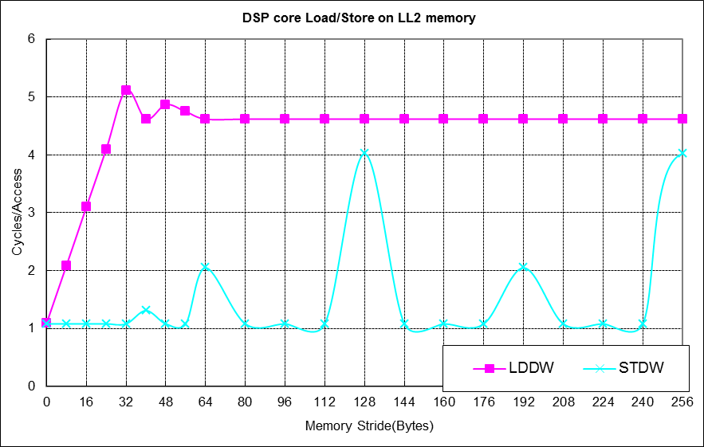
- DSP Core access LL2
Since the L1D is a read-allocate cache, DSP core read LL2 should always go through L1D cache. So, DSP core access LL2 highly depends on the cache. The address increment (or memory stride) affects cache utilization. Contiguous accesses utilize cache to the fullest. A memory stride of 64 bytes or more causes every access to miss in the L1 cache because the L1D cache line size is 64 bytes.
Since the L1D is not a write-allocate cache, and the cache is flushed before the test, any write to the LL2 goes through L1D write buffer (4x32bytes). For write operation, if stride is less than 32 bytes, several writes may be merged into one write to the LL2 in the L1D write buffer, thus achieves the efficiency close to 1 cycle/write. When the stride is multiple of 128 bytes, every write always access to the same sub-bank of LL2 (because the LL2 is organized as 2 banks, each with 4 16-byte sub-banks), which requires 4 cycles. For other strides, the Consecutive writes access to different banks of LL2, they may be overlapped with pipeline, which requires less cycle.

Latency of DSP core access MSRAM
Following figure shows data collected from 1.2GHz KeyStone II EVM. The cycles used for 512 LDDW (LoaD Double Word) or STDW (STore Double Word) instructions was measured, and the average cycles for each instruction is reported. 32KB L1D cache is used for this test. The cycles for LDB/STB, and LDW/STW are same as LDDW/STDW.
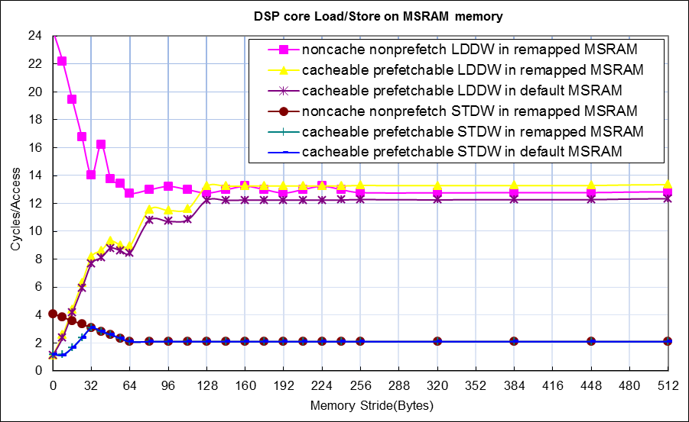
- DSP Core access MSRAM
DSP core read MSRAM should normally goes through L1D cache, so, DSP core access MSRAM highly depends on the cache just like LL2. There is an additional data prefetch buffer (8x128bytes) inside XMC, which can be looked as an additional cache for read only, which is configurable by software through PFX (PreFetchable eXternally) bit of MAR (Memory Attribute Register), enabling it will benefit mulit-core access, it improves the performance of consecutive read from the MSRAM dramatically. But prefetch buffer does not help write operation.
MSRAM can be accessed through default space at 0x0C000000, which is always cacheable, normally that is also be configured as prefetchable. MSRAM can be remapped to other memory space through XMC, normally that is for non-cacheable nonprefetchable access, but it can also be configured as cacheable and prefetchable. Access through default space is a little bit faster than access through remapped space, because the address remapping consumes about one more cycle.
Since the L1D is not a write-allocate cache, any write may go through L1D write buffer (4x32bytes) to the MSRAM. For write operation, if stride is less than 32 bytes, several writes may be merged into one write to the MSRAM in the L1D write buffer, thus achieves better efficiency.
Following figure shows performance comparison of DSP core access MSRAM vs LL2. For memory stride less than 16 bytes, the performance of MSRAM access is almost same as LL2. For access with bigger memory stride, the performance of MSRAM is worse than LL2. So, MSRAM is suitable for linearly accessed codes or read only data.
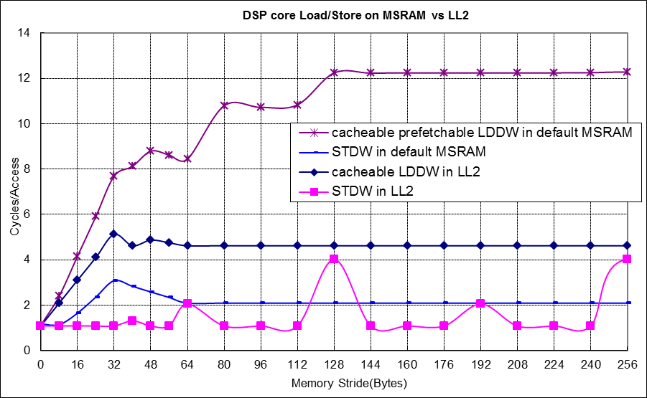
- Performance of DSP core access MSRAM vs LL2
Latency of DSP core access external DDR memory
DSP core access external DDR memory highly depends on the cache. When the DSP core accesses external memory spaces, a TR (transfer request) may be generated (depending on whether the data are cached and prefetchable) to the XMC. The TR will be for one of the following:
- a single element - if the memory space is non-cacheable, nonprefetchable
- a L1 cache line - if the memory space is cacheable and the L2 cache is disabled,
- a L2 cache line - if the memory space is cacheable and L2 cache is enabled.
- If the space is prefetchable, prefetch may be generated for a prefetch buffer slot.
No transfer request is generated in the case of an L1/L2 cache or prefetch hit.
An external memory can be cached by L1 cache, L2 cache, or neither. If the PC (Permit Copy) bit of appropriate MAR (Memory Attribute Register) for a memory space is not set, it is not cacheable. If the PC bit of MAR is set and L2 cache size is zero (all L2 is defined as SRAM), the external memory space is cached by L1. If the MAR bit is set and L2 cache size is greater than 0, the external memory space is cached by L2 and L1.
Read to external memory can also utilize the prefetch buffer in XMC, which is programmable by software through PFX (PreFetchable eXternally) bit of MAR (Memory Attribute Register).
The address increment (or memory stride) affects cache and prefetch buffer utilization. Contiguous accesses utilize cache and prefetch memory to the fullest. A memory stride of 64 bytes or more causes every access to miss in the L1 cache because the L1 line size is 64 bytes. A memory stride of 128 bytes causes every access to miss in L2 because the L2 line size is 128 bytes.
If cache miss happens, the DSP Core will stall, waiting for the return data. The length of the stall is equal to the sum of the transfer latency, transfer duration, data return time, and some small cache request overhead.
Following figures show data collected from 1.2GHz KeyStone II EVM with 64-bit 1600MTS DDR. The cycles required for 512 LDDW (LoaD Double Word) or STDW (STore Double Word) instructions was measured, and the average cycles for each instruction is reported. 32KB L1D cache and 256KB L2 cache are used for this test. The cycles for LDB/STB, and LDW/STW are same as LDDW/STDW.
Note, the second figure is the zoom in version of the first figure.
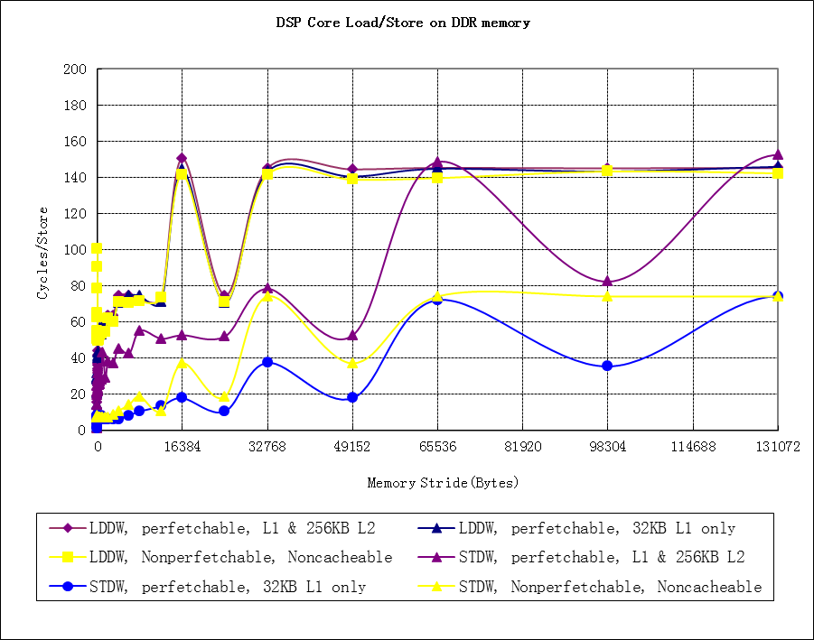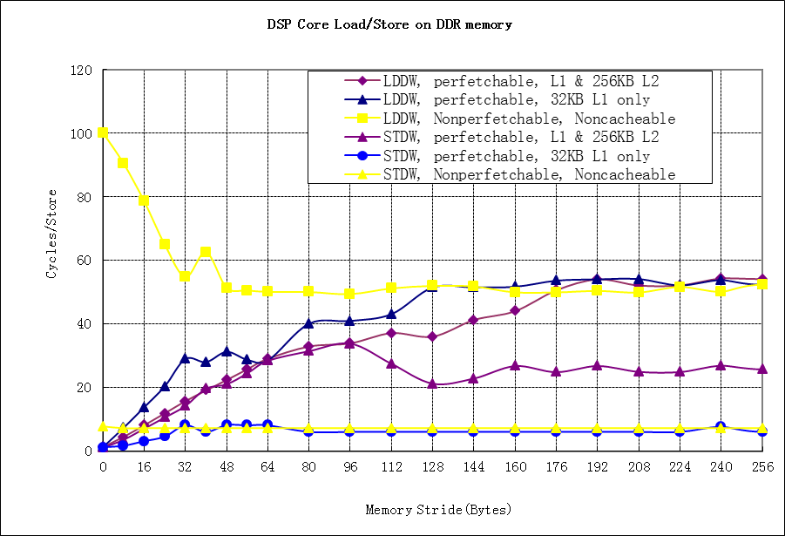

- DSP Core Load/Store on DDR3A
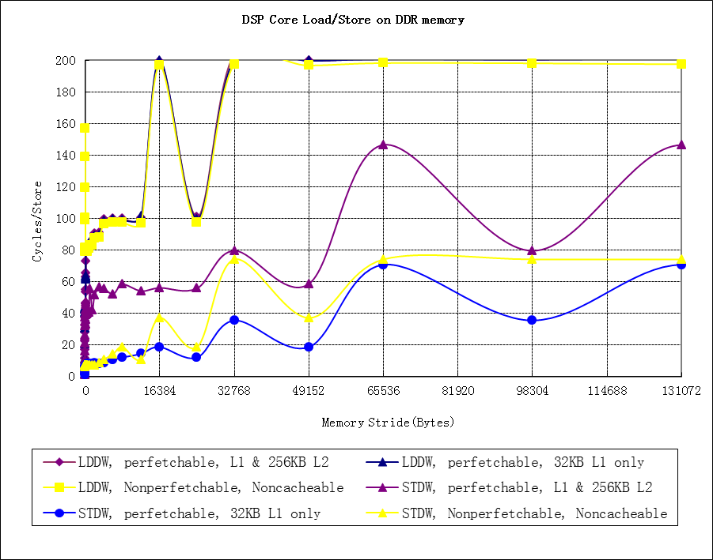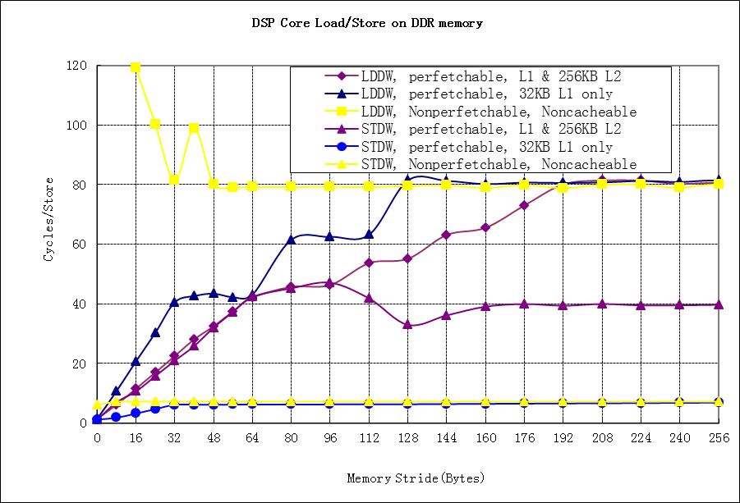

- DSP Core Load/Store on DDR3B
For memory stride less than 128 bytes, the performance is dominated by cache as discussed above.
L2 cache is a write-allocate cache, for any write operation, it always read the 128 bytes including the accessed data into a cache line firstly, and then modify the data in the L2 cache. This data will be written back to real external memory if cache conflict happens or by manual writeback. When the memory stride equals to multiple of KB, the cycles for L2 cacheable write operation increases dramatically, because the conflict happens frequently for big memory stride, thus every write operation may result in a cache line write back (for conflict) and a cache line read (for write-allocate).
For memory stride larger than 512 bytes, DDR row switch overhead becomes a main factor of performance degrading. The DDR row size or bank width on the KeyStone II EVM is 8KB, the DDR is organized as 8 banks. For access with memory stride equal to multiple of 64KB, the performance becomes worst because every read or write access to a new row in same bank, the row switch result in about 60 extra cycles. Please note, the DDR SDRAM row switch overhead may be different for different DDR SDRAM.
The latency for DSP core accessing DDR3B is higher than DSP core accessing DDR3A because DSP core accessing DDR3B goes through additional bus switches/bridges (refer to Figure 1).

Latency of ARM core access memory
Similar methods introduced in above sections are used to measure the latency of ARM core accessing memories.
Latency of ARM core access MSRAM
Following figure shows data collected from 1.2GHz KeyStone II EVM. The cycles required for 512 consecutive LDRD (load double word) or STRD (store double word) instructions was measured, and the average cycles for each instruction is reported.
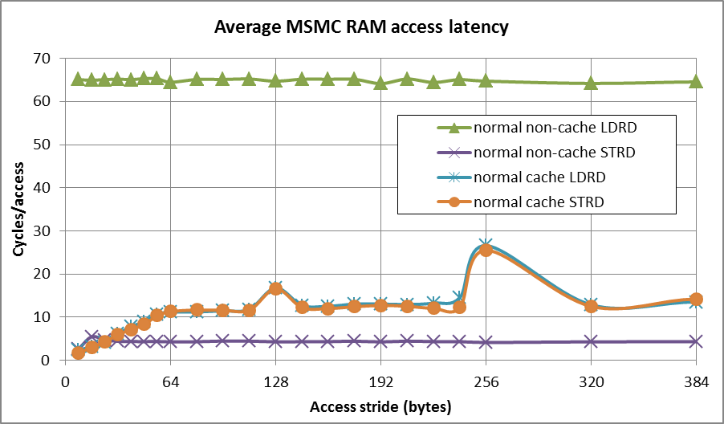
- ARM Core access MSRAM
The test result shows ARM core access MSMC highly depends on the cache. The address increment (or memory stride) affects cache utilization. Contiguous accesses utilize cache to the fullest. A memory stride of 64 bytes or more causes every access to miss in the cache because the ARM cache line size is 64 bytes.
The latency for DSP core to access MSRAM is a little bit less than the ARM core to access MSRAM.
Latency of ARM core access extern DDR memory
Following figure shows data collected from 1.2GHz KeyStone II EVM with 64-bit 1600MTS DDR. The time required for 512 consecutive LDRD (load double word) or STRD (store double word) instructions was measured, and the average time for each instruction is reported.
Note, the second figure is the zoom in version of the first figure.
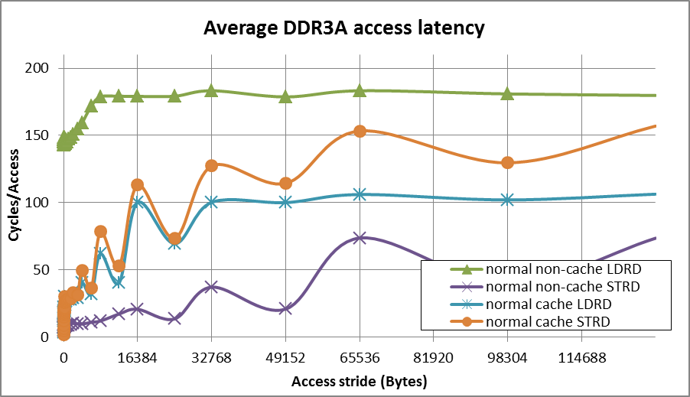
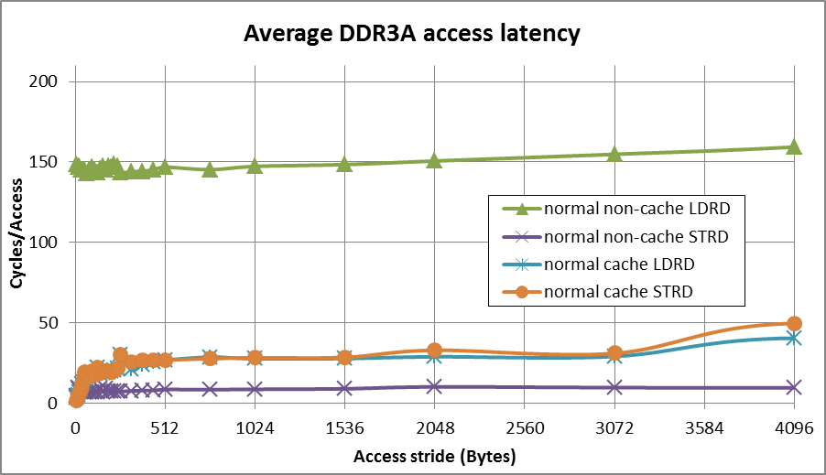
- ARM Core access DDR3A
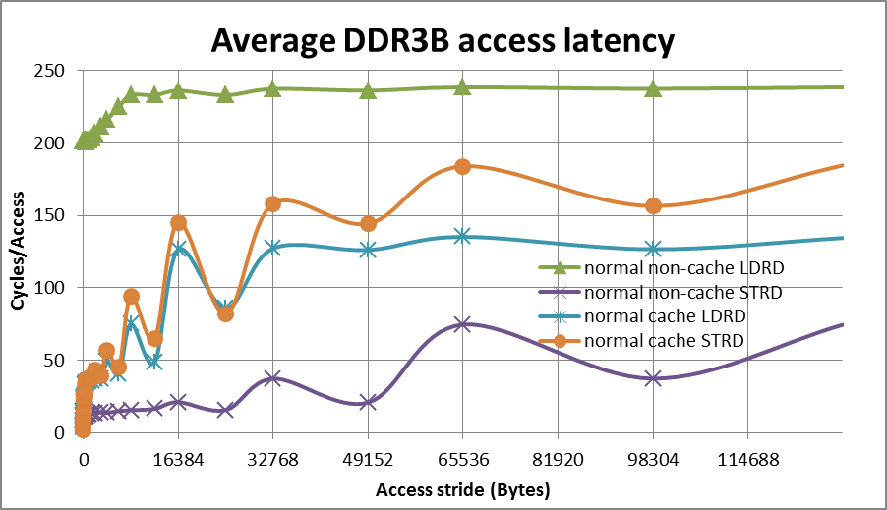
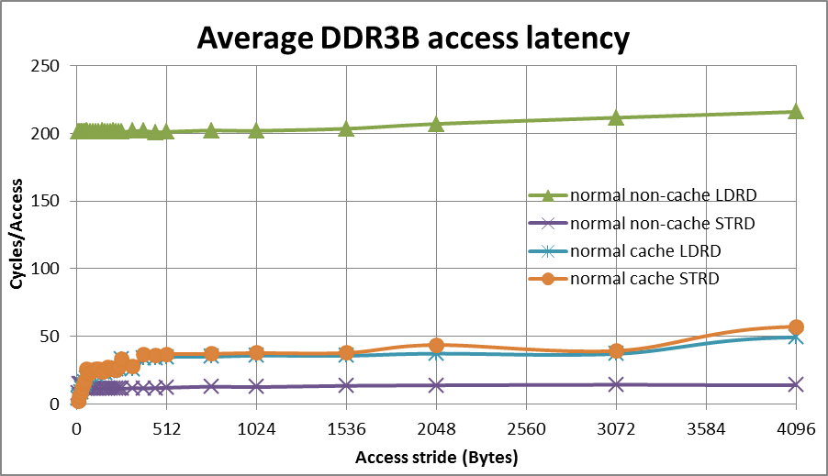
- ARM Core access DDR3B
For memory stride less than 64 bytes, the performance is dominated by cache as discussed above. For memory stride of multiple KB, DDR row switch overhead becomes a main factor of performance degrading.
The latency for ARM core accessing DDR3B is higher than ARM core accessing DDR3A because ARM core accessing DDR3B goes through additional bus switches/bridges (refer to Figure 1).
The latency for DSP core to access DDR is a little bit less than the ARM core access DDR.

Performance of DMA access memory
The EDMA3 architecture has many features designed to facilitate simultaneous multiple high-speed data transfers. Its performance affected by the memory type and many other factors discussed in following sections.
DMA Transfer overhead

Initial latency is defined as the time between DMA event happen to real data transfer begin. Since initial latency is hard to measure. We measured transfer overhead instead; it is defined as the sum of the Latency, and the time to transfer smallest element. The values vary based on the type of source/destination endpoints. Following tables show the average cycles measured between EDMA trigger (write ESR) and EDMA completion (read IPR=1) for smallest transfer (1 word) between different ports on 1.2GHz KeyStone II EVM with 64-bit 1600MTS DDR.
- EDMA CC0 and CC4 Transfer Overhead
destination  source | LL2 | MSRAM | DDR3A | DDR3B
LL2 | 376 | 325 | 376 | 376
MSRAM | 325 | 325 | 325 | 325
DDR3A | 427 | 376 | 478 | 427
DDR3B | 427 | 376 | 427 | 478
- EDMA CC1, CC2 and EDMA CC3 Transfer Overhead
destination  source | LL2 | MSRAM | DDR3A | DDR3B
LL2 | 325 | 376 | 376 | 376
MSRAM | 325 | 376 | 478 | 376
DDR3A | 427 | 427 | 529 | 478
DDR3B | 376 | 427 | 478 | 529
Since EDMA CC0 and CC4 are connected to TeraNet switch fabric close to MSRAM and DDR3A (refer to Figure 1), so it’s overhead to access MSRAM and DDR3A is smaller. While EDMA CC1 CC2 and CC3 are connected to TeraNet switch fabric close to DDR3B and DSP CorePac which including LL2 (refer to Figure 1), so their overhead to access LL2 and DDR3B is smaller.
The average measured IDMA transfer overhead is about 66 cycles.
Transfer overhead is a big concern for short transfers and need to be included when scheduling DMA traffic in a system. Single-element transfer performance will be latency-dominated. So, for small transfer, you should make the trade off between DMA and CPU.

EDMA performance Difference between 14 transfer engines

EDMA3 on KeyStone II includes up to 14 TC (transfer controller). The 14 transfer engines are not exactly same. Table 7 is a summary of the difference.
- Difference between TCs
 | CC0 |  | CC1 |  |  |  | CC2 |  |  |  | CC3 |  | CC4
 | TC0 | TC1 | TC0 | TC1 | TC2 | TC3 | TC0 | TC1 | TC2 | TC3 | TC0 | TC1 | TC0 | TC1
Bus Width (bits) | 256 | 256 | 128 | 128 | 128 | 128 | 128 | 128 | 128 | 128 | 128 | 128 | 256 | 256
Speed ratio to DSP core | 1/3 | 1/3 | 1/3 | 1/3 | 1/3 | 1/3 | 1/3 | 1/3 | 1/3 | 1/3 | 1/3 | 1/3 | 1/3 | 1/3
FIFO Size (bytes) | 1024 | 1024 | 1024 | 1024 | 1024 | 1024 | 1024 | 1024 | 1024 | 1024 | 1024 | 1024 | 1024 | 1024
Default Burst Size (bytes) | 128 | 128 | 128 | 128 | 128 | 128 | 128 | 128 | 128 | 128 | 128 | 128 | 64 | 64

Following tables compare the maximum throughput measured for different TCs on 1.2GHz KeyStone II EVM with 64-bit 1600MTS DDR. AB_Sync is used, ACNT=1024, BCNT=128.
- Throughput comparison between TCs on 1.2GHz KeyStone II
MB/s | CC0 | CC1 | CC2 | CC3 | CC4
LL2 → LL2 | 6291 | 6033 | 6033 | 6033 | 6291
LL2 → MSRAM | 6304 | 6021 | 6021 | 6021 | 6304
MSRAM → LL2 | 6304 | 6021 | 6021 | 6021 | 6304
MSRAM → MSRAM | 11388 | 6009 | 6009 | 6009 | 11388
LL2 → DDR3A | 6291 | 6009 | 6009 | 5783 | 6291
DDR3A → LL2 | 6080 | 5446 | 5524 | 5189 | 6092
DDR3A → DDR3A | 3991 | 3257 | 3263 | 3423 | 3971
MSRAM→DDR3A | 11061 | 6009 | 6009 | 5816 | 11181
DDR3A→MSRAM | 7503 | 5398 | 5388 | 5180 | 7448
LL2 → DDR3B | 6215 | 5917 | 5827 | 5666 | 6279
DDR3B → LL2 | 6080 | 5584 | 5584 | 5544 | 5962
DDR3B → DDR3B | 4396 | 3458 | 3427 | 3591 | 4473
MSRAM→DDR3B | 11141 | 5827 | 5849 | 5816 | 10789
DDR3B→MSRAM | 7807 | 5564 | 5751 | 5504 | 8137
DDR3A→DDR3B | 7255 | 5287 | 5305 | 4876 | 7290
DDR3B→DDR3A | 7907 | 5554 | 5564 | 5296 | 7787
For data transfer between MSRAM and DDR, CC0 and CC4 achieve about two times throughput as other TCs. Without special note, all performance data in this application report is measured on CC0 TC0.
EDMA Throughput vs Transfer Flexibility
EDMA3 channel parameters allow many different transfer configurations. Most typical transfers burst properly, and memory bandwidth is fully utilized. However, in some less common configurations, transfers are unable to burst, reducing performance. To properly design a system, it is important to know which configurations offer the best performance for high speed operations, and which must trade throughput for flexibility.
First Dimension Size (ACNT) Considerations, Burst width
To make full utilization of bandwidth in the transfer engine, it is important to fully utilize the bus width available and allow for data bursting.
ACNT size should be multiple of 16 bytes to fully utilize 128bit or 256bit bus width; ACNT should be multiple of 64 bytes to fully utilize default burst size; ACNT should be multiple of 1024 bytes to fully utilize the FIFO.
Figure 10 shows performance data from 1.2GHz KeyStone II EVM with 64-bit 1600MTS DDR, transferring 1~24K bytes from MSRAM to DDR using an EDMA3 channel.
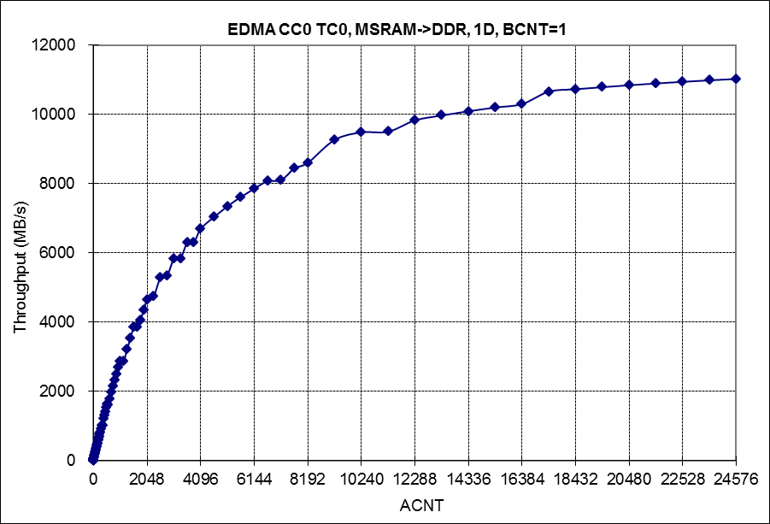
- effect of ACNT size on EDMA throughput
As conclusion, the bigger ACNT, the more bandwidth can be utilized.
Two Dimension Considerations, Transfer Optimization
If 2D transfer (AB_Sync) is linear (BIDX=ACNT), and the ACNT value is a power of 2, the 2D transfer will be optimized as 1D transfer. Various ACNT and BCNT combinations were investigated; however, the overall transfer size (ACNT * BCNT) was proved to have more bearing than the particular combination settings. Figure 11 is linear 2D transfer test result on 1.2GHz KeyStone II EVM with 64-bit 1600MTS DDR, it shows, no matter what BCNT, the throughput are similar as long as ACNTxBCNT are same.
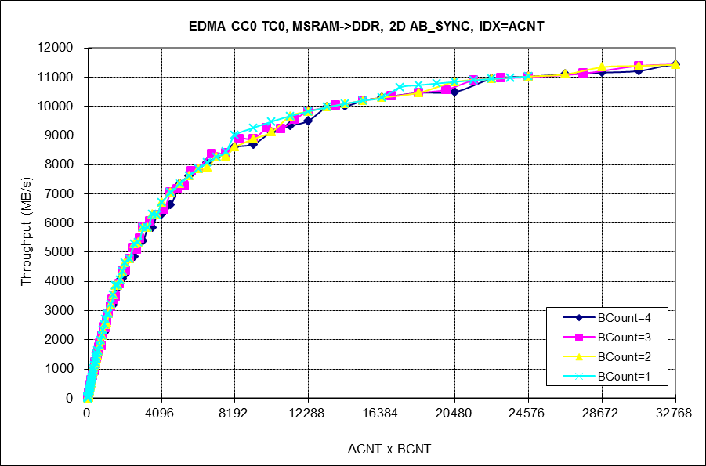
- Linear 2D transfer
If 2D transfer is not linear, the bandwidth utilization is determined by the ACNT as showed in Figure 10.
Index Consideration
Index dramatically affects the EDMA throughput. Linear transfer (Index= ACNT) fully utilizes bandwidth; Other index modes may lower the EDMA performance. Odd index has worst performance. If index is power of 2, and it is larger than 8, the performance degradation is very small.
Figure 12 shows the index effect on EDMA throughput, transferring 1024 rows (BCNT= 1024) of 2D data form MSRAM to DDR, with different index on 1.2GHz KeyStone II EVM with 64-bit 1600MTS DDR.
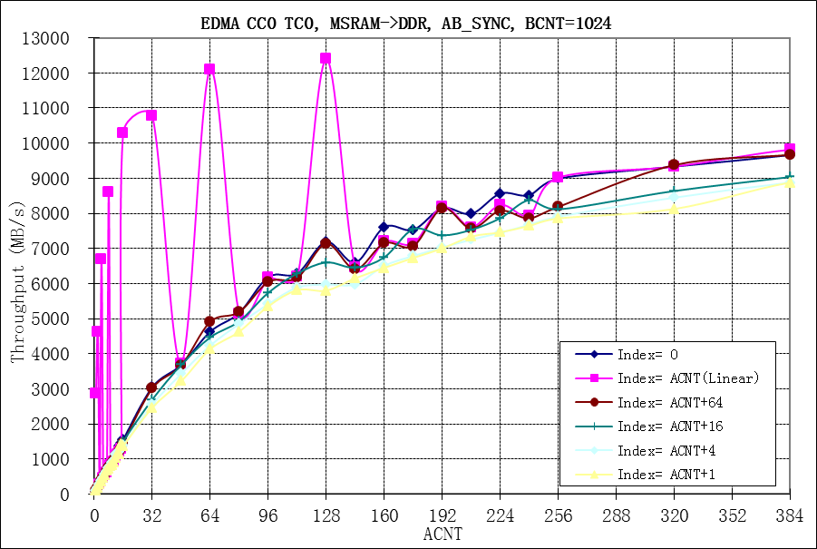
- Index effect on EDMA throughput
Please note, for Index= ACNT, and ACNT is a power of 2, the 2D transfer will is optimized as 1D transfer, thus achieve much better performance.
Without special note, all performance data in this application report is measured with Index= ACNT.
Address Alignment
Address alignment may slightly impact the performance. The default burst size of EDMA3 is 64bytes or 128 bytes, if the transfer across the 64 bytes boundary, then the EDMA3 TC breaks the ACNT array into 64-bytes burst to the source/destination addresses. So, if the source or destination address is not align to 64 bytes boundary, and the transfer across 64 bytes boundary, extra burst will be generated to handle the unaligned head and tail data.
For big transfer this overhead may be ignored. All data presented in this document are based on the address aligned transfer.
Performance of Multiple masters sharing memory
Since the KeyStone 2 includes up to 12 cores and multiple DMA masters, they may access memory in parallel. This section discusses the performance of multiple masters sharing memory.
Following figures show the typical test setup for CPU and EDMA sharing memory.
- Multiple DSP cores copy date to/from same shared memory
- Multiple ARM cores copy date to/from same shared memory

- Multiple EDMA TCs copy date to/from MSRAM
- Multiple EDMA TCs copy date to/from DDR3A
Each master copies data from its source buffer to its destination buffer. In shared memory, each master has separated buffer. All masters transfer data simultaneously, total data bytes transferred by each master in same time period (about 3 seconds) are counted; the throughput each master achieved is calculated by taking total bytes copied and dividing it by the time period.
Performance of Multiple masters sharing MSMC RAM
The data on MSMC RAM is organized as following.
Bank 0 |  |  | Bank 1 |  |  |  |  |  | Bank 7
byte 0 | … | byte 31 | byte 128 | … | byte 159 | … | … | … | byte 896 | … | byte 927
byte 32 | … | byte 63 | byte 160 | … | byte 191 | … | … | … | byte 928 | … | byte 959
byte 64 | … | byte 95 | byte 192 | … | byte 223 | … | … | … | byte 960 | … | byte 991
byte 96 | … | byte 127 | byte 224 | … | byte 255 | … | … | … | byte 992 | … | byte 1023
byte1024 |  | byte 1055 | … | … | … | … | … | … | … | … | …
… | … | … | … | … | … | … | … | … | … | … | …
- Data organization on MSMC RAM banks
All masters can access the 8 MSMC RAM banks through MSMC (Multicore Shared Memory Controller), which is actually a bus switch. Multiple masters can access different banks in parallel; if multiple masters access same bank, it is arbitrated based on priority.
Following tables show the performance data measured when multiple masters access MSMC RAM simultaneously on 1.2GHz KeyStone 2.
In following tables, each column represents a test case, different test case use different number of masters to access memory simultaneously, the blank cell in a column means corresponding master is not used for that case, and the number in a cell means the throughput the corresponding master achieve in that case. The last row is the total throughput achieved by all masters for that case.
Performance of Multiple DSP cores sharing MSMC RAM
In this test, DSP core L1D cache size is set to 32KB, L2 cached is not used, prefetch buffer is enabled.
- Performance of Multiple DSP cores sharing MSMC RAM
MSMC RAM->LL2 throughput(MB/s), same priority
Core0 | 2784 | 2780 | 2780 | 2781 | 2782 | 2783
Core1 |  | 2761 | 2761 | 2760 | 2761 | 2761
Core2 |  |  | 2761 | 2760 | 2761 | 2761 | 2761
Core3 |  |  |  | 2760 | 2761 | 2761 | 2761
Core4 |  |  |  |  | 2761 | 2761 | 2761 | 2762
Core5 |  |  |  |  | 2761 | 2761 | 2761 | 2762 | 2762
Core6 |  |  |  |  |  | 2761 | 2761 | 2762 | 2762 | 2762
Core7 |  |  |  |  |  | 2761 | 2761 | 2762 | 2762 | 2762 | 2762
Total | 2784 | 5541 | 8302 | 11061 | 16587 | 22110 | 16566 | 11048 | 8286 | 5524 | 2762
LL2->MSMC RAM throughput(MB/s), same priority
Core0 | 4350 | 4351 | 4351 | 4353 | 4353 | 4353
Core1 |  | 4303 | 4303 | 4303 | 4302 | 4301
Core2 |  |  | 4303 | 4303 | 4302 | 4301 | 4304
Core3 |  |  |  | 4303 | 4302 | 4301 | 4304
Core4 |  |  |  |  | 4302 | 4301 | 4304 | 4304
Core5 |  |  |  |  | 4302 | 4301 | 4304 | 4304 | 4304
Core6 |  |  |  |  |  | 4301 | 4304 | 4304 | 4304 | 4304
Core7 |  |  |  |  |  | 4301 | 4304 | 4304 | 4304 | 4304 | 4304
Total | 4350 | 8654 | 12957 | 17262 | 25863 | 34460 | 25824 | 17216 | 12912 | 8608 | 4304
Above data proves the MSMC RAM is NOT the bottle neck for multiple DSP cores access MSMC RAM simultaneously. The MSMC RAM has enough bandwidth (600M x 32 x 8 = 153600MB/s) to support multiple cores access simultaneously. The throughput limitation is on DSP core itself.
Since the MSMC RAM bandwidth is enough for multiple core access, the priority of different core is not important for these cases.

Performance of Multiple EDMA sharing MSMC RAM
- Performance of Multiple EDMA sharing MSMC RAM
Throughput (MB/s), Write to MSRAM, same priority
CC0 TC0 |  | 6722 | 4942 | 4044 | 4167 | 3623 | 3614 | 3497 | 3333
CC0 TC1 |  |  | 4942 | 5828 | 4167 | 3623 | 3614 | 3497 | 2113
CC1 TC0 |  |  |  | 4328 | 4293 | 4021 | 2018 | 1935 | 1763 | 2731
CC1 TC1 |  |  |  | 4328 | 4293 | 4021 | 2013 | 1935 | 1763 | 2729
CC1 TC2 |  |  |  |  | 4293 | 4021 | 3962 | 2607 | 1436 | 1899 | 1908
CC1 TC3 |  |  |  |  | 4293 | 4021 | 3949 | 1855 | 1037 | 1352 | 1357
CC2 TC0 |  |  |  |  |  | 2805 | 2836 | 3043 | 4087 | 4722 | 4689 | 4725
CC2 TC1 |  |  |  |  |  | 6027 | 6022 | 6001 | 5354 | 5337 | 5217 | 5310
CC2 TC2 |  |  |  |  |  |  | 1988 | 1901 | 1733 | 2665 | 5141 | 5228 | 6020
CC2 TC3 |  |  |  |  |  |  | 1989 | 1902 | 1734 | 2666 | 5131 | 5216 | 6020
CC3 TC0 |  |  |  |  |  |  |  | 1343 | 730 | 971 | 974 | 2948 | 3437 | 3433
CC3 TC1 |  |  |  |  |  |  |  | 1825 | 1026 | 1334 | 1339 | 2550 | 2910 | 2918
CC4 TC0 |  |  |  |  |  |  |  |  | 1989 | 2550 | 2563 | 2656 | 3047 | 3054 | 5552
CC4 TC1 |  |  |  |  |  |  |  |  | 1989 | 2550 | 2563 | 2656 | 3047 | 3054 | 5552 | 7310
Total |  | 6722 | 9884 | 18528 | 25506 | 32162 | 32005 | 31341 | 30087 | 31506 | 30882 | 31289 | 24481 | 12459 | 11104 | 7310
Throughput (MB/s), Write to MSRAM, different priority
CC0 TC0 | 0 | 6721 | 4888 | 4031 | 4101 | 2870 | 2863 | 2869 | 3638
CC0 TC1 | 1 |  | 4888 | 5829 | 4101 | 2866 | 2863 | 2868 | 2266
CC1 TC0 | 2 |  |  | 4333 | 4320 | 4691 | 2440 | 2409 | 2156 | 3158
CC1 TC1 | 3 |  |  | 4332 | 4320 | 4622 | 2438 | 2407 | 2155 | 3150
CC1 TC2 | 4 |  |  |  | 4320 | 4614 | 4486 | 3004 | 1589 | 2079 | 2152
CC1 TC3 | 5 |  |  |  | 4320 | 4613 | 4475 | 2122 | 1139 | 1486 | 1540
CC2 TC0 | 6 |  |  |  |  | 2110 | 2111 | 2108 | 2850 | 3667 | 4058 | 4278
CC2 TC1 | 7 |  |  |  |  | 5650 | 5467 | 5196 | 3972 | 3966 | 4466 | 4756
CC2 TC2 | 0 |  |  |  |  |  | 2389 | 2359 | 2115 | 3012 | 5941 | 5955 | 6029
CC2 TC3 | 1 |  |  |  |  |  | 2390 | 2360 | 2115 | 3020 | 5921 | 5941 | 6029
CC3 TC0 | 2 |  |  |  |  |  |  | 1552 | 810 | 1066 | 1100 | 3347 | 3506 | 3500
CC3 TC1 | 3 |  |  |  |  |  |  | 2086 | 1127 | 1467 | 1520 | 2914 | 3056 | 3063
CC4 TC0 | 4 |  |  |  |  |  |  |  | 2151 | 2732 | 2819 | 2924 | 3077 | 3084 | 6574
CC4 TC1 | 5 |  |  |  |  |  |  |  | 2120 | 2614 | 2692 | 2706 | 2818 | 2828 | 4507 | 7316
Total |  | 6721 | 9776 | 18525 | 25482 | 32036 | 31922 | 31340 | 30203 | 31417 | 32209 | 32821 | 24515 | 12475 | 11081 | 7316
Throughput (MB/s), Read from MSRAM, same priority
CC0 TC0 |  | 10004 | 5048 | 4981 | 4961 | 3356 | 3359 | 3352 | 3910
CC0 TC1 |  |  | 5048 | 4981 | 4961 | 3356 | 3358 | 3352 | 2255
CC1 TC0 |  |  |  | 3871 | 3838 | 4535 | 2263 | 2315 | 1893 | 2975
CC1 TC1 |  |  |  | 3870 | 3838 | 4535 | 2261 | 2313 | 1892 | 2970
CC1 TC2 |  |  |  |  | 3838 | 4535 | 4398 | 2069 | 1171 | 1467 | 1531
CC1 TC3 |  |  |  |  | 3838 | 4535 | 4380 | 2225 | 1166 | 1493 | 1560
CC2 TC0 |  |  |  |  |  | 3293 | 3299 | 3326 | 3843 | 5527 | 5677 | 5927
CC2 TC1 |  |  |  |  |  | 5988 | 6007 | 5967 | 5907 | 5559 | 5677 | 5927
CC2 TC2 |  |  |  |  |  |  | 2219 | 2265 | 1858 | 2880 | 5677 | 5927 | 5586
CC2 TC3 |  |  |  |  |  |  | 2220 | 2266 | 1858 | 2884 | 5676 | 5927 | 5586
CC3 TC0 |  |  |  |  |  |  |  | 1391 | 615 | 852 | 892 | 1917 | 2572 | 2586
CC3 TC1 |  |  |  |  |  |  |  | 1151 | 586 | 753 | 787 | 1691 | 2136 | 2130
CC4 TC0 |  |  |  |  |  |  |  |  | 2241 | 2844 | 2972 | 3210 | 3848 | 3848 | 5732
CC4 TC1 |  |  |  |  |  |  |  |  | 2241 | 2844 | 2972 | 3210 | 3848 | 3848 | 5732 | 10654
Total |  | 10004 | 10096 | 17703 | 25274 | 34133 | 33764 | 31992 | 31436 | 33048 | 33421 | 33736 | 23576 | 12412 | 11464 | 10654
Throughput (MB/s), Read from MSRAM, different priority
CC0 TC0 | 0 | 10000 | 5710 | 5000 | 4910 | 4848 | 4850 | 4849 | 4851
CC0 TC1 | 1 |  | 4377 | 4998 | 4867 | 3634 | 3637 | 3649 | 3638
CC1 TC0 | 2 |  |  | 3870 | 3865 | 3822 | 1932 | 1924 | 1917 | 2764
CC1 TC1 | 3 |  |  | 3870 | 3865 | 3800 | 1930 | 1923 | 1916 | 2762
CC1 TC2 | 4 |  |  |  | 3866 | 4157 | 4128 | 1589 | 1090 | 1348 | 1367
CC1 TC3 | 5 |  |  |  | 3865 | 4144 | 4115 | 1847 | 655 | 805 | 817
CC2 TC0 | 6 |  |  |  |  | 403 | 406 | 395 | 406 | 1546 | 1778 | 1717
CC2 TC1 | 7 |  |  |  |  | 1369 | 1246 | 718 | 651 | 1545 | 1777 | 1718
CC2 TC2 | 0 |  |  |  |  |  | 1935 | 1926 | 1920 | 2701 | 5221 | 5192 | 5488
CC2 TC3 | 1 |  |  |  |  |  | 1936 | 1926 | 1921 | 2702 | 5211 | 5183 | 5488
CC3 TC0 | 2 |  |  |  |  |  |  | 2149 | 1684 | 1746 | 1760 | 3044 | 3301 | 3328
CC3 TC1 | 3 |  |  |  |  |  |  | 1845 | 1542 | 1906 | 1920 | 2633 | 2861 | 2911
CC4 TC0 | 4 |  |  |  |  |  |  |  | 2377 | 3937 | 3978 | 4086 | 4313 | 4356 | 6107
CC4 TC1 | 5 |  |  |  |  |  |  |  | 220 | 1578 | 1611 | 1485 | 1777 | 1741 | 5280 | 10649
Total |  | 10000 | 10087 | 17738 | 25238 | 26177 | 26115 | 24740 | 24788 | 25340 | 25440 | 25058 | 23228 | 12336 | 11387 | 10649
Though MSMC RAM has very high bandwidth, but all EDMA TCs access it through three bridges (1/3 core clock speed, 256-bit) on TeraNet switch fabric, the port on the switch fabric becomes the bottleneck, refer to section “System Interconnect” in device data manual for more details. The theoretic bandwidth of those ports is 400MHz x 32 bytes x 3 = 38400MB/s.
The memory bandwidth allocation between EDMA TCs is affected by following factors:
- Bus width of TCs. The bus width of CC0 and CC4 is 256 bits, the other CCs are 128 bits.
- The connection to the bridges. Each TC connects to shared memory through one of the three bridges. There are up to 14 TCs, but only 3 bridges, so, some TCs share same bridge, refer to section “System Interconnect” in device data manual for more details.
- Priority. Different priority is shown in the second column of above tables
If these factors are equivalent for several TCs, then the bandwidth will be allocated between them almost equally.

Performance of Multiple masters sharing DDR
If multiple masters access DDR at same time, it is arbitrated based on priority of the masters.
The bank number of different DDR device may be different. The DDR controller on KeyStone 2 can support DDR memory with 1, 2, 4, or 8 banks. The DDR on KeyStone 2 EVM has 8 banks; the data on it is organized as following. Please note, the row size for different DDR device may be different.
 | Bank0 | Bank1 | … | Bank7
Row 0 | byte 0~8191 | byte 8192~8192*2-1 | … | byte 8192*7~8192*8-1
Row 1 | byte 8192*8~8192*9-1 | byte 8192*9~8192*10-1 | … | byte 8192*15~8192*16-1
… | … | … | … | …
- Data organization on DDR banks
Though DDR has multiple banks, but there is NO multiple buses connect to each bank like MSMC RAM. So, the bank number does not directly improve the throughput.
The DDR SDRAM is accessed based on row or page. Before a master accesses data in a page, it must open the page firstly, and then it can randomly access any bytes in the page. If master wants to access data in a new row in same bank, the old row must be closed firstly, and then open the new row in the same bank for access. The row switch (row close/open) operations introduce extra delay cycles, which is called row switch overhead.
Every bank can have one open row, so the DDR with 8 banks can have 8 open rows at the same time, which reduces the probability of row switch. For example, after a master opens row 0 in bank 0 for access, it can open row 1 in bank 1 without closing the row 0 in bank 0, and then the master can access both row 0 in bank 0 and row 1 in bank 1 randomly without row switch overhead.
Two data structures for test are defined to verify the effect of DDR row switch (row close/open) overhead.
 | Bank 0 | Bank 1 | Bank2 | … | Bank n | …
Row 0 | Master 0 Access Range
Row 1 | Master 1 Access Range
Row 2 | Master 2 Access Range
… | …
Row n | Master n Access Range
… | …
- Multiple master access different rows on same DDR bank
Above case is the worst case with maximum row switch overhead. Every master access may result in row switch.
Following case is the best case without any row switch because every master always access an open row dedicated for it.
 | Bank 0 | Bank 1 | Bank2 | … | Bank n | …
Row 0 | Master 0 Access Range
Row 1 |  | Master 1 Access Range
Row 2 |  |  | Master 2 Access Range
… |  |  |  | …
Row n |  |  |  |  | Master n Access Range
… | … |  |  |  |  | …
- Multiple master access different rows on different DDR banks
Following table shows the Performance of Multiple DSP cores sharing the 64-bit 1600M DDR3A on 1.2GHz KeyStone 2 EVM under different scenarios. Test result for sharing DDR3B is almost same. Every master accesses its own data buffer on the DDR repeatedly. Total data bytes transferred by each master in same time period (about 3 seconds) are counted; the throughput each master achieved is calculated by taking total bytes copied and dividing it by the time period.
In following tables, each column represents a test case, different test case use different number of masters to access memory simultaneously, the blank cell in a column means corresponding master is not used for that case, and the number in a cell means the throughput the corresponding master achieves in that case. The last row is the total throughput achieved by all masters for that case.

Performance of Multiple DSP cores sharing DDR
The DDR is cacheable and prefetchable for this test, and the L1D cache is set to 32KB, L2 cache size is set to 256KB, prefetch buffer is enabled. Non-cacheable case is not measured because it demands much less bandwidth than cacheable case.
- Performance of Multiple DSP cores sharing DDR
DDR->LL2 throughput(MB/s), different row in different bank, same priority
Core0 |  | 1652 | 1637 | 1633 | 1633 | 1602 | 1454
Core1 |  |  | 1613 | 1616 | 1617 | 1587 | 1450
Core2 |  |  |  | 1616 | 1617 | 1587 | 1449 | 1596
Core3 |  |  |  |  | 1616 | 1587 | 1449 | 1587
Core4 |  |  |  |  |  | 1586 | 1448 | 1587 | 1633
Core5 |  |  |  |  |  | 1585 | 1448 | 1586 | 1621 | 1634
Core6 |  |  |  |  |  |  | 1448 | 1585 | 1621 | 1621 | 1633
Core7 |  |  |  |  |  |  | 1448 | 1585 | 1620 | 1621 | 1619 | 1647
Total |  | 1652 | 3250 | 4865 | 6483 | 9534 | 11594 | 9526 | 6495 | 4876 | 3252 | 1647
DDR->LL2, different row in different bank, different priority
Core0 | 0 | 1650 | 1638 | 1641 | 1648 | 1645 | 1632
Core1 | 1 |  | 1610 | 1613 | 1620 | 1621 | 1626
Core2 | 2 |  |  | 1603 | 1610 | 1609 | 1616 | 1644
Core3 | 3 |  |  |  | 1593 | 1592 | 1596 | 1623
Core4 | 4 |  |  |  |  | 1553 | 1550 | 1611 | 1642
Core5 | 5 |  |  |  |  | 1449 | 1445 | 1595 | 1622 | 1637
Core6 | 6 |  |  |  |  |  | 1174 | 1555 | 1611 | 1617 | 1633
Core7 | 7 |  |  |  |  |  | 788 | 1440 | 1595 | 1608 | 1614 | 1647
Total |  | 1650 | 3248 | 4857 | 6471 | 9469 | 11427 | 9468 | 6470 | 4862 | 3247 | 1647
DDR->LL2 throughput(MB/s), different row in same bank, same priority
Core0 |  | 1650 | 1398 | 1287 | 1088 | 741 | 554
Core1 |  |  | 1394 | 1285 | 1085 | 739 | 553
Core2 |  |  |  | 1285 | 1085 | 739 | 553 | 739
Core3 |  |  |  |  | 1085 | 739 | 553 | 739
Core4 |  |  |  |  |  | 739 | 553 | 739 | 1077
Core5 |  |  |  |  |  | 739 | 553 | 739 | 1077 | 1286
Core6 |  |  |  |  |  |  | 552 | 739 | 1077 | 1286 | 1373
Core7 |  |  |  |  |  |  | 516 | 739 | 1077 | 1286 | 1373 | 1648
Total |  | 1650 | 2792 | 3857 | 4343 | 4436 | 4387 | 4434 | 4308 | 3858 | 2746 | 1648
LL2->DDR throughput(MB/s), different row in different bank, same priority
Core0 |  | 1821 | 1814 | 1812 | 1810 | 1749 | 1478
Core1 |  |  | 1791 | 1791 | 1789 | 1731 | 1473
Core2 |  |  |  | 1792 | 1790 | 1731 | 1473 | 1738
Core3 |  |  |  |  | 1789 | 1731 | 1473 | 1729
Core4 |  |  |  |  |  | 1731 | 1473 | 1729 | 1800
Core5 |  |  |  |  |  | 1731 | 1473 | 1729 | 1789 | 1802
Core6 |  |  |  |  |  |  | 1473 | 1729 | 1791 | 1791 | 1801
Core7 |  |  |  |  |  |  | 1473 | 1729 | 1790 | 1792 | 1787 | 1812
Total |  | 1821 | 3605 | 5395 | 7178 | 10404 | 11789 | 10383 | 7170 | 5385 | 3588 | 1812
LL2->DDR, different row in different bank, different priority
Core0 | 0 | 1820 | 1813 | 1821 | 1825 | 1824 | 1811
Core1 | 1 |  | 1775 | 1785 | 1789 | 1787 | 1790
Core2 | 2 |  |  | 1780 | 1783 | 1785 | 1784 | 1813
Core3 | 3 |  |  |  | 1767 | 1771 | 1770 | 1788
Core4 | 4 |  |  |  |  | 1693 | 1679 | 1785 | 1817
Core5 | 5 |  |  |  |  | 1455 | 1403 | 1770 | 1791 | 1811
Core6 | 6 |  |  |  |  |  | 961 | 1688 | 1785 | 1784 | 1801
Core7 | 7 |  |  |  |  |  | 545 | 1442 | 1769 | 1778 | 1772 | 1811
Total |  | 1820 | 3588 | 5386 | 7164 | 10315 | 11743 | 10286 | 7162 | 5373 | 3573 | 1811
LL2->DDR throughput(MB/s), different row in same bank, same priority
Core0 |  | 1821 | 1531 | 1334 | 1103 | 741 | 555
Core1 |  |  | 1527 | 1330 | 1100 | 739 | 554
Core2 |  |  |  | 1330 | 1100 | 739 | 554 | 739
Core3 |  |  |  |  | 1100 | 739 | 554 | 739
Core4 |  |  |  |  |  | 739 | 554 | 739 | 1100
Core5 |  |  |  |  |  | 739 | 554 | 739 | 1100 | 1330
Core6 |  |  |  |  |  |  | 553 | 739 | 1100 | 1330 | 1499
Core7 |  |  |  |  |  |  | 482 | 739 | 1100 | 1330 | 1499 | 1812
Total |  | 1821 | 3058 | 3994 | 4403 | 4436 | 4360 | 4434 | 4400 | 3990 | 2998 | 1812
The performance of multiple cores access different rows on same DDR bank is worse than the performance of multiple cores access different rows on different DDR banks, the reason is the DDR row switch overhead.
Above table shows the DDR bandwidth (1600 x 8 = 12800MB/s) is NOT enough for all DSP cores access simultaneously, the priority of different core affects the bandwidth allocation between these cores. When the priority is same, the bandwidth is allocated between cores almost equally; while priority is different (different priority is shown in the second column of above tables), the low priority core gets lower bandwidth.
The DDR controller has the feature to momentarily raise the priority of oldest request to avoid starvation. There are configurable counters, which specifies Number of DDR3CLKOUT cycles after which DDR3 controller momentarily raises the priority of oldest request. Without special note, all tests for this application report are done with this counter to be 16x16=256. In 256 DDR3CLKOUT cycles, 256x2x8=4K bytes can be transferred, that is, after transfer of 4K bytes, DDR controller may raise the priority of oldest request.
Following tables show the performance of Multicore sharing the 64-bit 1600M DDR3A on 1.2GHz KeyStone 2 EVM with different priority raise count. Different priority is shown in the second column of the tables.
- Effect of DDR priority raise count
LL2->DDR, different bank, different priority, priority raise count = 0
Core0 | 0 | 1799 | 1764 | 1702 | 1591 | 1427
Core1 | 1 | 1783 | 1751 | 1694 | 1585 | 1421 | 1586
Core2 | 2 | 1783 | 1751 | 1694 | 1585 | 1421 | 1586 | 1705
Core3 | 3 | 1783 | 1751 | 1694 | 1585 | 1421 | 1586 | 1705 | 1752
Core4 | 4 |  | 1751 | 1694 | 1585 | 1421 | 1586 | 1705 | 1752 | 1807
Core5 | 5 |  |  | 1694 | 1585 | 1421 | 1586 | 1705 | 1752 | 1807
Core6 | 6 |  |  |  | 1584 | 1421 | 1586 | 1705 | 1752 | 1807
Core7 | 7 |  |  |  |  | 1421 | 1585 | 1705 | 1752 | 1807
Total |  | 7148 | 8768 | 10172 | 11100 | 11374 | 11101 | 10230 | 8760 | 7228
LL2->DDR, different bank, different priority, priority raise count = 256
Core0 | 0 | 1825 | 1826 | 1824 | 1821 | 1811
Core1 | 1 | 1789 | 1791 | 1787 | 1783 | 1790 | 1810
Core2 | 2 | 1783 | 1786 | 1785 | 1781 | 1784 | 1789 | 1813
Core3 | 3 | 1767 | 1770 | 1771 | 1769 | 1770 | 1785 | 1788 | 1816
Core4 | 4 |  | 1686 | 1693 | 1693 | 1679 | 1769 | 1785 | 1791 | 1817
Core5 | 5 |  |  | 1455 | 1455 | 1403 | 1685 | 1770 | 1785 | 1791
Core6 | 6 |  |  |  | 992 | 961 | 1436 | 1688 | 1769 | 1785
Core7 | 7 |  |  |  |  | 545 | 987 | 1442 | 1684 | 1769
Total |  | 7164 | 8859 | 10315 | 11294 | 11743 | 11261 | 10286 | 8845 | 7162
LL2->DDR, different bank, different priority, priority raise count = 4080
Core0 | 0 | 1827 | 1827 | 1825 | 1823 | 1814
Core1 | 1 | 1791 | 1792 | 1788 | 1785 | 1791 | 1811
Core2 | 2 | 1786 | 1787 | 1785 | 1784 | 1786 | 1790 | 1814
Core3 | 3 | 1770 | 1771 | 1772 | 1772 | 1774 | 1786 | 1789 | 1816
Core4 | 4 |  | 1687 | 1696 | 1700 | 1689 | 1771 | 1785 | 1792 | 1817
Core5 | 5 |  |  | 1454 | 1465 | 1416 | 1692 | 1772 | 1786 | 1791
Core6 | 6 |  |  |  | 985 | 966 | 1443 | 1691 | 1770 | 1785
Core7 | 7 |  |  |  |  | 516 | 978 | 1440 | 1684 | 1769
Total |  | 7174 | 8864 | 10320 | 11314 | 11752 | 11271 | 10291 | 8848 | 7162
According to above result, priority raise count=0 actually disable the priority scheme. The bigger the count, the priority scheme makes more difference. So, for real application, designer may chose a value between 0 and the maximum (4080) for the count according to his application requirement.

Performance of Multiple EDMA sharing DDR
Following table shows the Performance of Multiple EDMA TCs sharing 64-bit 1600M DDR3A on 1.2GHz KeyStone 2 EVM under different conditions. Test result for sharing DDR3B is almost same.
- Performance of Multiple EDMA sharing DDR
Write to DDR3A, different bank, same priority
CC0 TC0 |  | 11894 | 6054 | 2077 | 2025 | 1350 | 1129 | 1161 | 1172
CC0 TC1 |  |  | 6053 | 5893 | 2025 | 1351 | 1133 | 1161 | 707
CC1 TC0 |  |  |  | 2065 | 2011 | 1344 | 569 | 586 | 592 | 938
CC1 TC1 |  |  |  | 2065 | 2011 | 1344 | 569 | 586 | 592 | 938
CC1 TC2 |  |  |  |  | 2011 | 1344 | 1135 | 777 | 472 | 627 | 639
CC1 TC3 |  |  |  |  | 2011 | 1344 | 1134 | 586 | 355 | 472 | 481
CC2 TC0 |  |  |  |  |  | 2019 | 1701 | 1751 | 1767 | 1873 | 1911 | 2021
CC2 TC1 |  |  |  |  |  | 2019 | 1701 | 1751 | 1767 | 1872 | 1911 | 2021
CC2 TC2 |  |  |  |  |  |  | 567 | 583 | 589 | 935 | 1911 | 2021 | 3035
CC2 TC3 |  |  |  |  |  |  | 567 | 583 | 589 | 935 | 1911 | 2021 | 3035
CC3 TC0 |  |  |  |  |  |  |  | 393 | 238 | 316 | 322 | 1011 | 1519 | 3194
CC3 TC1 |  |  |  |  |  |  |  | 583 | 354 | 470 | 480 | 1011 | 1519 | 2909
CC4 TC0 |  |  |  |  |  |  |  |  | 702 | 931 | 949 | 1011 | 1519 | 3019 | 5717
CC4 TC1 |  |  |  |  |  |  |  |  | 702 | 931 | 949 | 1011 | 1519 | 3018 | 5717 | 7409
Total |  | 11894 | 12107 | 12100 | 12094 | 12115 | 10205 | 10501 | 10598 | 11238 | 11464 | 12128 | 12146 | 12140 | 11434 | 7409
Write to DDR3A, different bank, different priority
CC0 TC0 | 0 | 11905 | 7004 | 2316 | 2277 | 2250 | 1949 | 1867 | 1856
CC0 TC1 | 1 |  | 5117 | 4502 | 1493 | 1367 | 1302 | 1258 | 761
CC1 TC0 | 2 |  |  | 2291 | 2255 | 2228 | 990 | 947 | 941 | 1381
CC1 TC1 | 3 |  |  | 2291 | 2250 | 2223 | 990 | 947 | 941 | 1381
CC1 TC2 | 4 |  |  |  | 1485 | 1360 | 1297 | 842 | 508 | 624 | 613
CC1 TC3 | 5 |  |  |  | 1483 | 1359 | 1296 | 635 | 382 | 470 | 462
CC2 TC0 | 6 |  |  |  |  | 173 | 231 | 231 | 224 | 227 | 227 | 195
CC2 TC1 | 7 |  |  |  |  | 173 | 231 | 231 | 224 | 227 | 226 | 195
CC2 TC2 | 0 |  |  |  |  |  | 981 | 940 | 934 | 1367 | 2715 | 3259 | 3353
CC2 TC3 | 1 |  |  |  |  |  | 981 | 940 | 934 | 1367 | 2714 | 3258 | 3353
CC3 TC0 | 2 |  |  |  |  |  |  | 426 | 256 | 315 | 309 | 1031 | 1154 | 3214
CC3 TC1 | 3 |  |  |  |  |  |  | 632 | 381 | 468 | 460 | 1031 | 1152 | 2980
CC4 TC0 | 4 |  |  |  |  |  |  |  | 755 | 924 | 907 | 1031 | 1154 | 3004 | 6548
CC4 TC1 | 5 |  |  |  |  |  |  |  | 755 | 924 | 907 | 1031 | 1153 | 2852 | 4857 | 7413
Total |  | 11905 | 12121 | 11400 | 11243 | 11133 | 10248 | 9896 | 9852 | 9675 | 9540 | 11031 | 11319 | 12050 | 11405 | 7413
Write to DDR3A, same bank, same priority
CC0 TC0 |  | 11938 | 4160 | 756 | 523 | 344 | 298 | 262 | 233
CC0 TC1 |  |  | 4160 | 2207 | 523 | 344 | 298 | 262 | 140
CC1 TC0 |  |  |  | 754 | 522 | 343 | 149 | 131 | 117 | 171
CC1 TC1 |  |  |  | 754 | 522 | 343 | 149 | 131 | 117 | 171
CC1 TC2 |  |  |  |  | 522 | 343 | 298 | 174 | 93 | 114 | 136
CC1 TC3 |  |  |  |  | 522 | 343 | 298 | 131 | 70 | 85 | 102
CC2 TC0 |  |  |  |  |  | 515 | 448 | 393 | 351 | 341 | 409 | 427
CC2 TC1 |  |  |  |  |  | 515 | 447 | 393 | 351 | 341 | 409 | 427
CC2 TC2 |  |  |  |  |  |  | 149 | 131 | 117 | 170 | 409 | 427 | 908
CC2 TC3 |  |  |  |  |  |  | 149 | 131 | 117 | 170 | 409 | 426 | 908
CC3 TC0 |  |  |  |  |  |  |  | 87 | 47 | 57 | 68 | 213 | 454 | 1113
CC3 TC1 |  |  |  |  |  |  |  | 131 | 70 | 85 | 102 | 213 | 454 | 1111
CC4 TC0 |  |  |  |  |  |  |  |  | 140 | 170 | 204 | 213 | 454 | 1119 | 3841
CC4 TC1 |  |  |  |  |  |  |  |  | 140 | 170 | 204 | 213 | 454 | 1119 | 3841 | 7400
Total |  | 11938 | 8320 | 4471 | 3134 | 3090 | 2683 | 2357 | 2103 | 2045 | 2452 | 2559 | 3632 | 4462 | 7682 | 7400
Read from DDR3A, different bank, same priority
CC0 TC0 |  | 7470 | 6032 | 3169 | 2694 | 1807 | 1756 | 1780 | 1775
CC0 TC1 |  |  | 6032 | 4949 | 2694 | 1807 | 1756 | 1571 | 805
CC1 TC0 |  |  |  | 2029 | 1690 | 1131 | 554 | 563 | 563 | 1012
CC1 TC1 |  |  |  | 2029 | 1690 | 1131 | 554 | 563 | 563 | 1011
CC1 TC2 |  |  |  |  | 1690 | 1131 | 1106 | 603 | 403 | 504 | 536
CC1 TC3 |  |  |  |  | 1690 | 1131 | 1106 | 609 | 404 | 505 | 537
CC2 TC0 |  |  |  |  |  | 2010 | 1960 | 1985 | 1983 | 1986 | 2107 | 2209
CC2 TC1 |  |  |  |  |  | 2010 | 1958 | 1984 | 1981 | 1984 | 2107 | 2209
CC2 TC2 |  |  |  |  |  |  | 552 | 561 | 560 | 1003 | 2107 | 2209 | 3141
CC2 TC3 |  |  |  |  |  |  | 552 | 561 | 560 | 1003 | 2106 | 2209 | 3141
CC3 TC0 |  |  |  |  |  |  |  | 316 | 203 | 254 | 270 | 566 | 1005 | 2179
CC3 TC1 |  |  |  |  |  |  |  | 307 | 202 | 254 | 270 | 566 | 1005 | 2098
CC4 TC0 |  |  |  |  |  |  |  |  | 798 | 1002 | 1065 | 1119 | 1959 | 3897 | 5595
CC4 TC1 |  |  |  |  |  |  |  |  | 798 | 1002 | 1065 | 1119 | 1958 | 3897 | 5595 | 6945
Total |  | 7470 | 12064 | 12176 | 12148 | 12158 | 11854 | 11403 | 11598 | 11520 | 12170 | 12206 | 12209 | 12071 | 11190 | 6945
Read from DDR3A, different bank, different priority
CC0 TC0 | 0 | 7474 | 5932 | 2438 | 1987 | 2040 | 2191 | 2181 | 2178
CC0 TC1 | 1 |  | 5932 | 4050 | 1963 | 1935 | 2050 | 2026 | 1927
CC1 TC0 | 2 |  |  | 1558 | 1278 | 1313 | 683 | 685 | 683 | 1165
CC1 TC1 | 3 |  |  | 1558 | 1276 | 1312 | 682 | 686 | 684 | 1166
CC1 TC2 | 4 |  |  |  | 1255 | 1244 | 1333 | 432 | 379 | 443 | 447
CC1 TC3 | 5 |  |  |  | 1254 | 1242 | 1332 | 399 | 146 | 221 | 219
CC2 TC0 | 6 |  |  |  |  | 180 | 149 | 84 | 79 | 441 | 531 | 520
CC2 TC1 | 7 |  |  |  |  | 180 | 149 | 84 | 79 | 440 | 531 | 520
CC2 TC2 | 0 |  |  |  |  |  | 743 | 742 | 741 | 1191 | 2247 | 2280 | 2351
CC2 TC3 | 1 |  |  |  |  |  | 743 | 741 | 741 | 1191 | 2245 | 2279 | 2350
CC3 TC0 | 2 |  |  |  |  |  |  | 767 | 704 | 691 | 668 | 1122 | 1297 | 2830
CC3 TC1 | 3 |  |  |  |  |  |  | 742 | 544 | 819 | 805 | 1037 | 1206 | 2554
CC4 TC0 | 4 |  |  |  |  |  |  |  | 674 | 1632 | 1602 | 1702 | 1965 | 3932 | 5172
CC4 TC1 | 5 |  |  |  |  |  |  |  | 8 | 379 | 376 | 292 | 473 | 1501 | 5172 | 6952
Total |  | 7474 | 11864 | 9604 | 9013 | 9446 | 10055 | 9569 | 9567 | 9779 | 9671 | 9752 | 9642 | 10817 | 10344 | 6952
Read from DDR3A, same bank, same priority
CC0 TC0 |  | 7461 | 4007 | 1706 | 1425 | 765 | 715 | 589 | 506
CC0 TC1 |  |  | 4007 | 3259 | 1425 | 765 | 715 | 529 | 228
CC1 TC0 |  |  |  | 1070 | 892 | 478 | 224 | 184 | 158 | 277
CC1 TC1 |  |  |  | 1070 | 892 | 478 | 224 | 184 | 158 | 277
CC1 TC2 |  |  |  |  | 892 | 478 | 448 | 198 | 114 | 138 | 147
CC1 TC3 |  |  |  |  | 892 | 478 | 448 | 199 | 114 | 138 | 147
CC2 TC0 |  |  |  |  |  | 855 | 801 | 661 | 569 | 552 | 589 | 612
CC2 TC1 |  |  |  |  |  | 855 | 801 | 661 | 569 | 551 | 589 | 612
CC2 TC2 |  |  |  |  |  |  | 224 | 184 | 158 | 276 | 589 | 612 | 1187
CC2 TC3 |  |  |  |  |  |  | 224 | 184 | 158 | 276 | 589 | 612 | 1187
CC3 TC0 |  |  |  |  |  |  |  | 100 | 57 | 69 | 74 | 154 | 373 | 736
CC3 TC1 |  |  |  |  |  |  |  | 100 | 57 | 69 | 74 | 154 | 373 | 736
CC4 TC0 |  |  |  |  |  |  |  |  | 227 | 276 | 295 | 307 | 737 | 1435 | 3516
CC4 TC1 |  |  |  |  |  |  |  |  | 227 | 276 | 295 | 307 | 737 | 1435 | 3516 | 6914
Total |  | 7461 | 8014 | 7105 | 6418 | 5152 | 4824 | 3773 | 3300 | 3175 | 3388 | 3370 | 4594 | 4342 | 7032 | 6914
Above table shows the DDR has NO enough bandwidth to support all EDMA TCs access it simultaneously. So, priority affects the bandwidth allocation between EDMAs. The low priority EDMA gets less bandwidth.
The performance of multiple EDMA TCs access different rows on same DDR bank is much worse than the performance of multiple EDMA TCs access different rows on different DDR banks, the reason is the DDR row switch overhead. The result becomes worse when DDR load becomes heavy. The worst case is multiple EDMA TCs write to different rows on same DDR bank, which is almost dominated by the row switch overhead because every write burst result in row switch.
The probability of row switch, i.e. multiple master accesses same DDR bank depends on the master number and DDR bank number. For example, if 4 EDMA randomly access DDR memory, the probability of at least two TCs access same DDR bank is:
= 59%
Following table list the probability for different master number.
- Probability of multiple masters access same DDR bank in 8 banks
2 masters | 4 masters | 6 masters | 8 masters | 10 masters
12.5% | 59% | 92.3% | 99.7% | 100%
The DDR controller on KeyStone 2 is optimized to alleviate the row switch overhead. An access to an open row may be given priority over the access to a closed row.

Performance of Multiple ARM cores sharing memory
Following table shows the Performance of Multiple ARM cores sharing MSRAM and 64-bit 1600M DDR3A on 1.2GHz KeyStone 2 EVM under different conditions.
- Performance of Multiple ARM cores sharing memory
DDR3A->MSRAM throughput (MB/s)
CPU 0 | 2550 | 1387 | 962 | 745
CPU 1 |  | 1498 | 979 | 781 | 1000
CPU 2 |  |  | 991 | 754 | 999 | 1356
CPU 3 |  |  |  | 735 | 956 | 1438 | 2478
Total | 2550 | 2885 | 2932 | 3015 | 2955 | 2794 | 2478
MSRAM->DDR3A throughput (MB/s)
CPU 0 | 2793 | 1951 | 1382 | 1100
CPU 1 |  | 1951 | 1332 | 1045 | 1161
CPU 2 |  |  | 1341 | 1001 | 1161 | 1914
CPU 3 |  |  |  | 1045 | 1161 | 1957 | 2674
Total | 2793 | 3902 | 4055 | 4191 | 3483 | 3871 | 2674
Since all ARM cores sharing same bus to MSMC, when multiple ARM cores access shared memory in parallel, the throughput of each core decreases obviously. This is different from DSP core, each DSP core has separate bus to MSMC (refer to Figure 1).
Following figure compares the performance of multiple cores sharing DDR3A.
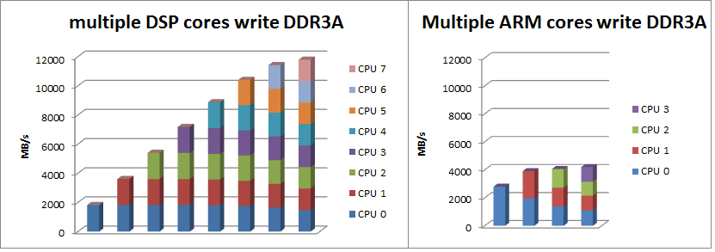
- Comparison of multiple DSP cores and multiple ARM cores sharing DDR
The ARM core has big L2 cache, up to 4MB. In most usage cases, most data access will hit in L2 cache, and this will alleviate the contention on the bus to MSMC. However, in above test cases, the cache are flushed before each test case, and cores access shared memory through same bus in parallel, this is actually a worst case may rarely happen in real application.

References
- TMS320C66x DSP CorePac User Guide (SPRUGW0)
- KeyStone II Architecture ARM CorePac User Guide (SPRUHJ4)
- KeyStone II Architecture Multicore Shared Memory Controller (MSMC) User Guide (SPRUHJ6)
- KeyStone II Architecture DDR3 Memory Controller User Guide (SPRUHN7A)
- KeyStone Architecture Enhanced Direct Memory Access (EDMA3) Controller User Guide (SPRUGS5)
- K2H SOC data manual (SPRS866)

