Texas Instruments
Keystone II Multicore Workshop
ARM-based Lab Manual

March 2015

Contents
Prerequisites 1
Hardware 1
Software 1
Workshop Network 3
Setting up a Serial Terminal Session to the EVM via USB 4
Setting up a VNC View to the Ubuntu Server 4
Updating the U-BOOT 5
Update SPI NOR Flash with U-boot GPH image 5
Server Directory Structure 6
Lab 1: EVM Board Bring-up 7
Purpose 7
Load and Run standard “Hello World” application 7
Lab 2: Build a New ARM Program 12
Projects and Source Code 12
Purpose 12
Task 1: Modify the File System 12
Task 2: Retrieve Example Simple Code 13
Task 3: Build the Executable 14
Task 4: Unzip and Decompress the File System & Add New Executable 15
Task 5: Compress and Zip the New File System 16
Task 6: Reboot the EVM and Run the New Program 16
Lab 3: Boot Using NFS-mounted File System 19
Purpose 19
Task 1: Build a File System on a Linux Host, Use the NFS Server 19
Task 2: Configure U-BOOT to Mount the File Server and Boot 20
Task 3: Build a New C Program in the File System and Debug It 21
Lab 4: Boot Using USB Flash Drive 23
Purpose 23
Task 1: Preparing the USB 23
Task 2: Reboot the EVM 29
Lab 5: Build, Run and Optimize DSP Project Using CCS 31
Purpose 31
Project Files 31
Task 1: Build and Run the Project 31
Task 2: Define the Target 41
Task 3: Connect to the EVM 42
Task 4: Load and Run CASE 1 43
Task 5: Use Optimization and Disable Symbol Debug for the fir Filter Routine 44
Task 6: Optimize Software Pipeline 46
Task 7: Enable the Cache 48
Task 8: Running in Parallel on Multiple Cores 49
Lab 6: Load and Run DSP Code Using MPM Server 53
Purpose 53
Project Files 53
Task 1: Build and Run the Project 53
Task 2: Using MPM to Load, Run and Observe Results 56
Lab 7: ARM-DSP Communication Using MPM & Shared DDR 59
Purpose 59
Linux and DSP Simple Memory Management 59
Building the Project with the Default Platform 60
Task 1: Build and Run the Project 60
Task 2: Using MPM to Load, Run and Observe Results 66
Task 3: Modify the Platform and Run Again 68
Lab 8: ARM Optimization Using SMP Linux 70
Projects and Source Code 70
Purpose 70
Task 1: Copy the Source Files 70
Task 2: Compile, Build, & Run the Project on a Single Core 72
Task 3: Run the Code on Multiple Cores 75
Lab 9: Inter-Processor Communication (IPC) 77
Projects and Source Code 77
Purpose 77
Task 1: Run the Demo from a Web Server 77
Task 2: Run the Demo from the Terminal 82
Task 3: Rebuild the Executable 85
Task 4 (Optional): Modify Source Code & Rebuild Executable 92

Prerequisites
The following hardware and software are needed to perform the labs in this manual.

Hardware
- Update BMC and UCD on EVMK2H (optional):
  - The wiki page http://processors.wiki.ti.com/index.php/EVMK2H_Hardware_Setup gives instructions on how to detect if the board needs BMC (Baseboard Management Controller) update. It also instructs how to do the update the BCM using CCS.
NOTE: A PDF version of the wiki page (KeyStone2_EVM_hardwareSetUp.pdf) is also available. Ask your instructor.
  - The user must also check the UCD Power Management version (see EVMK2H Hardware Setup at link above) and update if necessary.
NOTE: Instructions and scripts that show how to update the UCD are provided in the zip file XTCIEVMK2X-UCD-Update.zip (ask your instructor).
- TI training EVMs are already updated. The above update may be required on a customer’s personal EVM.

Software
The following software packages must be pre-installed on the student laptop before the workshop starts. NOTE: During the workshop, the laptop is attached to local network and has limited access to internet.
- Download the MCSDK and CCS:
  - For details regarding the instructions in this section, refer to the MCSDK User Guide for KeyStone II.
  - The latest release of MCSDK is found here:
http://software-dl.ti.com/sdoemb/sdoemb_public_sw/mcsdk/latest/index_FDS.html
    - For this lab you can use the Windows or the Linux version, depends on your laptop. Linux MCSDK was pre-installed on an Ubuntu server that will be used in some of the labs.
  - From the same download page as the MCSDK, locate and download the latest CCS version and the emupack version that goes with the CCS. Follow the instructions on the page. Note, installing CCS requires licensing from TI.
- Installing VNC Viewer:
VNC server that supports graphic interface was installed on the Ubuntu server. Each laptop must have a VNC viewer. Texas Instruments and many other corporations purchased global licenses for Real VNC enterprise users and it can be downloaded from internal software download site (EDS). Limited functionality Real VNC viewer is available as freeware from multiple sites.

- FTP Client
FTP server is installed on the Ubuntu server. Moving files between the student Laptop and the Ubuntu server can be done with the enterprise version of Real VNC or (if the student uses a freeware real VNC) by using ftp client on the laptop. The student must confirm that ftp client is installed on the laptop.
- For communication between the student PC and the EVM, the FTDI driver is required. As needed, download the 32-bit driver here: http://www.ftdichip.com/Drivers/D2XX.htm
- Terminal emulator such as Tera Term or Putty (or other). Tera Term is installed on TI’s laptops.
- It is assumed that the user knows how to use the tools, VNC, terminal emulator, and FTP client.

Workshop Network
The diagram above shows the workshop network environment:
- There are up to 10 lab stations. EVMs at each station are numbered from 1 to 10. Each station has the following:
  - One EVMK2H
  - One laptop that is connected to the EVM via JTAG cable.
  - One optional laptop that is not connected to the EVM, called the second laptop in the station.
- All EVMs and students laptops are connected to the local network 192.168.0.XX via a wired connection to a switch or a router.
- The Ubuntu server is connected as well. The Ubuntu server has access to an external network with a global IP that have access to the Web.
- The IP addresses of the local network (192.168.0.XX) is provided by the Ubuntu server DHCP.

Setting up a Serial Terminal Session to the EVM via USB
The EVM has two (mini) USB ports.
  - One of the ports accesses the JTAG connection and can be used to connect CCS to the board. This USB connector is part of the emulator daughter (mezzanine) card.
  - The second USB port is part of the mother board and can be used to connect two serial terminals into the EVM. We will refer to these serial terminals as Tera Term (to distinguish from the window viewer terminal to the Ubuntu machine). The tera-terminals are connected using a single USB cable but can be opened as two tera-terminals.
    - The first serial terminal (ARM Tera Term) is connected to the ARM terminal (e.g., the lower COM port)
    - The second serial terminal (BMC Tera Term) is connected to the FPGA/BMC on the board.
    - The user must open the two Tera Term connections and set the serial rate to 115200 Baud.

Setting up a VNC View to the Ubuntu Server
Launch the VNC Viewer application from the desktop of your laptop/PC. The server IP will be given by the instructor. For static configuration, when DHCP is not available, the server IP is 192.168.0.100.
  - The login instance for student N is :N. For example, student 3 will VNC to address 192.168.0.100:3, while student number 7 will use 192.168.0.100:7.
  - The VNC password for all studentN is “studentN” where N is the student number in hexadecimal notation, that is, student10 password is studenta, and student11 password is studentb and so on.

Updating the U-BOOT
The U-BOOT that is programmed into flash on the EVM must be updated when moving ti a new version of the MCSDK. The following process will be done at the beginning of every training session

Update SPI NOR Flash with U-boot GPH image
The following process is used to update the U-BOOT image in SPI Flash. It must be done every time a new release of MCSDK is used.
- Power cycle the EVM and stop the autoboot by pressing any key.
- The image sub-directory of the MCSDK release (for MCSDK release 3.1.1.4 the image directory path is /tiTools/MCSDK_3_1_4\mcsdk_linux_3_X_Y_Z\images) has a gph file - u-boot-spi-k2hk-evm.gph. This file was copied to the TFTP root directory (see the table below for the path to the TFTP root directory)
- Make sure the tftp server is running. Then issue the following commands to U-Boot console:

setenv serverip 192.168.0.100
dhcp 0xc300000 u-boot-spi-k2hk-evm.gph

sf probe
sf erase 0 < the size of u-boot-spi-k2hk-evm.gph in hex up rounded to sector boundary of 0x10000>
sf write 0xc300000 0 <size of u-boot-spi-k2hk-evm.gph image in hex>

NOTE: The size of the image will be displayed as part of the DHCP command.

Server Directory Structure
The following directories and sub-directories were added to facilitate the workshop. The directory name includes the absolute path of any directory.
Directory | Purpose | Comments
/tiTools | Contains TI tools that are to be used by all students: Linaro cross compiler tool chain, CCS, and MCSDK | Sub-directories are MCSDK, CCS and Linaro tools chain (cross compiler)
/tiTools/CCS | CCS installation location
/tiTools/MCSDK_X_Y_Z | MCSDK installation directory, version number is X_Y_Z
/tiTools/gcc | Linaro tools chain – cross compiler
/tftpboot | Root directory for the TFTP server. | Each student has a sub-directory
/ tftpboot /studentN | TFTP directory for student N, where N is 1 .., 10 | Student has to copy images from the MCSDK to this directory for ramfs boot
/opt/filesys | Root directory for the NFS server that enables mounting of the server file system into the EVM | Each student has a sub-directory
/ opt/filesys /studentN | NFS directory for student N, where N is 1..,10 | Each student should build private file system into this directory
/global/scripts | This directory has scripts that initialize environment variables. studentStartInsideTI.sh is used when the server is inside TI network, and studentStartOutsideTI.sh is used when the server is outside the firewall. Other scripts may be developed for other locations | The student must run the script for every terminal by doing  Source /global/scripts/scriptXXX.sh
/global/projects | Contains the source code for projects that are used during the Lab. | It has two sub-directories, DSP and ARM. Students will copy the source code files from this directory to their private directories
/global/projects /ARM | Source code for ARM projects
/global/projects /DSP | Source code for DSP projects
/home/studentN | Home private directory of student N N=1 ..,10 | All changes to files are done in the student private directory
/global/git | All sources for TI Arago distribution

Lab 1: EVM Board Bring-up

Purpose
The purpose of this lab is to boot the EVM from TFTP server. In addition to the kernel, device tree and the monitor, the file system is loaded from the TFTP server.

Load and Run standard “Hello World” application
- In order for the U-BOOT to get files from a sub-directory, the tftp download path for u-boot command needs to be specified via the tftp_root value. In our server, the root address of TFTP is /tftpboot. Each student has a private sub-directory /tftpboot/studentN where N is the student number.
- Make a subdirectory /tftpboot/studentN if it does not exist already and copy the MCSDK release binary images into this directory. The binary images are located in the /tiTools/MCSDK_X_Y_Z/mcsdk_linux_X_Y_Z/images directory on the Ubuntu server, where X,Y and Z are the release number.
cd /tftpboot/studentN
Where N is the student number you have been assigned for this lab.
cp /tiTools/MCSDK_3_X_Y_Z/mcsdk_linux_X_Y_Z/images/*.* .

- U-BOOT loading and running Linux Kernel using TFTP with ramfs file system
  - First verify that the DIP switch (sw1) are in ARM SPI boot mode:
1 OFF 2 OFF 3 ON 4 OFF
  - Power up EVM, look at the ARM tera-terminal window

  - After power cycle, press the return key to stop autoboot in the ARM tera-terminal
  - Enter the following command to reset the current environment variables.
env default -f –a
  - MCSDK release has multiple file systems. The stripped-down file system name is arago-console-image-k2hk-evm.cpio.gz. This file system is small and does not have most of the applications. Two other file systems, tisdk-rootfs and tisdk-rootfs-rt (real time) include all TI applications and tools, but they are too large to be loaded from TFTP. We will use these file systems during mounting boot and USB boot. A smaller version of tisdk-rootfs.cpio.gz from older release is used in this Lab.
NOTE: This file system will be used ONLY in lab 1.The file tisdk-rootfs.cpio.gz was already copied from older release to the current release.
The file system used in this example is tisdk-rootfs.cpio.gz
  - The following steps are used to configure the environment variables in u-boot:
    - In the terminal, write print <variableName> where variable name is the environment variable that you want to view.
    - If the return value is the correct value, you are done with this variable. If not, use the command setenv <variableName> <’variableValue’> where variableValue is the new value given in the instructions.
NOTE: You can use copy/paste and modify for long variable values.
    - After all variables are configured, save the new environment variables using the command saveenv
    - For example, to set the name_fs to arago-console-image-k2hk-evm.cpio.gz do the following:
      - Enter the command print name_fs
      - If the value is anything other than arago-console-image-k2hk-evm.cpio.gz, go to the next step
      - Enter the command setenv name_fs ‘arago-console-image-k2hk-evm.cpio.gz’
      - Enter the command saveenv

The following is a list of variables (variableName) and the values they should be (variable value)
Variable | Value
args_ramfs | 'setenv bootargs ${bootargs} earlyprintk rdinit=/sbin/init rw root=/dev/ram0 initrd=0x802000000, 80M’
name_fs | tisdk-rootfs.cpio.gz
name_fdt | uImage-k2hk-evm.dtb
name_kern | uImage-keystone-evm.bin
name_mon | skern-k2hk-evm.bin
serverip | 192.168.0.100
boot | ramfs
tftp_root | studentN where N is the student number
bootargs | ‘console=ttyS0,115200n8 rootwait=1 earlyprintk rdinit=/sbin/init rw root=/dev/ram0 initrd=0x802000000,80M’

  - At the end, do not forget to save the settings using saveenv
  - Boot the EVM using either a hardware or software reboot:
- Hardware reboot = power cycle
- Software reboot = type reboot in the BMC terminal window
- From U-boot prompt, type boot

- The ARM Tera Terminal starts as follows:
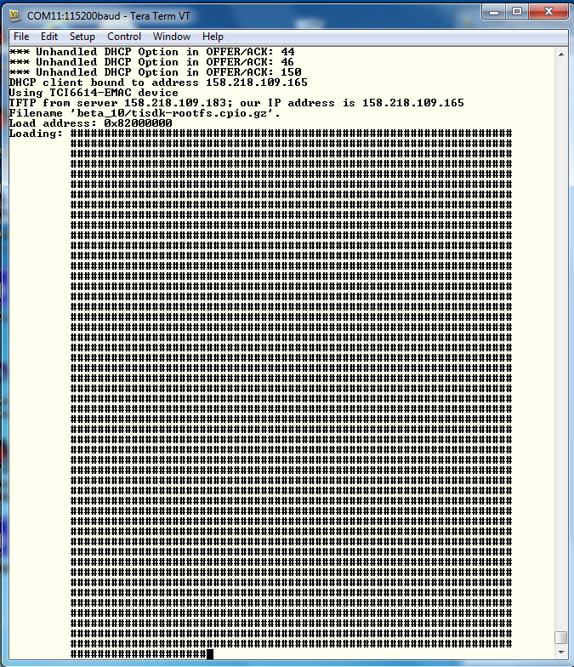

- When booting ends, login as root (no password)
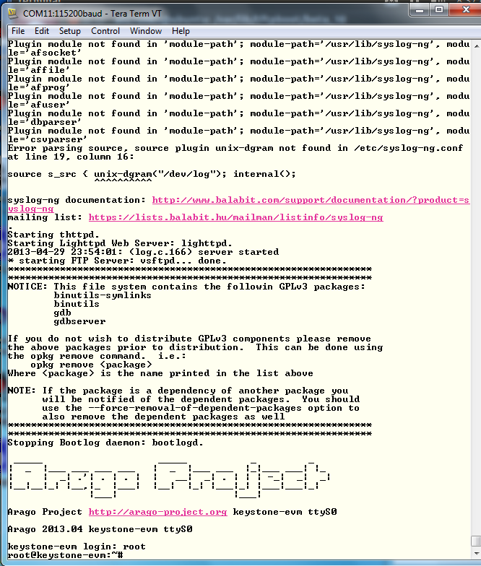

- After you login as root, run the hello world program ./hello and look for the hello world response

Lab 2: Build a New ARM Program

Projects and Source Code
All projects and source code are available on the Ubuntu server. The directory /global/Projects has two sub-directories:
- /ARM contains ARM projects
- /DSP contains DSP projects
NOTE: When the DSP projects are built using CCS on the student PC, projects should be moved via Samba or FTP from the server to the student laptop.

Purpose
The purposes of this lab are:
- To demonstrate how to build a simple ARM program using all cross compiler tools on Ubuntu server.
- Build a new file system and load the net file system to the EVM
- Run the built code
NOTE: In this Lab, the arago-console-image-k2hk file system is used.

Task 1: Modify the File System
First, you will modify the arago-console-image-k2hk file system
Modifying the file system involves three steps:
- First, a new main function is developed. Using the cross compiler tools on Ubuntu, the function is compiled and an executable is built.
- Next, the arago-console-image-k2hk compressed file system is unzipped and de-compressed into a temporary directory, and the new executable that was built in the previous step is added.
- Last, the new file system is compressed, zipped, and moved to the tftp directory. The u-boot updates name_fs, the name of the filesystem. The EVM is then booted, the new program is executed, and produces the expected results.

Task 2: Retrieve Example Simple Code
- The example code myHello.c is located on the Ubuntu server in /global/Projects/ARM/myHello directory
- Copy this file to the student directory /home/studentN/temp
NOTE: If the temp directory does not exist, create it as follows:
- cd ~ takes you to the home directory
- mkdir temp
- cd temp
- sudo cp /global/Projects/ARM/myHello/myHello.c .
- For a system that is outside of the TI fire wall, studentStartOutsideTI.sh is a script that defines all the paths and exports for each individual user. The user must call this script for each new terminal:
Source: /global/scripts/studentStartOutsideTI.sh
- For system inside of TI firewall, studentStartInsideTI.sh is a script that defines all the paths and exports for each individual user.
Source: /global/scripts/studentStartInsideTI.sh
- The Linaro toolchain and all other shared software are installed on the Ubuntu server in directory /tiTools/. A path to the Linaro tool chain is defined in the script above.
- Before compiling, look at the source code of myHello.c. You can modify it, add printf or any other C instruction that you like.

Task 3: Build the Executable
- To use the cross compiler to build the executable, use the following command:
arm-linux-gnueabihf-gcc -o myHello –g myHello.c
The cross compiler tools will compile the file and build an executable called myHello in the same directory.
- To verify that the compilation was done for the ARM processor and not for the native Intel (or other) processors do the following:
file myHello
- The results should show the ARM architecture:
“myHello: ELF 32-bit LSB executable, ARM, version 1 (SYSV), dynamically linked (uses shared libs), for GNU/Linux 2.6.31, BuildID[sha1]=0x953dac672e7159d481d5a6d3bbb5356e5f870d21, not stripped”

Task 4: Unzip and Decompress the File System & Add New Executable
The compressed file system arago-console-image-k2hk-evm has a cpio.gz compression. You will build a new file system in the student home directory.
- Copy the current compressed file system to the new directory:
sudo cp /tftpboot/studentN/ arago-console-image-k2hk-evm.cpio.gz .
- Unzip the compressed file system
sudo gzip –d arago-console-image-k2hk-evm.cpio.gz
- Uncompress the file system from the cpio file. This operation builds the complete file system.
sudo cpio –i –F arago-console-image-k2hk-evm.cpio
- Remove arago-console-image-k2hk-evm.cpio
sudo rm arago-console-image-k2hk-evm.cpio
- The file system resides in the temp directory. Copy the executable that was built previously (myHello) into the usr/bin directory in the file system. The complete path is /home/studentN/temp/bin
sudo mv myHello /home/studentN/temp/bin/.
sudo mv myHello.c /home/studentN/temp/bin/.

Task 5: Compress and Zip the New File System
- The next step is to compress the file system back into a new file system. This is done by piping all the directories and the files in the file system into the cpio zipped format. The resulted compressed file system must reside in one directory above temp. From the temp directory (/home/studentN/temp) do the following:
sudo find . | sudo cpio –H newc –o –O ../myArago.cpio
cd ..
sudo gzip myArago.cpio
- The resulting file is myArago.cpio.gz This file should be copied to the student’s TFTP directory:
sudo cp myArago.cpio.gz /tftpboot/studentN/.
- At this point, studentN has a new file system: myArago.cpio.gz

- The user should change the environment variable name_fs in the EVM U-BOOT to myArago.cpio.gz

Task 6: Reboot the EVM and Run the New Program
- Reboot the EVM and stop the U-BOOT before it starts loading.
- Change name_fs to the new filesystem
setenv name_fs myArago.cpio.gz
- Enter saveenv
- Enter boot
- After boot, login as a root
- Run myHello /bin/myHello
- Observe the results.

Lab 3: Boot Using NFS-mounted File System

Purpose
The purpose of this lab is as follows:
- Demonstrate how to boot the EVM when the file system resides on a different server that is mounted on the EVM.
- Develop code on the EVM and use the native gcc tools to build a debuggable executable.
- Use gdb debugger to debug the developed code.

Task 1: Build a File System on a Linux Host, Use the NFS Server
The NFS server is installed on the Ubuntu server in the directory /opt/filesys. Each student has a sub-directory where he or she builds the file server, and the Uboot is configured to reach this directory for each student. The file system to be mounted should be built on the local Ubuntu machine.
- Change the directory into the NFS mount private directory for studentN /opt/filesys/studentN (where N is the student number).
- Copy a tar version of the compressed file system tisdk-rootfs-k2hk-evm.tar.gz into /opt/filesys/studentN. This file system has the complete TI LINUX applications.
tisdk-rootfs-k2hk-evm.tar.gz is part of the release in the images directory, currently in /tiTools/MCSDK_X_Y_Z/mcsdk_linux_X_Y_Z/images
NOTE: The release version shown here may not be the same as the one on your system)
- Change the directory:
cd /opt/filesys/student
- Copy the image:
sudo cp /tiTools/MCSDK_X_Y_Z/mcsdk_linux_X_Y_Z/images/tisdk-rootfs-k2hk-evm.tar.gz .
- Untar the file system:
sudo tar zxf tisdk-rootfs-k2hk-evm.tar.gz
- Remove the original compressed file:
sudo rm tisdk-rootfs-k2hk-evm.tar.gz

Task 2: Configure U-BOOT to Mount the File Server and Boot
- Power cycle the EVM.
- In the ARM Tera Term, stop the autoboot.
- Use the instructions in Lab 1 to set the following environment variables:
Variable | Value
nfs_serverip | 192.168.0.100
boot | Net
nfs_root | /opt/filesys /studentN where N is the student number
args_net | setenv args_net 'setenv bootargs ${bootargs} rootfstype=nfs root=/dev/nfs rw nfsroot=${nfs_serverip}:${nfs_root},${nfs_options} ip=dhcp'

- Save the new environment variables:
saveenv
- Boot the EVM.

Task 3: Build a New C Program in the File System and Debug It
- After login as root in the ARM terminal you are in root home directory. Create an application directory:
mkdir applications
- Change directory to applications: cd applications
- In the server window, copy myHello.c from /global/Projects/ARM/myHello to the mounted applications directory of root /opt/filesys/studentN/home/root/applications
sudo cp /global/Projects/ARM/myHello/myHello.c /opt/filesys/studentN/home/root/applications/.
- Back in the EVM terminal, locate the gcc native compiler and verify that it exists:
which gcc
Note: The response should be /usr/bin/gcc
- Compile and build the application similar to the method used in the previous lab, but add the debug flag (-g) to the command and use the native gcc
gcc –g -o myHello myHello.c
- Make sure that myHello.c and myHello are both in the applications directory:
ls –ltr myHello*
- Start a debug session:
gdb myHello
- Simple gdb commands:
  - list see the source
  - b set a break point
  - r run to the break point
  - s step
  - n next (step over)
  - c run to the next breakpoint
  - finish end
  - delete n delete breakpoint at line n
- There are many gdb quick guides on the Web. Here are URLs to two of them:
http://condor.depaul.edu/glancast/373class/docs/gdb.html
http://darkdust.net/files/GDB%20Cheat%20Sheet.pdf
- Put some break point, look at the source (using the list or l command), run to breakpoint, do next and so on and so forth.

Lab 4: Boot Using USB Flash Drive

Purpose
The purpose of this lab is to demonstrate how to boot the EVM from a USB flash drive. The Kernel, monitor, and device tree reside on one partition of the USB. The file system resides on a second partition.
NOTE – USB boot is not available on release 2 and 3 of the EVM unless they were changed to supply the USB with power. Release 1.1 of the EVM has USB power.

Task 1: Preparing the USB
NOTE: This procedure may already be done. In that case the instructor will provide pre-prepared USB memory stick. Preparing the USB requires Ubuntu host to be physically available for USB stick. So if the students have to prepare USB, it will be done one after another on the Ubuntu host.

Step 1: Install GParted On Ubuntu Host
Used GParted 0.11.0 for this test. So exact steps may vary if version is different
$sudo apt-get install gparted

Step 2: Partition the Device
Before you start partitioning the USB, verify what /dev are currently connected so it will be easy to identify the device name of the USB.

Prepare the USB for New Partitions
  - Do not connect the USB stick to the server.
  - Start GParted sudo gparted
  - The following is a screen shot from GParted. In the upper right corner, click the small arrow and verify what devices are connected and their respective sizes.
In the screen shot below, there is a single device /dev/sda with size of 238.47 GB
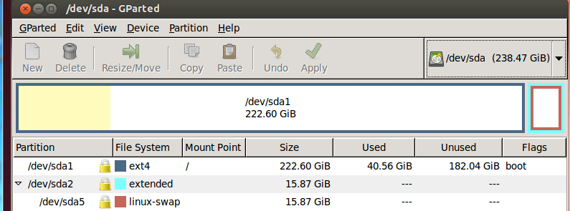
  - Quit GParted (GParted -> Quit), insert the USB stick into a USB port, and start GParted again. This time the device list will show a new device. The new device /dev/sdb has size of 982MB. This is the USB stick that needs reformatting. See the screen shot below:
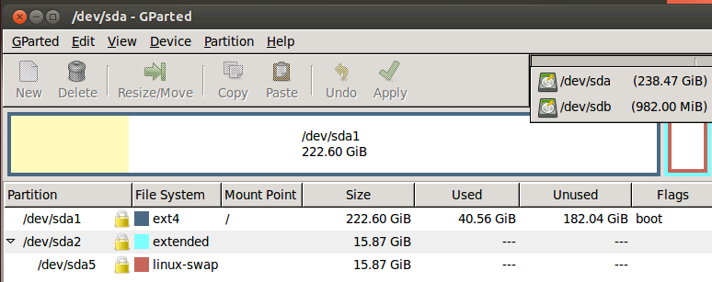

  - Select the new device.
In this case, /dev/sdb (NOTE: If the server has multiple disks, the name may be different)
  - Unmount the device: Partition -> Unmount
  - If there is existing partition, delete it: Partition -> Delete
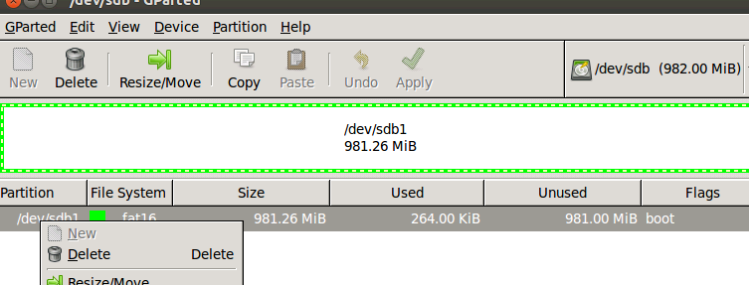

Add Two New Partitions
After deleting the old partition, the partition and filesystem status now shows as unallocated. You can now start building two new partitions:
- partition 1 for boot images
- partition 2 for rootfs

Create fat32 Partition for Boot (contains boot images)
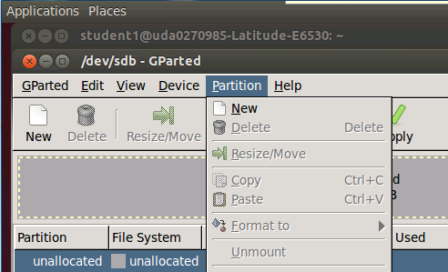
- Create a new partition: Partition -> New
  - New size = 32MiB
  - File system = fat32
  - label = boot
  - Keep rest of the fields default
- Click add to add the new partition

- Select the partition you just created and format it: Partition -> Format to
- Select fat32 format
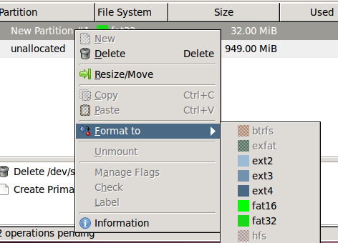

Create ext4 Format for rootfs (contains root filesystem)
- Select the unallocated partition and create a new one: Partition -> New
  - File system = ext4
  - label = rootfs
  - Keep rest of the fields default
- Click add to add the new partition
- Select the partition you just created and format it: Partition -> Format to
- Select ext4 format
- Apply the changes and Quit:
- Edit -> Apply All Operations
- GParted -> Quit

Step 3: Copy Images and rootfs Files to Partitions
Assume that the USB device name is /dev/sdb (if different name, change the instructions accordingly).
- Unmount if the devices are auto mounted.
sudo umount /dev/sdb1
sudo umount /dev/sdb2
- Copy images to partition #1 (boot). First partition is mounted to /mnt/test
sudo mount -t vfat /dev/sdb1 /mnt/test
- Change directory to image release directory
cd /tiTools/MCSDK_X_Y_Z/mcsdk_linux_x_y_Z/images
- Copy the kernel, device tree and monitor to the first partition
sudo cp skern-k2hk-evm.bin /mnt/test/
sudo cp uImage-k2hk-evm.dtb /mnt/test/
sudo cp uImage-keystone-evm.bin /mnt/test/

ls /mnt/test
skern-k2hk-evm.bin uImage-k2hk-evm.dtb uImage-keystone-evm.bin
sudo umount /dev/sdb1

- Copy rootfs files to partition #2 (rootfs). Change directory to the student directory where the NFS mounted filesystem was built previously.
cd /opt/filesys/studentN
Where N is the student number.

sudo mount -t ext4 /dev/sdb2 /mnt/test
cd ..
sudo cp -r studentN/* /mnt/test
ls /mnt/test/
bin boot dev etc home init lib lost+found media mnt proc sbin srv sys tmp usr var
sudo umount /dev/sdb2

Task 2: Reboot the EVM

Configure U-BOOT Environment Variables
- Insert USB flash drive to usb slot on EVM and Power ON EVM
- Type the following commands to setup the env for usb boot:
setenv boot usb
setenv args_usb 'setenv bootargs ${bootargs} rootfstype=ext4 root=/dev/sda2 rw ip=dhcp'
setenv init_usb 'usb start; run set_fs_none args_all args_usb'
setenv get_fdt_usb 'fatload usb 0:1 ${addr_fdt} ${name_fdt}'
setenv get_kern_usb 'fatload usb 0:1 ${addr_kern} ${name_kern}'
setenv get_mon_usb 'fatload usb 0:1 ${addr_mon} ${name_mon}'

Make sure that name_mon, name_kern, and name_fdt are the same as were loaded into
partition 1. In our case these are the expected values:
- name_fdt=uImage-k2hk-evm.dtb
- name_kern=uImage-keystone-evm.bin
- name_mon=skern-k2hk-evm.bin

If any of the above values are not correct, use setenv to configure the correct value.
- Type saveenv
- Type boot
Boot takes about 1 minute
- Login as root and run the program that was developed for the NFS case (myHello)
- Change the source code myHello.c (for example, add a printf saying that this is part of the USB boot)
- Compile the new file and run it.

Lab 5: Build, Run and Optimize DSP Project Using CCS

Purpose
In previous labs, you developed and debugged an ARM program. The purpose of this lab is to develop and debug a multicore C66x program using CCS IDE. This lab has the following parts:
- Using CCS, build a simple FIR project that runs on a single core.
- Optimize the code by achieving software pipeline, understand what can prevent the compiler from generating software pipeline code.
- Optimize execution by enabling cache.
- Perform parallel processing of the code and observe multi-cores processing speed up.
CCS IDE is used to execute the lab.
Before starting, the EVM should be configured to no-boot mode. To do so, set the dipswitch (SW1) on the EVM to: 1 Off 2 Off 3 Off 4On
The EVM emulator is the mezzanine card on the top of the EVM. The mini USB cable should be connected to the mezzanine card and to a computer with CCS installed.

Project Files
The following files are used in this lab:
- firMain.c
- firRoutines.c
- firTest.cmd
- firTest.h
- utilities.c
- Utilities.h
- firFilterLab.cfg

Task 1: Build and Run the Project
- FTP into the Ubuntu server and get all the files in directory /usb/global/Projects/DSP/firFilter into the local directory c:\ti\labs\firFilter on your PC. If this directory does not exist, create it.
- Open CCS.
- Create new project through the CCS menu item File New CCS Project.
- Enter firLab1 as a Project Name.
- Click the check box to Use default location.
- Set the Family to C6000 and Variant to Generic C66xxx Device
- Then press Finish to create the new project. See the screen shot.
NOTE: You will use the default location and not the location in the screen shot.
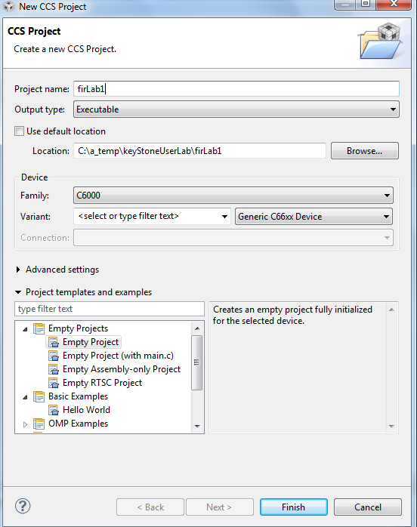
- Then in the Project Explorer view, right-click on the newly-created firLab1 project, and click on Add Files…
- Browse to C:\ti\labs\firFilter, select all the files in this directory, and click Open. When prompted how files should be imported into the project, leave it as default of Copy File. If you defined the new project with main.c, remove the main.c file that may be created.

- As soon as the file firFilter.cfg is imported into the project, CCS will ask you to enable RTSC support. See the screen shot below. Select Yes. Note, if CCS does not ask you to enable RTSC, rename the cfg file to some other name, and rename it back to firFilterLab.cfg

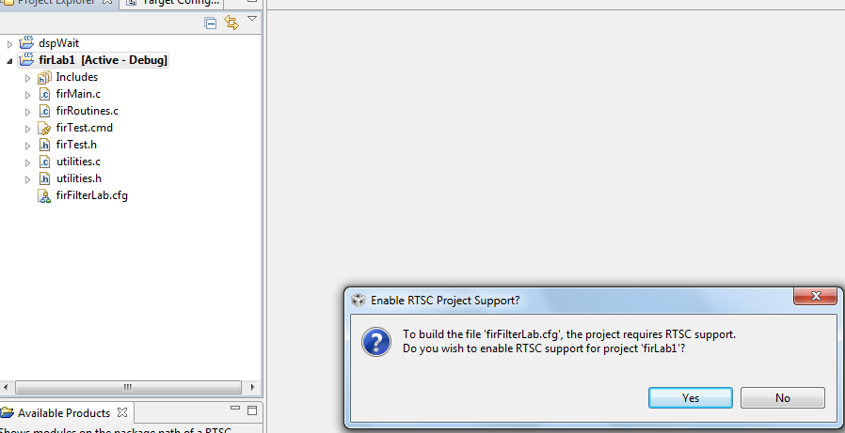

- Open Project Properties and select general->RTSC. Look at the RTSC modules that are selected in the screen shot below and make sure that you select ONLY the same RTSC modules (or packages). When a project starts, RTSC attempts to include all the modules in the release. So unselect any module that is not in the screen shot.
NOTE: The TARGET CONTENT BASE should reflect the location of CCS on your system.
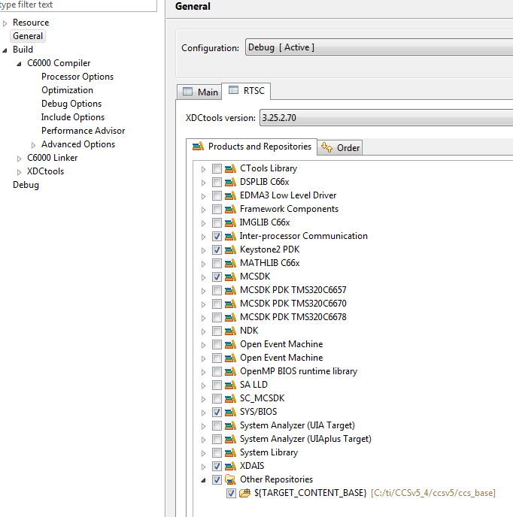

- If the XDAIS product does not appear in your screen (usually in CCSv6) add the XDCtools repository to the list. Find the location of XDCtools in the MCSDK release (in my case it is C:\ti\MCSDK_X_Y_Z\xdctools_X_Y_Z\packages). Make sure you have the packages and add it to the product.
Property->RTCS->Add and add the path to the packages

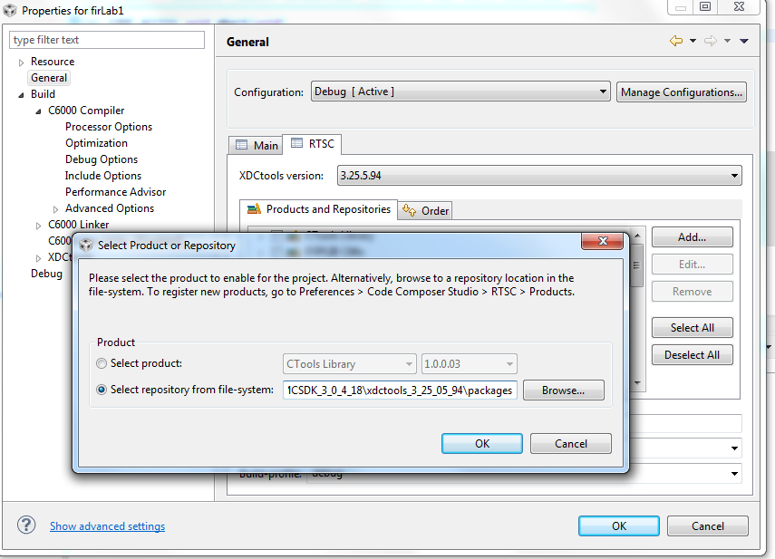

- Click on the platform tab and select ti.platform.evmTCI6638K2K platform as shown in the next screen shot.
NOTE: RTSC projects require the user to select three types of information.
- The device family in the CCS create page determines what core is used and thus what version of the compiler should be used (different cores have different intrinsic functions).
- The platform that is defined here determines the memory configuration of the core.
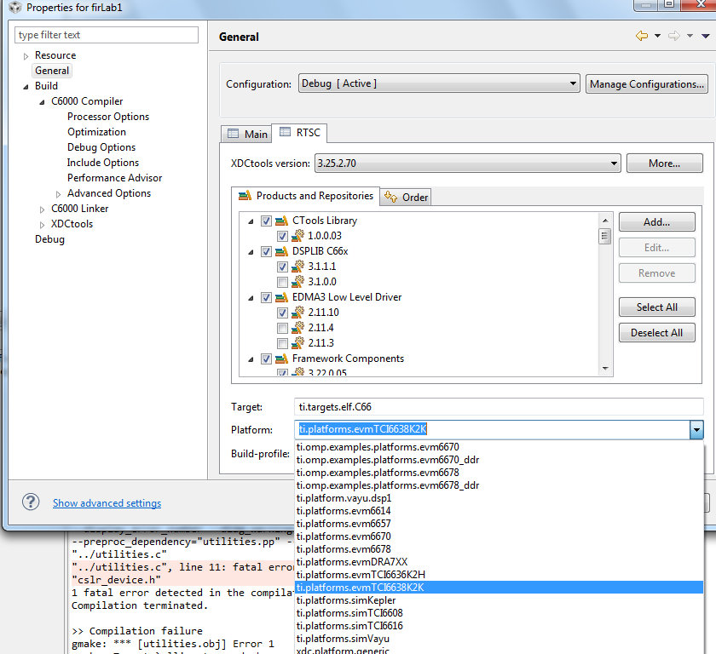

- Add csl include files location. On your laptop, find the directory: \pdk_keystone2_X_Y_Z\packages\ti\csl and add this directory to the include options property of the project. On my system the location of the file is in: C:\ti\MCSDK_X_Y_Z\pdk_keystone2_X_Y_Z\packages\ti\csl
See the following screen shot:
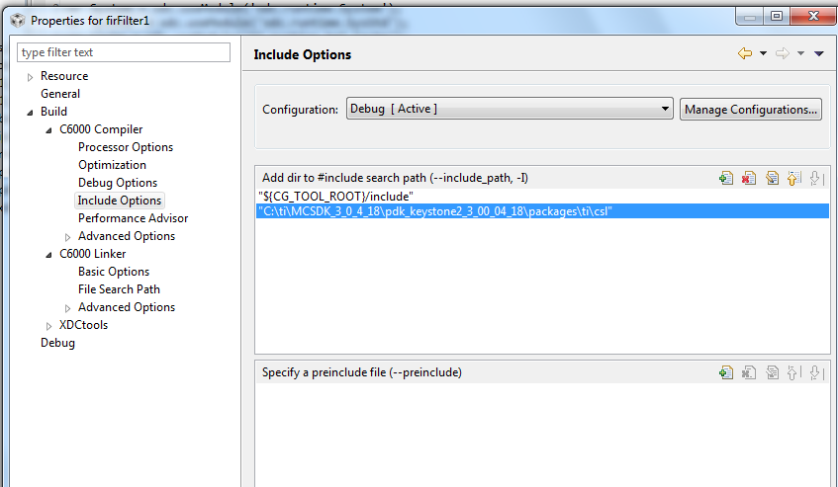

- Add the include file cslr_device.h at the above screen. Select a pre-include file and add cslr_device.h
- Add a path to cslr_device.h similarly to the above instructions. The path is pdk_keystone2_X_Y_Z\packages\ti\csl\device\k2k\src

- Add the CSL library and the path to the CSL library to the project properties. Libraries and paths to libraries are defined in the linker tab of the properties under file search path section.
The following is a screen shot from my system. You have to modify the path to the library based on the location of your release. Note: There are other ways to define the library and the paths as relative to the release location.
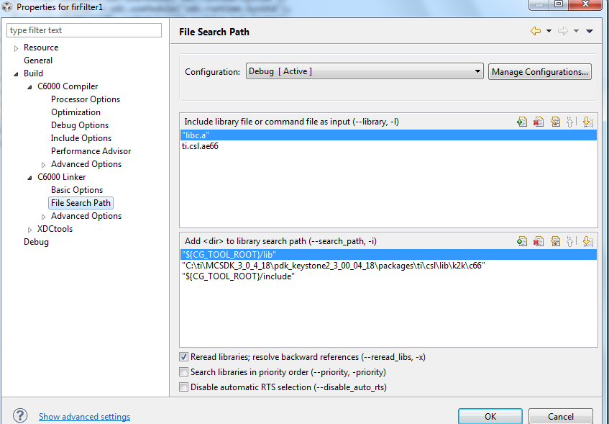

- Right click on the project name and select rebuild. If the build goes correctly, you will see the following in the console window.
NOTE: Look at the debug directory to ensure that the file firLab1.out is there. Ignore any warnings.
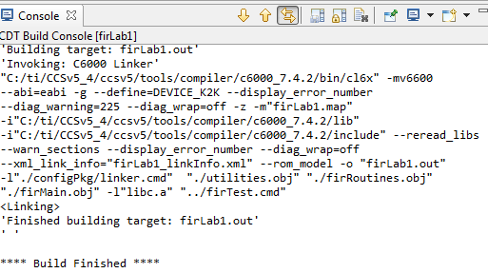
- Examine the code in firMain.c. There are five cases, but only case 1 is not commented out.
  - DSP 0 generates input data (inputData) and a set of filter coefficients (filterCoef)
  - Depending on the case, a set of fir filters is applied to the data and the results are written to the out file (outputFilter).
  - A set of timer registers (TSCL and TSCH) measure the execution time of the fir filter.
  - The standard printf function prints the results on the console.

Task 2: Define the Target
In this lab, the DSP code is run from no-boot mode. The no-boot mode requires setting the dipswitch SW1 of the EVM to: 1 Off 2 Off 3 Off 4 On.
Since no-boot mode is chosen, the device configuration (DDR configuration, PLL configuration and so on) must be done in a gel file.

Create a New Target in CCS
NOTE – the paths and other variables that are defined in this document may not reflect exactly the directory structure on your system. Use common sense and search to find the exact paths.
- Create a new target configuration:
  - Select the CCS menu option View Target Configurations.
  - Select User Defined.
  - Right-click and select New Target Configuration.
- Enter the name of the new target configuration in the File Name: text box.
  - Set the File name based on the EVM model, <model>.ccxml
For example, ‘TCI6638.ccxml’
  - Leave the Location the default value:
“C:\Documents and Settings\student\ti\CCSTargetConfigurations”
  - Click the Finish button. The .ccxml file will now open in a GUI-based view with the Basic tab active.
- Define the new target configuration by selecting the connection type in the Basic Tab.
- The Connection drop-down menu identifies the emulator type. For example, ‘Texas Instruments XDS2xx USB Emulator.”
  - Board or Device identifies the TI processor device, set it to 6638 and select TCI6638K2H
  - Under Save Configuration, click the Save button.
- Configure setup in Advance Tab
  - Click the Advanced tab at the bottom of the screen.
  - Select Core 0 on the target device:
    - TCI6638_0 IcePick_C_0 Subpath_1 C66xx_0
  - You will now see a sub-window called Cpu Properties that allows you to choose an initialization script.
  - Locate the appropriate GEL file, then click Open:

- Depending on your CCS version select the gel file. For example, for CCSv5 that is installed in directory c:\ti\CCS_5_5 the gel file is located at
C:\ti\CCS_5_5\ccsv5\ccs_base\emulation\boards\xtcievmk2x\gel\ xtcievmk2x.gel
Note, if the CCS that you use is located in a different directory, change the path accordingly
- Repeat the process for all C66x cores (C66xx_1, C66xx_2, … C66xx_7)
- Click the Save button.

Task 3: Connect to the EVM
- Click the Open Perspective (available at the right top corner of the CCS window).
- Switch to the Debug Perspective by selecting the CCS menu option Window Open Perspective CCS Debug.
- Select the CCS menu option View Target Configurations. Select the target configuration you created
- Launch the target configuration as follows:
  - Select the target configuration .ccxml file.
  - Right click and select Launch Selected Configuration.
- This will bring up the Debug window. NOTE: This may take some time, but you will eventually see all the device cores.
  - Select all C66x cores (select + Ctrl)
  - Right click and choose group cores.
  - Select the group, then right click and select Connect Target.

Task 4: Load and Run CASE 1
- Select the core group and load the .out file created earlier in the lab.
  - Select the CCS menu option Run Load Load Program
  - Click Browse project…
  - Select firLab1.out by unwrapping the firLab1->Debug and click OK.
  - Click OK to load the application to the target (all Cores).
- Run the application by selecting the CCS menu option Run Resume.
- A successful run should produce a console output as shown below. Record the cycles time:
[C66xx_0] start generating input data
finish generating input data
case 1 -> time consumed By core -> 0 610749952.000000

Issues to think about:
Look at the function CACHE_disableCaching ((Uint8) 144) which disables cache-ability for memory region. What memory region is it?
See Table 4-20 in the C66 CorePac User’s Guide http://www.ti.com/lit/ug/sprugw0c/sprugw0c.pdf
Look at the User Guide, the code, and the map file.

Task 5: Use Optimization and Disable Symbol Debug for the fir Filter Routine
As the project is still in development/debug state, there is no optimization and full debug support. The next step is to optimize the fir filter and disable the debug information. However, leave the other parts of the project without optimization and with full debug support. The properties for the file firRoutines.c will be changed. No other file will be effected.
- In the project explorer, select the file firRoutines.c and right click. Open the properties dialogue window as shown below.
- Select build->optimization. In the dialogue window set optimization to 3
- From the debug options dialogue select suppress all symbolic debug generation from the pull-down menu.
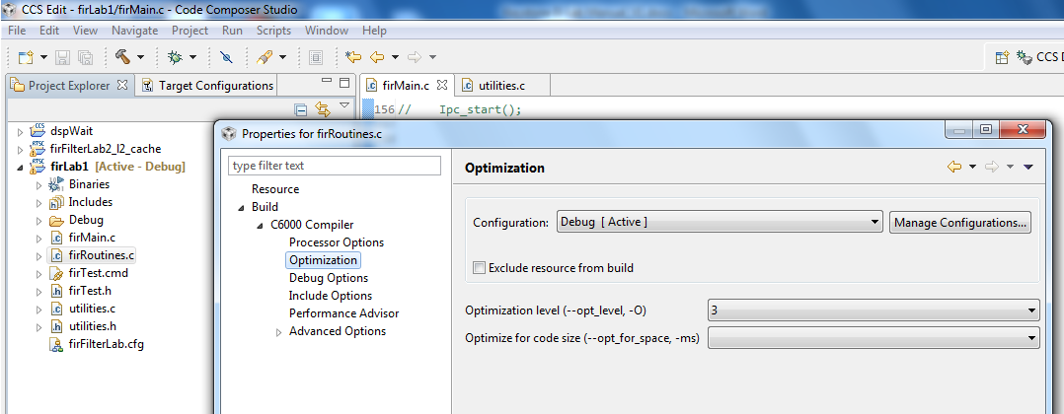

- From the build ->C6000 compiler -> Advanced Debug, select Assembly options and check Keep the generated assembly language (.asm) file as shown in the screen shot below.
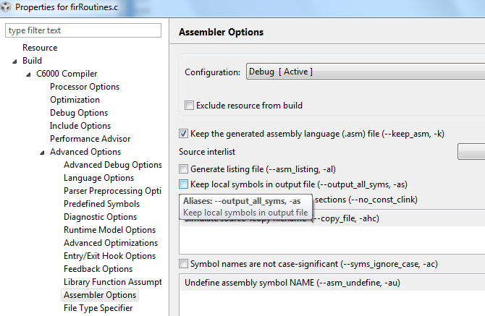

- Click OK and rebuild the project. Load and run.
- A successful run should produce a console output as shown below. Record the cycles time:
Start generating input data
Finish generating input data
Case 1: Time consumed by core -> 0 500579008.000000

QUESTION:
Is the code really optimized? Only 15% improvement.
Look at the assembly file firRoutines.asm in the debug directory and search for the function firRealFilter. Look for the loop and see if the compiler could get software pipeline
What is the reason that the loop does not qualify for software pipeline?

Task 6: Optimize Software Pipeline
The reason why the fir filter loop is not qualified for a software pipeline is because it calls myMultiply. The next task is to inline this function. myMultiply is an artificial function (i.e., no one will develop this function in real code). So it is easy to “inline” it. Look at the definition of myMultiply in the utilities.c file and inline it.
- Change the function firRealFilter by inline myMultiply function
- Save and build the project. Load and run.
- A successful run should produce a console output as shown below. Record the cycle time:
start generating input data
finish generating input data
case 1 -> time consumed By core -> 0 273086080.000000
- Next, tell the compiler the minimum number times that each loop will be executed. The filter size in this program is 8. Assume that the filter size will always be more than 4 and divided by 4, so adding a pragma( #pragma MUST_ITERATE(4,,4); ) will tell the compiler that the inner loop must be performed at least 4 times and the number of iterations is divided by 4.
- The outer loop presents the size of the output vector. The number of elements is 16K, but eventually we would like to run it on all 8 cores, so each core will have about 2K element. It is enough if we tell the compiler that the number of elements is more than, say 64. However, if you look carefully, you will notice that the number of output results is 16K – filter size + 1, so this is an odd number. You can tell the compiler that the number of elements is more than 64. In that case use something like (#pragma MUST_ITERATE(64,,1); ) or, if you agree to ignore the last fake result, you can tell the compiler (#pragma MUST_ITERATE(4,,2); ))
- Add the two pragma directives before the two loops (internal and external) in the function save and build.
- If the external loop is pragma MUST_ITERATE(64,,1)
start generating input data

finish generating input data
case 1 -> time consumed By core -> 0 221407008.000000

- If the external loop is pragma MUST_ITERATE(64,,2);
start generating input data

finish generating input data

case 1 -> time consumed By core -> 0 221306848.000000

QUESTION: To summarize the code optimization section, complete the following table:

Optimization Technique | Cycles | Improvements Compared with Previous Line
No Optimization
Compiler optimization 3, no symbolic debug
Software Pipeline
Adding pragma must iterate

Task 7: Enable the Cache
Enabling the cache is done in CASE 2. Un-comment the line #define CASE_2 above the main() in firMain.c
QUESTION:
What instruction(s) enable the cache?
The function CACHE_enableCaching ((Uint8) 128) ; was discussed in Task 4. The function CACHE_setL2Size ((CACHE_L2Size) 4); is part of the file csl_cachAux.h in the \MCSDK_3_14\pdk_keystone2_3_00_02_14\packages\ti\csl directory. Note, version number and location of MCSDK may be different for your setting.

- Un-comment the line #define CASE_2 in firMain.c
- Save, build, load and run. The results will look like the following:
start generating input data
finish generating input data
case 1 -> time consumed By core -> 0 221223008.000000
case 2 -> time consumed By core -> 0 7491409.000000

QUESTION: Complete the table.
Optimization Technique | Cycles | Improvements compare with previous line
No Optimization
Compiler optimization 3, no symbolic debug
Software Pipeline
Adding pragma must iterate
Enabling cache

QUESTION: What are the most important steps to optimize code running on a single core?

Task 8: Running in Parallel on Multiple Cores
Multiple cores are enabled in CASE 3 (2 cores), CASE 4 (4 cores) and CASE 5 (8 cores).
Un-comment the lines #define CASE_3 #define, CASE_4 and #define CASE_5 above the main() in firMain.c

- Un-comment the line #define CASE_3 #define CASE_4 #define CASE_5 in firMain.c
- Save, build, load and run. The results will be look like the following:

finish generating input data
case 1 -> time consumed By core -> 0 288423616.000000
case 2 -> time consumed By core -> 0 7493824.000000
case 3 -> time consumed By core -> 0 3680093.000000
[C66xx_1] case 3 -> time consumed By core -> 1 3678251.000000
[C66xx_0] case 4 -> time consumed By core -> 0 1839643.000000
[C66xx_1] case 4 -> time consumed By core -> 1 1838608.000000
[C66xx_2] case 4 -> time consumed By core -> 2 1839438.000000
[C66xx_3] case 4 -> time consumed By core -> 3 1836440.000000
[C66xx_0] case 5 -> time consumed By core -> 0 918711.000000
[C66xx_1] case 5 -> time consumed By core -> 1 921884.000000
[C66xx_2] case 5 -> time consumed By core -> 2 921973.000000
[C66xx_3] case 5 -> time consumed By core -> 3 920785.000000
[C66xx_6] case 5 -> time consumed By core -> 6 922374.000000
[C66xx_4] case 5 -> time consumed By core -> 4 923078.000000
[C66xx_5] case 5 -> time consumed By core -> 5 921646.000000
[C66xx_7] case 5 -> time consumed By core -> 7 920075.000000
For each case, the total time that is consumed to perform the FIR filter is the maximum time of all the cores.
QUESTION: Complete the table
Case | Cycles per core | Execution cycles (this is the cycles of the core with the highest cycles count) | Accumulate execution time for all the cores | Penalty of the accumulation execution time compared to single core (CASE 2)
Case 2 – single core
Case 3 – 2 cores
Case 4 – 4 cores
Case 5 – 8 cores

QUESTIONS:
- What is the purpose of the function waitBarrier(barrier_1, coreNum, jointNumber)? What would happen if the function is commented out?
Try to comment out the function (3 places) and see what happens.

- What is the purpose of the function waitAboutNSeconds(10) inside the function waitBarrie? What would happen if the function is commented out? Do you understand why?

Try to comment out the function and see what happens. Think about timing between cores.

- Can you think about other (better) methods to synchronize the execution of all the cores?
Semaphores?, QMSS queues based solution?, openMP? .

Lab 6: Load and Run DSP Code Using MPM Server
In this lab, you build a DSP project similar to the previous lab. Before starting, you should change the boot mode of the EVM back to boot mode. Set SW1 of the EVM back to 1 Off 2 Off 3 On 4 Off.
Read the instructions in Lab 3 to ensure that the EVM boots using NFS-mounted file system.

Purpose
Building a DSP code that is managed by the ARM. The ARM will reset C66x Core 0, load it with an executable, run it, and retrieve the results.

Project Files
The following files are used in this lab:
- Main.c
- mpmsrv_keystone2_example1.cfg

Task 1: Build and Run the Project
- FTP into the Ubuntu server and copy all the files that are in the directory /global/Projects/DSP/mpm_example into a local directory c:\ti\labs\mpm_example on your PC. If this directory does not exist, create it.
- Open CCS.
- Create new project through the CCS menu item File New CCS Project.
- Enter mpm_example as a Project Name.
- Click the check box to Use default location.
- Set the Family to C6000 and Variant to Generic C66xxx Device.
- Then press Finish to create the new project.
- Then in the Project Explorer view, right-click on the newly-created mpm_example project, and click on Add Files…
- Browse to C:\ti\labs\mpm_example, select all the files in this directory, and click Open. When prompted how files should be imported into the project, leave it as default of Copy File. If you defined the new project with main.c, remove the main.c file that may be created.
- As soon as the file mpmsrv_keystone2_example1.cfg is imported into the project, CCS will ask you to enable RTSC support. Select Yes.

- Open Project Properties and select general->RTSC. Look at the RTSC modules that are selected in the screen shot below and make sure that you select ONLY the same RTSC modules (or packages). When a project starts, RTSC attempts to include all the modules in the release. So unselect any module that is not in the screen shot.
NOTE: The TARGET CONTENT BASE should reflect the location of CCS on your system.
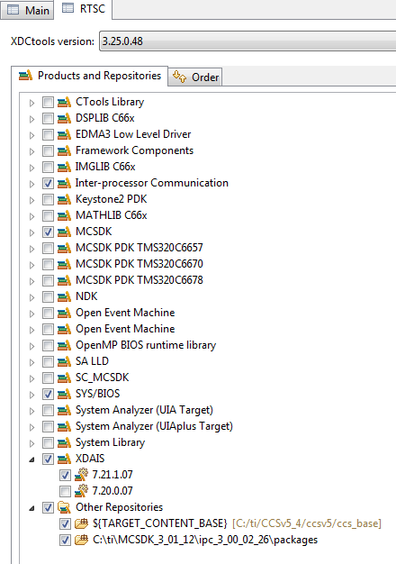
- Click on the platform tab and select ti.platform.evmTCI6638K2K platform

NOTE: RTSC projects require the user to select three types of information.
- The device family in the CCS create page determines what core is used and thus what version of the compiler should be used (different cores have different intrinsic functions).
- The platform that is defined here determines the memory configuration of the core.
- To build the correct RTSC drivers, the device name should be defined. This is done by adding a predefined symbol with the device name. More about it later.

- Right click on the project name and select rebuild. If the build goes correctly, you will see the following in the console window. NOTE: Look at the debug directory to ensure that the file MPM_example.out is there. Ignore any warnings.
'Building target: MPM_example.out'
'Invoking: C6000 Linker'
"C:/ti/CCSv5_4/ccsv5/tools/compiler/c6000_7.4.2/bin/cl6x" -mv6600 --abi=eabi -g --display_error_number --diag_warning=225 --diag_wrap=off -z -m"MPM_example.map" -i"C:/ti/CCSv5_4/ccsv5/tools/compiler/c6000_7.4.2/lib" -i"C:/ti/CCSv5_4/ccsv5/tools/compiler/c6000_7.4.2/include" --reread_libs --warn_sections --display_error_number --diag_wrap=off --xml_link_info="MPM_example_linkInfo.xml" --rom_model -o "MPM_example.out" -l"./configPkg/linker.cmd" "./main.obj" -l"libc.a"
<Linking>
'Finished building target: MPM_example.out'
'

**** Build Finished ****

Task 2: Using MPM to Load, Run and Observe Results
In this part, we assume that the EVM is boot in net mode, that is, the file system is on the server and it is mounted to the EVM as used in Lab3
- Find the location where the out file resides. To do so find the outfile in the debug directory of the project, select the outfile and right click properties. Look at the location at the top of the open dialogue
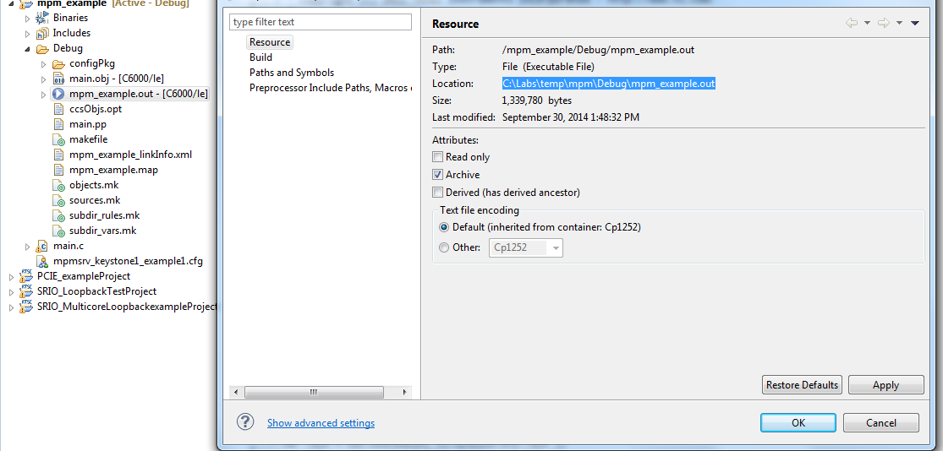
- From the VNC navigate to you directory /opt/filesys/studentN
- Change the permission of the bin subdirectory, do sudo chmod 777 bin
- FTP the out file into the server to /opt/filesys/studentN/bin where N is the student number.
- Reboot the EVM using NFS.
- From the terminal login as root
- cd /bin
- Use MPM to reset, load, and run core 0 with MPM_example.out by using the following MPM commands:
mpmcl reset dsp0
mpmcl load dsp0 MPM_example.out
mpmcl run dsp0

- After the end of run, look at the trace buffer printing by using the following command:
cat sys/kernel /debug/remoteproc/remoteproc0/trace0

- Change the main.c file as you wish, build it again, ftp to the file system (step 7) load the code to a different dsp (use N here) and run it:
mpmcl reset dspN
mpmcl load dspN MPM_example.out
mpmcl run dspN
- After the end of run look at the trace buffer printing by using the following command:

cat sys/kernel/debug/remoteproc/remoteprocN/trace0

Lab 7: ARM-DSP Co-working Using MPM & Shared DDR
In this lab, you build a DSP project that uses the DDR. Unlike the previous Lab where the code and the data were only in L2, in this lab some DDR is used by the DSP.

Purpose
Building a DSP code that uses the DDR and is managed by the ARM.

Linux and DSP Simple Memory Management
The previous project uses private L2 memory for program and data. This DSP project uses DDR. How does the system manage the DDR resources between the DSP and the ARM?
The Linux uses part of the DDR. So if a DSP program uses some of the DDR, it must tell the Linux. This is done in the U-BOOT environment.
To do it correctly, the user must follow the following steps:
- Stop autoboot and look at the messages from the U-BOOT. It looks like the following:
U-Boot 2013.01 (Oct 02 2014 - 00:16:34)

I2C: ready
Detected SO-DIMM [18KSF1G72HZ-1G6E2 ]
DRAM: 8 GiB (includes reported below)
NAND: 512 MiB
Net: K2HK_EMAC, K2HK_EMAC1, K2HK_EMAC2, K2HK_EMAC3
Hit any key to stop autoboot: 0
The size of the DRAM is 8 GiB in this case. It can be different size, depending on the EVM revision and memory configuration.
- TI software divides the total DRAM into two segments – Segment 0 with 2GB and segment 1 with 6GB. U-BOOT enables the user to define reserve one area in each segment for DSP usage. The DSP area (key word mem_reserve) is located at the end of the segment.
- Now determine how much DRAM the DSP needs. Obviously it must be less than the total DRAM in the EVM. Assume that in segment 0 Linux uses 1536 M and the DSP will use 512MB. The user must tell the U-BOOT that 512MB is reserved for the DSP.
- After stopping the autoboot, configure the memory that is assigned to the DSP (if it is not configured already).
setenv mem_reserve 512M
saveenv and boot

- The memory that is reserved for the DSP is located at the end of the available memory. For the 2G DRAM case, available memory is between 0x80000000 and 0xffffffff, so the 512M reserved for the DSP start at address 0xE0000000 to address 0xffffffff
- The first part of the project we will try to build the project without changing the platform and encounter an error
- Next, you need to build the DSP code and ensure that it uses only the assigned DDR. One way to do this is by using direct addressing. We will use this method in the Lab.

Building the Project with the Default Platform

Task 1: Build and Run the Project
- FTP into the Ubuntu server and copy all the files that are in the directory /global/Projects/DSP/mpm_example_sum into a local directory c:\ti\labs\mpm_example_sum on your PC. If this directory does not exist, create it. To ftp all files with wild character you can use mget *.
- Open CCS.
- Create new project through the CCS menu item File New CCS Project.
- Enter mpm_example_sum as a Project Name.
- Click the check box to Use default location.
- Set the Family to C6000 and Variant to Generic C66xxx Device.
- Then press Finish to create the new project.
- Then in the Project Explorer view, right-click on the newly-created mpm_example_sum project, and click on Add Files…
- Browse to C:\ti\labs\mpm_example_sum, select all the files in this directory, and click Open. When prompted how files should be imported into the project, leave it as default of Copy File. If you defined the new project with main.c, remove the main.c file that may be created.
- As soon as the file .cfg is imported into the project, CCS will ask you to enable RTSC support. Select Yes.

- Open Project Properties and select general->RTSC. Look at the RTSC modules that are selected in the screen shot below and make sure that you select ONLY the same RTSC modules (or packages). When a project starts, RTSC attempts to include all the modules in the release. So unselect any module that is not in the screen shot.
NOTE: The TARGET CONTENT BASE should reflect the location of CCS on your system.
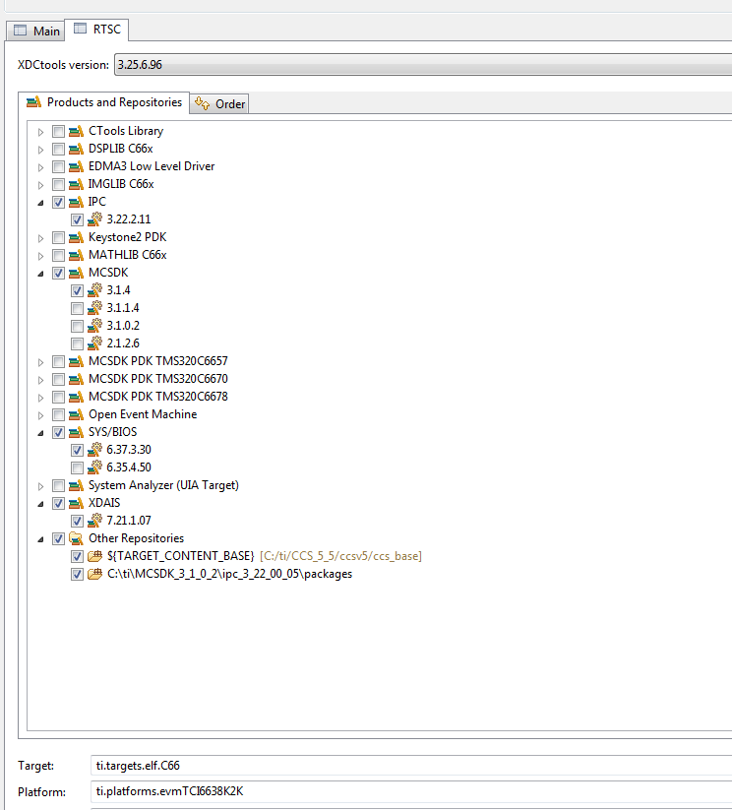

- Use the pull down menu to choose the XDC version to use. Different versions of xdc exist in the CCS install and in the MCSDK install. Choose the latest XDC and make a comment of the XDC version.
- Add the path to ti/csl/csl.h
Find the path in your release. In my release, the path is:
C:\ti\MCSDK_X_Y_Z\pdk_keystone2_X_Y_Z\packages
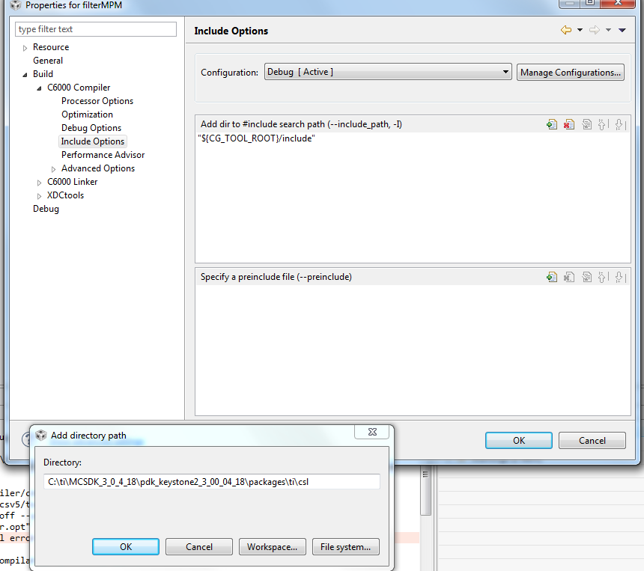

- Adding the device name to include device specific include file instead of including the file explicitly. Properties->Advanced Options->predefine Symbol and enter the device name, DEVICE_K2H or DEVICE_K2K (both share the same definitions)

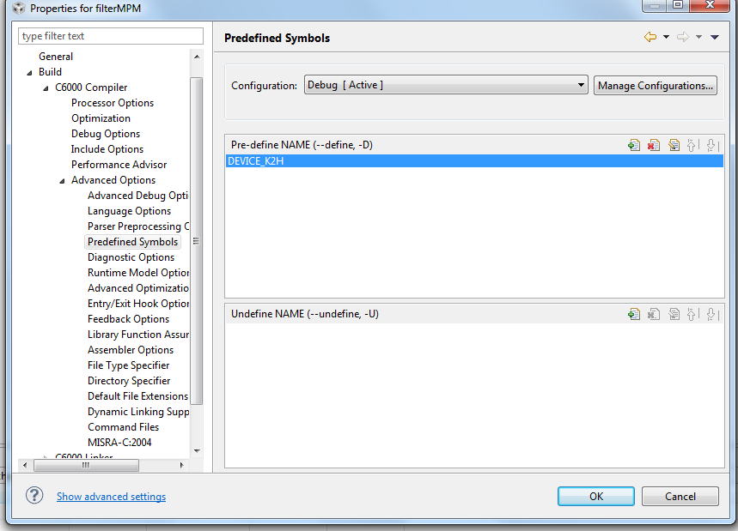

- Adding the csl library and the path to the library. To do so click on the link tab, file search path and enter the csl library ti.csl.ae66 at the top window. Add the path to the library at the lower window. In my setting the path to the csl library is C:\ti\MCSDK_3_1_4\pdk_keystone2_3_01_01_04\packages\ti\csl\lib\k2k\c66 The following screen shot shows the adding of the csl library and the path:
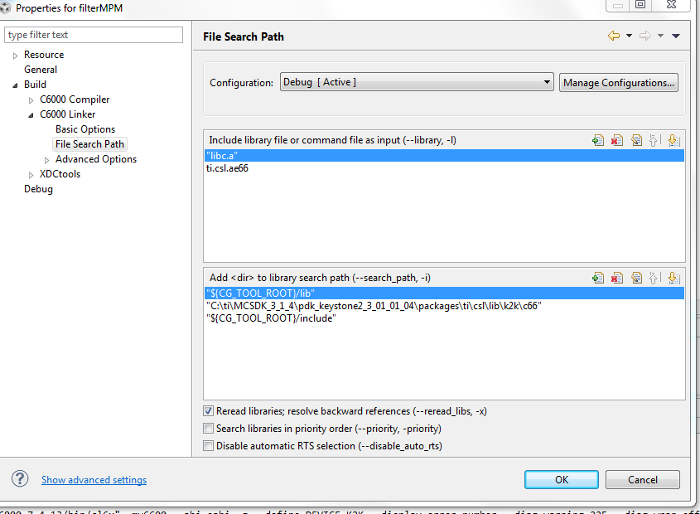

- If you have not set the platform before, click on the General tab, RTSC, click on the platform tab at the bottom of the dialogue box and select ti.platform.evmTCI6638K2K platform
- Select OK to close the property dialogue window.

NOTE: RTSC projects require the user to select three types of information.
- The device family in the CCS create page determines what core is used and thus what version of the compiler should be used (different cores have different intrinsic functions).
- The platform that is defined here determines the memory configuration of the core.
- To build the correct RTSC drivers, the device name should be defined. This is done by adding a predefined symbol with the device name. More about it later.

- Right click on the project name and select rebuild. If the build goes correctly, you will see the following in the console window. NOTE: Look at the debug directory to ensure that the file mpm_example_sum.out is there. Ignore any warnings.
- Look at the map file (located in the Debug sub-directory) and notice that DDR address 0x8000 0000 is used in the project.
******************************************************************************
TMS320C6x Linker PC v7.4.8
******************************************************************************
>> Linked Thu Oct 02 13:46:19 2014

OUTPUT FILE NAME: <filterMPM.out>
ENTRY POINT SYMBOL: "_c_int00" address: 8011ca80

MEMORY CONFIGURATION

name origin length used unused attr fill
---------------------- -------- --------- -------- -------- ---- -------
L2SRAM 00800000 00100000 0002fcb4 000d034c RW X
L1PSRAM 00e00000 00008000 00000000 00008000 RW X
L1DSRAM 00f00000 00008000 00000000 00008000 RW
MSMCSRAM 0c000000 00600000 00028000 005d8000 RW X
DDR3 80000000 20000000 001211e0 1fedee20 RW X

Task 2: Using MPM to Load, Run and Observe Results
In this part, we assume that the EVM is boot in net mode. That is, the file system is on the server and mounted to the EVM as done in Lab 3.
- Find the location where the .out file resides. To do so, find the outfile in the debug directory of the project, select the outfile, and right click properties. Look at the location at the top of the open dialogue.
- From the VNC, navigate to your directory /opt/filesys/studentN
- Change the permission of the bin subdirectory:
sudo chmod 777 –R bin
- FTP the out file onto the server at /opt/filesys/studentN/bin
Where N is the student number
- Change the permission of the out file
cd bin
sudo chmod 777 mpm_example_sum.out
- Reboot the EVM using NFS.
- From the terminal login as root
- cd /bin
- Use MPM to reset, load, and run core 0 with mpm_example_sum.out by using the following MPM commands:
mpmcl reset dsp0
mpmcl load dsp0 mpm_example_sum.out
You get an error message as follows:
root@k2hk-evm:/bin# mpmcl reset dsp0
[ 790.263525] remoteproc0: stopped remote processor 2620040.dsp0
reset succeeded
root@k2hk-evm:/bin# mpmcl load dsp0 mpm_example_sum.out
load failed (error: -104)

Task 3: Using direct addressing and Run Again

- The source code main.c defines a pointer to the output vector outputData[]. A pragma DATA_SECTOR tells the compiler to allocate the vector in the section .DDR3. The linker command file link_file.cmd tells the linker to put this vector in the DDR3 memory.
- If the symbol VECTRO_DEFINE is not defined, then the pointer p2 will get its value from direct assignment, and this value will be in the DSP reserved area (0xE000 0000) See the following:
#define VECTOR_DEFINE

#define NUMBER_OF_ELEMENTS 1024

int *p_output ;

#ifdef VECTOR_DEFINE
#pragma DATA_SECTION (outputData, ".DDR3")
#pragma DATA_ALIGN (outputData,8)
int outputData[NUMBER_OF_ELEMENTS];
int *p2 = (int *) &outputData[0] ;
#else

int *p2 = (int *) 0xe0000000 ;
#endif

- In the main.c file, comment out the definition of VECTOR_DEFINE
// #define VECTOR_DEFINE

- Save and rebuild the project. Look at the map file. This time it looks like the DDR memory is not used;
******************************************************************************
TMS320C6x Linker PC v7.4.13
******************************************************************************
>> Linked Mon Feb 23 10:27:42 2015

OUTPUT FILE NAME: <mpm_example_sum.out>
ENTRY POINT SYMBOL: "ti_sysbios_family_c64p_Hwi0" address: 00819800

MEMORY CONFIGURATION

name origin length used unused attr fill
---------------------- -------- --------- -------- -------- ---- --------
L2SRAM 00800000 00100000 0001a00c 000e5ff4 RW X
L1PSRAM 00e00000 00080000 00000000 00080000 RW X
L1DSRAM 00f00000 00080000 00000000 00080000 RW
MSMCSRAM 0c000000 00600000 00000000 00600000 RW X
DDR3 80000000 20000000 00000000 20000000 RW X
DDR3_forDSP e0000000 20000000 00000000 20000000 RW X

- Repeat Task 2 of the Lab (ftp the out file to /opt/filesys/studentN/bin) and repeat the process. This time you will be able to load and run the code. The following is a screen shot after running the new program.

root@k2hk-evm:/bin#
root@k2hk-evm:/bin# mpmcl reset dsp0
reset succeeded
root@k2hk-evm:/bin# mpmcl load dsp0 mpm_example_sum.out
load succeeded
root@k2hk-evm:/bin# mpmcl run dsp0
[ 7415.136643] remoteproc0: powering up 2620040.dsp0
run succeeded
- Look at the trace 0 file the end of the run

root@k2hk-evm:/bin# cat /sys/kernel/debug/remoteproc/remoteproc0/trace0

4 values start at 964 2912 14543 2918 14573
4 values start at 968 2924 14603 2930 14633
4 values start at 972 2936 14663 2942 14693
4 values start at 976 2948 14723 2954 14753
4 values start at 980 2960 14783 2966 14813
4 values start at 984 2972 14843 2978 14873
4 values start at 988 2984 14903 2990 14933
4 values start at 992 2996 14963 3002 14993
4 values start at 996 3008 15023 3014 15053
4 values start at 1000 3020 15083 3026 15113
4 values start at 1004 3032 15143 3038 15173
4 values start at 1008 3044 15203 3050 15233
4 values start at 1012 3056 15263 3062 15293
4 values start at 1016 3068 15323 3074 15353
4 values start at 1020 3080 15383 3086 15413
Setting 'global_variable' to 1

Lab 8: ARM Optimization Using SMP Linux

Projects and Source Code
Unless instructed by the instructor otherwise, all projects and source code are available on the server. Directory /global/Projects has two sub-directories, ARM and DSP. The source for this ARM sub-directory is in the ARM subdirectory in a subdirectory called SMP.

Purpose
The purpose of this lab is to demonstrate how the SMP LINUX distributes threads between multiple cores and as a result, speed, up the processing of time sensitive application, running on the four ARM A15 cores of the KeyStone II device.
The default application is a typical signal processing fir filter algorithm. Fir filters can be easily partitioned between multiple threads. The program was structured such that it is very easy to replace the fir filter with any generic easy-to-partition application.

Task 1: Copy the Source Files
It is assumed that the file system is mounted to the EVM (NFS boot, setenv boot net) and that the file system is in location /opt/filesys/studentN where N is the student number.
- From the VNC window log-in as your student name (user name studentN, password WsN where N is the student number) and run the initialization script file.
Source: /global/scripts/studentStartOutsideTI.sh
- In the studentN file system location make a new directory (if it does not exist already) and name it applications and then make a subdirectory smp_test
cd /opt/filesys/studentN
sudo mkdir applications
cd applications
sudo mkdir smp_test
cd smp_test

NOTE: If the file system is located in a different directory, change the instructions accordingly. Next, copy the four source files to the new directory:
sudo cp /global/Projects/ smp_threads /smp_test.c .
sudo cp /global/Projects/ smp_threads /multithreads.h .
sudo cp global /Projects/ smp_threads /application.c .
sudo cp / global/Projects/ smp_threads /application.h .
- Last copy the three Makefiles to the new directory
sudo cp /global/Projects/smp_threads /Makefile_no_optimization.mak .
sudo cp /global/Projects/ smp_threads /Makefile_O2_optimization.mak .
sudo cp /global/Projects/smp_threads /Makefile_full_optimization.mak .
Questions
Assume you want or need to change the algorithm that runs on the A15.
- Does the file smp_test.c need to be changed?
- Does the include file multithreads.h needs to be changed?
- Does the file application.c need to be changed or replaced?
- Does the file application.h need to be changed or replaced?
- Which instruction spans threads?
- Optional: What does each of the parameters of the clone () function represent?

Task 2: Compile, Build, & Run the Project on a Single Core

Cross Compiler Instructions (you can use the native tools)
From the VNC terminal, you need to build the project. The path to the cross compiler should be defined. To verify this, do the following:
printenv |grep arm
printenv |grep gcc
The output on the terminal will appear as follows:
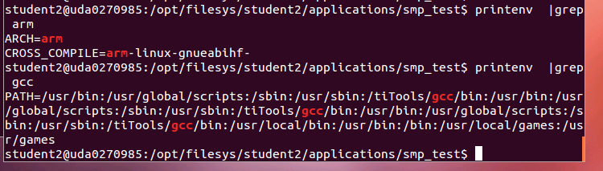

Make sure that the path to arm-linux-gnueabihf is defined and the arm-linux-gnueabihf is defined as the CROSS_COMPILER
First build the project with full debug and no optimization:
make –f makefile_No_Optimization.mak
Note that the optimization flag (dash capital O) is set to zero, and there is –o (small o) to smp_test_no_optimization.out Thus, the built project will have the name smp_test_no_optimization.out.
Before running the code, you need to verify that the EVM is connected to the local network via Ethernet, that you have a terminal window (either Putty or Tera Term or other) into the EVM as explained in previous labs, and that NSF boot from TFTP is working.
- Power on the EVM
- Wait for the login screen.
- Login as root:
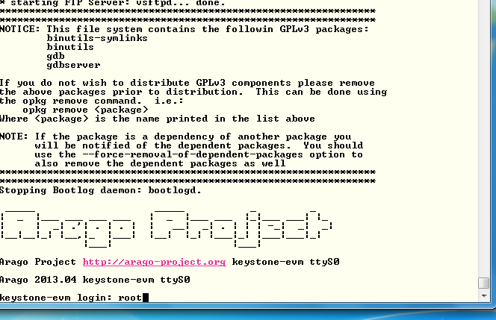
- Change the location of the terminal to the smp_test directory:
cd /applications/smp_test
ls
The four source files, the three Make files, and the a.out file should be in the directory.
- To run the code with a single thread, first ensure that the file a.out has executable permission:
chmod +x smp_test_no_optimization.out
- Run the code:
./smp_test_no_optimization.out 1

After a few seconds (wait until all the printing is done), the results should appear as follows:
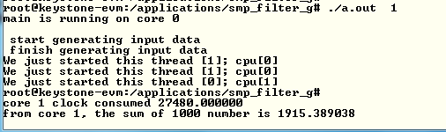
- Record the clock consumed value in the table (next page).
- Back in the VNC window re-build the executable with O2 optimization:
make –f makefile_O2_Optimization.mak

- Run smp_test_o2.out The results should look like the following:
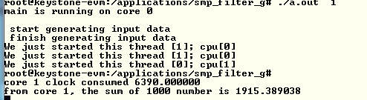
- Back in the VNC window, re-build the executable with full optimization:
make –f makefile_full_Optimization.mak
- And run smp_test_full.out
Questions
- What is the speed-up percentage of performance improvements when the optimization O2 is on?
- What is the speed-up percentage of performance improvements when the full optimization is on?
  - Compare to non-optimization
  - Compare to –O2

Task 3: Run the Code on Multiple Cores
From this point on you only run the full optimized version of the a.out executable.
In this task you run the program on multiple cores. While the total processing time on all the cores remains almost the same, the elapsed time (the time that the slowest core consumes) will be reduced almost linearly by the number of cores that are involved.
The SMP operating system will distribute threads between cores. The number of thread in this program is limited to 32, but the number of cores is 4. So if the number of threads is bigger than 4, multiple threads will be assigned to each core.
Run the following cases and compete the table below:
./ smp_test_full.out 1
./ smp_test_full.out 2
./ smp_test_full.out 4
./ smp_test_full.out 8
./ smp_test_full.out 16
./smp_test_full.out 32
Number of threads | Core 0 total time consumed | Core 1 total time consumed | Core 2 total time consumed | Core 3 total time consumed | Slowest core time consumed | Total time consumed by the 4 cores

Questions
- The shared ARM L2 cache is 4MB. Do all the vectors fit into the cache?
- The private L1 cache for each ARM A15 core is 32KB. What is the maximum input vector that will not cause L1 cache to be trashed?
- What is the speed-up percentage when four cores are used compared to a single core?
- How does the cache size effect the total time when multiple threads are used?

Lab 9: Inter-Processor Communication (IPC)

Projects and Source Code
The original files for this Lab are part of the MCSDK release. The student will copy MCSDK release into his private directory (studentN/MCSDK_X_XX) before changing any file.

Purpose
The purpose of this lab is to demonstrate messages transfer between the ARM and the DSP cores. The source code may be a starting point for customer who needs sending messages and data between cores.

Task 1: Run the Demo from a Web Server

Step 1: Boot and Obtain IP Address
The file system that is loaded into the EVM should be tisdk based file system. Boot the EVM using NFS (mount) boot and wait until the display on the EVM gives the IP address of the board. Note that the display flips between several messages. IP address is one of the messages.

Step 2: Start Terminal Session
Open a terminal into the EVM and log in as root

Step 3: Access Matrix Application Loader
From a computer that is on the same sub-net as the EVM, or from VNC into a computer that is on the same subnet as the EVM, start Firefox (or any other browser) and put the IP address of the EVM as shown in the following screen shot. The EVM in the screen shot has IP address of 192.168.0.24.
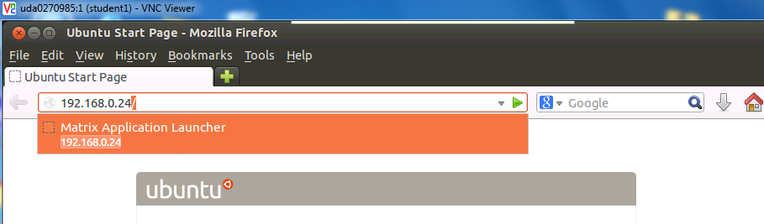

If the Firefox is connected via VNC, Ubuntu may ask you if you have a display device. Answer OK. The EVM respondx with a set of out-of-the-box applications as seen in the next screen:
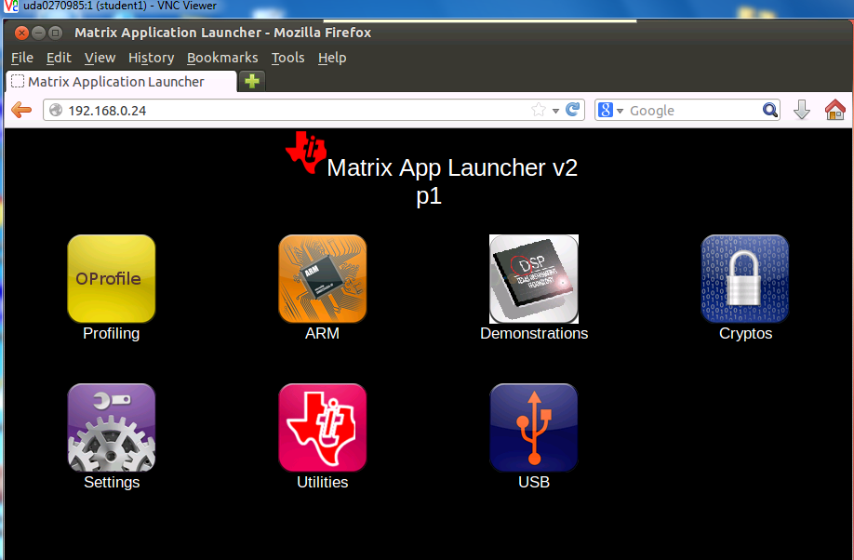

It is highly recommended to go through each one of the applications. However, in this lab we only use the IPC demo. Click on the Demonstrations tab and then the IPC Demo. The next screen shot will be displayed:
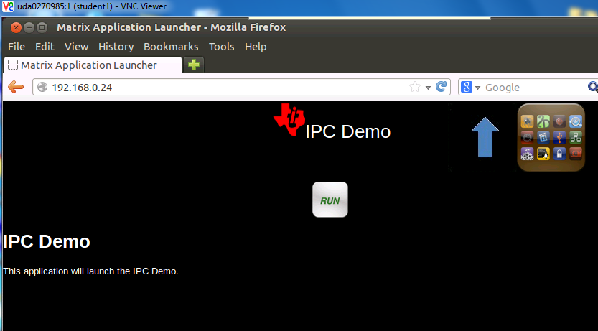

Click on RUN and follow the progress on the browser and on the terminal that is connected to the EVM.
The browser display:
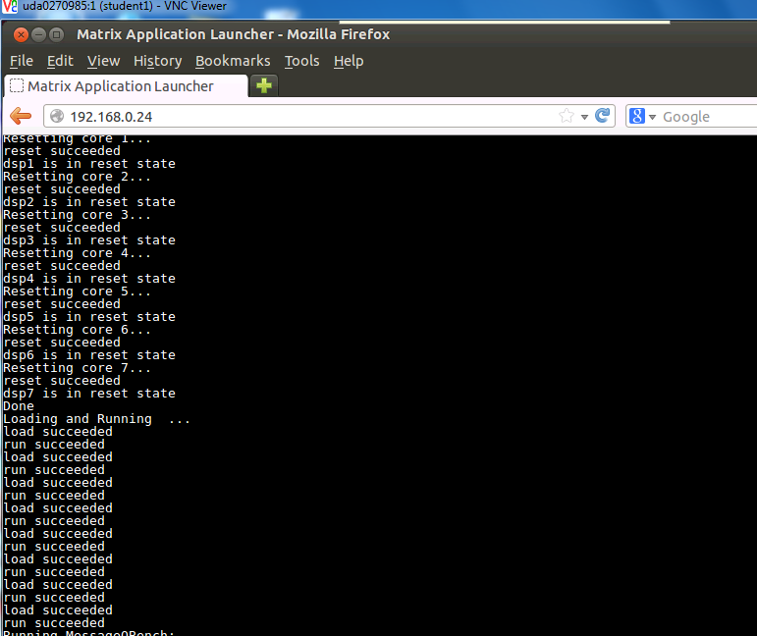
You may have to use the arrow to see the complete execution of the demo. The last lines are the following:
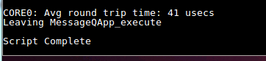

The terminal that is connected to the EVM displays something like:
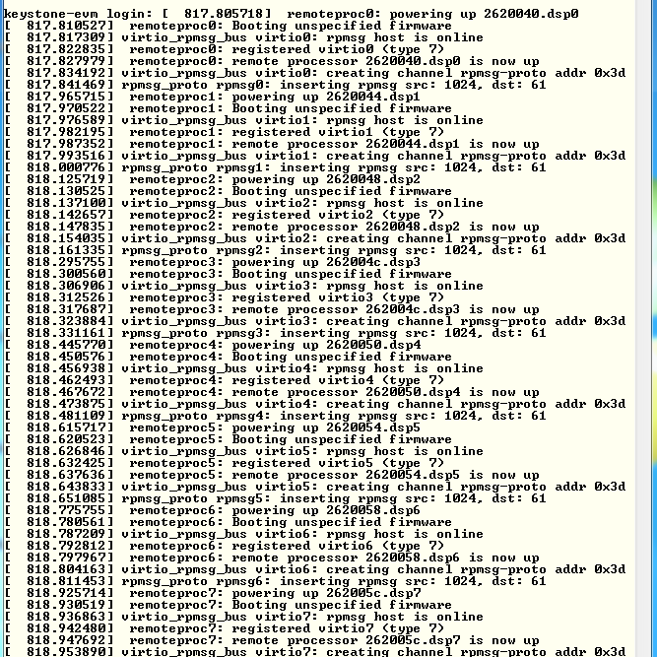
Follow the messages on the terminal and see what software modules are used (remoteproc, virtio, rpmsg).

Task 2: Run the Demo from the Terminal

Purpose
The purpose of this task is to familiar the user with the directory structure and the main files of the demo

Step 1: Observe the File demo_ipc.sh
In the directory /usr/share/matrix-gui-2.0/apps/demo_ipc there are three files:
- demo_ipc.desktop
- demo_ipc.sh
- desc_demo_ipc.html
Look at the file demo_ipc.sh using vi, more, less, cat or any other utility.

The following screen shot was taken using cat:
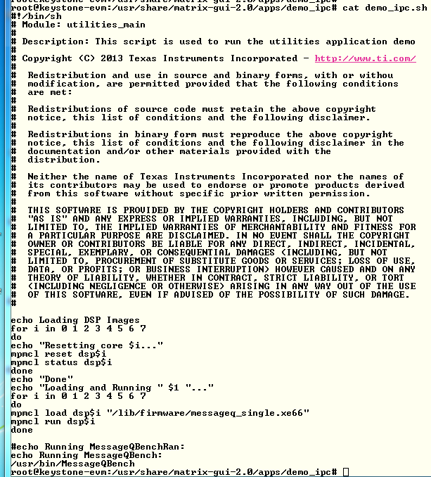
Notice that the DSP code is loaded from directory /lib/firmware and the name of the execution is message_single.xe66. The Linux code is loaded from directory /usr/bin and the executable name is MessageQBench. In the next task, you will build these two executable files in your local directory and move them to your private file system.

Step 2: Run the File demo_ipc.sh
In the terminal, move to directory /usr/share/matrix-gui-2.0/apps/demo_ipc (cd /usr/share/matrix-gui-2.0/apps/demo_ipc) and run the sh file ./demo_ipc.sh as shown the following screen shots:
After the run, the terminal looks like the following:
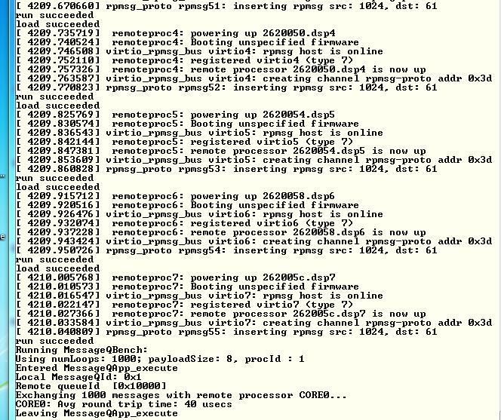

Task 3: Rebuild the Executable

Purpose
In this task, the student will re-build the DSP and ARM executable to prepare for modifying the code for a new project.

Step 1: Get a Private Copy of IPC from the Release
Back to VNC window … In your home directory /home/student, create a new directory named IPC and move there:
sudo mkdir IPC
cd IPC
Copy the IPC directory from the latest release into the new created private directory. Currently, the latest release is release 3_18:
sudo cp -R /tiTools/MCSDK_3_4_18/ipc_3_00_04_29 / .
cd ipc_3_00_04_29
ls
The directory should look like the following:
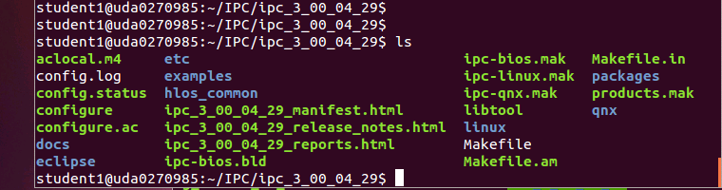

Step 2: Build the ARM Executable
Detailed instructions how to install and build the Linux version of IPC are in the file IPC_Install_Guide_Linux.pdf that is part of the release in directory \MCSDK_3_4_18\ipc_3_00_04_29\docs. The install part of the IPC is already in the release. So we will start with the build procedure.
First, set the environment variables in the file products.mak in the directory ipc_3_00_04_29 (or any later version of IPC) as follows:
DEPOT (Optional, depends how you define the other variables)
TOOLCHAIN_LONGNAME
TOOLCHAIN_INSTALL_DIR
PLATFORM
KERNEL_INSTALL_DIR
XDC_INSTALL_DIR
BIOS_INSTALL_DIR
ti.targets
The IPC install guide explains what needs to be set in the variables mentioned above. The following is an example of the definition. You may have to modify the variables based on structure of your system.

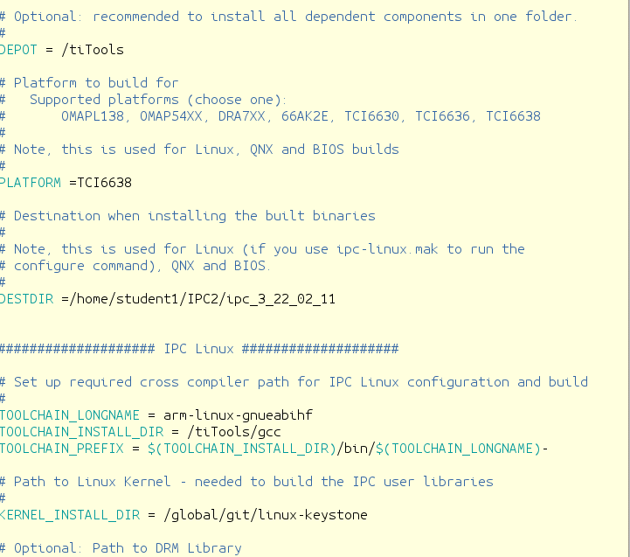

The platform is TCI6638 (Hawking).
The TOOLCHAIN_INSTALL_DIR is the location where the Linaro tools were installed on the server.
The KERNEL_INSTALL_DIR is where the kernel sources were installed using the git repository /global/git/linux-keystone.
The TOOLCHAIN_PREFIX is the final location where the linaro tools are the gcc and all other tools are located. It must have the – at the end
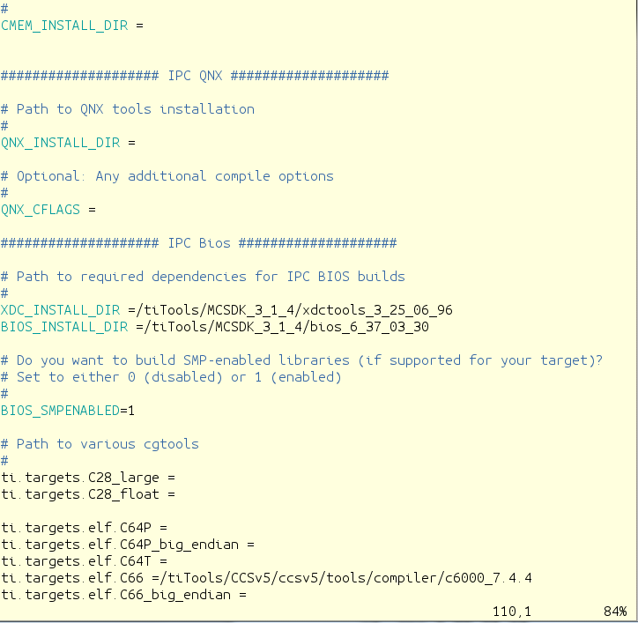

XDC_INSTALL_DIR is part of the MCSDK release and the location points to where the XDC part of the MCSDK was installed. The same is true for the BIOS_INSTALL_DIR. The ti.targets.elf.c66 is the location of the code generating tools for this platform. The tools location is part of the CCS release. The CCS was installed in /tiTools/CCS5_v5 directory.
In order to manipulate files in the ipc directory you have to change the permission. Since this is a private copy on a local network, you can give full permission.
cd ..
sudo chmod 777 –R ipc_3_00_04_29
cd ipc_3_00_04_29
Next, run the make utility with the Linux makefile:
make –f ipc-linux.mak config
When building a second time, you have to clean the environment before:
sudo make clean
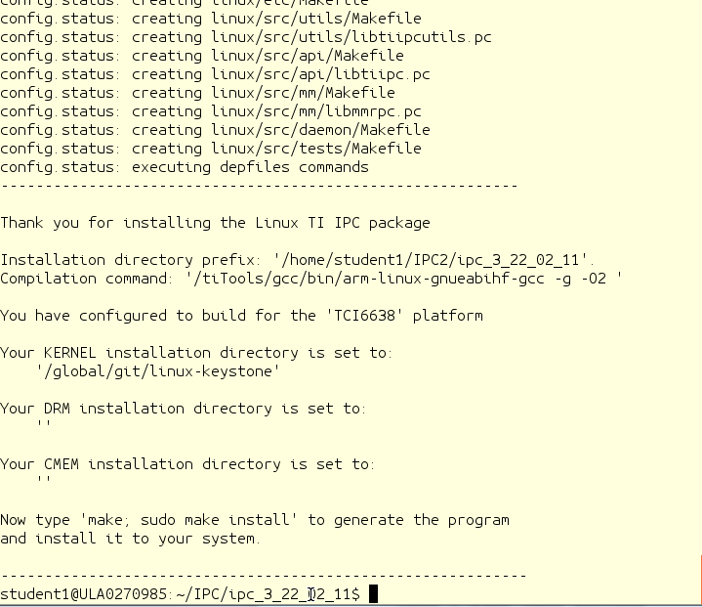

The screen prompts you to run the next make
make ; sudo make install
Follow the printing in the window. It may ask you for a password for the sudo part. The following screen shot shows the end of the build. In case of error, see the note after the screen shot. Note that the script reports an error at the end, (libtool: line 6556: arm-linux-gnueabihf-ranlib: command not found ). Ignore this error; the executable was built, though some of the libraries may not be rebuilt. In addition, the script might ask you for the sudo password during the execution.
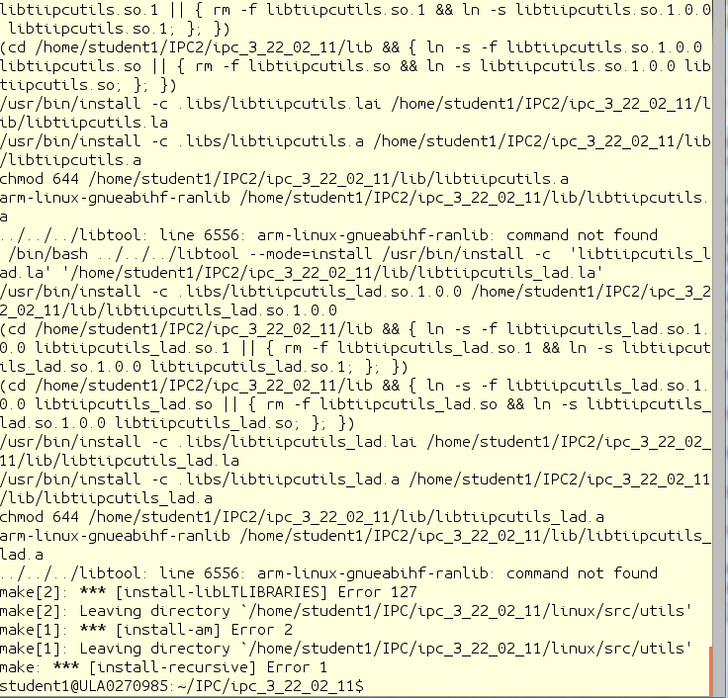

The build process builds several files. The file MessageQBench in directory linux/src/tests/ is a temporary wrapper script file that shows how the build is done. The file MessageQBench (yes, the same name) in directory linux/src/tests/.libs is the executable. After the build, move this file to the file system location:
sudo cp linux/src/tests/.libs/MessageQBench /opt/filesys/studentN/usr/bin/.
Verify that the executable in the /opt/filesys/studentN/usr/bin directory is the one that you built by doing ls –ltr MessageQBench and verifying the data and time.

Step 3: Build the DSP Executable
Detailed instructions how to install and build the DSP-BIOS version of IPC are in the file IPC_Install_Guide_BIOS.pdf, which is part of the release in directory \MCSDK_X_Y_Z\ipc_X_Y_Z\docs. The install part of the IPC is already in the release, so we will start with the build procedure.
The environment variables in the file products.mak were already set in the previous step.
Return back to the ipc directory
Next step is to run the make utility with the linux makefile:
cd ~/IPC/ipc_3_00_04_29 (or a newer version of IPC)
make –f ipc-bios.mak all
The build will take several minutes. The following is a screen shot when the build is done:
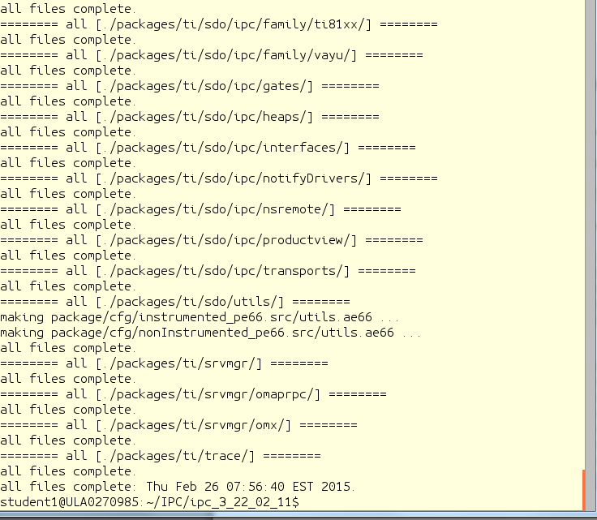
The executables are built in the directory IPC/ipc_X_Y_Z/packages/ti/ipc/tests/bin/ti_platforms_evmTCI6638K2K_core0. There are five ex executables as follows:
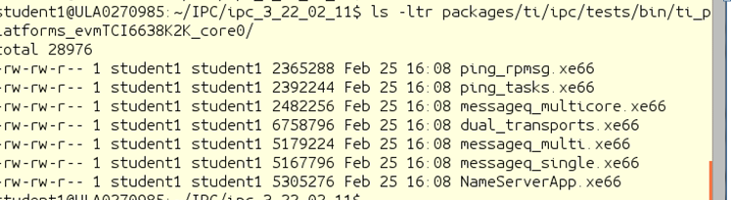
The file messageQ_signal.xe66 should be copied to the file server at location /opt/filesys/studentN/mcsdk_x_XX/lib/firmware
sudo cp packages/ti/ipc/tests/bin/ti_platforms_evmTCI6638K2K_core0/messageq_single.xe66 /opt/filesys/student1/lib/firmware/.
Verify that the executable in the /opt/filesys/studentN/lib/firmware directory is the one that you built by doing ls –ltr messageQ_single.xe66 and verify the data and time
From Tera Term, run the demo_ipc.sh again. Verify that it is working.
/usr/share/matrix-gui-2.0/apps/demo_ipc/demp_ipc.sh

Task 4 (Optional): Modify Source Code & Rebuild Executable

Purpose
In this task the student will change the ARM code and the DSP code, build and run the executable
You are welcome to do any change you want. The following instructions and screen shots will show how to add an index to the message from the ARM to the DSP, and the DSP will read the index, add 1000 to it and send it back to the ARM.

Step 1: Modify the ARM Code
The demo source file is MessageQBench.c in directory /IPC/ipc_3_00_04_29/linux/src/tests. Following the source file, it looks like the ARM allocates a message, sends it to the DSP, and then gets the message back and make sure that the data was not corrupted during the transfer. The changes that are suggested for the ARM side are the following:
- Modify a printf statement to show that the code has been modified
- Adding an additional value (or values) to the message, load the additional value with a known data, and print the additional information from the DSP side.
Here are the suggested changes:
- Enable printing from the DSP side. This is done by changing the second parameter in the first control message to TRUE. Note that by enabling printing, the execution time is increased.
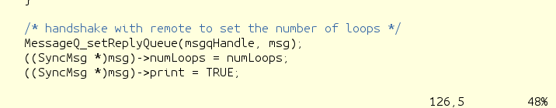
- Load the next value in the message to ten times the index number:
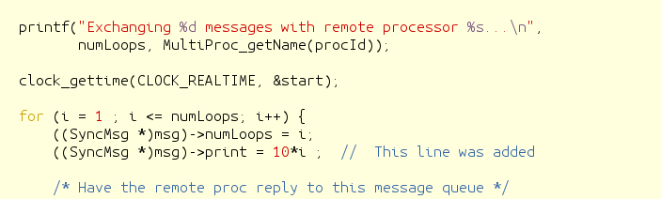

- In the DSP the second value will be read, multiplied by 10 and sent back to the ARM. Thus in the ARM print the receive value and compare it to 100*index (10 times in the ARM and 10 times in the DSP
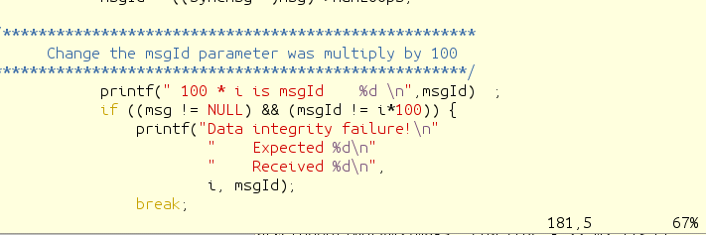

Step 2: Build the ARM Code
Repeat the steps from the previous task and re-build the ARM executable MessageQBench

Step 3: Modify the DSP Code
The DSP source function messageq_single.c is in directory IPC/ipc_3_00_04_29/packages/ti/ipc/tests .
- Add a new variables newVar1 and newVar2 to the tsk1Fxn
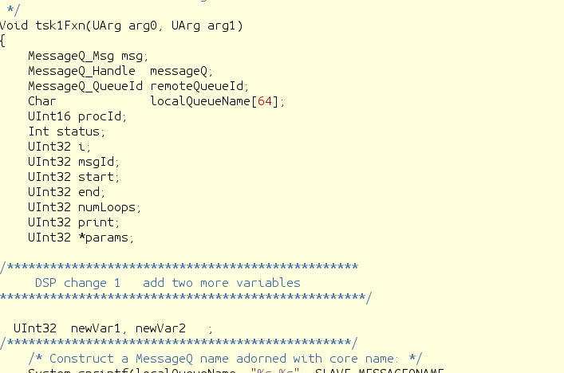

- Load the new values value from the ARM message and print it. (The value is 10*I, and the System_printf prints on the DSP trace buffer that is accessed by the Linux)
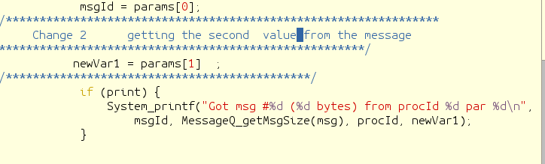

- DSP core multiplies the new values by 10 (again, so now it is 100*I), adds it to the message and sends the message back to ARM
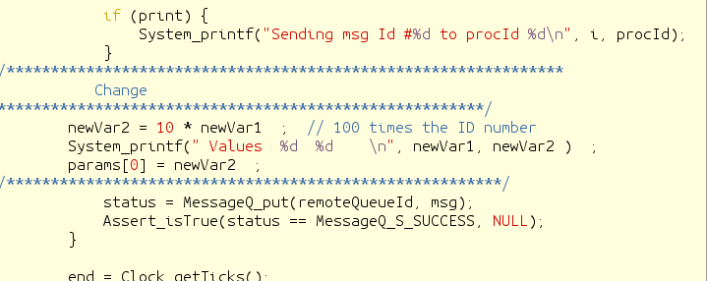

Step 4: Build the DSP Code
Follow the instructions from the previous task.

Step 5: Run the File demo_ipc.sh
Follow the instructions of Task 2.
- Observe the printing on the terminal to see the changes that you did in the printf of the ARM code
- Look at the ARM trace buffer of DSP core 0 and see all the printing that arrived from the DSP:
Cat sys/kernel/debug/remoteproc/remoteproc0/trace0
Here are some screen shots from the terminal during running the script:
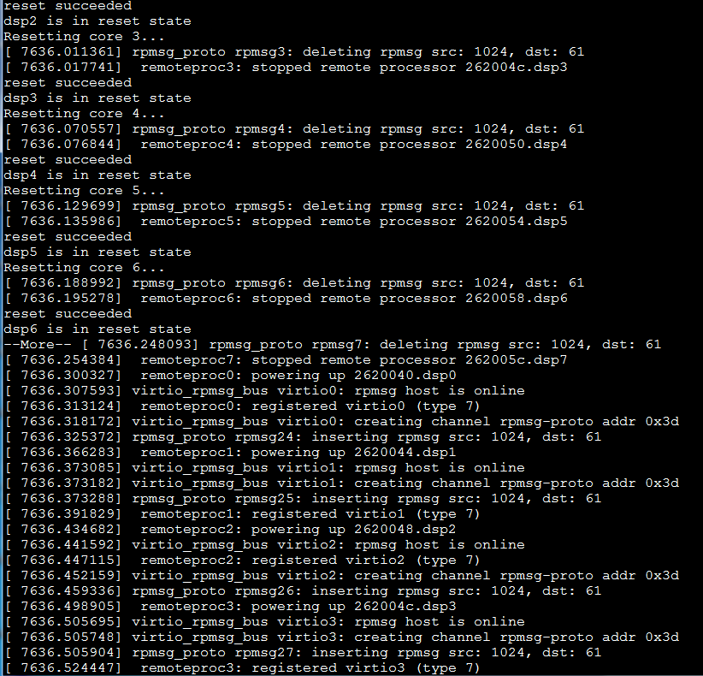
The ARM prints messages back from the DSP:
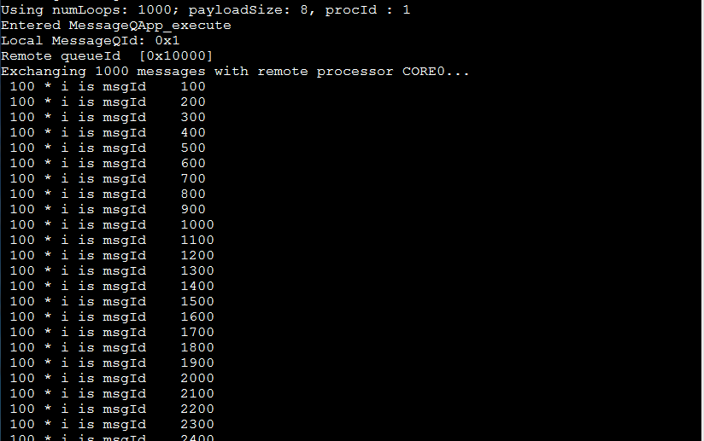

Looking at the trace buffer for the DSP System_printf, and remember that this is a circular buffer:

