Load program, go main()
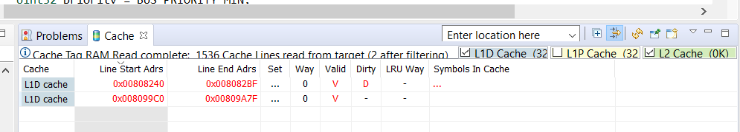
After ddr_write_access(&ptab0[0], size_to_test_bytes);

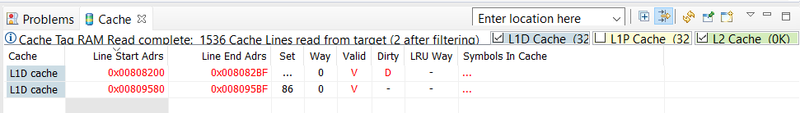
After CACHE_invL1d(&ptab0[0], size_to_test_bytes, CACHE_WAIT);
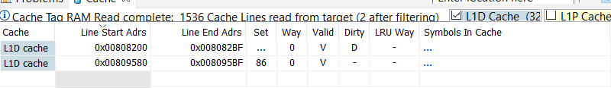
After err = verif(&ptab0[0], size_to_test_bytes);
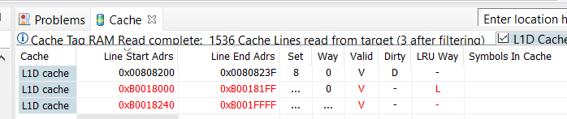
After printf("Throughput for size bytes %d = %f MB/s \n", size_to_test_bytes, f32_speed_mb_per_sec);
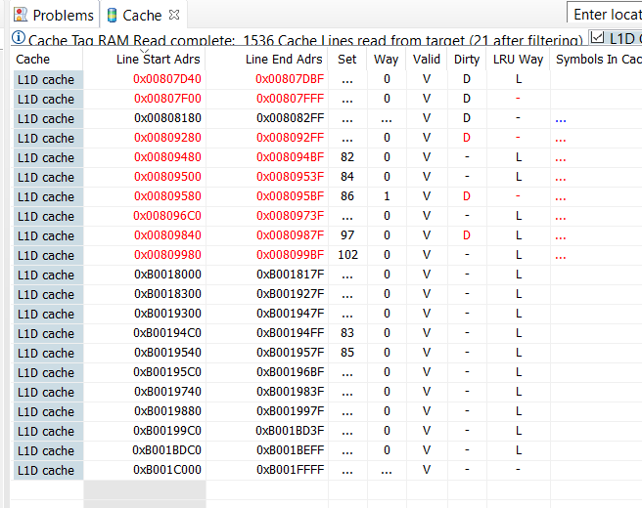
After CACHE_wbInvL1d(&ptab0[0], size_to_test_bytes, CACHE_WAIT);
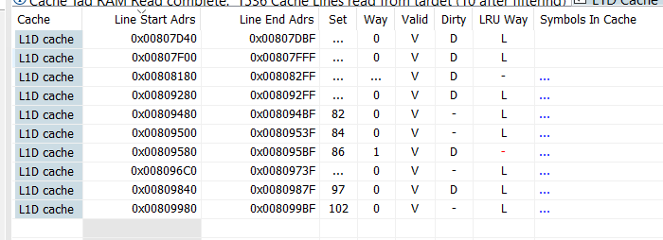
This is an infinite loop:
*next=0;
do
{

} while(*next==0);

I changed it *next = 1
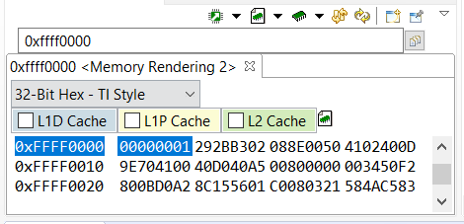
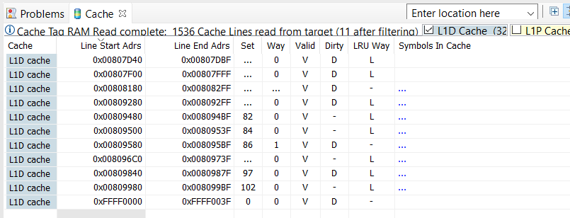
After ddr_write_access(&ptab0[0], size_to_test_bytes);

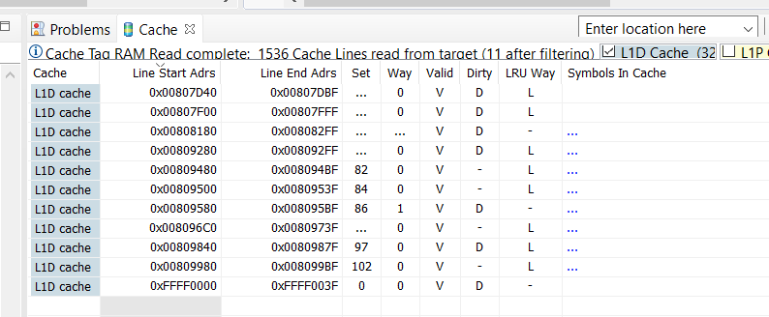
After CACHE_invL1d(&ptab0[0], size_to_test_bytes, CACHE_WAIT);

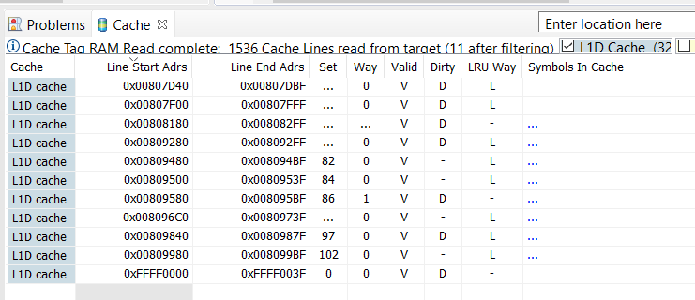
After err = verif(&ptab0[0], size_to_test_bytes);
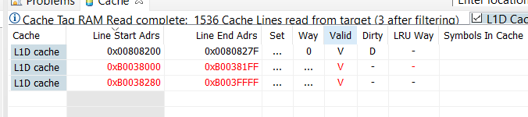
After printf("Throughput for size bytes %d = %f MB/s \n", size_to_test_bytes, f32_speed_mb_per_sec);

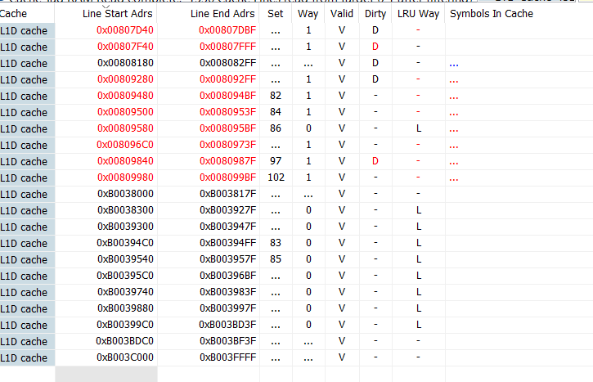
After memset(&ptab0[0], 0, size_to_test_bytes);
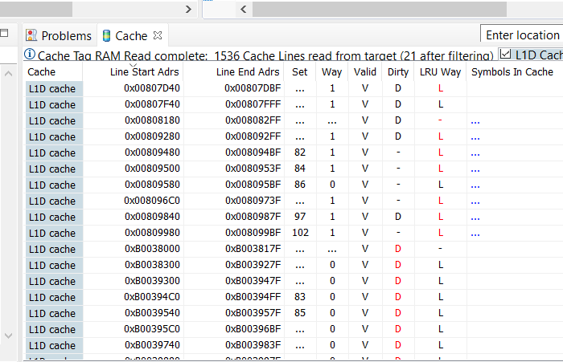
After CACHE_wbInvL1d(&ptab0[0], size_to_test_bytes, CACHE_WAIT);

