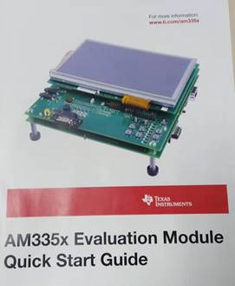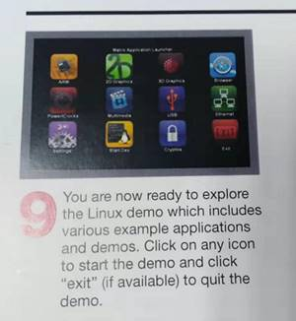
Customer do Default setup (OS boot from SD card) according to Quick Start Guide .
From Step 1 to step 8 ,are running smooth ,but at step 9 ,they Click any icon ,but haven’t any response by moitor.

