[Slide 1 – Title page]


Hi, everyone. There are times that NOR memory gets corrupted due to reasons of bad u-boot image written to it, or the NOR gets accidentally erased, and the EVM can’t boot. This video is to show how to restore the manufacture default image in the NOR memory on Keystone-2 platforms using Program EVM. The same method can be used to restore the NAND image as well. That is to program the NOR and NAND with pre-built images in the Linux Processor SDK. The Keystone-2 platforms are the K2H/K/E/L without a SD card. Therefore, K2G is not in the scope of this video.

[Slide 2 – Agenda]
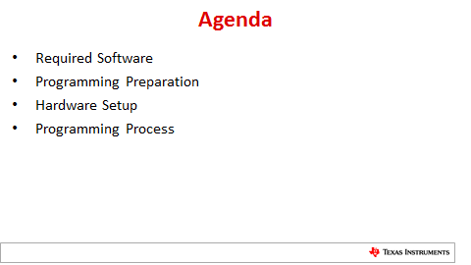

In this video, we’ll go through what software are required, the preparation before programming, how to set it up, and the actual programming process.

[Slide 3 – Required Software]
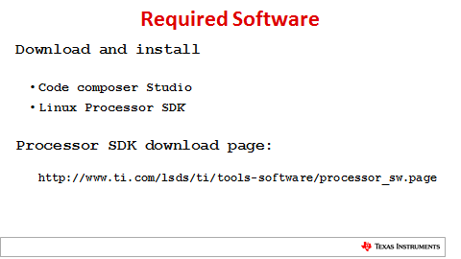

To restore manufacture default images, the Code Composer Studio and Linux Processor SDK release are required and can be downloaded from Processor SDK download page as shown here.
In the download page, it has link of corresponding version of CCS to the ProcSDK release for download, and of course, also the link to download Linux ProcSDK release.

[Video to show CCS and Linux ProcSDK directory on Linux machine]

I am using K2E Linux ProcSDK 3.2 release and CCS 6.1.3. So the CCS is downloaded and installed under {MyHomeDirectory}/ti/ccs6.1.3_00034 directory, and Linux ProcSDK at {myHomeDirectory}/work/work/ti-processor-sdk-linux-k2e-evm-03.02.00.05/

[Slide 4 – Programming preparation]
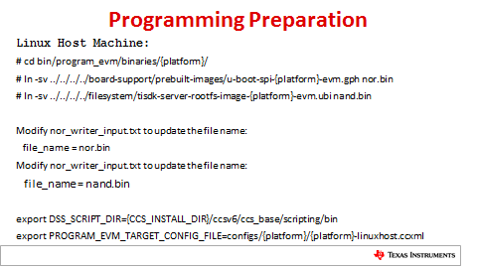
[Video to show commands and modification of the files]
In the ProcSDK package, the pre-built NOR image is the u-boot-spi.gph file with platform name in it which is located in board-support/prebuilt-images directory. The NAND image is the combined kernel and filesystem ubi image in filesystem directory. The file name is tisdk-server-rootfs-image.ubi also with platform name in it.
To make it less confusion, we either rename or symbolically link the u-boot SPI GPH image to nor.bin which will be program to NOR. Same process to rename or symbolically link the UBI image to nand.bin.
The corresponding file name changes should be reflected in both nor_writer_input.txt and nand_writer_inpput.txt files. So, we edit them, and update them with correct file names.
Then we need to export 2 environment variables, the DSS_SCRIPT_DIR, and PROGRAM_EVM_TARGET_CONFIG_FILE. They should be pointed to ccs_base/scripting/bin directory and to the platform linuxhost.ccxml respectively.

[Slide 5 – Hardware Setup]
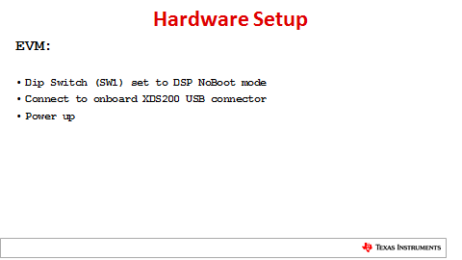

[Video to show dip switch setting, connecting USB cable, and power up]
Using K2E EVM as an example, the SW1 dip switch by the LCD screen should be set the “DSP NoBoot” mode. That is, all 4 pins should be set to “ON”.
Then we connect Linux PC to the onboard XDS200 USB connector through provided USB cable.
Then, we can power up the EVM.

[Slide 6 – Programming Process]
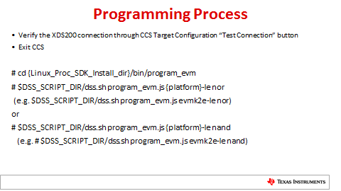

[Video to show CCS testing connection]
Before we start programming the EVM, the connection to XDS200 should be tested to be sure we have a good connection. If test failed, correct the errors. It could be wrong ccxml file, bad cable, etc. Once verified the connection is good, exit the CCS.

[Video to show programming the EVM]
Now, we can start program the EVM with default manufacture images. This should be done in bin/program_evm directory by running JavaScripted-based DSS script with platform information and which memory to restore.
Because NAND image is big so it will take a while to complete.

[Video to show reset dip switch and booting]
Once completed, the SW1 dip switch can be set back to ARM SPI boot, that is Off-Off-On-Off. It is recommended to reset the u-boot environment variables if NOR image has been changed using u-boot command “env default –f –a”. Then, “saveenv’ to save it for future use.
To test NAND image is restored successfully, set the u-boot variable boot to ubi, and boot the EVM.

[Slide 7 – For More Information]
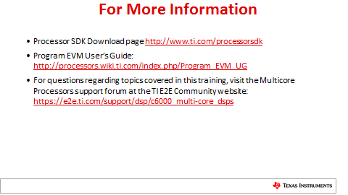

Thank you for taking the time to watch this video. You can refer to the links shown here for more information. If you have any questions, please post them on the Texas Instruments E2E forums at e2e.ti.com

