This is the soft-uart which transplant by myself.I do not founf am33xx_pruss_uart.1.(new SDK)
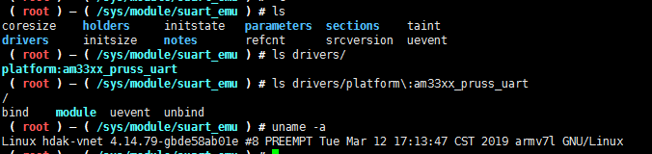

This is right(old SDK)
